Planning Statement
Description of development
Erection of a two storey extension above the existing commercial ground floor building for residential purposes comprising of 4 x 1 bed 2 person units.
Site location
The site is located to the west of Drayton Garden Village, behind the shopping parade of Station road and just to the south of West Drayton Station. Warwick road connects to Station road.
The site sits off the edge of Warwick road where it connects to Tachbrook street and on a pedestrian route which connects to a footbridge with direct access to the Station.
The site falls within the Yiewsley and West Drayton Town Centre as identified within the Hillingdon Local Plan Part 2 – Development Management Policies document.
The site consists of a range of single storey commercial buildings constructed in Brick and concrete panel under profiled sheet roof covering. The commercial space extends to around 180m2 and comprises a shop front office/ retail space with office space behind. To the south of the site is a row of Victorian terrace houses fronting Warwick road

5 station road which extends form station road to Tachbrook street and sits directly to the North of the site for 38 apartments The buildings provide the site context of the character of the immediate area for our design purposes.

Relevant planning history

9746/APP/2017/3485 - Extension to existing offices at ground floor and creation of two additional floors to create 4 x 1-bed self-contained flats with associated parking. Dismissed at Appeal 03-07-18

Reason for refusal (1) : The proposed extended building, by virtue of its excessive, height, scale and bulk would result in a cramped overdevelopment of the site, which would be visually incongruous and over dominant, therefore failing to harmonise with the established character of the surrounding area. The proposal is therefore contrary to Policy BE1 of the Hillingdon Local Plan: Part One - Strategic Policies (November 2012), Policies BE13, BE19, BE21 and BE22 of the Hillingdon Local Plan: Part Two - Saved UDP Policies (November 2012), Policies 3.5 and 7.4 of the London Plan (2016) and the adopted Supplementary Planning Document HDAS: Residential Layouts.

Reason for refusal (2) : The proposed extended building, by virtue of its excessive, height, scale and bulk would result in an unacceptably oppressive and overbearing form of development which would result in an unacceptable loss of light and outlook to the occupants of Number 9 Warwick Road. As such the proposal would result in an unneighbourly form of development in conflict with policies BE19, BE20 and BE22 of the Hillingdon Local Plan: Part Two -Saved UDP Policies (November 2012).

Appeal inspector’s decision
“13 Conclusion
Whilst the development would not have a harmful effect on the living conditions of the occupiers of No 9 Warwick Road, with particular regard to light and outlook, the development would have a harmful effect on the character and appearance of the area. Therefore, for the reasons given and having regard to all other matters raised, I conclude that the development would be contrary to the development plan when taken as a whole and the Framework. There are no material considerations to suggest a decision other than in accordance with the development plan and therefore the appeal is dismissed.”

Assessment of planning history

The base of any assessment of the proposed application should be the planning history of the site particularly where it has been subject to a refusal of a planning application for a similar development and even more so where the refusal has been subject to an appeal decision.

It is clear from the planning history that the principle of extending the building for residential use is acceptable. However, the Councils view on the recent application was that it failed to integrate with the street scape and resulted in unacceptable levels of impact upon the neighbouring property No.9 with regards to light and outlook. As stated above the inspector concurred with the Councils first reasons for refusal (impact to streetscape) but clearly did not agree with the second (impact to No.9). As such the basis of the assessment of the application should be that providing the proposed extension does not extend further that the previously refused rear elevation the second reason for refusal should not be brough forward in the determination of this current application.

Consideration has been given to how the design could evolve to respond positively to the first reason for refusal and the inspector’s comments. This is elaborated further within the design sections of this planning statement but one of the main points is that the street scape has seen significant change in recent years due to the construction of the Station Road development next door and Kitchener House development across the road which clearly shows that the proposed development is relatively modest in scale and height when compared with both of these sites.

Policy context

Nation Planning Policy Framework (NPPF)

The NPPF was published in February 2019, superseding the previous version published in July 2018, and sets out the Government’s proposed economic, environmental, and social planning policies for England. The NPPF carries forward the Government’s commitment to support sustainable economic growth and indicates that significant weight should be placed on the need to support economic recovery through the planning system. The NPPF also carries forward the requirement for Local Planning Authorities (LPAs) to approve development proposals without delay unless the adverse impacts of allowing development would significantly and demonstrably outweigh the benefits.
The NPPF confirms that the Development Plan remains the statutory basis for the determination of planning applications unless material considerations indicate otherwise. The NPPF constitutes guidance for LPAs and decision-takers both in and drawing up plans as material considerations in determining applications.

The NPPF defines Sustainable Development as ‘meeting the needs of the present without compromising the ability of future generations to meet their own needs’. At paragraph 8, it sets out three overarching and interdependent objectives, stating that these should be pursued in mutually supportive ways:

- An economic objective – to help build a strong, responsive and competitive economy, by ensuring that sufficient land of the right types is available in the right places and at the right time to support growth, innovation and improved productivity; and by identifying and coordinating the provision of infrastructure;
- A social objective – to support strong, vibrant and healthy communities, by ensuring that a sufficient number and range of homes can be provided to meet the needs of present and future generations; and by fostering a well-designed and safe built environment, with accessible services and open spaces that reflect current and future needs and support communities’ health, social and cultural well-being; and
- An environmental objective – to contribute to protecting and enhancing our natural, built and historic environment; including making effective use of land, helping to improve biodiversity, using natural resources prudently, minimising waste and pollution, and mitigating and adapting to climate change, including moving to a low carbon economy.

Paragraph 10 of the NPPF states that at the heart of the Framework is a presumption in favour of sustainable development

Paragraph 11 states that plans and decisions should apply a presumption in favour of sustainable development. For decision taking this means:

- approving development proposals that accord with an up-to-date development plan without delay; or
- where there are no relevant development plan policies, or the policies which are most important for determining the applications are out-of-date, granting permission unless:
* the application of policies in this Framework that protect areas or assets of particular importance provides a clear reason for refusing the development proposed; or
* any adverse impacts of doing so would significantly and demonstrably outweigh the benefits, when assessed against the policies in this Framework taken as a whole.

Paragraph 59 sets out the government’s objective of ‘significantly boosting the supply of homes’. It goes on to outline that it is important that a sufficient amount and variety of land can come forward where it is needed, that the needs of groups with specific housing requirements are addressed, and that the land with permission is developed without unnecessary delay.
Paragraph 61 states that the ‘size, type and tenure of housing needed for different groups in the community should be assessed, and reflected in planning policies (including, but not limited to, those who require affordable housing, families with children, older people, students, people with disabilities, service families, travellers, people who rent their homes and people wishing to commission or build their own homes)’ (paragraph 61).
Paragraph 91 states that ‘planning policies and decisions should aim to achieve healthy, inclusive and safe places which:

- Promote social interaction
- Are safe and accessible
- Enable and support healthy lifestyles’

Paragraph 92 states that in order to provide the ‘social, recreational and cultural facilities and services the community needs, planning policies and decisions should:

- Plan positively for the provision and use of shared spaces, community facilities and other local services
- Support the delivery of local strategies to improve health, social and cultural well-being for all sections of the community
- Guard against the loss of valued facilities and services
- Ensure that established facilities are able to develop and modernise
- Ensure an integrated approach to considering the location of housing, economic uses and community facilities.’

Paragraph 96 states that ‘access to a network of high-quality open spaces and opportunities for sport and physical activity is important for the health and well-being of communities’.

Section 9 of the NPPF relates to accessibility; it places emphasis on reducing the need to travel and providing a real choice of sustainable modes of transport. Development proposals are required to promote sustainable modes of transport, provide safe and suitable access and undertake improvements to limit any significant impacts. Paragraph 103 encourages development in locations which are or can be made sustainable, through limiting the need to travel whilst offering a genuine choice of transport modes.

Paragraph 110 requires applications for development to:

- Give priority firstly to pedestrian and cycle movements within the scheme and with neighbouring areas, and second to facilitate access to high quality public transport
- Address the needs of people with disabilities and reduced mobility in relation to all modes of transport
- create places that are safe, secure and attractive – which minimise the scope for conflicts between pedestrians, cyclists and vehicles, avoid unnecessary street clutter, and respond to local character and design standards
- allow for the efficient delivery of goods, and access by service and emergency vehicles; and
- be designed to enable charging of plug-in and other ultra-low emission vehicles in safe, accessible and convenient locations.’

Paragraph 111 states that ‘all developments which will generate significant amounts of movement should be required to provide a travel plan, and the application should be supported by a transport statement or transport assessment so that the likely impacts of the proposal can be assessed.’

Paragraph 117 requires planning policies and decisions to promote an effective use of land in meeting the need for homes and other uses, whilst safeguarding the environment and ensuring healthy and safe living conditions.
Paragraph 118 refers to the requirement for planning policies and decisions to:
- ‘give substantial weight to the value of using suitable brownfield land within settlements for homes and other identified needs, and support appropriate opportunities to remediate despoiled, degraded, derelict, contaminated or unstable land; and
- ‘promote and support the development of under-utilised land and buildings, especially if this would help to meet identified needs for housing where land supply is constrained and available sites could be used more effectively.’

Section 12 of the NPPF identifies the creation of high-quality buildings and places as fundamental to what the planning and development process should achieve.
It states that ‘good design is a key aspect of sustainable development, creates better places in which to live and work and helps make development acceptable to communities’. Paragraph 127 sets out a list of design-based criteria which policies and decisions should aim to ensure that development achieves.
The Development Plan
The Development Plan remains the statutory basis for the determination of planning applications unless material considerations indicate otherwise3 and the NPPF is a material consideration in planning decisions.
The NPPF establishes that Local Planning Authorities should approach decisions on proposed development in a positive and creative way. They should seek to approve applications for sustainable development where possible, using the full range of planning tools available, including brownfield registers and permission in principle, whilst working proactively with applicants to secure developments that will improve the economic, social and environmental conditions of the area.
In summary, the NPPF sets out the Government’s economic, environmental and social planning policies for England, it supports sustainable economic growth and gives significant weight to supporting economic recovery through the planning system. The NPPF requires Local Planning Authorities to approve development proposals without delay unless the adverse impacts of allowing development would significantly and demonstrably outweigh the benefits. The NPPF constitutes guidance for Local Planning Authorities and decision-takers both in drawing up plans and as a material consideration in determining applications.

The Development Plan for the London Borough of Hillingdon currently consists of The London Plan – Consolidated with Alterations (2016), the West London Waste Plan (2015), Hillingdon Local Plan: Part 1 – Strategic Policies (2012), Hillingdon Local Plan: Part 2 – Development Management Policies (2020), and Hillingdon Local Plan: Part 2 – Site Allocations and Designations (2020).
The London Plan

The London Plan 2021 is the Spatial Development Strategy for Greater London. It sets out a framework for how London will develop over the next 20-25 years and the Mayor’s vision for Good Growth.
The Plan is part of the statutory development plan for London, meaning that the policies in the Plan should inform decisions on planning applications across the capital. Borough’s Local Plans must be in ‘general conformity’ with the London Plan, ensuring that the planning system for London operates in a joined-up way and reflects the overall strategy for how London can develop sustainably, which the London Plan sets out.
The document was adopted earlier this year and has replaced the previous 2016 document.
Whilst the London Plan policies are mostly associated to larger scale major developments some of the policies may be considered relevant to small site developments such as the one proposed as part of the current application.

- Policy GG1 – Building strong and inclusive communities, states that developments must, among other things, support and promote the creation of an inclusive London where all Londoners can share in its prosperity.
- Policy GG2 – Making best use of land, states that those involved in planning and development must, amongst other things, enable the development of brownfield land, prioritise well-connected sites, proactively explore the potential to intensify the use of land to support additional homes by promoting high-density developments, introduce urban greening, and should plan for good sustainable transport connections.
- Policy GG3 – Creating a healthy city, states that those involved in planning and development must, amongst other things, promote more active and healthy lifestyles, seek to improve London’s air quality, and plan for improved access to spaces for play and recreation.
- Policy GG4 – Delivering the homes Londoners need, states that those involved in planning and development must support the delivery of the strategic target of 50% of all new homes being genuinely affordable and should create mixed and inclusive communities, with good quality homes that meet high standards of design and provide for identified needs.
- Policy GG6 – Increasing efficiency and resilience, states that those involved in planning and development must ensure buildings are designed to adapt to a changing climate, as well as creating a safe and secure environment which is resilient the impact of emergencies including fire and terrorism.
- Policy D3 – Optimising site capacity through the design-led approach, states that all developments must make the best use of land by following a design-led approach that optimises the capacity of sites. The design-led approach requires consideration of design options to determine the most appropriate form of development that responds to a site’s context and capacity for growth, and existing and planned supporting infrastructure capacity. The design-led approach refers specifically to; form and layout, experience, and quality and character.
- Policy D4 – Delivering good design, recommends that masterplans and design codes should be used to help bring forward development and states that the design of developments will be scrutinised by the Council.
- Policy D5 – Inclusive design, states that Boroughs, in preparing their Development Plans, should support the creation of inclusive neighbourhoods by embedding inclusive design, and collaborating with local communities in the development of planning policies that affect them. Development proposals should look to achieve the highest standards of accessible and inclusive design, whilst Design and Access Statements should be submitted as part of development proposals.
- Policy D6 – Housing quality and standards, states that housing developments should be of high-quality design and provide adequately-sized rooms with comfortable and functional layouts which are fit for purpose and meet the needs of Londoners without differentiating between tenures. Dual aspect dwellings should be maximised, and single aspects dwellings should be avoided where possible. The design of development should provide sufficient daylight and sunlight to new and surrounding housing that is appropriate for its context, whilst avoiding overheating, minimising overshadowing and maximising the usability of outside amenity space. Housing should also be designed with adequate and easily accessible storage space that supports the separate collection of dry recyclables, food waste and residual waste.
- Policy D7 – Accessible housing, to provide suitable housing and genuine choice for London’s diverse population, residential developments must ensure that at least 10% of dwellings meet Building Regulation requirement M4(3) – wheelchair user dwellings, and 90% of dwellings meet Building Regulation requirement M4(2) – accessible and adaptable dwellings.
- Policy D13 – Agent of Change, states that Boroughs should ensure that Development Plans and planning decisions reflect the Agent of Change principle and take account of existing noise and other nuisance-generating uses in a sensitive manner when new development is proposed nearby
- Policy D14 – Noise, in order to reduce, manage and mitigate noise to improve health and quality of life, residential development proposals should manage noise by; avoiding significant adverse noise impacts on health and quality of life, reflecting the Agent of Change principle, and mitigating and minimising potential adverse impacts of noise.
- • Policy H1 – Increasing housing supply, to ensure that ten-year housing targets are achieved, Boroughs should optimise the potential for housing delivery on all suitable and available
- brownfield sites through their Development Plans and planning decisions, especially the following sources of capacity:
- sites with existing or planned public transport access levels (PTALs) 3-6 or which are located within 800m distance of a station or town centre boundary; and
small sites.
- Policy H2 – Small sites, states that Boroughs should pro-actively support well-designed new homes on small sites (below 0.25ha in size).
- Policy H10 – Housing size mix, states that schemes should generally consist of a range of unit sizes.

Development proposals should ensure that there is no net loss of education or childcare facilities, unless it can be demonstrated that there is no ongoing or future need.

- Policy S4 – Play and informal recreation, states that development proposals for schemes that are likely to be used by children should not result in a net loss of play provision and for residential development, at least 10 square metres of play space should be provided per child.
- Policy G7 – Trees and woodlands, states that development proposals should ensure that, wherever possible, existing trees of value are retained.
- Policy SI2 – Minimising greenhouse gas emissions, states that major developments should be net zero-carbon.
- Policy SI13 – Sustainable drainage, states that development proposals should aim to achieve greenfield run-off rates and ensure that surface water run-off is managed as close to its source as possible.
- Policy T4 – Assessing and mitigating transport impacts, states that transport assessment/statements should be submitted with development proposals to ensure that impacts on the capacity of the transport network are fully assessed.
- Policy T5 – Cycling, states that development proposals should help remove barriers to cycling and create a healthy environment in which people choose to cycle. Cycle parking should be designed and laid out in accordance with the guidance contained in the London Cycling Design Standards. Development proposals should also demonstrate how cycle parking facilities will cater for larger cycles, including adapted cycles for disabled people
- Policy T6 – Car parking, states that car-free development should be the starting point for all development proposals in places that are well-connected by public transport Car-free developments have no general parking but should still provide disabled persons parking

Local Plan

Policy NPPF 1 – National Planning Policy Framework – Presumption in Favour of Sustainable Development, states that when considering development proposals, the Council will take a positive approach that reflects the presumption in favour of sustainable development contained in the NPPF. Planning applications that accord with the policies in this Local Plan will be approved without delay, unless material considerations indicate otherwise.

Policy H1 – Housing Growth, states that the Council will meet and exceed its minimum strategic dwelling requirement, where this can be achieved.

Policy BE1 – Built Environment, states that the Council will require all new development to improve and maintain the quality of the built environment in order to create successful and sustainable neighbourhoods, where people enjoy living and working and that serve the long-term needs of all residents. All new developments should:
- Achieve a high quality of design;
- Be designed to be appropriate to the identity and context of Hillingdon's buildings, townscapes, landscapes and views, and make a positive contribution to the local area in terms of layout, form, scale and materials and seek to protect the amenity of surrounding land and buildings, particularly residential properties;
- Be designed to include “Lifetime Homes” principles so that they can be readily adapted to meet the needs of those with disabilities and the elderly, 10% of these should be wheelchair accessible or easily adaptable to wheelchair accessibility;
- Improve the quality of the public realm and provide for public and private spaces that are attractive, safe, functional, diverse, sustainable, accessible to all, respect the local character and landscape, integrate with the development, enhance and protect biodiversity through the inclusion of living walls, roofs and areas for wildlife, encourage physical activity and where appropriate, introduce public art;
- Create safe and secure environments that reduce crime and fear of crime, anti-social behaviour and risks from fire and arson having regard to Secured by Design standards;
- Maximise the opportunities for all new homes to contribute to tackling and adapting to climate change and reducing emissions of local air quality pollutants;

Policy EM1 – Climate Change Adaptation and Mitigation, states that the Council will ensure that climate change mitigation is addressed at every stage of the development process.

Policy EM4 – Open Space and Informal Recreation, states that major developments will be expected to make appropriate contributions to the delivery of new opportunities, or to the improvement and enhancements of existing facilities. The Council will also seek to protect existing tree and landscape features.

Policy EM6 – Flood Risk Management, states that the Council will require all development across the borough to use sustainable urban drainage systems (SUDS) unless demonstrated that it is not viable. The Council may require developer contributions to guarantee the long-term maintenance and performance of SUDS is to an appropriate standard.

Policy EM8 – Land, Water, Air, Noise, states that all developments should not cause deterioration in the local air quality levels and should ensure the protection of both existing and new sensitive receptors. The Council will seek to ensure that noise sensitive development and noise generating development are only permitted if noise impacts can be adequately controlled and mitigated. The Council will also expect proposals for development on contaminated land to provide mitigation strategies that reduce the impacts on surrounding land uses.

Policy EM11 – Sustainable Waste Management, states that the Council will require all new development to address waste management at all stages of a development's life from design and construction through to the end use and activity on site, ensuring that all waste is managed towards the upper end of the waste hierarchy.

Policy T1 – Accessible Local Destinations, states that the Council will steer development to the most appropriate locations in order to reduce their impact on the transport network. All developments should encourage access by sustainable modes and include good cycling and walking provision

Policy CI1 – Community Infrastructure Provision, states that the Council will ensure that community and social infrastructure is provided in Hillingdon to cater for the needs of the existing community and future populations by resisting the loss of community facilities, and where the loss of these facilities is justified it will seek to ensure that resulting development compensates these uses to ensure no net loss. The Council will also support the development of new schools and youth facilities, as well as the enhancement of existing community

The Hillingdon Local Plan Part 2: Development Management Policies and Site Allocations and Designations were adopted as part of the Borough's Development Plan at Full Council on 16th January 2020. The new Local Plan Part 2 replaces the Local Plan Part 2 Saved UDP Policies (2012).
Policy DMCI 7 – Planning Obligations and Community Infrastructure Levy, states that to ensure development is sustainable, planning permission will only be granted for development that clearly demonstrates there will be sufficient infrastructure of all types to support it. Infrastructure requirements will be predominantly addressed through the Council's Community Infrastructure Levy (CIL). Planning obligations will be sought on a scheme-by-scheme basis and applications that fail to secure appropriate planning obligations will be refused.

Policy DMH 2 – Housing Mix, states that the Council will require the provision of a mix of housing units of different sizes in schemes of residential development to reflect the Council’s latest information on housing need.

Policy DMH 7 – Provision of Affordable Housing, sets out the national policy requirements for the provision of affordable housing.

Policy DMHB 1 – Heritage Assets, states that the Council will expect development proposals to avoid harm to the historic environment. Development that has an effect on heritage assets will only be supported where:

- it sustains and enhances the significance of the heritage asset and puts them into viable uses consistent with their conservation;
- it will not lead to a loss of significance or harm to an asset, unless it can be demonstrated that it will provide public benefit that would outweigh the harm or loss, in accordance with the NPPF;
- it makes a positive contribution to the local character and distinctiveness of the area; and
- the proposal would relate appropriately in terms of siting, style, scale, massing, height, design and materials.

Policy DMHB 11 – Design of New Development, states that all developments will be required to be designed to the highest standards and, incorporate principles of good design, including; harmonising with the local context, ensuring the use of high-quality building materials and finishes, ensuring that the internal design and layout of development maximises sustainability and is adaptable to different activities, safeguarding designated and un-designated heritage assets, and the provision of landscaping and tree planting. Development proposals should not adversely impact on the amenity, daylight and sunlight of adjacent properties and open space.

Development proposals should also make sufficient provision for well-designed internal and external storage space for general, recycling and organic waste, with suitable access for collection.

Policy DMHB 12 – Streets and Public Realm, states that developments should be well integrated with the surrounding area and should be accessible.

Policy DMHB 14 – Trees and Landscaping, states that all developments will be expected to retain or enhance existing landscaping and trees. Developments will be required to provide a landscape scheme and where space for ground level planting is limited, the inclusion of living walls and roofs will be expected where feasible. Planning applications for proposals that would affect existing trees will be required to provide an accurate tree survey showing the location, height, spread and species of trees.

Policy DMHB 16 – Housing Standards, states that all housing developments should have an adequate provision of internal space in order to provide an appropriate living environment. To achieve this all residential developments should meet or exceed the most up to date internal space standards. In the case of major developments, provide at least 10% of new housing to be accessible or easily adaptable for wheelchair users.

Policy DMHB 17 – Residential Density, states that all new residential developments should take account of the Residential Density Matrix contained in Table 5.3 of this Plan.

Policy DMHB 18 – Private Outdoor Amenity Space, states that all new residential developments will be required to provide good quality and useable private outdoor amenity space.

Policy DMT 1 – Managing Transport Impacts, states that developments will be required to meet the transport needs of the development and address its transport impacts in a sustainable manner. Development proposals will be required to undertake a satisfactory Transport Assessment and Travel Plan if they meet or exceed the appropriate thresholds

Policy DMT 2 – Highways Impacts, states that development proposals must ensure that:
- safe and efficient vehicular access to the highway network is provided to the Council’s standards;
- they do not contribute to the deterioration of air quality, noise or local amenity or safety of all road users and residents;
- safe, secure and convenient access and facilities for cyclists and pedestrian are satisfactorily accommodated in the design of highway and traffic management schemes;
- impacts on local amenity and congestion are minimised by routing through traffic by the most direct means to the strategic road network, avoiding local distributor and access roads; and
- there are suitable mitigation measures to address any traffic impacts in terms of capacity and functions of existing and committed roads, including along roads or through junctions which are at capacity.

Policy DMT 5 – Pedestrians and Cyclists, states that development proposals will be required to ensure that safe, direct and inclusive access for pedestrians and cyclists is provided on the site connecting it to the wider network.

Policy DMT 6 – Vehicle Parking, states that development proposals must comply with the parking standards outlined in Appendix C, Table 1 of the Plan, in order to facilitate sustainable development and address issues relating to congestion and amenity.

Principle of development

The application site is brownfield land and the redevelopment of such sites to meet housing needs is strongly supported throughout national, regional and local policy. It should be noted that there was no in principle objection to the construction of an extension above the existing building for C3 use in any of the previous applications or the appeal inspector who dealt with the 2018 appeal. As such the principle of extending the building for residential purposes is established and should again be accepted.

In terms of the unit mix, it is proposed to extend the property to create 4 x 1 bed units therefore the unit mix remains unchanged from the previous application. Whilst this application was refused no objection was raised to the proposed unit mix. Furthermore, given the sites location within approximately 120 metres of West Drayton Train Station and its moderate PTAL rating the site should be considered suitable for a unit mix consisting of 1 bed units only.

With regards to the density of development the proposal would result in a density of 129 units p/hectare and 258 habitable rooms p/hectare. This falls short of the optimal density range stated within the table which supports local plan policy DMHB 17. Whilst the London Plan and NPPF provide support and direction for the redevelopment of land to be maximised where there is potential to do so the constraints of the site would not allow for a taller building to be constructed to provide additional units. As such we feel the density of the development should be accepted.

Design

Character and appearance of the street scene
It is noted that the appeal inspector agreed with the Councils first reason for refusal for the most recent application. In the assessment of the appeal the inspector states:

“The form and scale of the development would respond to the transitional role the site has, creating a step change between the lower stories of the terraced houses and the larger development to the north. However, the ground floor of the existing offices would be extended with two floors of accommodation which would protrude as far forward as the bay window at No 9 Warwick Road and therefore would protrude forward of the main wall of this property. Combined with the rectangular form of the development at this point and the blank south elevation, the development would appear awkwardly juxtaposed to No 9 and overly dominant and incongruous within the street scene.”

Warwick Road was previously characterised by two storey dwellings of a traditional design however in more recent years the road has been subject to the construction of 3 storey flatted developments which sited opposite and next door to the site.

When the previous application was submitted the adjoining flatted development at 5 Station Road had not been constructed however design ques were taken from the flatted development opposite at Kitchener House. The building adopted a similar block design with a flat roof and glazing to the front to give the impression of a light weighted structure which would reduce the impact of the scale of the 3 storey height on the street scape.
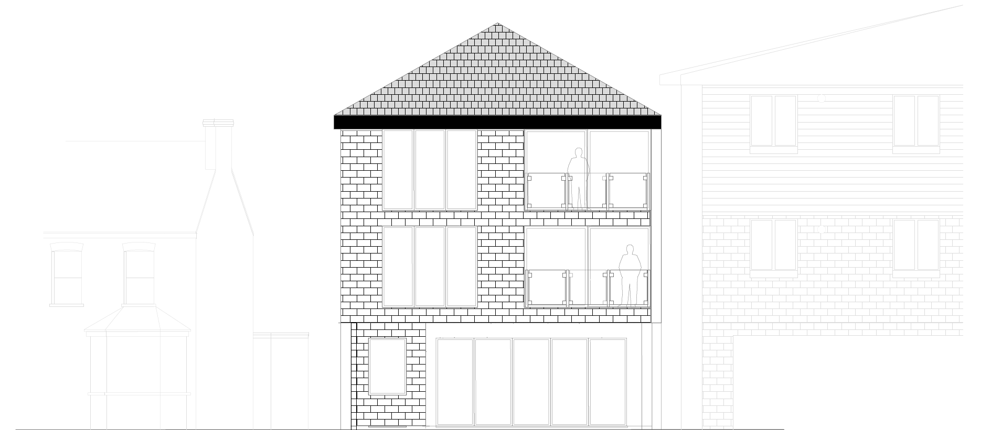

In order to respond to both the Councils reason for refusal and the inspectors concluding comments relating to the impact the development would have upon the street scape a pitched roof the proposal has been amended to feature a pitched tiled roof which would relate to the both the two storey dwelling (No.9 Warwick Rd) and the flatted development at 5 Station Road .
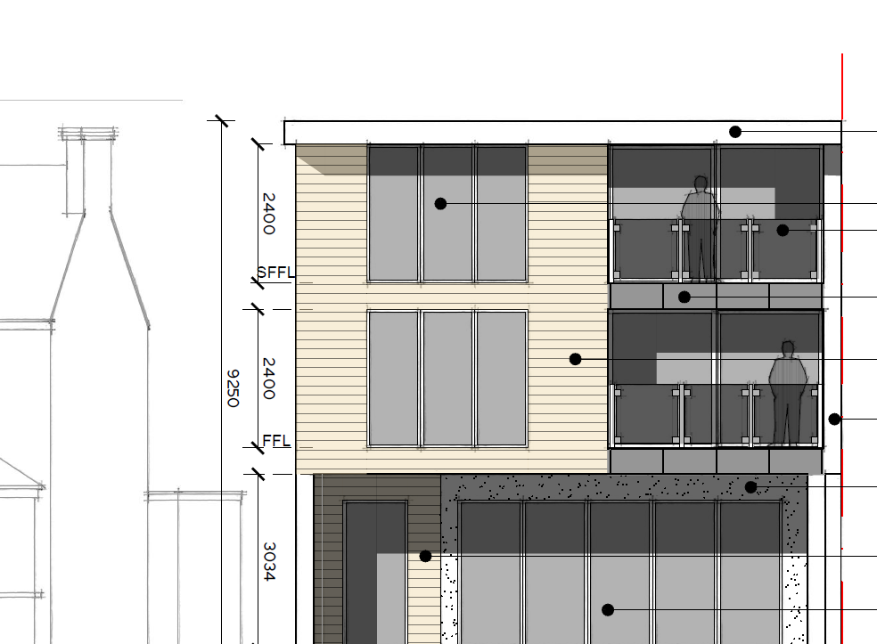

The previous design featured a flat roof which has been changed to a pitched roof. As you can see from the image below the height of the roof has been kept below the that of the adjacent flatted development which results in stepped height which gradually rises as you view the site and the adjacent buildings from the surrounding roads. A crown roof design was another possible roof option however this was not brought forward as the scale of the crown roof was considered to appear over dominant.

The second point within the inspector’s report which has been addressed is the impact the elevations would have on the character and appearance of the street scene and surrounding properties. As stated above the previous application was submitted prior to the flatted development adjacent to the site being constructed. It is clear to see from the images below that there is already an element of impact resulting from the blank elevation which bounds the site to the east.

View of the side elevation of Pullman Court from outside of the site
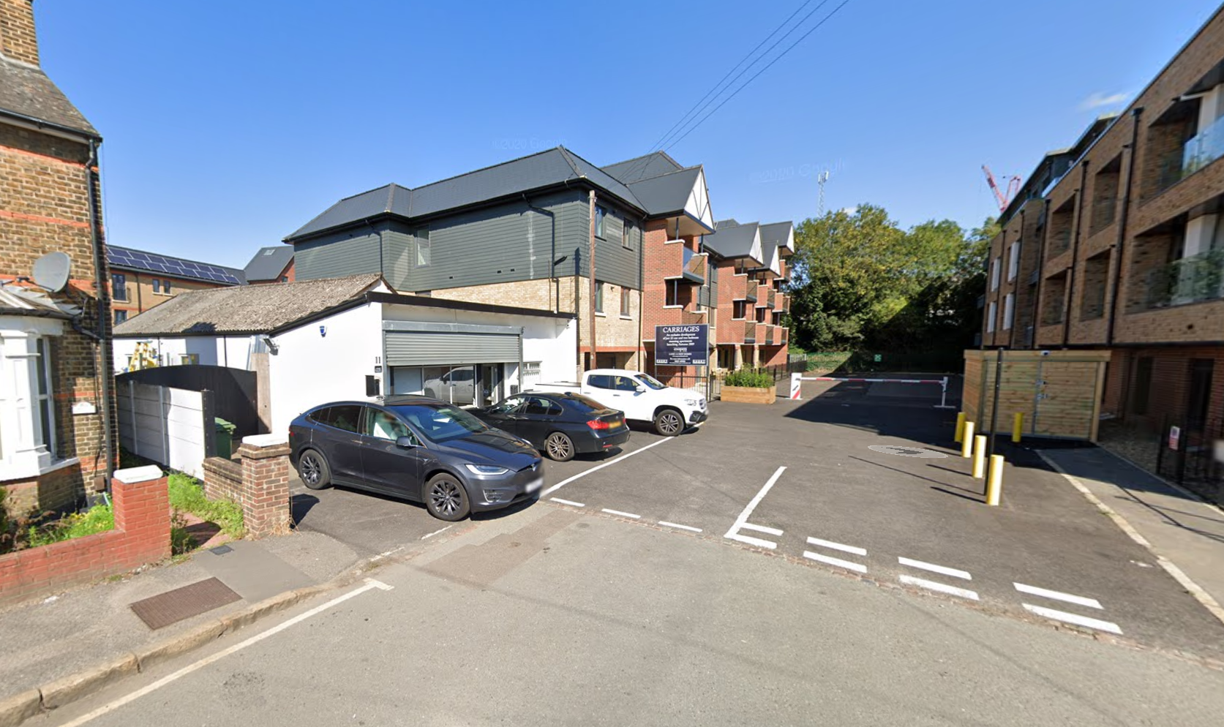

View from the bottom of Warwick Road showing the side/front elevations of both Pullman Court and Kitchener House

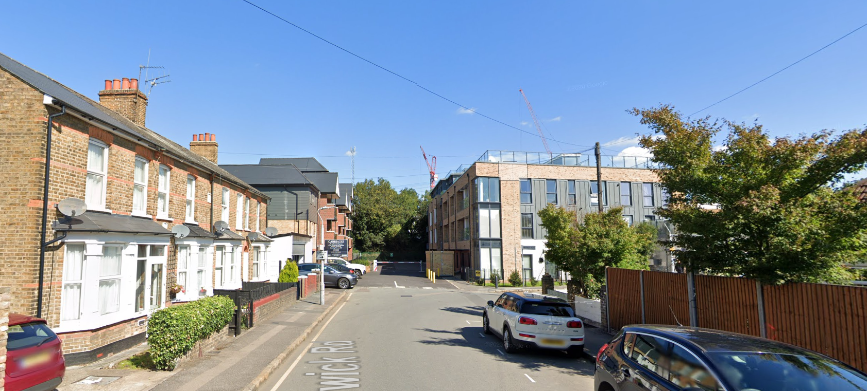

The comments from the inspector’s report related to the previous propose front building line projecting forward of the neighbouring property at No. 9 Warwick Road. However, the existing building already sits further forward than this property and the proposed extension would not protrude further forward than the existing front façade. Furthermore, balconies have been incorporated into the elevation and additional glazing to break up the scale and bulk of the rectangular form which the inspector alludes to in the report.

Give the impact upon the street scape resultant of the neighbouring development at 5 Station Road the amendments which we have incorporated into the elevations combined with the alterations to the roof form and a change of materials which would see the residential part of the development constructed of brick we feel responds positively to the inspector’s comments. Further material details can be conditioned, and we are open to using a contrasting brick which would add further details to the elevations.

In addition consideration should also be given to the impact the blank elevation of the neighbouring flatted development has on the character and appearance of the street scene when assessing the application and we feel that the proposed development would result in an improvement to views from outside of the site in this direction.

The image below shows an example of contrasting brick detail which could be used to break up the rectangular view of the facades which we feel is reduced already by the stepped front elevation and glazing.
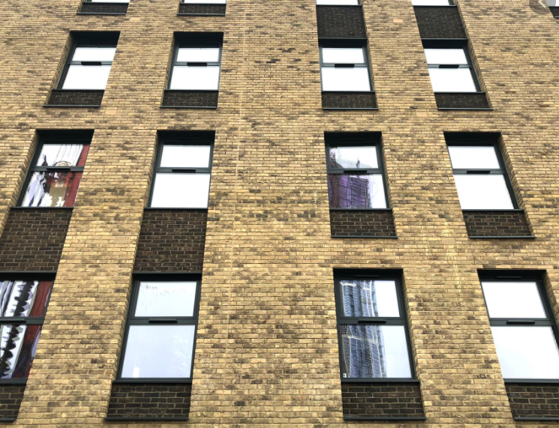

Amenity
The supporting text from Policy DMHB 11 states that to protect the outlook and privacy of existing residential properties the windows serving habitable rooms of new buildings should be located at least 21 metres away. However it is generally accepted that where the new development would be located across an existing road from another row of properties the 21 metres can be reduced as long as the distance mirrors that of the row of properties which line both sides of the street.

In terms of neighbour amenity, whilst the Council included a reason for refusal relating to the potential impact upon the windows of the adjacent property at No 9 Warwick Road, it is clear from the inspectors report that they did not agree with the Councils view and chose not to uphold this reason for refusal. The rear elevation remains unchanged from the refused application and therefore we are of the view that there would be no impact to the residential amenities of this property.

The application does however need to consider the impact the development would have on the neighbouring property at 5 Station Road. The only elevation which there could be potential impact upon would be the western side elevation however this contains 1 window which serves a stairwell and as such the proposed development would not result in any harm to these properties.

In addition to the side elevation facing Pullman Court (5 Station Road) and the rear elevation would face Midland House which fronts the High Street. Plan No SES-000-1-SP clearly marks the separation distance between the nearest habitable room window between the closest residential unit to the closest window in the rear elevation of the proposed development.

With regards to landscaping, the constraints restrict the ability to provide any on site landscaping of any merit. As the proposal is of a minor scale it is not required to meet the London Plan policies relating to Urban Greening. The developments at both Kitchener House and Station Road Road (Pullman Court and Midland House) both benefit from very limited landscaping. In addition to this, both the Council and Appeal Inspector raised no concerns in terms of landscaping in the assessment of the previously refused application.

Quality of residential accommodation
The proposal is for 4 x 1 bedroom 2 person units which would all have a floor area well in excess of the minimum floor space standard required to meet policy DMHB 16 of the Local Plan.

Unit 1: 57 sqm
Unit 2: 51 sqm
Unit 3: 54 sqm
Unit 4: 56 sqm

Total overall internal floor area (including communal areas): 240 sqm

Each habitable room within the proposed units would benefit from large windows which would provide adequate levels of daylight and sunlight as well as outlook. The habitable room windows have been incorporated within the front and rear elevations and all windows meet the necessary 21 m separation distance where required.

In terms of private amenity space, it is understood that the proposal should provide 160 square metres of private and usable amenity space in order to comply with local plan policy DMBH 18. However, the London Plan states that support should be given to proposals which may fail to provide policy compliant levels of amenity space where the internal floor space measurements for each unit exceed the policy compliant standards. As stated above the internal floor measurements all exceed the 50 square metre minimum and therefore, in our view should be supported. As with other elements of the proposal, the Council and the Appeal Inspector did not raise the lack of compliant levels of private amenity space as a concern during the assessment of the previously refused application. In addition, both the Kitchener House and Station Road flatted developments failed to provide adequate levels of amenity space for each of the residential units. Finally, the site falls within a walking distance to West Drayton Train Station which is one of the Crossrail stations and is considered to be a sustainable location which should be balanced against the other material considerations such as amenity space.

Transport and Parking
The site is located within an area of PTAL 3 according the TFL webcat tool which means that it benefits from a moderate level of access to alternative transport modes other than a motor vehicle. The site is located within a 2-3 minutes’ walk of the West Drayton Train and Bus Station which is soon to accommodate the Crossrail Line. As such the PTAL level is likely to improve in the not to distant future. In addition, there are a number of developments which have recently been approved within the local area which will no doubt have some form of contribution associated to them in order to improve transport infrastructure within the local area.

In terms of parking the existing office space at ground floor level benefits from 6 spaces as shown on the site plan below, 2 of which would be tandem and allocated to the office space at ground floor level. As the tandem spaces would be used by office staff this should be considered acceptable as it can be managed between the officer employees who work in the space at ground floor level. 2 visitor spaces are indicated on the site plan and these will be allocated to the ground floor commercial space as well.

The 2 remaining spaces would be allocated to the residential units which are proposed as part of this application. In reviewing the parking provision for the commercial and residential uses we noted that a recent appeal for the Morrisons application (2370/APP/2019/2880) the inspector concluded that a parking ratio of 0.16 was acceptable due to the site’s sustainable location. The application site is located within the same PTAL and same distance to the train station and should therefore be assessed with this decision in mind. The proposal would provide a parking ration of 0.5 spaces per unit which is more than the ratio allowed at appeal and should therefore be considered acceptable. In addition, the Highways Officer who assessed the previous application agreed that the proposal for 4 residential units would not result in a detrimental highway impact.
With regards to cycle parking, 4 secured cycle spaces shall be provided, and these can be secured by condition if necessary. As per the previous application the applicant would be willing to accept the requirement for 2 active and 2 passive EV charging spaces.

Conclusion
This statement sets out the how the proposal has been developed since the refusal of the previous application and subsequent appeal decision. All apart from one element of the previous proposal (impact on the street scene) were considered to be acceptable therefore we have retained much of the agreed positives from the previous scheme and introduced changes which we hope are viewed positively.
We would like to stress that we are open to making further amendments to the proposal in order to achieve a positive recommendation and would welcome early engagement with the planning department.

