TOWERS ASSOCIATES LTD
towers
Harefield Oil Terminal
Harvil Road,
UB9 6JL
01895 812822

REF:3321-24-01
DATE 22/08/2024

Design and Access Statement
90 Long Lane
Demolition of the existing detached, single dwelling and the erection of a building consisting of 9 no. two-bedroom flats, with associated parking and amenities.

Introduction
This statement has been prepared to accompany a full planning application regarding the demolition of the existing detached, dwelling and the erection of a building consisting of 9 no. two-bedroom flats, with associated parking and amenities with the retention of the external masonry boundary wall at 90 Long Lane
Site and Surroundings
The application site, presently occupied by a single detached dwelling, is located on the northwest side of Long Lane, to the north of the Western Avenue (A40), towards the southern extremity of Ickenham.
It falls within the developed residential area comprising, of fairly large detached and semi-detached dwellings, and is separated from the Douay Martyrs School (Cardinal Hulme Campus) to the north, by three-storey detached block comprising nine flats.
Site History
The existing dwelling at 90 Long Lane has had a number of extensions and alterations approved by the planning department. These however are not relevant to this application as the dwelling house is to be demolished under this proposal.

The two applications with significant relevance are those as follows:
Planning permission was granted in 2017, ref. 29164/APP/2016/4622, in respect of the redevelopment of the adjoining property, no. 88 Long Lane – the former detached dwelling on that site being replaced by a three-storey building comprising nine flats.

The location of that development, which is now complete, can be seen on the drawings.
This current application draws upon that approved and implemented proposal at no. 88.

8905/APP/2023/2419 | 90 Long Lane Ickenham | Demolition of the existing detached, single dwelling and the erection of a building consisting of 9 no. two-bedroom flats, with associated parking and amenities.
The revised proposal has been prepared with the officer’s report and recommendation of the above application. The comments made in the officer’s report will be explored below and amendments to the new scheme will be discussed.
Fundamentally, it is accepted that given the limited introduction of flatted developments on Long Lane, most notably at 88 Long Lane, the demolition of the property is acceptable in principle.

Housing Mix
- ‘The proposed development fails to provide any three or more-bedroom units (Family size).
In this scheme we have revised the internal layouts to provide 3no. three-bedroom units. 6no two-bedroom units have also been provided. Thus, the proposal would provide a suitable housing mix of housing to support sustainable, inclusive and mixed communities in accordance with Policy DMH 2 of the Hillingdon Local Plan part 2, Policy H10 of the London Plan and the NPPF. The three bedrooms on the ground floor have been made to comply with M (2) requirements.
- Character and appearance
- 3. Neighboring Amenity Impacts
It was considered that the proposed development by reason of its siting, size, width scale and missing alongside overall design would fail to harmonise with the character and composition of surrounding properties.
The abovementioned item has been considered in detail and several amendments have been made as follows.

The proposed building massing has been reduced, the width has been refused by 600mm, the length of front element has been reduced by 900mm, the first and second floor has been reduced in depth by over 1.2m. This can be seen by a purple dotted line on the floor plans of all three floors.
The position of the building and its relationship to no.88 has not changed.
Comparisons have been made to the approved development at 88 to ensure the size of the development is appropriate. The below table details the size of the site and percentage of built area.
 | 88 Long Lane | 90 Long Lane Existing | 90 Long Lane Scheme 1 | 90 Long Lane Current Scheme
Site Area | 1807 | 2197 | 2197 | 2197
Percentage of Built Area | 19.04% | 18.20 | 18.79 | 18.06

As can be seen by the table above the percentage of built area is actually less than that of the scheme approved at 88 Long Lane and the existing building at number 90 and although the building is larger than the neighbouring building it is proportionate to the size of the site.
In regard to the concern that the neighbours would experience a sense of enclosure, a BRE daylight, sunlight has been prepared by Hawkins environmental. The results of the assessment demonstrate that under the guidance contained within Appendix H of the BRE it is considered that the proposed development will have an insignificant impact to surrounding dwellings.
In addition to the aforementioned points, the permission granted at number 92 Long Lane for the construction of Part two storey, part single storey side extension with 2 front dormers and rear conservatory states in condition 4. ‘A 2.0-metre-high close boarded fence or imperforate wall shall be maintained on the boundary with No. 90 Long Lane for the full depth of the development hereby approved and shall be permanently retained for so long as the development remains in existence’. This condition has not been adhered to but for privacy reasons three panels of 2m close boarded fence has been erected by the owner of number 90 and therefore screens the neighbouring property.
The elevations have been amended to suit the conservations officer’s request.
The elevation facing Long Lane would comprise a steeply pitched gable and with a gambrel roof form for the rear projecting element, reflecting the design for the building at no. 88.
It is proposed to have red brick on the 1st floor and red/brown roof tiles on the roof with timbering detail designed to reflect other houses down Long Lane particularly those shown opposite. Please see below pictures.
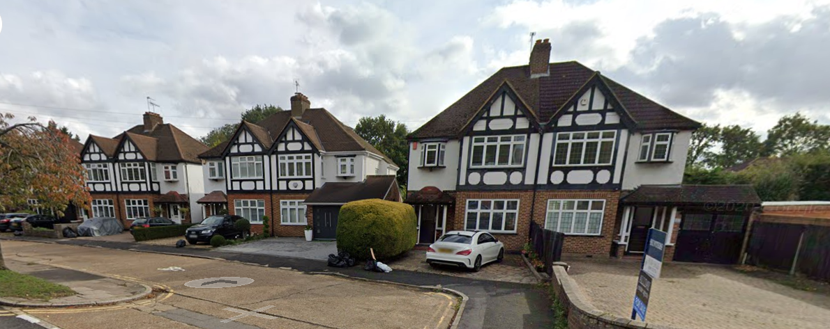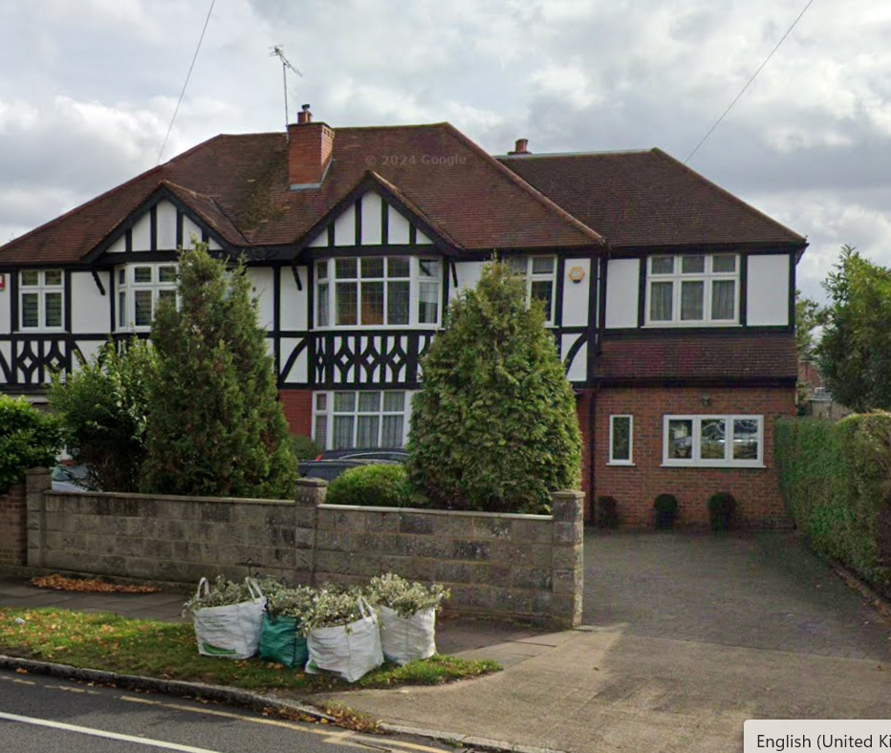

The conservation officer also requested a more barn style rear elevation however we cannot find any ‘barn-style’ building in the locality which reflect these types of property, we have therefore worked to mimic a more generic barn style, with GRP weather board panelling on the upper part of the rear elevation which is based on the Old-Barn in Ruislip. Fenestration is uniform in size and will be fitted with leaded glass on the outer skin. We have removed balconies to be more sympathetic to the requested style. A full detailed material list can be secured as part of a condition to be agreed.
All sideways facing windows above ground floor level are to be obscured glass on the inner skin and non-opening below 1.7m above finished floor level.

It is contended that not only would the proposed development satisfy all of those elements relating to “design” set out at Policy DMHB11 of the Local Plan but, furthermore, it would satisfy the special requirements set out at DMHB4 relating to development in Conservation Areas and those at DMHB1 concerning the effect upon Heritage Assets.
The development would satisfy the requirements of the Listed Buildings and Conservation Areas Act 1990, as it would “preserve or enhance the character and appearance of the Conservation Area”, as was considered to be the case with regard to the development at no. 88.

There does not appear to be any Appraisal or Management Plan in relation to the Ickenham Village Conservation Area, but it is contended that the general policies with regard to development in Conservation Areas found in the Local Plan would be satisfied.

Highways
‘The proposal would fail to provide acceptable pedestrian, cycle and vehicular access to the application site’
A dedicated pedestrian only access has been provided at 1.5m clear width which also allows for access to cycle stores and alternative access to bin store to ensure there will be no conflict with cars.
The vehicular access is set back over 4.5m from the rear of the paved footpath and in excess of 8m from the kerb line from the main roadway. This is compared with the access for number 88 which is only 3.8m and 92 is as little as 1.2m from the paved Given this is in excess of the distance in relation to the existing developments, it can be assumed this is acceptable.
The existing neighbouring sites currently have sliding gates and we propose to implement the same within this application.

Trees
‘The application has failed to justify the need for the layout of the development which includes the removal of category A and B value trees’
In relation to this comment, the parking layout has been adjusted to allow the existing category A, Lawson Cypress (T38) to be retained as well as the hedge line G7 and four trees (T2, T3,T4 and T5). An arboricultural report has been provided to mitigate any potential damage to trees and replacement trees have been suggested. Further tree protection measures can be secured by condition if the tree department require.

Fire Safety
A fire evacuation and fire safety statement have been provided in accordance with Policy D12 of the London plan. Upon obtaining approval, a further final fire statement and plan including detectors can be provided. Consultation with building control will be carried out and full plans approval obtained prior to any works above DPC level on site.

Conclusion
In summary, it is clear the above the proposal will make best use of this site and provide good-quality, in-demand, housing stock to the local area. The scheme has been carefully considered to ensure there are no negative impacts on the street scene. We have carefully considered all relevant planning policy and guidance and trust you will find the attached proposal acceptable.

