2.7m Victorian lamp post
SKU : LF1001/ LF1051
Purchased From : The Black Country Metal Works
Victorian Lamp Post - Black 2.7m | Black Country Metalworks

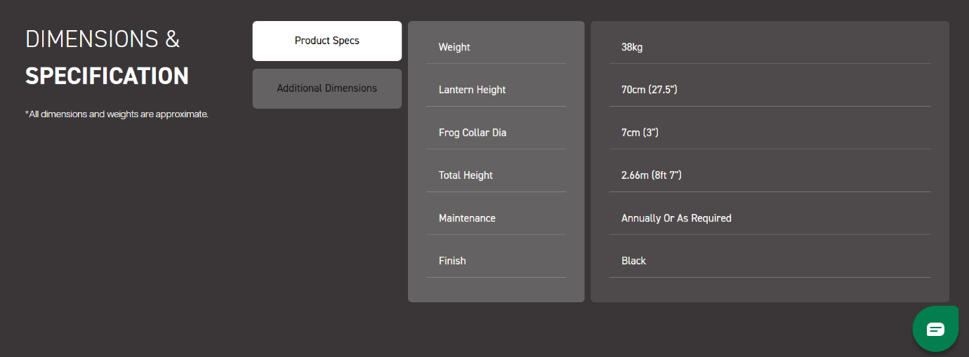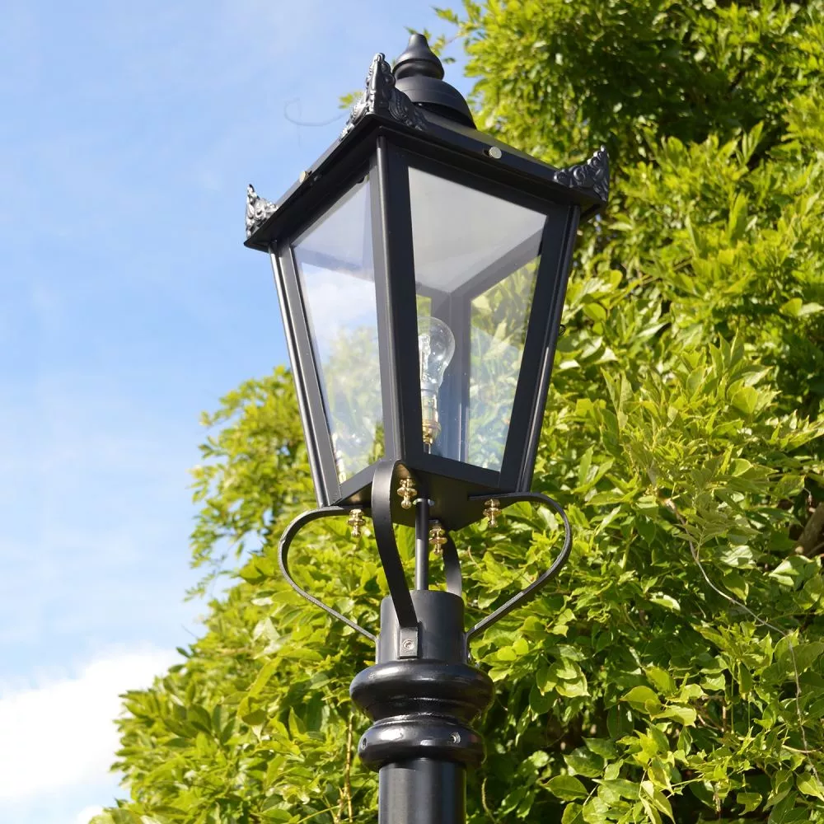
BULB USED
- 4W
- Approximately 320LUMEN
- In warm white

