Date: | 30 March 2020 | BY EMAIL ONLY
Our Ref: | 1803-20-MS3 | BY EMAIL ONLY
Email: | planning@micasagroup.co.uk | BY EMAIL ONLY
Michael Briginshaw
London Borough of Hillingdon
Planning Department
3 North Civic Centre
High Street
Uxbridge UB8 1UW


Subject: Material Report to Discharge Condition

Contents:
- Introduction
- Materials
- Design Aspiration

- Introduction

- This report is for the discharge of Condition 3 imposed by Hillingdon Council for the consented application ref 8378/APP/2016/2705. To be read in conjunction with drawing layout 1803-600.

Compliance Condition:-

Condition 3

Detailed drawings or samples of materials, as appropriate, in respect of the following shall be submitted to and approved in writing by the Local Planning Authority before the relevant part of the work is begun:

- Doors and windows, including garage doors and roof lights.
- Plinth material
- External timber cladding
- Roof tiles
- Guttering and Downpipes

Reason:

To safeguard the special architectural and/or historic interest of the building in accordance with Policy BE8 of the Hillingdon Local Plan: Part Two Saved UDP Policies (November 2012).

- Materials – Building

1
Plinth Material  (Facing Brickwork) | Type: Imperial Brickworks Richmond Soft Red
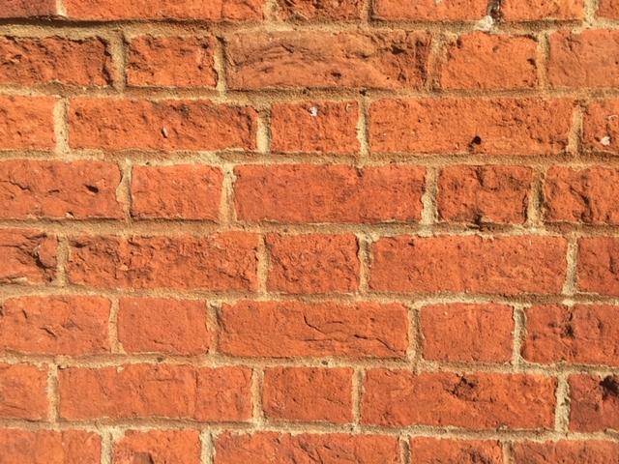
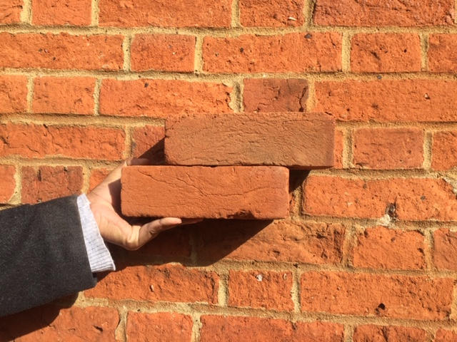

2
External Timber Cladding  (Feather edge weatherboarding with black paint finish) | Manufacturer/Supplier: Chiltern Timber or similar  Weatherboard Black Barn Cladding W-clad or Similar
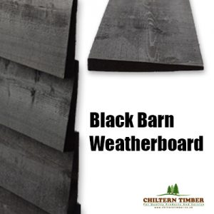
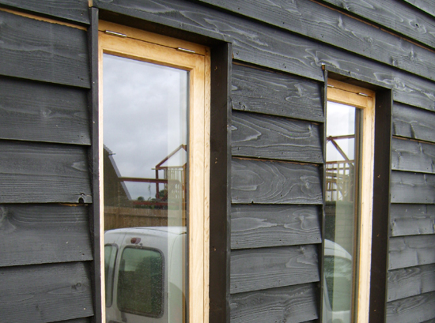

3
Roof Tiles  (Handmade clay tiles or similar) | Manufacturer/Supplier: SIG Roofing similar  Mix of three handmade clay tiles Henley Weathered, Holmbury Blend and Chartham Red.
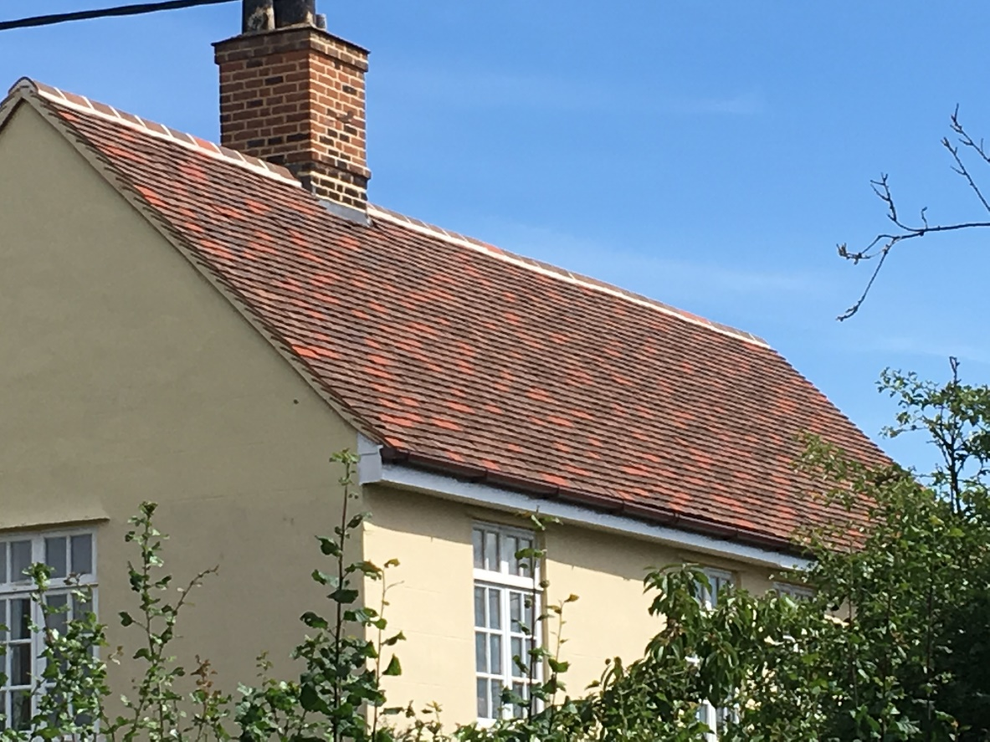
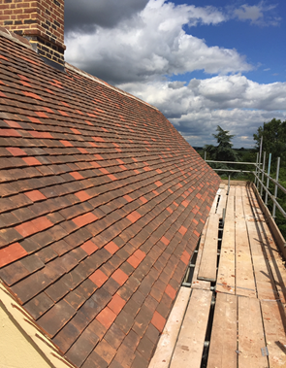

4
Guttering and downpipes  (Black Aluminium rainwater goods) | Manufacturer/Supplier: Guttercrest
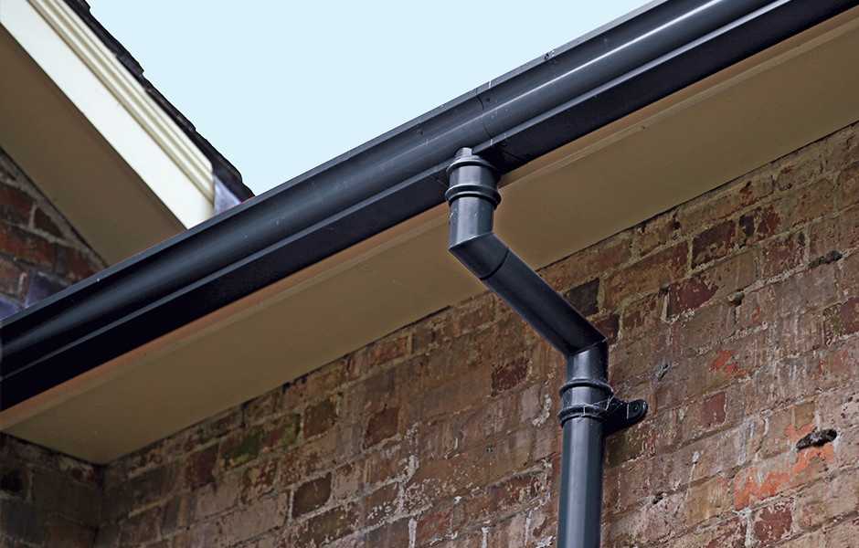
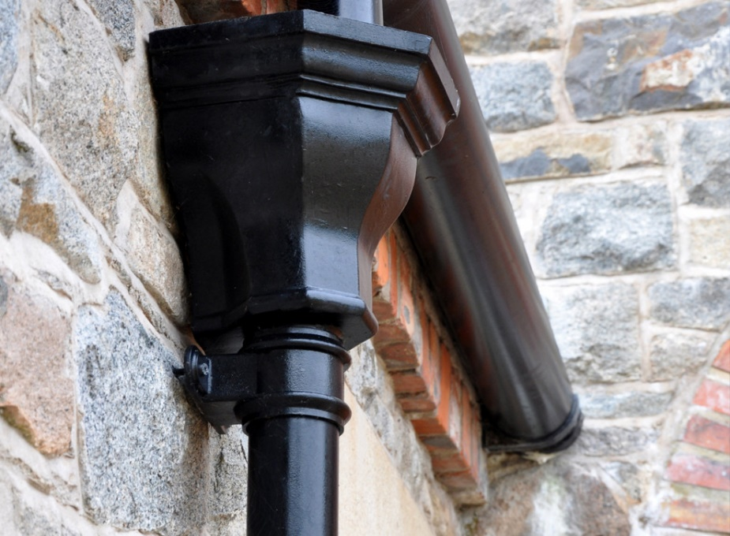

5
Stable and Garage Door  (Traditional Barn Type) | Manufacturer/Supplier: Prime Stables Ltd or similar  Garage door manufacturer/Supplier: The Garage Door Centre (Wessex style/ Cedar Door Ashbourne) in colour:  Ebony or similar
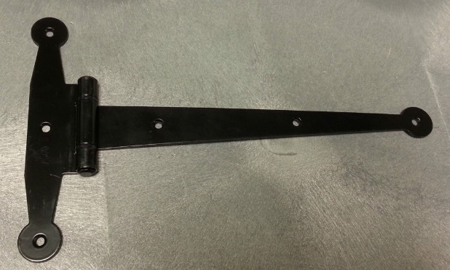
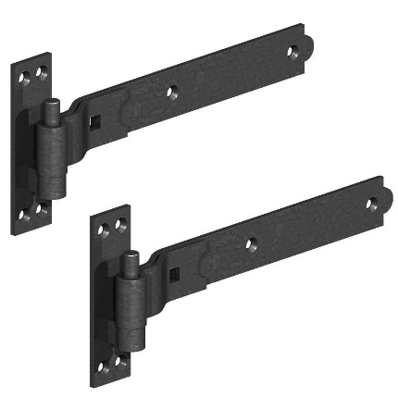
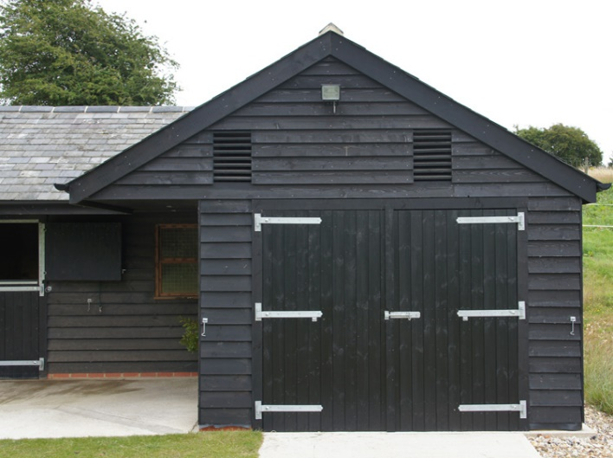
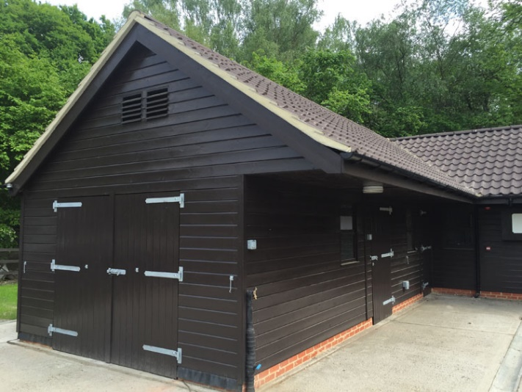

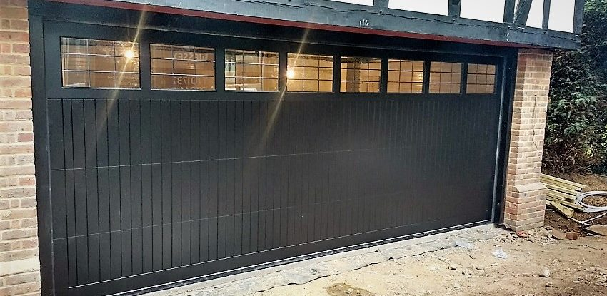

6
Roof Lights  (Conservation type lights) | Manufacturer/Supplier: The Rooflight company or similar
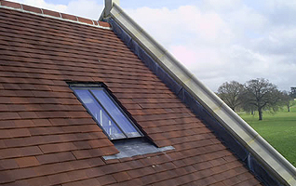

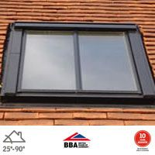

Design Concept Images
