FLOOD RISK ASSESSMENT

OUR REFERENCE
90019304
PROPERTY ADDRESS
74 Brampton road, Hillington, Uxbridge, UB10 0DR
PROPOSED DEVELOPMENT
Replacement of roof and frames to existing conservatory
FLOOD RISK ASSESSMENT
The flood risk map was taken from the Gov.uk Flood map website and as of 19/08/2026 its shows that the above property falls within flood risk zone 1.
Locations in flood zone 1 have a low probability of flooding.
This means, in any year, land has a less than 0.1% (1 in 1,000) chance of flooding from rivers or the sea.
Some flood zone 1 developments need a flood risk assessment as part of their planning application.

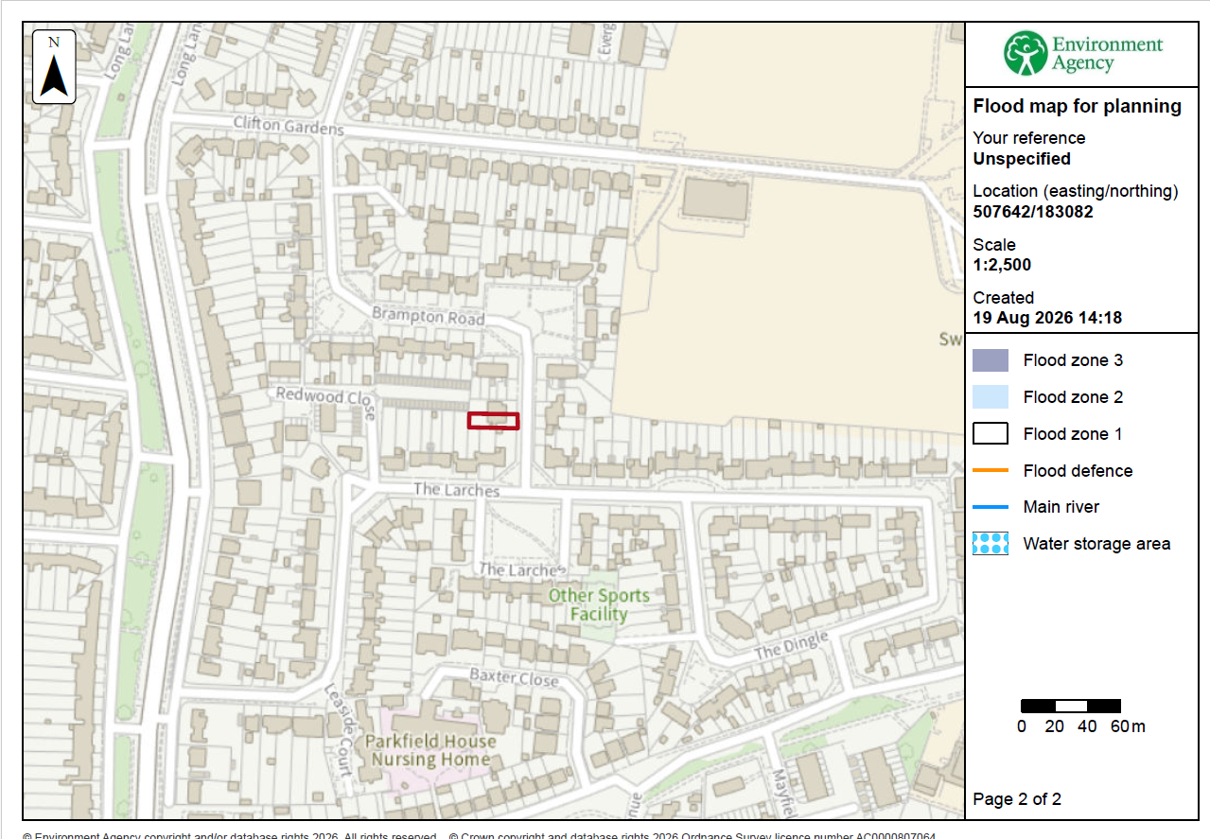

Please be advised that:
- The finished floor level of the proposed conservatory will remain the same as the existing house.

- The proposed conservatory is not to be used for storage and therefore there would be no loss should flooding ever occur. Additionally, any furniture positioned in the structure will be removable in the event of flooding.

- Our client should already be aware if ever any flood warnings should occur and therefore would move possessions that may be affected to a higher level to avoid damage.

- We will be using PVCu windows, doors and frames and special care will be taken to ensure adequate sealing of PVCu windows and doors to the fabric and double glazing will be to the relevant standards.

- All electrical sockets and switches, if applicable, will be positioned at level greater than at risk of flooding and will be fitted in compliance of current British standards.

Surface Water Drainage/Mitigation measures
Any rainwater drainage caused will be linked to the existing rainwater drainage and won’t cause any additional drainage onto any neighbouring properties. The neighbouring property also has an extension and extends approximately as far as the new proposal.

We have also included a completed an Environment Agency Flood risk assessment form to accompany the application.

