k

39H
Planning Consultancy

Project Management

Contract Procurement

Site Supervision

Project Coordination

Consultations

Feasibility Schemes

Architectural Design

Construction Drawings & Detailing

Planning & Building REG Applications

Management Contracting

Construction Management

____________________________________________

Planning Statement

LAND ADJACENT TO THE OLD ORCHARD PUB
PARK LANE
HAREFIELD
MIDDLESEX
UB9 6HJ

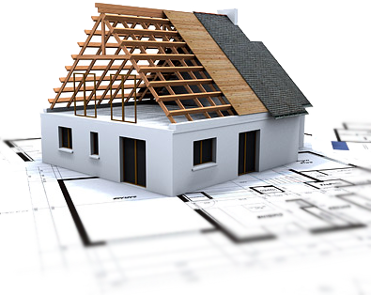

November 2025

Table of Contents

Introduction ..........................................................................….4
Site Description and Wider Landscape Context .....................…..5
Planning Policy Framework ...................................................…. 7
Principle of Development .....................................................…….9
Green Belt Openness .............................................................….. 9
Green Belt Purposes ..............................................................….10
Frays Farm Meadow SSSI .......................................................….11
Denham Lock SSSI ..............................................................……..12
Relationship Between Stables and Sensitive Landscapes ....…...15
Ecology Beyond Designated Sites ...........................…..........…….15
Landscaping and Landscape Integration ..........….................…… 15
Design and Appearance .....................................................…..... 16
Residential Amenity ........................................................…….... 21
Access and Highways ........................................................…….. 23
Planning Balance and Overall Assessment ..........................…... 23
Conclusion ..........................................................................…….24

Prepared by, Ray Deans BA (Hons) TCP, MA UDP
This document has been prepared in accordance with the scope of 39H Planning Consultancy’s appointment with its client and is subject to the terms and conditions of that appointment. It is addressed to, and intended solely for the confidential use and reliance of, 39H Planning Consultancy’s client. 39H Planning Consultancy accepts no liability for any use of this document by any party other than its client, nor for any purpose other than that for which the document was prepared and provided. No person other than the client may copy, reproduce (whether in whole or in part), make use of, or rely upon the contents of this document without the prior written consent of a Director of 39H Planning Consultancy. Any advice, opinions, or recommendations contained herein should be considered only in the context of the document as a whole. The contents of this document do not constitute legal or tax advice, nor should they be construed as such.

1. Introduction
This Planning Statement has been prepared in support of a full planning application for the erection of five stables on land located adjacent to the Old Orchard Public House in Harefield, within the London Borough of Hillingdon.
The application site lies within the Metropolitan Green Belt and immediately adjoins two nationally designated ecological sites: Frays Farm Meadow Site of Special Scientific Interest (SSSI) and Denham Lock Site of Special Scientific Interest (SSSI). These designations reflect the exceptional ecological, landscape and hydrological value of the River Colne corridor and its associated floodplain meadows.
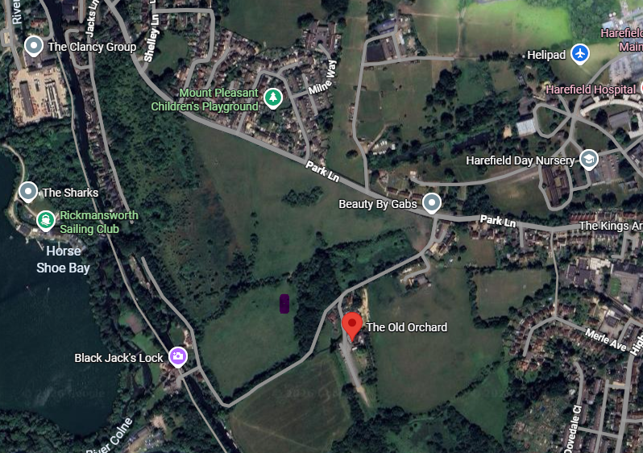

Given the sensitivity of the location, the application has been informed by a precautionary, evidence-led approach. The purpose of this Planning Statement is to demonstrate that the proposed development:
- constitutes an appropriate form of development within the Green Belt in accordance with the National Planning Policy Framework (NPPF);

- preserves the openness and purposes of the Green Belt;
- would not adversely affect the integrity, conservation objectives or setting of either SSSI; and
- accords with the Development Plan when read as a whole.

2. Site Description and Wider Landscape Context

2.1 Site Location and Characteristics
The application site comprises an area of open land situated to the west of the Old Orchard Public House, located at the urban–rural fringe of Harefield. The land is currently undeveloped and forms part of a broader mosaic of pasture, meadow and wetland associated with the Colne Valley.

View From The Old Orchard Public House
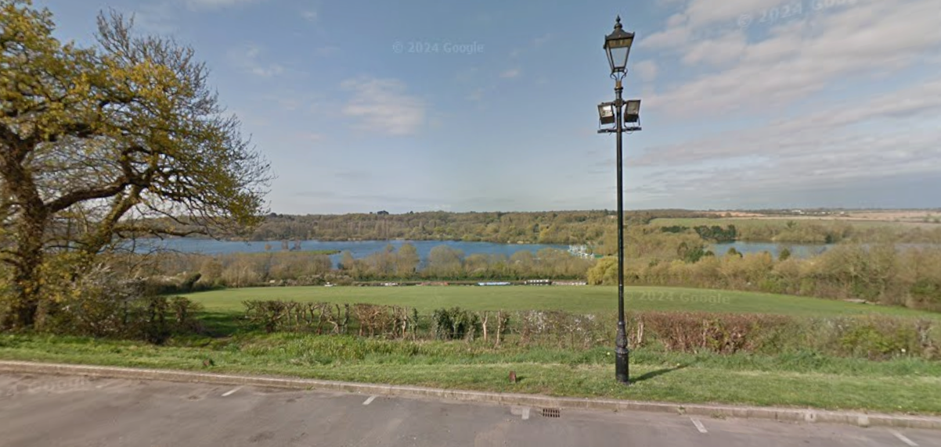
The site is characterised by flat to gently undulating topography, open views across adjacent meadows, and a strong functional relationship with surrounding agricultural and semi-natural land uses. Built development in the immediate vicinity is sparse and largely confined to small-scale rural structures and historic buildings.

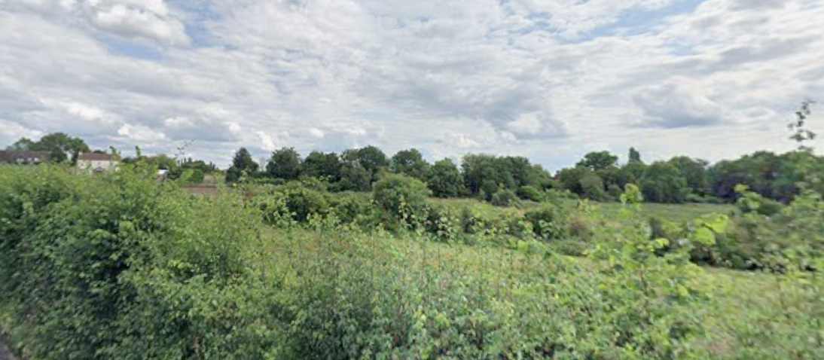
View from Park Lane across the site towards the Old Orchard Public House

2.2 Wider Landscape Context
The wider landscape is defined by its semi-natural character and its role as an ecological transition zone between urban Harefield and the extensive open landscapes of the Colne Valley Regional Park. The proximity of two SSSIs highlights the sensitivity of the area and its importance for biodiversity, landscape character and ecosystem services.
Although the application site itself is not designated, it performs an important buffering function between developed land and designated ecological assets.

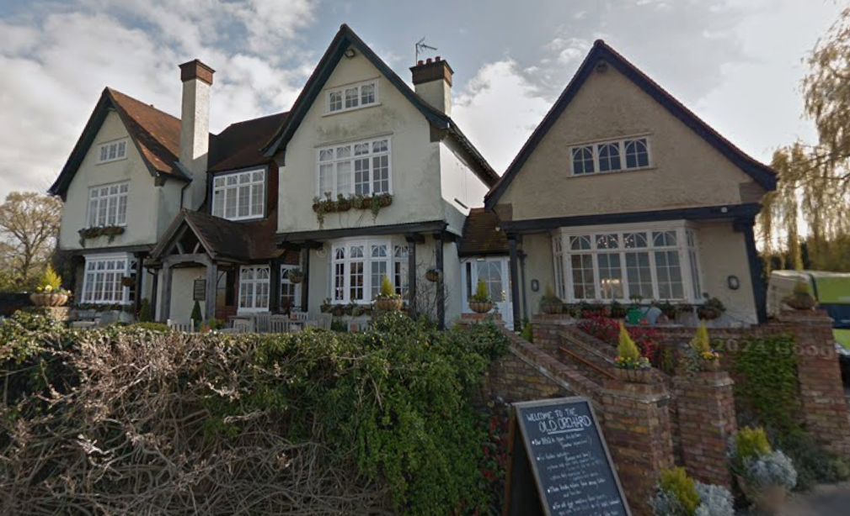
The Old Orchard Public House

The proposal has therefore been designed to maintain this role, ensuring that development is contained, low-intensity and compatible with the surrounding landscape.

3. Planning Policy Framework

3.1 Statutory and Policy Context
Section 38(6) of the Planning and Compulsory Purchase Act 2004 requires planning applications to be determined in accordance with the Development Plan unless material considerations indicate otherwise. The statutory Development Plan for the site comprises the Hillingdon Local Plan (Parts 1 and 2) and the London Plan (2021). The National Planning Policy Framework (NPPF, December 2024) is a material consideration of substantial weight.
This section demonstrates that the proposal accords with the Development Plan when read as a whole and is strongly supported by national policy.

3.2 National Planning Policy Framework (December 2024)
The NPPF establishes a clear and consistent framework for decision-making in Green Belt and environmentally sensitive locations.
Paragraph 152 confirms that the fundamental aim of Green Belt policy is to prevent urban sprawl by keeping land permanently open. Paragraph 153 makes clear that inappropriate development is, by definition, harmful to the Green Belt and should not be approved except in very special circumstances.
However, paragraph 154(b) expressly identifies that the provision of appropriate facilities for outdoor sport and outdoor recreation is not inappropriate development in the Green Belt, provided that openness is preserved and the purposes of including land within the Green Belt are not undermined. Equestrian development, including stables, is well-established in planning practice and appeal decisions as falling within this category, where it is genuinely ancillary to land-based activity and modest in scale.
Paragraphs 180–186 of the NPPF establish a clear hierarchy of protection for designated ecological sites, with Sites of Special Scientific Interest afforded the highest level of protection. Development adjacent to SSSIs must demonstrate, through evidence and design, that there would be no adverse effect on site integrity or conservation objectives.

3.3 Local and Strategic Policy Alignment
Hillingdon Local Plan policies EM2 and DMGB1 seek to protect the openness, permanence and purposes of the Green Belt, whilst allowing appropriate rural uses that preserve its character. Policy DMEI7 requires development proposals affecting or adjacent to SSSIs to demonstrate no adverse impact, either alone or in combination.
The London Plan reinforces these objectives through Policies G2 and G6, which promote the protection of the Green Belt and the enhancement of biodiversity, including through sensitive land management practices.
The proposal has been carefully designed to comply fully with these policies and is supported by detailed assessment in the sections that follow.

4. Principle of Development
The proposal seeks permission for the erection of five stables, tack room and WC, a use that is intrinsically linked to rural land management and countryside activities.
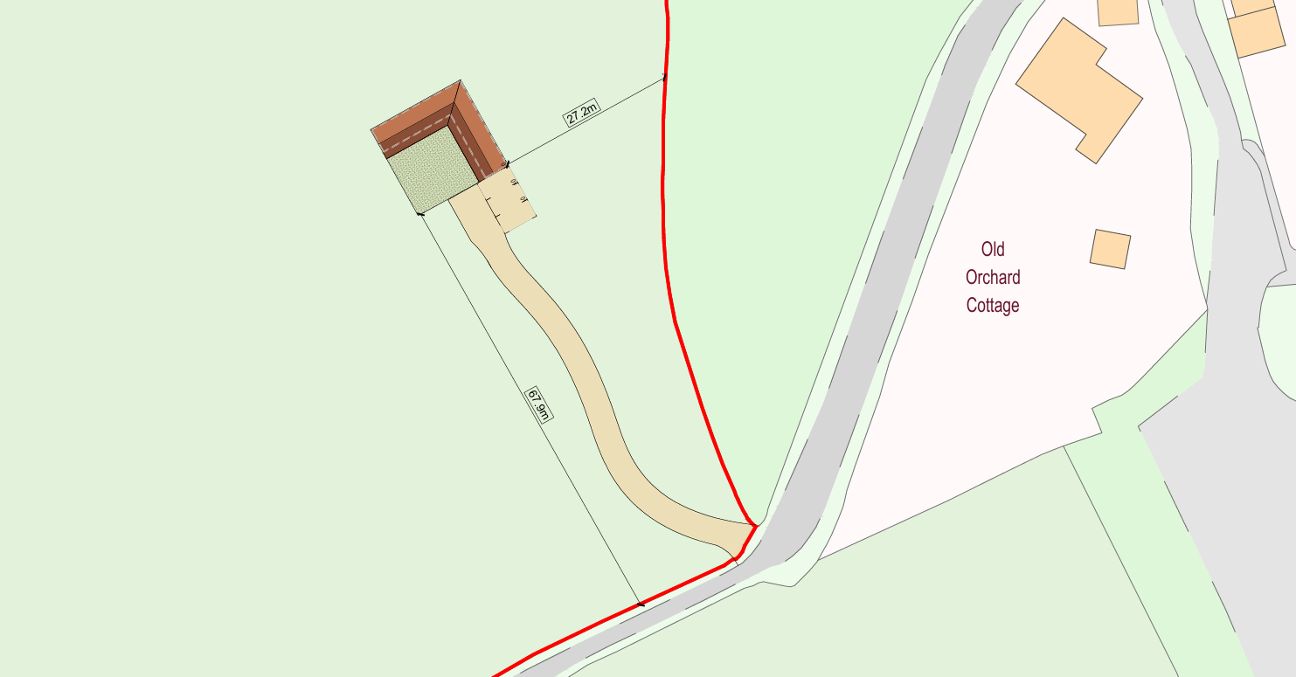
Equestrian development differs fundamentally from residential, commercial or industrial uses. It is low-intensity, does not introduce permanent human occupation, and relies upon the retention of open land for its functional operation. As such, it is wholly consistent with the rural character of the Green Belt.
In principle, the proposal accords with paragraph 154(b) of the NPPF and relevant key local policies, subject to detailed consideration of impacts on openness, landscape character and ecological assets.

5. Green Belt Openness

5.1 Legal and Policy Approach
Openness is not defined in the NPPF and is therefore a matter of planning judgment. Case law, including Timmins v Gedling Borough Council [2014] and Samuel Smith Old Brewery v North Yorkshire CC [2020], confirms that openness has both spatial and visual dimensions, and that decision-makers must consider the real-world effects of development rather than applying a purely mathematical assessment.

5.2 Spatial Openness
Spatial openness concerns the extent to which development reduces the physical availability of land as open countryside. The proposed development comprises five modest, single-storey stable buildings with a limited footprint. The buildings would be closely grouped, avoiding sprawl across the site, and would occupy only a small proportion of the overall landholding.
The proposal does not introduce hard urban edges, subdivision of land, or permanent domestic paraphernalia. The land would remain predominantly open and functional as pasture, ensuring that spatial openness is effectively preserved.

5.3 Visual Openness
Visual openness relates to the perception of openness as experienced from public and private viewpoints. The proposed stables are low in height, rural in form, and constructed from recessive materials such as timber. Their siting avoids skyline locations and sensitive sight-lines from Freys Farm Meadow SSSI, Denham Lock SSSI and the wider Colne Valley landscape.
When viewed in context, the development would be perceived as a minor rural feature rather than an urban intrusion. The openness of the Green Belt would therefore remain perceptually intact.

6. Green Belt Purposes
Paragraph 143 of the NPPF sets out the following five purposes of including land within the Green Belt.
a) to check the unrestricted sprawl of large built-up areas;
b) to prevent neighbouring towns merging into one another;
c) to assist in safeguarding the countryside from encroachment;
d) to preserve the setting and special character of historic towns; and
e) to assist in urban regeneration, by encouraging the recycling of derelict and other urban land.
The proposal has been assessed against each purpose.
The development would not lead to unrestricted sprawl of large built-up areas, as it is modest, contained and functionally tied to open land. It would not contribute to the merging of settlements, given its isolated siting and lack of urbanising influence. It would not encroach upon the countryside in the sense contemplated by policy; rather, it represents a countryside-appropriate use that depends upon the open character of the land.
The proposal would not affect the setting of historic towns, nor would it prejudice urban regeneration objectives. Accordingly, the development does not conflict with the purposes of the Green Belt and is fully compliant with national and local policy.

7. Frays Farm Meadow SSSI

7.1 Designation and Conservation Objectives
Frays Farm Meadow SSSI is nationally designated for its species-rich unimproved lowland wet alluvial grassland, a habitat of high ecological value and increasing rarity. The conservation objectives of the site focus on maintaining botanical diversity, low nutrient status, traditional grazing management and stable hydrological conditions.
The site forms part of a wider ecological network within the Colne Valley Regional Park and supports notable fauna including breeding birds, invertebrates and water vole populations.

7.2 Assessment Methodology and Impact Pathways
In accordance with Policy DMEI7 and paragraphs 180–186 of the NPPF, the assessment considers potential direct, indirect and cumulative impacts. Potential pathways include physical encroachment, hydrological change, nutrient enrichment, lighting disturbance and increased human or animal pressure.

7.3 Detailed Impact Assessment
The proposal has been designed to avoid all identified impact pathways. No development is proposed within the SSSI boundary and no changes are proposed to drainage regimes or watercourses. Surface water would be managed sustainably within the site, ensuring no run-off toward sensitive grassland.
Horse numbers would be limited and managed, with no grazing proposed within the SSSI. Buffer zones between built form and designated land would be retained, maintaining physical and functional separation. No new access routes or public rights of way into the SSSI would be created.
On this basis, it is concluded with a high degree of confidence that the proposal would have no adverse effect on the integrity or conservation objectives of Frays Farm Meadow SSSI, either alone or in combination with other development.

8. Denham Lock SSSI

8.1 Designation, Location and Statutory Status
Denham Lock Wood SSSI is a nationally protected ecological site located within the Colne Valley Regional Park, near Denham within the London Borough of Hillingdon. It was notified as a biological Site of Special Scientific Interest (SSSI) in 1986 under the Wildlife and Countryside Act 1981, reflecting its significance for wet woodland and fen habitats. The site encompasses approximately 6.3 hectares of biologically rich woodland adjacent to the Grand Union Canal and the Frays River corridor. It is managed by the London Wildlife Trust on behalf of Hillingdon Council as part of the Frays Valley Local Nature Reserve and the wider Colne Valley ecological network.
SSSI designation affords the site the highest tier of statutory protection under national planning policy. Section 28(I) of the Wildlife and Countryside Act 1981 makes it an offence to carry out operations likely to damage the special interest of an SSSI without consent from Natural England. This framework is given significant weight in planning decisions by NPPF paragraphs 180–186, which seek to avoid adverse effects on internationally, nationally and locally designated sites.

8.2 Ecological Characteristics and Qualifying Features
Denham Lock Wood is recognised for its wet woodland and fen habitats, which are rare in the Greater London context and contribute substantially to local biodiversity within the Colne floodplain. Key habitat features include:
- Wet woodland dominated by alder (Alnus glutinosa) and crack willow (Salix fragilis) in wetter areas, with oak and ash in slightly drier sections. A shrub layer of hazel and other native species supports structural complexity.
- A mosaic of wetland interfaces, ditches and minor watercourses that link the woodland to adjacent meadow and river habitats, providing habitat continuity and hydrological connectivity with Frays Farm Meadow SSSI and the broader Colne Valley habitat network.
- A suite of invertebrate species characteristic of wet woodland and fen transitional habitats, including banded demoiselles (Calopteryx splendens), glow-worm (Lampyris noctiluca) and historically the nationally rare balsam carpet moth (though its current status is uncertain).
- Bird assemblages and woodland fauna, contributing to the site’s ornithological value and ecological function.
Denham Lock Wood forms part of a broader conservation network that includes Frays Farm Meadows SSSI, the Colne floodplain habitats and other Local Nature Reserve designations; this landscape connectivity is a core basis of its national designation.

8.3 Conservation Objectives
The conservation objectives for Denham Lock Wood, as with all SSSIs, are aimed at maintaining or restoring the favourable condition of the habitats and species for which it was designated. In planning terms, this translates into ensuring that:
- the hydrological regime that sustains the wet woodland and fen communities is protected from change (e.g., modification of drainage, water abstraction or run-off alterations);
- nutrient enrichment and pollution inputs are avoided;
- disturbance from noise, lighting or public access is minimised; and
- direct physical encroachment and habitat fragmentation are avoided.
These objectives are embedded in Natural England’s SSSI interest statements and are reflected in the development management policies of the National Planning Policy Framework (paras 180–186) and the Hillingdon Local Plan, which require development proposals affecting or adjacent to SSSIs to demonstrate no adverse impacts on site integrity.

8.4 Assessment of Development Effects
The proposed stables development has been carefully sited and designed so that all development is outside the SSSI boundary and retains adequate buffers to avoid direct physical effects. Specific considerations include:
- Hydrological Neutrality: No alteration to existing watercourses or drainage pathways is proposed. Surface water management will be handled on-site using sustainable drainage principles to prevent any net increase of run-off toward the SSSI or adjacent wetland habitats.
- No Direct Habitat Loss: The stables and associated infrastructure are placed entirely outside the limits of the SSSI and its buffer areas, ensuring that the wet woodland and fen habitats remain undisturbed by construction activities.
- Lighting and Noise Control: External lighting is avoided and any necessary illumination will be limited, downward-focused and low intensity to prevent artificial light spill into woodland edges. Noise from equestrian activity is consistent with existing low-intensity rural land use and will not materially elevate ambient noise levels in the SSSI.
- Disturbance Prevention: Access arrangements and site management will ensure that there is no increase in footfall or activity within Denham Lock Wood that would result in trampling or disturbance to sensitive species assemblages.
Taken together, the evidence demonstrates that no adverse effects on the qualifying features, conservation objectives or ecological integrity of Denham Lock Wood SSSI are likely to arise from the proposed development, either alone or in combination with other proposals.

8.5 Local Planning Context and Precedent
Within the wider Colne Valley region, planning activity near SSSI designations has been assessed carefully in recent applications, with decision-makers routinely requiring adequate ecological assessment and avoidance of impacts on designated sites. Local planning practice has shown that proposals adjacent to or near SSSIs and other statutory designations are expected to submit proportionate ecology reports, demonstrate no adverse effects on site integrity and propose mitigation or avoidance measures where potential impact pathways exist.
For example, large infrastructure and development proposals within the Colne Valley corridor have undergone detailed ecological and hydrological assessment to satisfy Natural England and local authority biodiversity requirements, with consent often granted where robust avoidance and mitigation measures have been demonstrated and SSSI integrity preserved.

9. Relationship Between Stables and Sensitive Landscapes
Equestrian stables are historically associated with meadow and wetland landscapes. When appropriately designed and managed, they can coexist successfully with sensitive habitats.
The proposal reflects this relationship through its limited scale, low-intensity use and reliance on open land rather than hard surfacing.

10. Ecology Beyond Designated Sites
Beyond the SSSIs, the proposal would not result in habitat loss. Any temporary construction impacts would be managed through standard ecological mitigation measures, ensuring compliance with the precautionary principle.

11. Landscaping and Landscape Integration
A comprehensive landscaping strategy will reinforce existing landscape character, soften built form and strengthen ecological connectivity. Native planting and traditional boundaries would be employed.

12. Design and Appearance – Detailed Assessment
The design and appearance of the proposed stables have been developed in accordance with the relevant national, strategic and local planning policy framework, including the National Planning Policy Framework (December 2024), the London Plan (2021) and the Hillingdon Local Plan (Parts 1 and 2). The design approach has been informed by a desire to ensure that the proposal:
- preserves the openness and visual amenity of the Green Belt;
- integrates sympathetically with the existing rural character of the site and wider landscape;
- adopts materials and detailing appropriate to its countryside context;
- avoids harmful impact on neighbouring residents’ amenity;
- accords with established planning precedents for equestrian and ancillary rural development within the borough.

12.1 Policy Context
National Planning Policy Framework (NPPF) – Design
Paragraph 134 of the NPPF requires that development, inter alia, respond positively to local character and history, and reflect the identity of local surroundings and materials. Paragraph 130 c) sets out that planning decisions should ensure that developments are visually attractive as a result of good architecture and appropriate materials. Paragraph 138 emphasizes sensitive design in the Green Belt that preserves openness and does not result in inappropriate diminution of openness through bulk, scale or materials that detract from landscape character.
London Plan (2021) – Design and Character
Policy D3 of the London Plan states that developments should deliver high-quality design responses that are “contextual and appropriate to the surrounding… landscape.” Policy D4 emphasises the use of materials of high quality and appropriateness to context.

Hillingdon Local Plan – Design
Local Plan Part 2 DMHB 11 (Design of New Development) requires that development has regard to local character, form, scale, external materials and relationship with the street scene or landscape. It also requires developments to protect and, where possible, enhance the quality of the local environment. DMHB16 (Landscaping) further requires high standards of landscape integration.
Taken together, this policy framework emphasises that well-designed development must be sensitive to context, appropriate in its use of form and materials, and be cognisant of its landscape setting.

12.2 Design Approach – Form, Scale and Massing
The proposed stables are intentionally modest in scale and single-storey in height. This low-profile approach ensures that the buildings:
- avoid intrusion into key skyline views from the wider landscape, including from public vantage points within the immediate area and from elevated points within Harefield and the Colne Valley;
- maintain the spatial and visual openness of the Green Belt by limiting vertical and horizontal bulk;
- reflect the traditional architectural language of rural outbuildings, barns and farm structures which are characteristic of the local countryside.

Proposed Elevations and Floor Plans
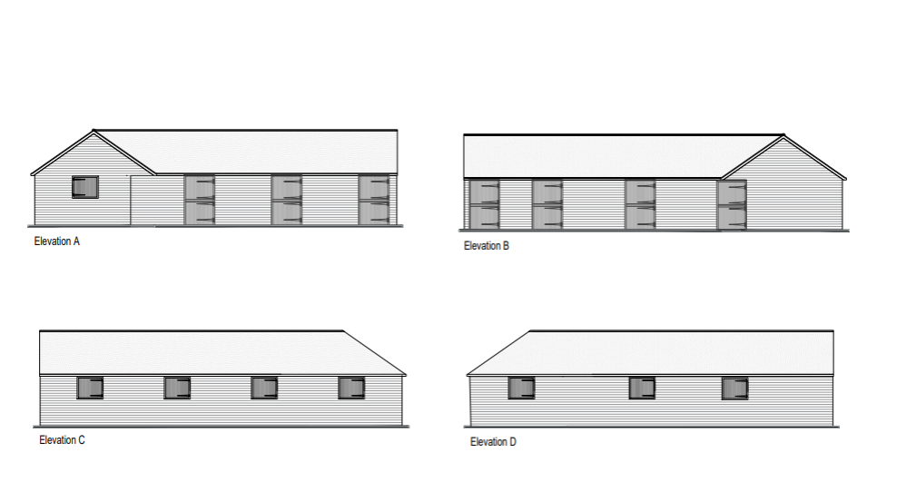
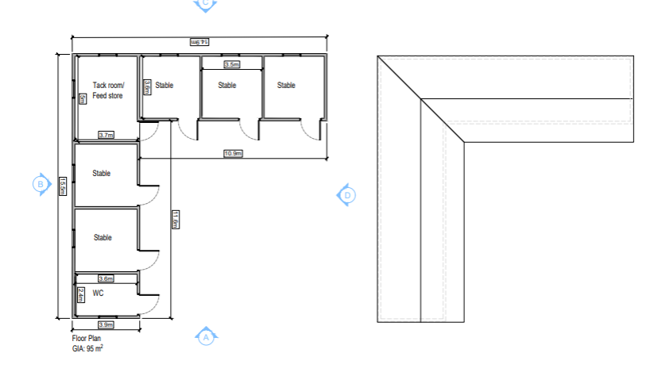
The cluster approach to siting (grouping the stables in a consolidated arrangement rather than spreading built form across the site) minimises visual impact and aligns with best practice in rural design where ancillary buildings are grouped close to existing or historic farmstead footprints.

12.3 Materials and Detailing
Material selection has been driven by the need for contextual integration and minimising visual prominence:
- Primary Cladding: Natural timber boarding has been chosen for all stable elevations. Timber is a traditional rural cladding material that:
  - weathers sympathetically into the landscape over time;
  - reduces visual contrast with the surrounding meadow and pasture;
  - reflects local vernacular more closely than more urban or industrial materials (e.g., metal sheeting).
- Roofing: A subdued, dark profile roofing material has been specified to ensure minimal visual brightness. The ridge heights are kept low relative to established equestrian buildings in the borough.
- Fenestration and Openings: Windows, doors and ventilation slats are positioned and sized to reduce reflective surfaces, limit visual prominence, and preserve privacy for neighbouring properties.
- Drainage / Hard Surfacing: Where surfaces are required for functional use (e.g., stable access), permeable, low-impact surfacing materials have been specified to reduce surface water run-off and preserve the rural character.
Together, these materials and finishes ensure that the development appears as a rural building rather than an urban or industrial structure. This material strategy aligns with the London Plan’s emphasis on high-quality, context-responsive materials.

12.4 Landscape Integration and Public Perception
To ensure that the scheme enhances rather than detracts from the local environment, a comprehensive landscape strategy has been integrated into the design. This includes:
- Replacing Native hedgerow along key boundaries to reinforce the existing rural grain;
- Specimen native trees and scrub to break up any potential visual massing of built form;
- Retention of existing pasture patterns, ensuring the land retains its functional identity;
- Open space retention between built form and adjacent SSSI boundaries to maintain ecological buffers.
This landscape approach supports the view of the development as an appropriate countryside feature, working within the existing landscape pattern rather than disrupting it.
Local planning decisions for similar rural and equestrian structures in Hillingdon have repeatedly emphasised the importance of landscape integration — for example, officer reports routinely reference hedgerow reinforcement and sympathetic cladding as conditions for approval.

12.5 Local Precedent
Numerous stables/equestrian and ancillary rural developments within the London Borough of Hillingdon have been considered acceptable due to similar design approaches. These include stable blocks, tack rooms and agricultural buildings that:
- adopt timber or muted materials,
- remain single-storey and low in ridge height,
- are sited sensitively away from residential property lines,
- integrate with landscape features rather than sit atop visible ridge lines.
In these decisions, planning officers and appeal inspectors have repeatedly affirmed that appropriately designed rural structures, using traditional materials and modest forms, can be visually acceptable and compliant with Green Belt and landscape design policy.

12.6 Design, Green Belt and Policy Compliance
The proposed stables preserve the openness of the Green Belt by virtue of their scale, limited footprint, low visual impact, and careful material selection. Unlike residential or commercial structures which introduce domestic paraphernalia and intensification, these stables:
- do not introduce significant new vertical built form;
- do not interrupt key landscape views;
- retain large tracts of open land surrounding them;
- avoid urbanising features such as tall façades, lighting arrays, or parapets.
In policy terms, the design therefore meets the tests provided by the NPPF (paras 130–134, 138), retains visual and spatial openness as required by Green Belt policy, and satisfies the design requirements of the London Plan and Local Plan Part 2 (DMHB 11 and DMHB 16).

13. Residential Amenity
The assessment of residential amenity considers the potential for development to result in harm to the living conditions of neighbouring occupiers and users of adjacent land. In doing so, the proposal has been considered against the relevant provisions of the National Planning Policy Framework (NPPF), the London Plan and Hillingdon Local Plan Part 2 (Development Management Policies).

Policy Framework
At the national level, the NPPF seeks high quality design and a good standard of amenity for all existing and future occupants of land and buildings (NPPF paras 126 and 130). Policy DMHB 11 of the Hillingdon Local Plan Part 2 requires that new development should safeguard the amenities of surrounding properties through appropriate layout, scale and design. This reflects the longstanding local approach that development should not cause unacceptable loss of privacy, outlook, daylight, sunlight, or generate unacceptable noise, disturbance or odour.
Although policies such as DMHB 17 and DMHB 18 in the Local Plan Part 2 focus on residential development amenity standards such as garden size and private outdoor amenity space, the underlying principle of protecting the amenity of existing residents remains consistent across the Local Plan and is relevant to all forms of development.

Assessment of Amenity Effects
Daylight and Sunlight:
The proposed stable buildings are single-storey, low-height rural outbuildings with simple agricultural proportions. They are sited at a distance from the nearest residential property at the Old Orchard Public House and other neighbouring dwellings such that there would be no material impact on daylight or sunlight. The limited height and orientation means there is no meaningful potential for overshadowing of habitable rooms or private gardens.
Overlooking and Loss of Privacy:
Stables by their very nature do not contain habitable rooms with primary outlooks toward neighbouring dwellings. There are no new openings at first-floor level and no terraces or balconies. As such, there would be no increase in overlooking or loss of privacy. This approach is consistent with Hillingdon’s emphasis on safeguarding privacy through design and siting, as set out in local planning policy.
Noise and Disturbance:
Equestrian stables can generate low-level intermittent noise associated with animal care but are inherently less intensive than residential or commercial uses. The limited number of horses, controlled access arrangements and absence of formal riding arenas mean noise levels would be consistent with the existing rural context of the site, where farm and countryside activities already occur. There would be no significant intensification of activity that could give rise to disturbance.
Odour and External Lighting:
Odour associated with stabling/equestrian use can be managed through best practice husbandry, management of manure storage within enclosed containers, and ensuring appropriate distance from residential curtilages. The proposed design also avoids external lighting that could result in light spill or disturbance to neighbouring homes, consistent with best practice design guidance.
Example Context:
Local decision-making examples within Hillingdon demonstrate that where development would materially harm residential amenities — for example through excessive bulk, overlooking or loss of private space — planning permission is routinely refused or withdrawn (for example rear extensions found harmful to neighbouring properties, enforcement requirements pursued, and appeal decisions cited refusal where amenity harm was evident). These outcomes underline the importance of a robust amenity assessment.
Taken together, the factors above show that the proposal would not materially harm the amenity of existing residents in terms of outlook, privacy, daylight/sunlight, noise, odour or light, and therefore complies with the NPPF and relevant Local Plan policies.

14. Access and Highways
Traffic generation would be minimal and consistent with existing rural land uses. The proposal is considered unlikely to impact adversely upon highway safety.

15. Planning Balance and Overall Assessment
The proposal constitutes appropriate development within the Green Belt under paragraph 154(b) of the NPPF and therefore does not require the demonstration of very special circumstances.
Nevertheless, the proposal delivers a countryside-appropriate use, preserves Green Belt openness and purposes, and safeguards nationally designated ecological assets. It introduces no material harm in landscape, ecological, residential or highway terms.
Significant weight should be afforded to the proposal’s compliance with national and local policy, its careful siting and design, and its avoidance of harm to SSSIs. There are no adverse impacts that would significantly or demonstrably outweigh the benefits of the scheme when assessed against the policies of the NPPF taken as a whole.

16. Conclusion
The proposed development of five stables at land adjacent to the Old Orchard Public House in Harefield represents a well-considered, modest and policy-compliant form of development that satisfies the requirements of the National Planning Policy Framework (December 2024), the London Plan (2021) and the Hillingdon Local Plan (Parts 1 and 2).
Green Belt Compliance:
Under paragraph 154(b) of the NPPF, appropriate facilities for outdoor sport and outdoor recreation (including equestrian stables) are not inappropriate development in the Green Belt provided they preserve openness and do not conflict with the purposes of Green Belt designation. The proposal introduces only low-intensity, single-storey buildings with a limited footprint and avoids urbanising pressures. The spatial and visual openness of the Green Belt would be preserved, in line with Green Belt policy and case-law principles established in Timmins v Gedling BC and similar determinations.
Policy Alignment:
The scheme is consistent with:
- NPPF objectives for rural land uses that maintain openness while supporting countryside activity;
- London Plan Policies G2 and G6 (Green Belt protection and biodiversity enhancement); and
- Hillingdon Local Plan Policies EM2, DMGB1 and DMEI7, which safeguard Green Belt land and protect designated ecological sites such as SSSIs.
Ecological Protection:
Detailed assessment demonstrates that there would be no adverse effect on the integrity, conservation objectives or setting of Frays Farm Meadow SSSI and Denham Lock SSSI, either alone or in combination with other developments. The proposal avoids impact pathways such as hydrological change, nutrient enrichment or physical disturbance.
Residential Amenity:
As demonstrated in the assessment above, the low-scale, rural nature of the proposal will not result in unacceptable impacts on local residents in terms of privacy, daylight/sunlight, noise, odour or light.
This complies with the amenity protection principles embedded in the NPPF and Hillingdon Local Plan development management policies.
Landscape and Design Integration:
Appropriate landscaping and sensitive siting ensure the stables integrate with the rural character of the area without harm to landscape quality or local character.
Highway and Access:
Traffic associated with the development would be minimal and consistent with rural equestrian use, with no material harm to highway safety.
In summary, the proposal is fully compliant with national, regional and local policy, preserves the openness and purposes of the Green Belt, protects designated ecological assets, respects neighbouring amenity and integrates successfully into its landscape setting.
The proposed development accords with the National Planning Policy Framework (December 2024), the London Plan (2021) and the Hillingdon Local Plan. In policy terms, it represents an acceptable form of rural stable and equestrian development and is considered appropriate for planning approval.

