k

39H
Planning Consultancy

Project Management

Contract Procurement

Site Supervision

Project Coordination

Consultations

Feasibility Schemes

Architectural Design

Construction Drawings & Detailing

Planning & Building REG Applications

Management Contracting

Construction Management

____________________________________________

Design and Access Statement

LAND ADJACENT TO THE OLD ORCHARD PUB
PARK LANE
HAREFIELD
MIDDLESEX
UB9 6HJ

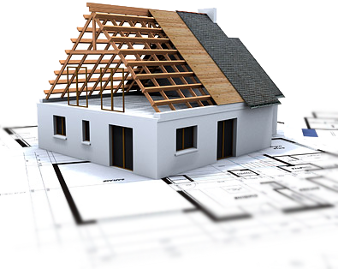

November 2025

Erection of Five Equestrian Stables, Tack Room and WC
Land Adjacent to the Old Orchard Public House, Harefield, London Borough of Hillingdon

1. Introduction and Purpose of the Statement
This Design and Access Statement has been prepared in support of a full planning application for the erection of five equestrian stables, tack room and WC on land adjacent to the Old Orchard Public House, Harefield, within the London Borough of Hillingdon.
The site lies within the Metropolitan Green Belt and immediately adjoins two nationally designated ecological sites: Frays Farm Meadow SSSI and Denham Lock Wood SSSI. The location is therefore highly sensitive in landscape, ecological and planning policy terms.
In recognition of this sensitivity, the proposal has been developed through a design-led, precautionary and context-driven approach.
The purpose of this Design and Access Statement is to explain:
- the design rationale underpinning the proposal;
- how the amount, layout, scale and appearance of development have been informed by local character and policy;
- how access arrangements have been carefully considered to minimise impacts; and
- how the scheme accords with national, regional and local planning policy, including the National Planning Policy Framework (December 2024), the London Plan (2021) and the Hillingdon Local Plan (Parts 1 and 2).

2. Site Context and Design Influences

2.1 Site Context
The application site comprises undeveloped pasture land located to immediately to the west of the Old Orchard Public House at the rural edge of Harefield.
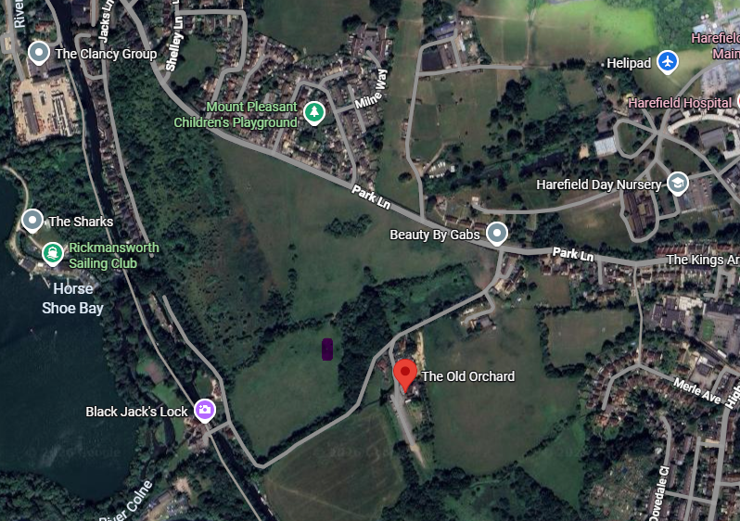
Aerial View of the Site
The site forms part of the wider Colne Valley landscape, characterised by open meadows, wet grassland, riparian corridors and pockets of wet woodland associated with the River Colne and the Grand Union Canal.
Built development within the immediate locality is sparse and typically comprises small-scale rural buildings, public houses, historic farmsteads, lock-keeper cottages and equestrian-related structures. This low-density pattern of development is fundamental to the openness and rural character of the area.

2.2 Local Vernacular and Character
The local vernacular around Denham Lock, the Colne Valley and Harefield is defined by:
- modest, low-rise buildings;
- agricultural and equestrian structures constructed from timber or muted materials;
- simple roof forms with low ridge heights;
- an absence of suburban or urban detailing;
- a strong visual relationship between buildings and surrounding open land.
Examples within the locality include stable blocks, barns and ancillary rural buildings associated with existing equestrian uses and countryside management within the Colne Valley Regional Park.
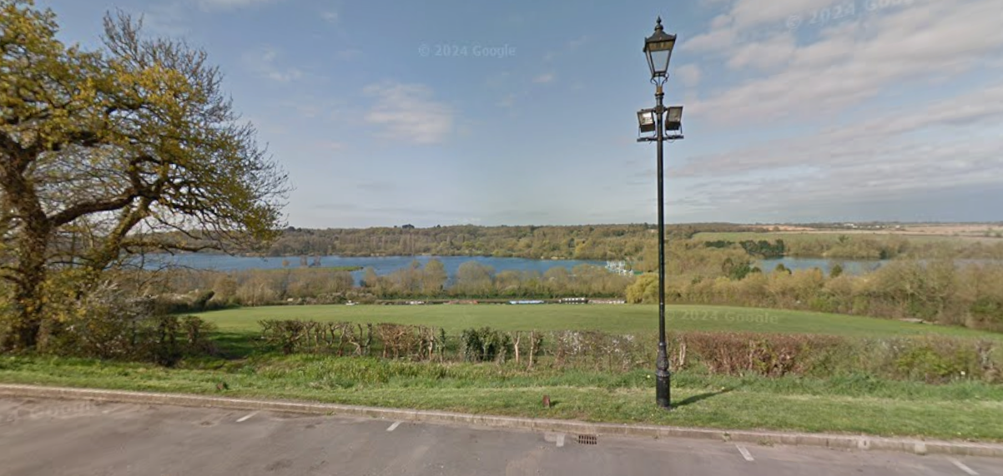
View west across the site from the Old Orchard Pub
These developments are typically understated in appearance and subordinate to the landscape, reinforcing rather than competing with the surrounding environment.
This proposal has been explicitly informed by this local vernacular and seeks to reflect these characteristics in its design, scale and material palette.

3. Policy Framework Influencing Design and Access

3.1 National Planning Policy Framework (December 2024)
The NPPF places strong emphasis on high-quality, context-sensitive design. Paragraphs 130–134 require development to be visually attractive, sympathetic to local character and history, and to establish a strong sense of place. Paragraph 138 emphasises that development in the Green Belt must preserve openness and avoid inappropriate bulk or form.
Paragraph 154(b) confirms that appropriate facilities for outdoor sport and recreation, including equestrian uses, are not inappropriate development in the Green Belt where openness is preserved.

3.2 The London Plan (2021)
The London Plan reinforces the importance of contextual design through Policy D3, which requires development to respond positively to its surroundings and landscape context. Policy D4 emphasises high-quality materials and detailing. Policies G2 and G6 further underline the importance of protecting the Green Belt and enhancing biodiversity through sensitive land use.

3.3 Hillingdon Local Plan
Local Plan Part 2 Policy DMHB 11 requires development to respect local character, scale and form, while DMHB 16 requires high-quality landscaping to integrate development into its setting. Policies EM2 and DMGB1 safeguard the Green Belt, and Policy DMEI7 requires development adjacent to SSSIs to demonstrate no adverse effects.
The proposal has been designed to respond directly to this policy framework.

4. Design Principles
The overarching design principles for the proposal are:
- landscape-led design;
- minimal intervention;
- low visual and spatial impact;
- use of traditional, recessive materials;
- clear functional relationship with open land.
These principles ensure that the development remains subordinate to the landscape and preserves the essential openness of the Green Belt.

5. Amount of Development
The amount of development has been deliberately limited to five stables only. This represents the minimum scale necessary to support the intended equestrian use and avoids over-development of the site.
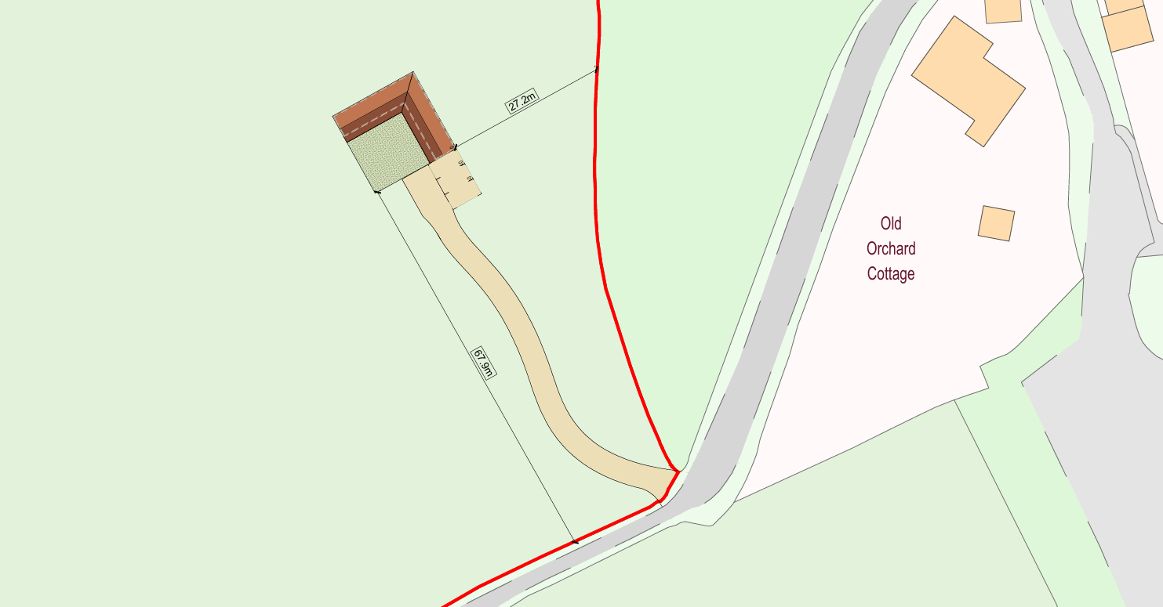
Site Layout
No ancillary residential accommodation, riding arenas or intensive equestrian infrastructure is proposed. The limited quantum of development ensures that built form remains secondary to the open land, in accordance with Green Belt policy.

6. Layout
The layout clusters the five stables in a compact arrangement rather than dispersing buildings across the site. This approach:
- reduces landscape fragmentation;
- limits visual spread;
- reflects the layout of traditional rural farmyards and equestrian groupings;
- maintains substantial areas of open pasture around the buildings.

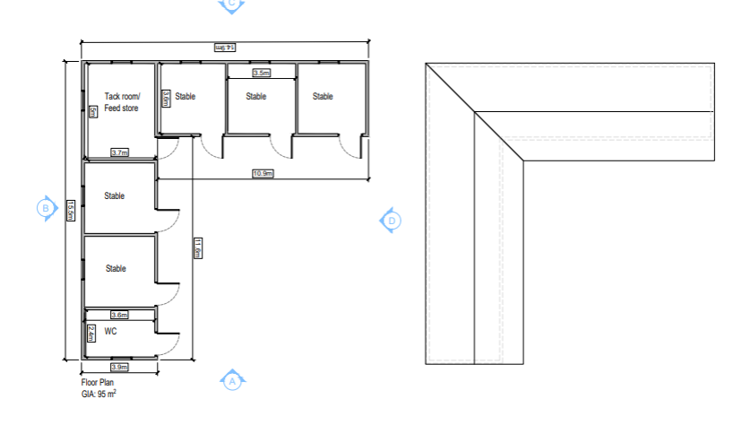
Proposed Floor Plans
Adequate buffers are retained between the stables and adjacent SSSI boundaries, ensuring no encroachment or perceived urban edge.

7. Scale and Massing
All buildings are single-storey with low ridge heights. The modest scale ensures:
- no skyline intrusion;
- preservation of long-distance views across the Colne Valley;
- compliance with Green Belt openness requirements.
The massing is deliberately simple and agricultural in character, avoiding articulation or detailing that would introduce an urban appearance.

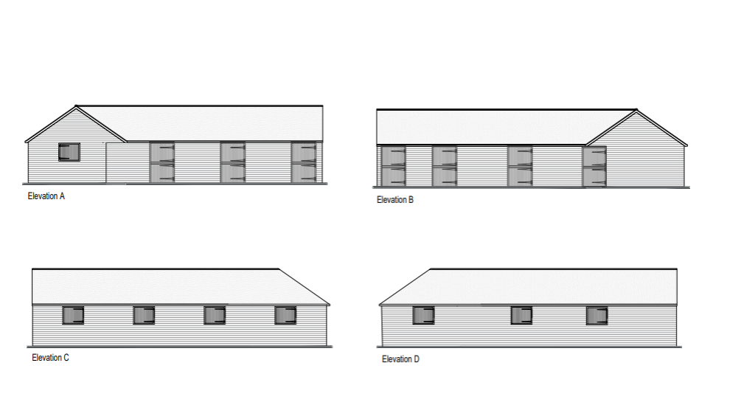

Proposed Elevations

8. Appearance and Materials

8.1 Materials
The selection of materials has been fundamental to ensuring landscape integration:
- Timber cladding forms the primary external finish, reflecting traditional rural construction and allowing the buildings to weather naturally into the landscape.
- Subdued roofing materials with a low-reflectivity finish are proposed to avoid visual glare.
- Simple detailing avoids ornamentation and maintains a functional agricultural appearance.
Proposed elevations
Timber is a material commonly used in equestrian development across Hillingdon and the wider Colne Valley, and its use here reinforces visual continuity with existing rural structures.

8.2 Visual Integration
The restrained appearance ensures the stables read as ancillary rural buildings rather than dominant features. Combined with landscaping, the buildings will be visually absorbed into their surroundings over time.

9. Landscaping Strategy
Landscaping plays a critical role in the design. The strategy includes:
- retention of existing pasture;
- reinforcement of boundary hedgerows using native species;
- selective native tree and scrub planting to soften views;
- maintenance of open buffers adjacent to designated ecological sites.
This approach accords with Policy DMHB 16 and supports ecological connectivity within the Colne Valley.

10. Access Strategy

10.1 Vehicular Access
Access to the site will be taken from an existing gated access off the private road adjacent to the Old Orchard Public House. No new vehicular access points are required.
The use of an existing access ensures:
- no alteration to the wider highway network;
- no loss of hedgerows or boundary features;
- minimal construction disruption.

10.2 Traffic Generation
The equestrian use will generate very low traffic levels, typically limited to approximately one to two vehicle movements per week associated with routine horse welfare, maintenance and occasional deliveries.
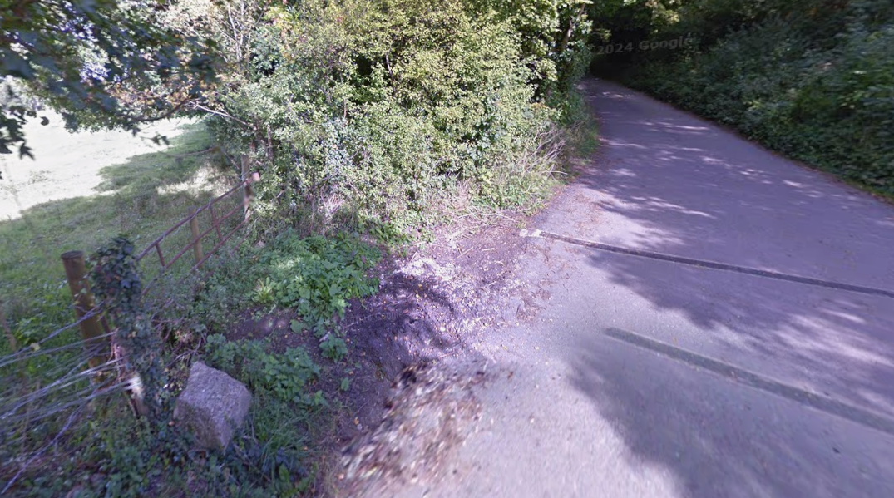
Existing gated access
There will be no intensification of use that could materially affect highway safety or capacity. The proposal therefore accords with NPPF objectives for safe and suitable access without severe residual impacts.
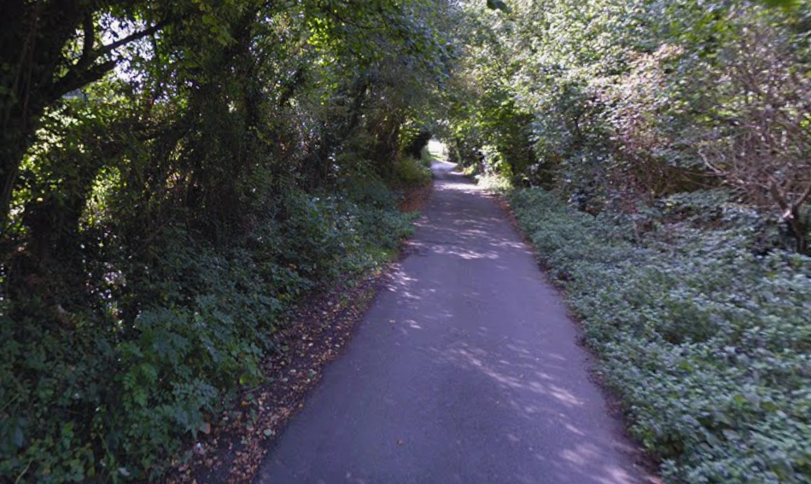
View south along private access road

11. Inclusive Access
The stables are designed to be accessed at ground level, with level thresholds and sufficient circulation space to allow safe access for all users, including those with limited mobility, in accordance with inclusive design principles.

12. Conclusion
This Design and Access Statement demonstrates that the proposed erection of five stables, tack room and WC has been shaped by its highly sensitive context. The design responds directly to the local vernacular of the Colne Valley and Denham Lock area, utilising traditional materials, modest scale and a landscape-led approach.
The proposal preserves the openness and purposes of the Green Belt, integrates harmoniously with the surrounding environment, safeguards designated ecological assets and provides safe, low-impact access arrangements.
The proposed development accords with the National Planning Policy Framework (December 2024), the London Plan (2021) and the Hillingdon Local Plan. In policy terms, it represents an acceptable form of rural stable and equestrian development and is considered appropriate for planning approval.

