
Unit 4, Langham Stables, Langham Lane, Lodsworth, Petworth, West Sussex, GU28 9BU.
Tel: 01798 861 800 - E-Mail: info@ecologyco-op.co.uk - Website: www.ecologyco-op.co.uk
15th June 2026
Ref: P11647, Bat Scoping Assessment – 78 Broadwood Avenue, Ruislip.

To whom it may concern,
The Ecology Co-op undertook a bat scoping assessment at 78 Broadwood Avenue, HA4 7XR, on 21st May 2026 at the request of Mr D. Rahman. This assessment was undertaken further to a proposal to demolish the existing dwelling and construct a new dwelling on the site. The survey was led by Holly Waters, a senior ecologist with over five-years of experience and a level 1 bat survey licence, and was undertaken in accordance with best practice guidance produced by the Bat Conservation Trust.
The site is situated in a suburban location in Ruislip, Greater London. It comprises a two-storey, detached, brick-built dwelling with a single-storey brick garage attached, a vegetated rear garden and a paved driveway. Given the nature and small scale of the proposals, this report has focused upon localised site impacts only. The site location is shown in Figure 1, Appendix 1.
The proposed development will remove the existing dwelling and the associated garage, replacing it with a larger dwelling. The proposals for the site are shown in Figure 2, Appendix 1.
Table 1 below summarises the structures assessed for bat roosting potential. Both the exterior and interior of the building were inspected as part of the survey.

Table 1. Summary of structures assessed for Potential Roost Features (PRFs) on the building.
Building section | Description of features | Assessment of suitability (Collins 2023)
Loft void – interior | The loft void is S-shaped with the northwest section approximately 7m (l) x 5m (w), and the southeast section approximately 12m (l) x 6m (w). It is lined internally with bitumen hessian, which appeared intact with no daylight gaps identified. Mineral wool insulation is present across the floor. The void was heavily cobwebbed throughout both major sections and the space connecting these. The void is un-boarded and could not be accessed or observed throughout; as a result, some areas could not be fully inspected and any droppings present may have been missed. | Negligible bat roost suitability
Exterior – house | Southern elevation: gaps were identified under the hip tiles, one of which was assessed as highly suitable for crevice-dwelling bats. Additionally, a suitable gap was identified where a tile has slipped on the cat slide roof and another where the soffit meets the cat slide roof. The soffit box gap does not connect into the loft void.  Eastern elevation: one to two small gaps under the roof tiles.  Northern elevation: a suitable gap near the apex of the roof where a section of mortar appears to be missing.  Western elevation: a potential gap associated with the lead flashing, along with one to two gaps beneath the roof tiles. The rear sections of the eastern and western elevations were not visible during the survey due to a lack of access to neighbouring gardens. | Low bat roost suitability
Exterior – garage | Brick-build garage with flat felt roof. No suitable gaps visible on the exterior of the property. | No bat roost suitability

The site is located within a predominantly suburban residential area, bounded by housing along Broadwood Avenue and the surrounding street network. Despite this context, the site lies in close proximity to a large parcel of ancient woodland, approximately 30m to the north, which represents a high-value foraging resource for bats and provides strong habitat connectivity into the wider landscape beyond the immediate built environment. A further parcel of lowland meadow priority habitat is present approximately 120m south of the site, and a watercourse runs through the open land to the south-east in the vicinity of Kings College Playing Fields. Watercourses and their associated vegetated margins are well documented as important commuting corridors and foraging areas for bats, owing to the elevated insect prey abundance they support. Similarly, the lowland meadow habitat represents a high value foraging habitat because it supports a great abundance of insects.
Taken together, the site's position on the edge of an extensive woodland block, in combination with the nearby lowland meadow and watercourse corridor, indicates that the site and its zone of influence are likely to be used by foraging and commuting bats, with the woodland edge and boundary features in particular likely to function as commuting routes.
Overall, the suitability of the house to support roosting bats is rated as low, considering the condition of the building and its context within suitable foraging habitat for bats. As such, one emergence survey is required to determine the importance of the building to bats, as without further surveys the level of impact upon bats cannot be fully assessed. To ensure adequate coverage of all potential roost features, it is estimated that three observers will be required for the survey visit to observe all suitable roost features. To ensure that the survey effort conforms with interim guidance on the use of night vision aids, produced by the Bat Conservation Trust2, three night-vision cameras supported by infra-red lighting will be used to support surveyors.
The survey can be undertaken at dusk between May and August. Surveyors will use ultrasonic recording equipment to try and establish the species of bat present. If bats are discovered, further surveys to classify the nature of the roost (day/maternity/social) may be required.
To mitigate disturbance to foraging and commuting bats from artificial lighting, the proposed development should include an ‘ecologically sensitive lighting scheme’ in accordance with guidance produced by the Bat Conservation Trust (summarised in Appendix 3).
Additionally, the site can be enhanced for bats by incorporating the features below into the fabric of the building. Where bat access tiles are used, only a Type 1F bitumen lining must be used instead of modern breathable membranes such as Tyvek, which over time fray and entangle bats. The bat boxes and features should be installed under the instruction of a suitably licensed ecologist to ensure that the positioning is optimal, but generally locations above 3.5m in the most southeasterly facing aspect of the building would be best.
These enhancement measures will help illustrate that the proposals are in adherence with Paragraph 187 (d) of the National Planning Policy Framework (NPPF) and should therefore be considered favourably within the planning process.
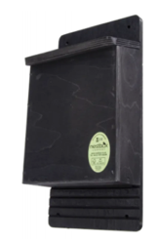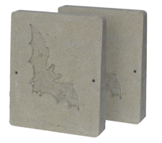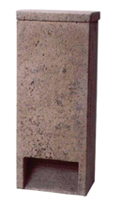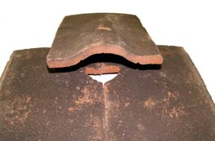
Bat Access Tile Set, 2FR Schwegler Bat Tube, 2FE Schwegler Wall-Mounted bat shelters and Improved Crevice Bat Box.

If you have any queries about the findings of this assessment, then please do not hesitate to contact me.
Kind regards,
Joshua McIlroy
BSc (Hons), MRes
Tel: 01798 861800
Email: joshua@ecologyco-op.co.uk

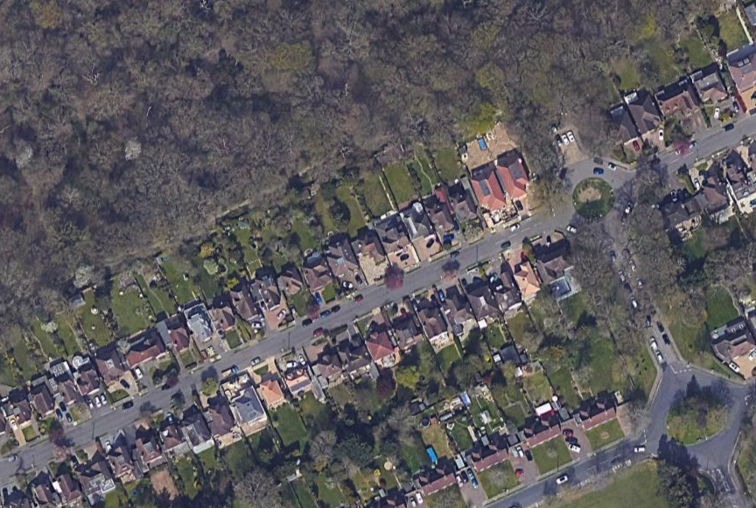
APPENDIX 1 – Figures

Figure 1. Aerial image showing the location of 78 Broadwood Avenue (indicated with a red outline). Image produced courtesy of Google maps (map data ©2021 Google). Ruislip Woods (ancient woodland) is visible just north of the site.

Figure 2. The proposed dwelling in drawing no. SS01 produced by JP of Scandia-Hus.

APPENDIX 2 – Site Photographs
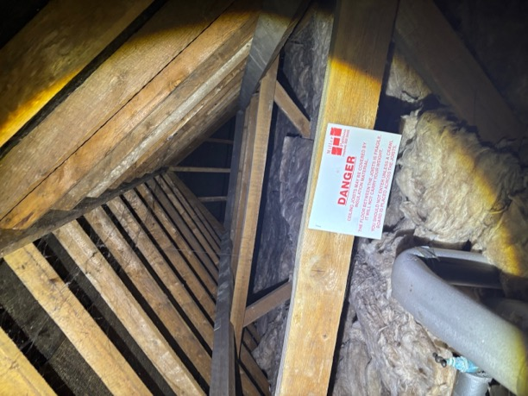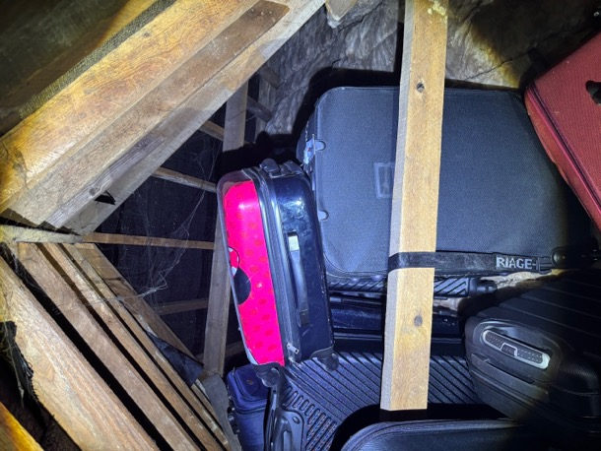
Photograph 1a and 1b. The loft void at 78 Broadwood Avenue.

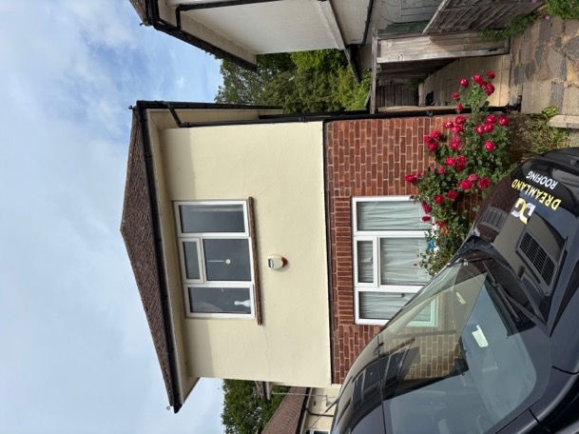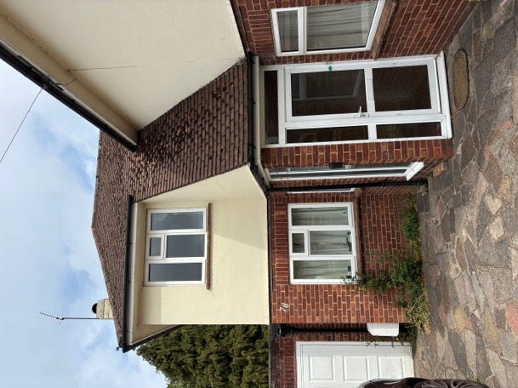
Photograph 2a and 2b. The southern elevation of the property with the catslide roof.

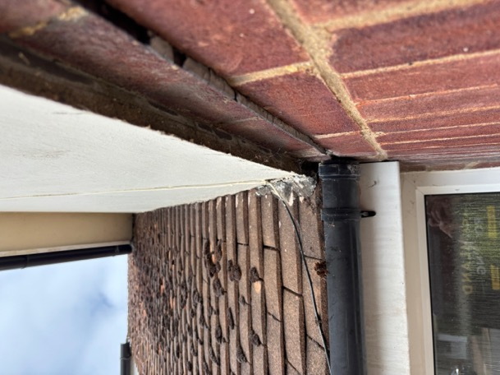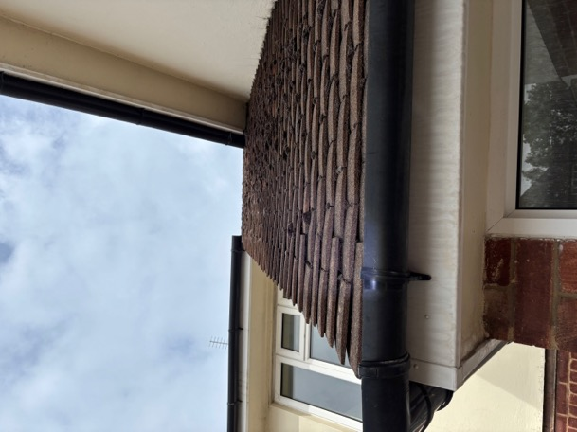
Photograph 3a and 3b. The gaps present where the soffit box meets the catslide roof (left) and on the catslide roof itself (right).

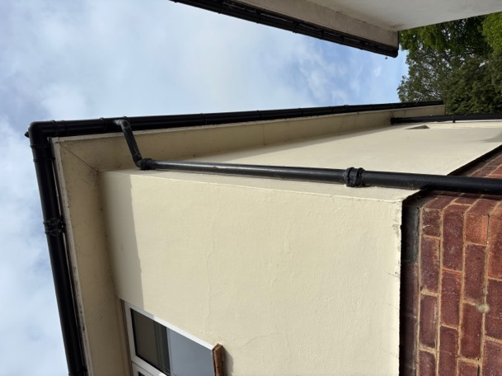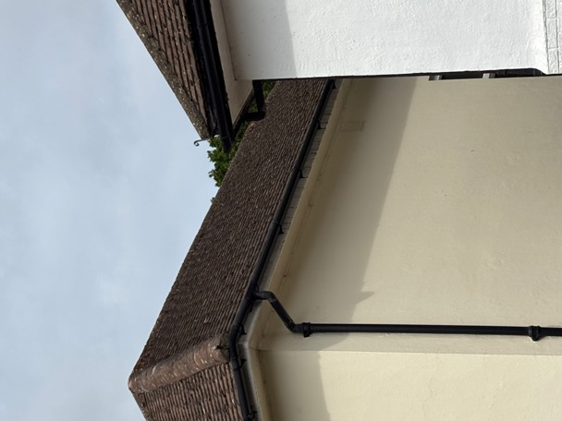
Photograph 4a and 4b. The eastern elevation of the property.

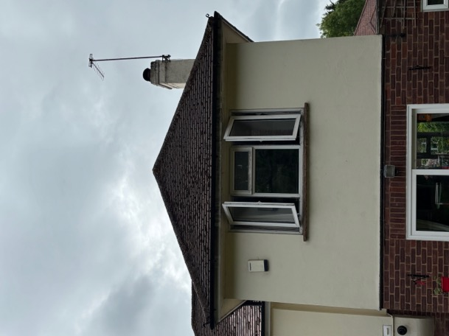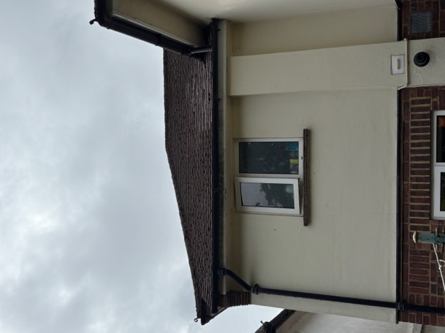
Photograph 5a and 5b. The northern elevation of the property, with few gaps in the roof tiles.

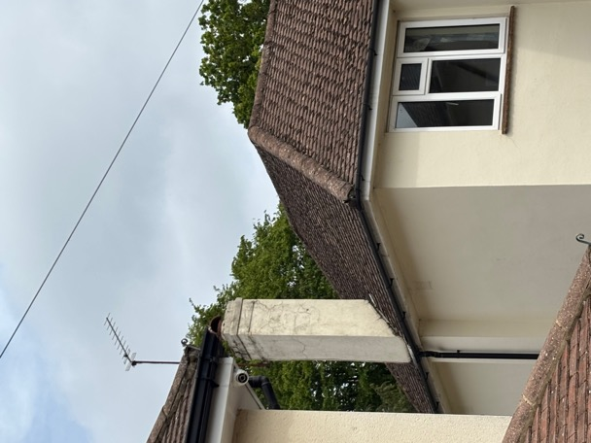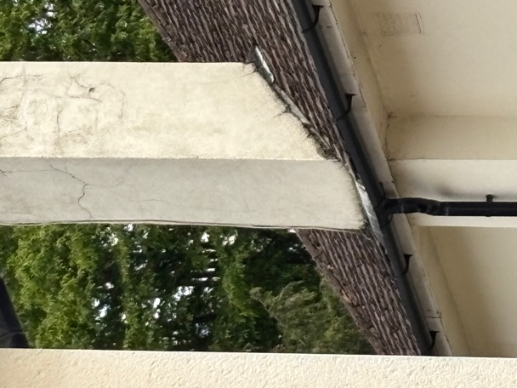
Photograph 6a and 6b. The western elevation of the property and the gap associated with the lead flashing.

APPENDIX 3 – Reducing Impacts of Artificial Light
Bright external lighting can have a detrimental impact upon foraging and commuting bat flight paths, but more importantly can also cause bats to remain in their roosts for longer. Artificial lighting can also cause significant impacts to other nocturnal species, most notably moths and other nocturnal insects. It can also result in disruption of the circadian rhythms of birds, reducing their fitness.
Guidelines issued by the Bat Conservation Trust should be referred to when designing the lighting scheme. Note that lighting designs in very sensitive areas should be created with consultation from an ecologist and using up-to-date bat activity data where possible. The guidance contains techniques that can be used on all sites, whether a small domestic project or larger mixed-use, commercial or infrastructure development. This includes the following measures:
Avoid lighting key habitats and features altogether
There is no legal duty requiring any place to be lit. British Standards and other policy documents allow for deviation from their own guidance where there are significant ecological/environmental reasons for doing so. It is acknowledged that in certain situations lighting is critical in maintaining safety, such as some industrial sites with 24-hour operation; however, in the public realm, while lighting can increase the perception of safety and security, measurable benefits can be subjective. Consequently, lighting design should be flexible and be able to fully consider the presence of protected species.
Apply mitigation methods to reduce lighting to agreed limits in other sensitive locations – lighting design considerations
Where bat habitats and features are considered to be of lower importance or sensitivity to illumination, the need to provide lighting may outweigh the needs of bats. Consequently, a balance between a reduced lighting level appropriate to the ecological importance of each feature and species, and the lighting objectives for that area will need to be achieved. The following are techniques which have been successfully used on projects and are often used in combination for best results:
- dark buffers, illuminance limits and zonation;
- sensitive site configuration, whereby the location, orientation and height of newly built structures and hard standing can have a considerable impact on light spill;
- consideration of the design of the light and fittings, whereby the spread of light is minimised ensuring that only the task area is lit. Flat cut-off lanterns or accessories should be used to shield or direct light to where it is required. Consideration should be given to the height of lighting columns. It should be noted that a lower mounting height is not always better. A lower mounting height can create more light-spill or require more columns. Column height should be carefully considered to balance task and mitigation measures. Consider no lighting solutions where possible such as white lining, good signage, and LED cats eyes. For example, light only high-risk stretches of roads, such as crossings and junctions, allowing headlights to provide any necessary illumination at other times;
- screening, whereby light spill can be successfully screened through soft landscaping and the installation of walls, fences and bunding;
- glazing treatments, whereby glazing should be restricted or redesigned wherever the ecologist and lighting professional determine there is a likely significant effect upon key bat habitat and features;
- creation of alternative valuable bat habitat on site, whereby additional or alternative bat flightpaths, commuting habitat or foraging habitat could result in appropriate compensation for any such habitat being lost to the development;
- dimming and part-night lighting. Depending on the pattern of bat activity across the key features identified on site it may be appropriate for an element of on-site lighting to be controlled either diurnally, seasonally or according to human activity. A control management system can be used to dim (typically to 25% or less) or turn off groups of lights when not in use.

Demonstrate compliance with illuminance limits and buffers
- Design and pre-planning phase; it may be necessary to demonstrate that the proposed lighting will comply with any agreed light-limitation or screening measures set as a result of your ecologist’s recommendations and evaluation. This is especially likely to be requested if planning permission is required.
- Baseline and post-completion light monitoring surveys; baseline, pre-development lighting surveys may be useful where existing on or off-site lighting is suspected to be acting on key habitats and features and so may prevent the agreed or modelled illuminance limits being achieved.
- Post-construction/operational phase compliance-checking; as a condition of planning, post-completion lighting surveys by a suitably qualified person should be undertaken and a report produced for the local planning authority to confirm compliance. Any form of non-compliance must be clearly reported, and remedial measures outlined. Ongoing monitoring may be necessary, especially for systems with automated lighting/dimming or physical screening solutions.

Lighting Fixture Specifications
The Bat Conservation Trust recommends the following specifications for lighting on developments to prevent disturbance:
- Lighting spectra: peak wavelength >550nm
- Colour temperature: <2700K (warm)
- Reduction in light intensity
- Minimal UV emitted
- Upward light ratio of 0% and good optical control

Further reading:
Buglife (2011) A review of the impact of artificial light on invertebrates.
Royal Commission on Environmental Pollution (2009) Artificial light in the environment. HMSO, London. Available at: https://www.gov.uk/government/publications/artificial-light-in-the-environment
Rich, C., Longcore, T., Eds. (2005) Ecological Consequences of Artificial Night Lighting. Island Press. ISBN 9781559631297.
CPRE (2014) Shedding Light: A survey of local authority approaches to lighting in England. Available at: http://www.cpre.org.uk/resources/countryside/dark-skies/item/3608-shedding-light
Planning Practice Guidance guidance (2014) When is light pollution relevant to planning? Available at: https://www.gov.uk/guidance/light-pollution
Institution of Lighting Professionals (2021) Guidance Notes for the Reduction of Obtrusive Light GN01:2011. Available at: https://www.theilp.org.uk/resources/free-resources/
Voigt, C.C., Azam, C., Dekker, J., Ferguson, J., Fritze, M., Gazaryan, S., Hölker, F., Jones, G., Leader, N., Lewanzik, D. and Limpens, H., 2018. Guidelines for consideration of bats in lighting projects. Unep/Eurobats. Available at:
https://cdn.bats.org.uk/uploads/pdf/Resources/EUROBATSguidelines8_lightpollution.pdf?v=1542109376

Collins, J.(ed.) (2023) Bat Surveys for Professional Ecologists: Good Practice Guidelines (4th edn). The Bat Conservation Trust, London.
Bat Conservation Trust and Institute for Lighting Professionals (2018) Guidance note 8. Bats and Artificial Lighting. https://www.theilp.org.uk/documents/guidance-note-8-bats-and-artificial-lighting/

