

07514 541 721: T
mark@pottleandco.com: E
www.pottleandco.com: W

Design and Access Statement: 27 Farmlands, Pinner, Middlesex. HA5 2LW

The existing property is a 3 bedroom semi-detached property with side garage. The property benefits from part face brickwork and part rendered finish with interlocking tiles to the main roof which features a gable side roof. The garage is face brickwork with flat roof to finish.

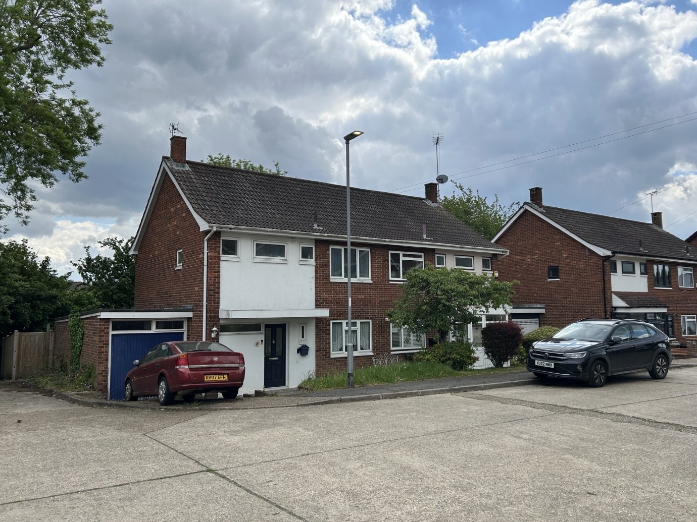

The access to the property is via Farmlands, this road has on-street parking, however most properties also benefit from off-street parking on their front drive, plus a block of garages are also available adjacent to the property at 27 Farmlands.

Our proposal is to convert the garage to habitable use including building on top of this footprint at 1st floor level to provide additional habitable space.

The purpose of the proposed works is to provide an annexe ancillary to the main dwelling which will provide a certain level of privacy and independence for their adult son who is already living at the dwelling.

The garage is not suitable for a car in its present form and is only used for storage, parking remains on the front drive in front of the garage and is also available on the street. The parking situation for this family at this dwelling will remain unchanged.

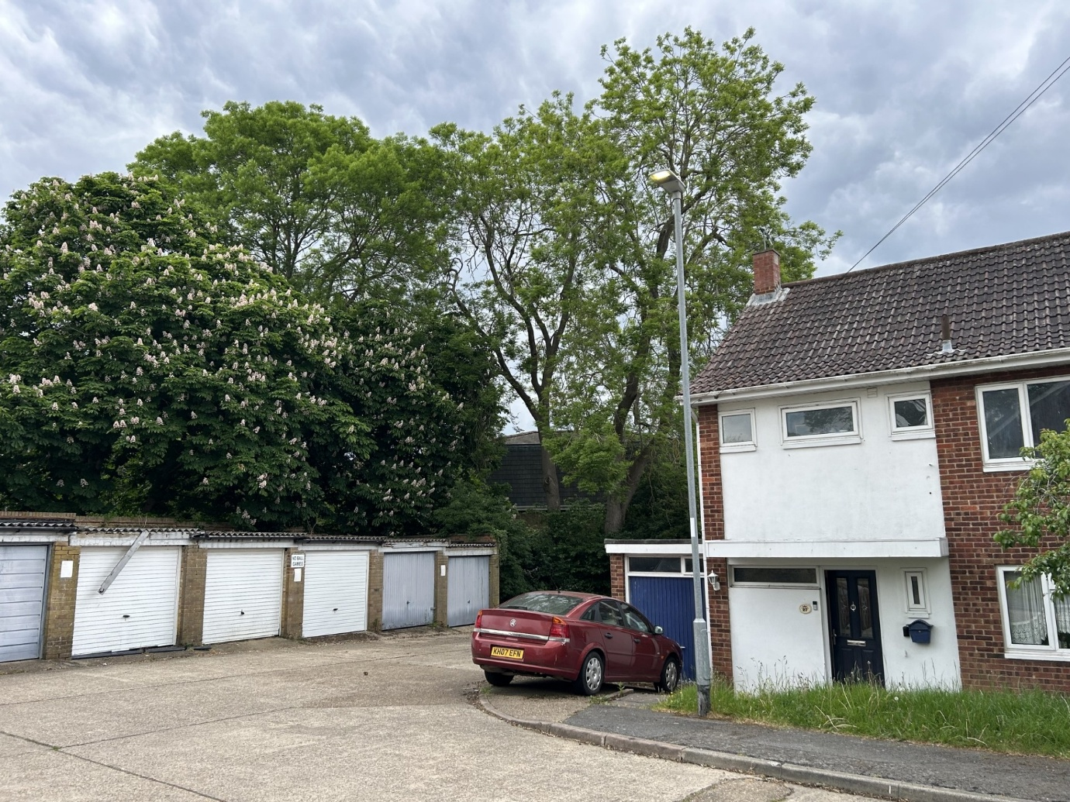

Access to the annexe will be via the main dwelling replacing an existing cupboard behind the staircase before the living room. Our clients wish to have minimal disruption to the existing dwelling to create the annexe and therefore this is the only alteration proposed internally.

The annexe will provide a 1 bedroom unit with separate shower room, living room and kitchen. The annexe will also have access to the rear garden, however the garden will not be separated and will be enjoyed as it currently is by the whole family.

The external design of the extension will be to create the proposed works in face brickwork to match the existing dwelling, with similar interlocking tile and gable side roof to match the existing design. We have proposed a small hipped roof to the rear extension at 1st floor level, the proposed roof pitches will match the main roof.

New windows and doors will also aim to match the main dwelling which will be white, UPVC.

Beyond the rear garden, the property benefits from a footpath to the rear and many mature trees, all will be unaffected by the proposed works.
The proposed works will only be on the same footprint as the existing garage, and the setback from the front of the existing dwelling will remain. The extension will be largely unseen from the road due to this being the last property on the road before the garages.

The properties opposite this one all benefit from a first floor over their garage which has created a link terraced effect with high level flat roofs, showing that a proposed 1st floor build would not be out of character within this road.

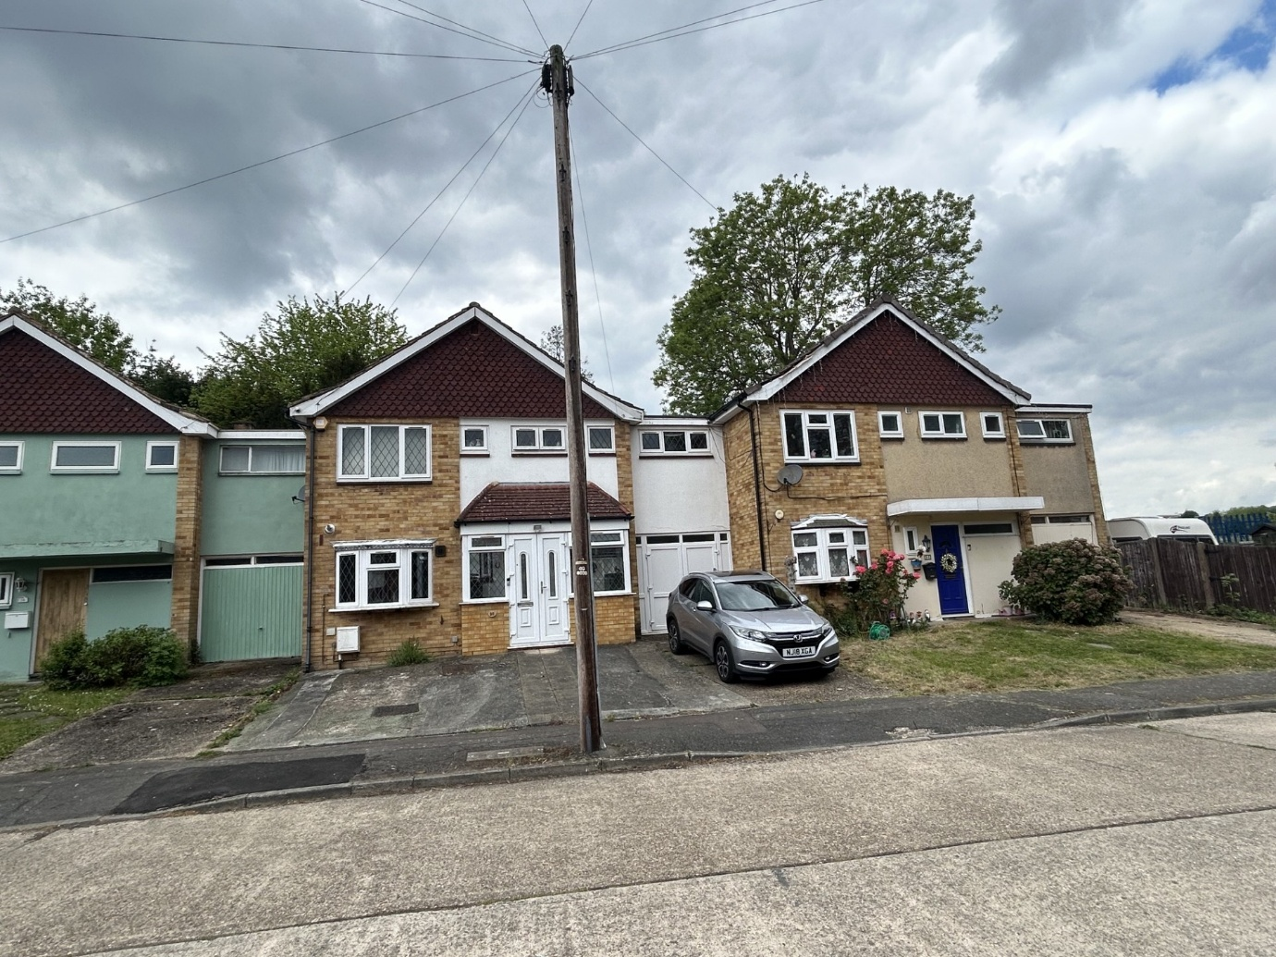

Our clients are simply trying to give their family a modern way of living to allow privacy and independency to all parties whilst trying not to disrupt the main family home. The design allows minimal works to the existing house and removes a garage which is no longer fit for purpose.

The new layout for the annexe provides an opportunity for an adult son to live independently with his own cooking and washing facilities, plus separate living area. The shared access from the front door and access to the shared garden remain to keep the property as a single family dwelling.

