Hyde Park Hayes
Economic Statement

Date:
July 2025
Prepared for:
Columbia Threadneedle Investments

Trium Environmental Consulting LLP
+44 (0) 20 3887 7118
hello@triumenv.co.uk
www.triumenvironmental.co.uk

This report has been prepared for the Client by Trium Environmental Consulting LLP with all reasonable skill, care and diligence and in accordance with the Client’s particular and specific instructions. This report is issued subject to the terms of our Appointment, including our scope of Services, with the Client.
This report has been prepared for, and is intended solely for the use of, the Client alone and accordingly is personal to the Client. The Report should not be disclosed, exhibited or communicated to any third party without our express prior written consent. Trium Environmental Consulting LLP accepts no responsibility whatsoever to any third parties to whom this report, or any part thereof, is disclosed, exhibited or communicated to, without our express prior written consent. Any such party relies upon the report at their own risk.
Trium Environmental Consulting LLP disclaims any responsibility to the Client and others in respect of any matters outside the agreed scope of the Services.
Trium Environmental Consulting LLP shall be under no obligation to inform any party of any changes or updates in respect of any matter referred to or contained in the Report.
This report is the Copyright of Trium Environmental Consulting LLP. Any unauthorised use or reproduction by anyone other than the Client is strictly prohibited.

CONTENTS

CONTENTS 3
INTRODUCTION 4
LEGISLATION AND POLICY 7
METHODOLOGY AND SCOPE 10
BASELINE 13
PROPOSED DEVELOPMENT EFFECTS 26
CONCLUSION 29

INTRODUCTION
- This Economic Statement is prepared on behalf of Columbia Threadneedle (hereinafter referred to as ‘the Applicant’) in support of an outline planning application for the land at Hyde Park Hayes, Millington Road, London UB3 4AZ (the ‘Site’), located within the London Borough of Hillingdon (LBH).
- The Applicant is seeking planning permission for the following works (the ‘Proposed Development’):
“Outline planning permission (with all matters reserved excluding access) for demolition of existing buildings (above basement level) and delivery of residential development (Class C3), flexible residential / commercial floorspace, new public realm, landscaping, play space, car parking, cycle parking and associated works.”

Overview of this Economic Statement
- This report has been undertaken to identify the likely socio-economic impacts of the Proposed Development, in support of this planning application and in line with Greater London Authority (GLA) guidance.
- This Economic Statement should be read in conjunction with other supporting documents submitted with the Planning Application, including the Planning Statement prepared by Montagu Evans and the Design and Access Statement (DAS) prepared by TP Bennett, which explain the Proposed Development in more detail and relate it to the Site’s surrounding context and applicable planning policy frameworks.

The Site and Existing Uses
- The Site is bound by:
- North Hyde Road (A347) to the north, beyond which lie residential properties and National Rail railway tracks;
- Millington Road to the east, beyond which lie commercial premises including a building merchant supplier;
- Millington Road to the south, beyond which lie commercial premises and residential uses; and
- Millington Road to the west, beyond which lies surface car parking and commercial uses, and beyond this Dawley Road.
- The Site is irregular in shape and currently occupied by a surface car park of 0.2ha, two vacant commercial buildings of three and five storeys in height, and a multi-storey car park of six storeys. The Site also comprises areas of hardstanding and limited areas of public realm. The Site currently contains limited vegetation with some trees around the Site boundary.
- The Site is allocated for development within the Hillingdon Local Plan Part 1, Hillingdon Local Plan Part 2 and Hillingdon Adopted Policy M. It is also adjacent to the LBH’s Hayes Housing Zone.
- The Site boundary is shown in Figure 1 below.
- Application Redline Boundary
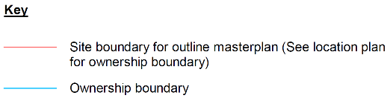
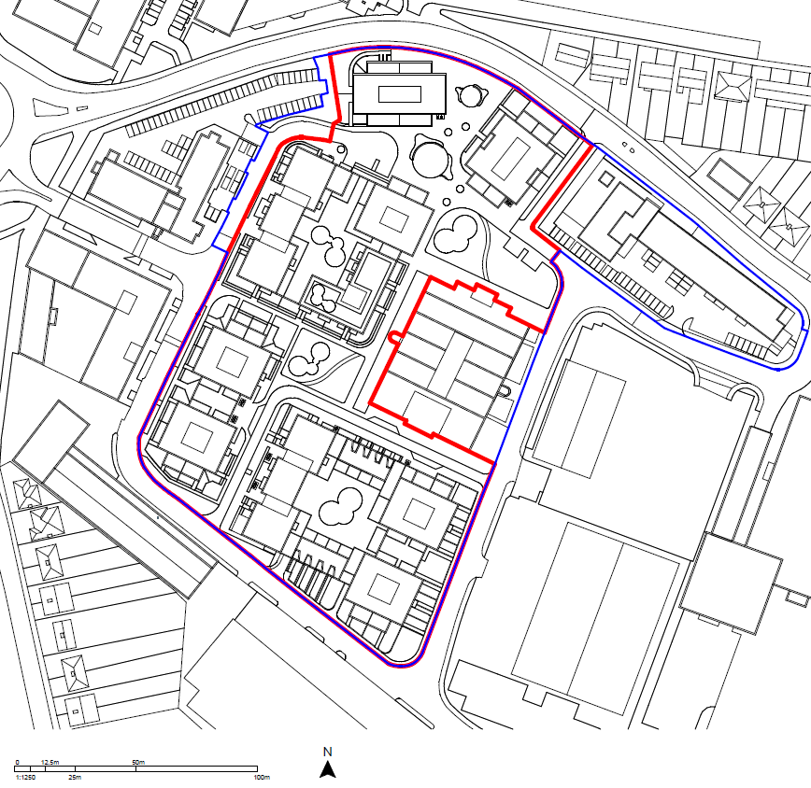

The Surrounding Context
- The Site forms part of a larger business and retail park between N Hyde Rd to the north, Station Road to the east, Redmead Road to the south and Dawley Road to the west. The area immediately surrounding this business and retail park is predominantly residential, with the communities of Pinkwell to the west and south and North Hyde to the east. To the northeast, the Site borders the ‘Keith Road triangle’, a former Metroland area, characterized by semidetached houses arranged around Keith and Albert Roads. To the north, beyond the National Rail line, lies the Botwell: Thorn Electric and Music Industries Ltd (EMI) Conservation Area.

The Proposed Development
- The Proposed Development will bring forward the demolition of existing structures on-Site, and the construction of a residential development (Use Class C3), with locally scaled flexible commercial use (Use Class E).
- The Proposed Development will bring forward 652 market rate residential units (Use Class C3). The illustrative unit mix for the housing provision is outlined in Table 1.
- Illustrative Unit Mix
Unit Type | Number of Units
1 Bedroom | 276
2 Bedroom | 269
3 Bedroom | 107
TOTAL | 652
- The Proposed Development will also provide 150m² gross internal area (GIA) of flexible commercial floorspace, as outlined in Table 2.
- Proposed Development Commercial Floorspace
Function | Gross Internal Area (GIA) | Floorspace (NIA)
Flexible Commercial (Use Class E) | 150m² | 127.5m²

LEGISLATION AND POLICY

National Planning Guidance

National Planning Policy Framework
- The National Planning Policy Framework (NPPF), most recently updated in February 2025, sets out the Government’s planning policies for England and how these are expected to be applied. At the heart of the NPPF is a “presumption in favour of sustainable development”, and the articulation of the Government’s vision for how the planning system should operate.
- The NPPF also identifies three interdependent roles for the planning system, to be pursued in mutually supportive ways:
- An economic role – ensuring that the right amount of land is available at the right time and place in order to support growth, innovation and improved productivity;
- A social role – providing a sufficient number and range of homes, accessible services, and open space in a well-designed and safe built environment, to meet the needs of present and future generations and to support communities’ health, social and cultural well-being; and,
- An environmental role – contributing to protecting and enhancing our natural, built and historic environment.

Planning Practice Guidance
- The Planning Practice Guidance (PPG), launched in March 2014, is an online resource which collates planning guidance on various topics into one place. It sets out technical guidance for delivering many of the policies set out within the NPPF.
- The PPG highlights the need for local authorities to identify economic and housing needs in their areas in order to plan effectively. It also recognises that good quality design is an integral part of ensuring that development responds in a practical and creative way to both the function and amenity of a place, as it can affect a range of economic, social and environmental objectives. Good design is considered to have the potential to deliver a number of planning objectives including, but not limited to, safe, connected and efficient streets; crime prevention; security measures; access and inclusion; cohesive and vibrant neighbourhoods; and economic growth.

Regional Guidance

The London Plan: The Spatial Development Strategy for Greater London
- The London Plan was adopted in March 2021. Under legislation establishing the GLA, the Mayor of London is required to publish a Spatial Development Strategy and keep it under review, namely, The London Plan. As the overall strategic plan for London, it sets out an integrated economic, environmental, transport and social framework for the development of London over the next 20-25 years.
- The London Plan is underpinned by the concept of Good Growth, which is defined as growth that is socially and economically inclusive, environmentally sustainable, and helps to build strong and inclusive communities. These principles are captured in a number of policies of relevance to this report, of which the key policies are outlined below.

Policy GG1 Building strong and inclusive communities
- This policy puts the onus on those involved in planning and development to seek to ensure that London continues to generate a wide range of economic and other opportunities benefiting all residents, as well as ensuring that good quality services, public places and open space, buildings and streets are designed well, to promote and build strong and inclusive communities.
- It also sets out requirements that ensure London generates a wide range of economic and other opportunities; provide access to good quality community spaces, services and amenities; ensure streets and public spaces are designed to allow communities to thrive; and promote town centres that provide opportunities for building relationships.

Policy GG2 Making the best use of land
- This policy outlines a range of measures to support development of successful, mixed-use places, particularly in areas close to transport and in existing town centres, with varying recommendations based on existing and proposed uses as well as relevant land allocations.

Policy D8 Public realm
- Under this policy, development proposals are required to deliver safe, accessible, inclusive, attractive, well-connected, easy to understand, service and maintain public realm.

Policy E3 Affordable workspace
- This policy defines what constitutes ‘affordable’ workspace and how such spaces should be provided and managed.

Policy E9 Retail, markets and hot food takeaways
- This policy sets out how London boroughs should allocate, develop and manage town centres and other retail centres, and stipulates that, wherever possible, such clusters prioritise town centre vitality, viability and diversity, sustainability and accessibility, place-making or local identity, community safety or security, and mental and physical health and wellbeing.

Policy E11 Skills and opportunities for all
- In tandem with the Mayor of London’s Skills for Londoners Strategy, this policy includes requirements that development support employment, skills development, apprenticeships and other educational and training opportunities during both the construction and operational phases of projects. This should be realised by enabling participants in training and apprenticeships to complete these programmes, ensuring that the greatest possible level of take-up by Londoners is achieved, and actively working to increase the proportion of underrepresented groups within industry workforces.

Policy H1 Increasing housing supply
- This policy sets the ten-year targets for net housing completions for each local planning authority, as well as recommendations for boroughs to help achieve these targets, including optimising housing delivery on brownfield Sites, publishing annual update housing trajectories and choosing high-density housing areas based on appropriate metrics such as levels of sustainable transport infrastructure.

Local Guidance

LBH Local Plan
- The LBH’s Local Plan sets out the council’s strategic vision for growth and prosperity in the LBH, as well as defining key locations for growth. It supersedes the policies and allocations previously set out in earlier local plans and defines key policies including those set out below:
- Policy DMH 2 Housing Mix – The LBH will require new residential development to provide a mix of housing unit sizes.
- Policy DMH 3 Office Conversion – Where offices are found to be redundant, their demolition and redevelopment will be supported by the LBH in support of bringing forward additional housing.
- Policy DMH 7 Provision of Affordable Housing – New residential development should provide sufficient affordable housing, with a minimum of 35% affordable units delivered with a tenure split of 70% Social/Affordable Rent and 30% Intermediate Rent (subject to viability). Affordable housing should be built to the same standards and share the same level of amenity as private housing.
- Policy DMHB 18 Private Outdoor Amenity Space – All new residential development should provide good quality private outdoor amenity space in accordance with the standards set out in Table 5.3 of the Local Plan (Part 2).
- Policy DMHB 19 Play Space – New major developments (resulting in ten or more children within its residential population) will be required to provide play facilities on-site.
- DMCI 4 Open Spaces in New Development – Proposals for major new residential development will be supported where they make provision for new open space or enhance existing open space.
- DMCI 5 Children’s Play Areas – For all major development proposals, 10m² of play space should be provided per child with an accessibility standard of 400m walking distance to equipped playgrounds.

Supplementary Planning Document: Planning Obligations
- The Planning Obligations supplementary planning document (SPD) provides additional guidance for planning applications in the LBH, with a specific focus on affordable housing; transportation, accessibility, air quality and noise; training and employment; community safety in the public realm; environmental impacts; and open space and recreation.

Hillingdon Open Space Strategy 2011-2026
- The LBH Open Space Strategy sets out the strategies for improving access to nature and protecting wildlife habitats throughout the Borough. The strategy guides the development and management of open spaces, including new parks and play areas in major developments, and sets out the minimum standards for open space, recreational space, and equipped play.

METHODOLOGY AND SCOPE

Demolition and Construction

Construction Employment
- To estimate the number of jobs likely to be generated as a result of the demolition and construction phase of the Proposed Development, labour coefficients (i.e. person years of employment per £1 million spend) for ‘new housing’ developments as defined within the HCA Calculating Cost Per Job – Best Practice Note have been applied to the forecasted costs associated with the construction programme, accounting for inflation. Person years of employment have then been divided by the expected construction period (approximately 9 years) to provide the average number of full-time equivalent (FTE) jobs supported each year.
- It should be noted that this methodology produces an estimate of construction employment and has been used for assessment purposes rather than formal construction requirements, which are not available at this stage.
- It is acknowledged that whilst some construction workers may live locally and thus their expenditure on household goods and services would support induced employment locally, many workers are expected to be drawn from the wider region, depending on their role. On this basis, an estimate of construction supply chain effects, or indirect employment, and induced effects, or local expenditure, are considered at a high level, quantitative manner, through an estimated additionality factor of 33%, as specified within the HCA Additionality Guide.

Completed Development

Housing Delivery
- Delivery of housing within the Proposed Development is assessed against the London Plan housing delivery targets, which set a target of 10,830 new homes within the LBH between 2019/20 and 2028/29, within the context of the LBH’s recent delivery performance.
- As this Economic Statement is for an outline planning application, an illustrative number of proposed residential units is assessed.

Social Infrastructure
- Demand for social infrastructure arising from the Proposed Development’s residential units is assessed based on the total likely residential population occupying the Proposed Development once complete and operational.
- It is assumed that the occupants of the residential units will have a demand for all social infrastructure assessed within this Economic Statement (i.e. primary healthcare, primary and secondary education, and open and play space). The total residential population has been calculated using the GLA Population Yield Calculator (version 3.2) which sets out the likely population of development schemes across several age brackets. This calculator requires the Site’s Transport of London (TfL) Public Transport Accessibility Level (PTAL), its geographic aggregation, and the proposed quantum of development, including residential unit type and tenure mix. In this case, the PTAL 3-4 and the geographic aggregation ‘Outer London’ are used.
- The population yield is based on the illustrative unit and tenure mix provided by the Applicant, which is anticipated to give a reasonable depiction of what is expected to be delivered by the Proposed Development.

Primary Healthcare
- Demand for GP services arising from the total population of the Proposed Development is assessed against the baseline availability and capacity of GP facilities within a 1.6km walking distance of the Site. This assessment uses the Healthy Urban Development Unit (HUDU) benchmark of 1,800 registered patients per NHS GP.

Primary Education
- Demand for primary schools arising from the number of children aged 5 – 11 years living in the Proposed Development is assessed against the baseline availability and capacity of primary schools within a 3.2km walking distance of the Site. In line with Audit Commission guidelines, this assessment is based on 95% of actual school capacity, to accommodate the potential for students joining mid-year and unforeseen staffing changes.

Secondary Education
- Demand for secondary schools arising from the number of children aged 12 – 17 years living in the Proposed Development is assessed against the baseline availability and capacity of secondary schools within the LBH. Analysis of secondary school capacity is carried out at the borough level to account for pupil preference and school specialisms, and to reflect secondary pupils’ tendency to travel farther than primary pupils to attend school. As with primary schools, this assessment is based on 95% of actual school capacity.

Open Space
- Demand for open space arising from the total population of the Proposed Development is assessed qualitatively, based on the availability of open space within a 1.2km walking distance of the Site.

Play Space
- Delivery of play space for children aged 0 – 17 years living in the Proposed Development is assessed against the LBH’s Local Plan Policy DMCI 5 ‘Children’s Play Areas’, which recommends at least 10m² of age-specific play space per child in new residential development.

Operational Employment
- The number of jobs that would be lost as a result of the Proposed Development and generated by non-residential floorspace has been calculated by applying the standard job density ratios based on the HCA’s Employment Density Guide. This guidance is the latest available and as such, does not relate to the latest use classes (i.e., Use Class E) published in 2020. Therefore, although the Proposed Development includes the provision of Class E floorspace, the correlating previous use classes have been used for the purposes of assessing operational employment creation.
- The HCA guidance sets out expected FTE employment created per m² of floorspace for varying use types, depending on how efficiently the floorspace can be used for various uses. For example, office use mainly requiring desktop work will allow for a higher density of employment than industrial use which requires floorspace for large machinery as well as space for employees. As well as considering spatial requirements, the employee density of other uses may be dependent on labour intensity. For example, a retail or other customer experience-oriented business would require more staff on-Site than a gym or cinema requiring less employee oversight.
- The HCA Additionality Guide has been used to establish net employment from the Proposed Development by accounting for wider additionality factors such as displacement, economic multipliers and leakage:
- A low displacement level of 25% has been assumed as the Proposed Development is expected to have “some displacement effects, although only to a limited extent” as there is an identified demand for more office space in the local area.
- A composite ready reckoner local multiplier of 1.25 has been used as this is the most appropriate value to use for the assessment of flexible commercial (i.e. retail/ office) uses and it allows for the estimation of indirect and informal employment.
- A leakage value of 0 has been assumed for the outline employment calculation as no specific groups are targeted by the employment floorspace at this stage, and it is therefore not possible to reliably predict this level of effect.

Operational Worker Expenditure
- To calculate spending by employees, an average spend per day of £10 per employee has been applied, based on the thresholds set out within the HMRC Employment Income Manual for daily meal allowances.
- To determine annual spend, it is assumed that workers are entitled to 5.6 weeks of annual leave each year, subtracted from the standard 52 week year, and so work an average of 46.4 weeks per year (232 days).

Residential Expenditure
- Residential expenditure in the local area has been calculated using the Office for National Statistics’ (ONS) Household Expenditure Data by countries and regions: Table A33 (£445 per week).

Assumptions and Limitations
- Wherever possible, the baseline year for this assessment is 2024, the latest year for which at least some complete data may be available. For some data, including some economic and Census data, the next most recent year is used, often 2022 or 2021.
- The illustrative unit and tenure mix used to calculate the population yield resulting from the Proposed Development represents one way in which the Proposed Development could come forward. Whilst the final unit and tenure mix will be determined through a Reserved Matters Application (RMA) at a later date, it is not expected that any changes included in the RMA would materially alter the results of this Economic Statement.
- For the purpose of establishing a baseline, Pinkwell ward has been used as the primary study area and LBH, London and England data have been used to contextualise any figures as available.

BASELINE

Existing Site
- The existing Site is currently vacant, with the exception of the second floor of ‘HPH2’, which is currently occupied by Rackspace Ltd. The floorspace and estimated FTE employment for Rackspace Ltd is presented below in Table 3. It is estimated that this office unit is occupied by an estimated 1,691 FTE workers.
- Existing Site Employment
Building | HCA Classification | Density | Floorspace (NIA) | Jobs Created (FTE)
HPH2 | Use Class E – Professional Services | 12m² NIA per FTE | 20,289m² | 1,691
- This estimate has been calculated by applying existing floorspaces (provided by the Applicant) to relevant use classes, as defined within the HCA Employment Density Guide.

Local Population

Population and Density
- Approximately 16,700 people live in Pinkwell ward, which is 5.5% of the LBH’s total residential population (305,900) and less than 1% of London’s (8.8 million). Pinkwell ward has a population density similar to London levels (5,598 people per square kilometre), housing approximately 5,225 people per square kilometre, but which is lower than the density of the LBH (2,644 people per square kilometre).

Age
- As illustrate in Figure 5, Pinkwell ward’s proportion of working age people, aged 16-64 years (67.5%), is generally on par with what is typical for the LBH (65.6%), London (68.9%) and England (63.0%). However, its proportion of older people, aged 65 years and older (10.1%), is lower than across other sampled areas while its population of children and young people, aged 15 years and younger (22.5%), is higher compared to other comparative areas.
- Population by Age

Deprivation
- The English Indices of Deprivation (IoD) is the official measure of relative deprivation in England. It is based on seven distinct domains of deprivation, which are weighted and combined to form the overall index. These seven domains include:
- Income;
- Employment;
- Education and skills training;
- Health deprivation and disability;
- Crime;
- Barriers to housing and services; and
- Living environment.
- IoD scores are assessed at the Lower Layer Super Output Area (LSOA) level and ranked to provide a relative score for each LSOA. The lower the decile score, the worse off an LSOA is in that domain, with scores of 1 indicating a ranking in the first decile, or amongst the 10% most deprived LSOAs in the country.
- Each LSOA comprises 400 to 1,200 households or 1,000 to 3,000 people. Pinkwell ward includes eight LSOAs, listed in Table 4 below and illustrated in Figure 3, which face varying levels of deprivation across the seven domains. The Site is situated within Hillingdon 030C.
- Study Area Deprivation (IoD Decile Scores)
 |  | Overall Deprivation |  | Income |  | Employment |  | Education, Skills and Training |  | Health Deprivation and Disability |  | Crime |  | Barriers to Housing and Services |  | Living Environment
Hillingdon 028A |  | 4 |  | 3 |  | 4 |  | 4 |  | 8 |  | 4 |  | 1 |  | 4
Hillingdon 028B |  | 4 |  | 4 |  | 4 |  | 4 |  | 8 |  | 5 |  | 1 |  | 4
Hillingdon 030B |  | 5 |  | 5 |  | 5 |  | 5 |  | 8 |  | 4 |  | 2 |  | 4
Hillingdon 030C |  | 6 |  | 5 |  | 7 |  | 6 |  | 8 |  | 4 |  | 3 |  | 5
Hillingdon 030D |  | 4 |  | 4 |  | 6 |  | 4 |  | 8 |  | 3 |  | 3 |  | 2
Hillingdon 030E |  | 5 |  | 4 |  | 5 |  | 4 |  | 8 |  | 4 |  | 3 |  | 3
Hillingdon 032D |  | 4 |  | 3 |  | 4 |  | 3 |  | 7 |  | 4 |  | 2 |  | 4
Hillingdon 032E |  | 3 |  | 3 |  | 4 |  | 2 |  | 5 |  | 4 |  | 1 |  | 6
1 | 2 |  | 3 |  | 4 |  | 5 |  | 6 |  | 7 |  | 8 |  | 9 |  | 10
- ‘Barriers to housing and services’ is clearly the worst scoring domain for Pinkwell ward overall, with all LSOAs scoring across the 10% to 30% most deprived neighbourhoods in the country. The domain of ‘health deprivation and disability’ sees the best scores across the ward, with six LSOAs amongst the top 30% best scoring LSOAs nationally, one LSOA amongst the top 40%, and one amongst the top 60%. Scores for all other domains are more variable, ranging from the second to eighth decile but generally demonstrating score homogeny within domains.
- Within Hillingdon 030C, which contains the Site, overall deprivation is moderate, with the LSOA amongst the 50% least deprived neighbourhoods in the country. This LSOA scores worst in the ‘barriers to housing and services’ and ‘crime’ domains, landing in the third and fourth decile respectively, indicating that there is a need for more affordable and quality housing and programmes which offer an alternative to anti-social and criminal activity. The LSOA scores moderately with regards to ‘income’ and ‘living environment’; for both it is in the fifth decile. As with other LSOAs, its best score is represented under ‘health deprivation and disability’, with the LSOA ranking amongst the 30% least deprived nationally for this domain.
- IoD Decile Rank, Local Area Map
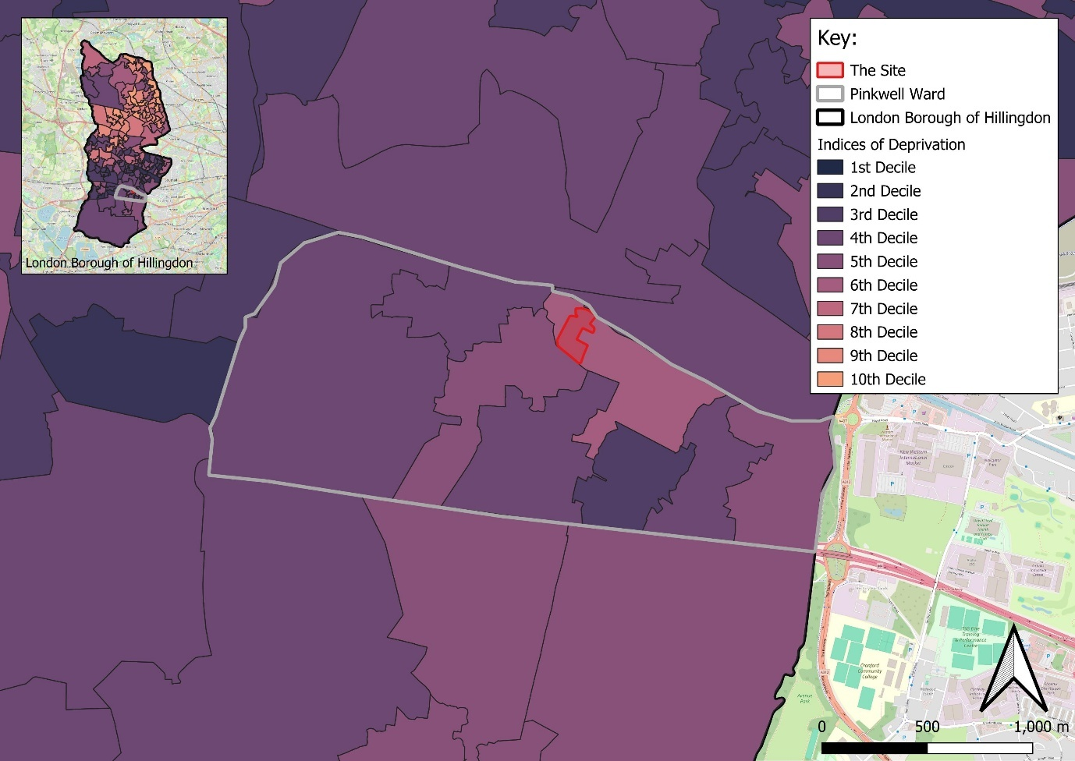
Base Map Source: OS data © Crown copyright and database right 2025

Poverty
- IoD trends are broadly consistent with other deprivation measurements, including the Income Deprivation Affecting Children Index (IDACI) and Income Deprivation Affecting Older People Index (IDAOPI). Rates of children and older people in poverty in the ward are higher than both the proportion across the LBH and nationally, as shown in Table 5. In the LBH more widely, the proportion of children in poverty is lower with the national rate, however the proportion of older people in poverty is only marginally higher than the national rate.
- Age-related Deprivation
Indicator | Pinkwell Ward | LBH | England
Child poverty (IDACI) | 18.1% | 15.7% | 17.1%
Older people in poverty (IDAOPI) | 20.4% | 14.5% | 14.2%
Note: Figures highlighted in red are poorer than the national average, figures highlighted in orange are approximately equal to the national average, and figures highlighted in green are better than the national average.

Housing
- The London Plan has set a target of 10,830 new homes within the LBH between 2019/20 and 2028/29, averaging 1,083 new homes for each year of this ten-year period.
- Within the first five years of this period (2019/20 to 2023/24), the LBH completed 4,959 new dwellings, representing about 45.8% of the ten-year target, of which about 15% are affordable rent and 85% are market tenure. As of 31 March 2025, there is a registered pipeline of 4,621 net dwellings in the LBH, representing an additional 42.7% of the London Plan target, of which about 22% are low-cost or intermediate rent and 78% are market tenure.
- The affordability of home ownership in the LBH is consistent with the rest of London, which has a higher cost for ownership than England as a whole. The LBH also sees a slightly lower proportion of households experiencing fuel poverty than both London and England. This is illustrated in Table 6 below.
- Home and Fuel Affordability
Indicator | LBH | London | England
Affordability of home ownership (ratio of median house price to median gross annual residence-based earnings) | 12.0 | 12.7 | 8.3
Fuel poverty (low income, low energy efficiency methodology) | 9.1% | 10.4% | 13.1%
Note: Figures highlighted in red are poorer than the national average, figures highlighted in orange are approximately equal to the national average, and figures highlighted in green are better than the national average.
- As shown in Figure 4, overcrowding is more of a problem within the Pinkwell ward (affecting 18.7% of households) than it is across the LBH (11.3%). Overcrowding in Pinkwell ward is also somewhat more prevalent than is typical for London (11.1%) and much more prevalent than is typical for England (4.3%).
- Overcrowding

Social Infrastructure

Primary Healthcare
- There are six GP surgeries within a 1.6km walking distance of the Site, as shown in Figure 5. Although these surgeries all accept new patients, they also exceed the NHS’ recommended GP FTE to patient ratio of 1,800 patients per GP FTE by 1,461 patients per GP FTE. This information is shown in Table 7 and Figure 5 below.
- Local GP Capacity
Map Ref. | GP Surgery Name | Walking Distance | Registered Patients | GP FTEs | Patients per GP FTE | Above / Below Capacity | Accepting New Patients
1 | Hayes Medical Centre, UB3 4NA | 450m E | 19,599 | 4.5 | 4,355 | -2,555 | Yes
2 | HESA Medical Centre, UB3 4DS | 950m NE | 22,191 | 7.6 | 2,920 | -1,120 | Yes
3 | Shakespeare Health Centre, UB3 1NY | 1.0km SW | 5,222 | 2.3 | 2,270 | -470 | Yes
4 | North Hyde Road Surgery, UB3 4NS | 1.2km SE | 8,148 | 2.2 | 3,704 | -1,904 | Yes
5 | Heathrow Medical Centre, UB3 5AB | 1.5km S | 6,047 | 1.6 | 3,779 | -1,979 | Yes
6 | Glendale Medical Centre, UB3 5DA | 1.6km S | 6,949 | 2.7 | 2,574 | -774 | Yes
Total |  |  | 68,156 | 20.9 | 3,261 | -1,461
- GP Surgeries within 1.6km Walking Distance of the Site
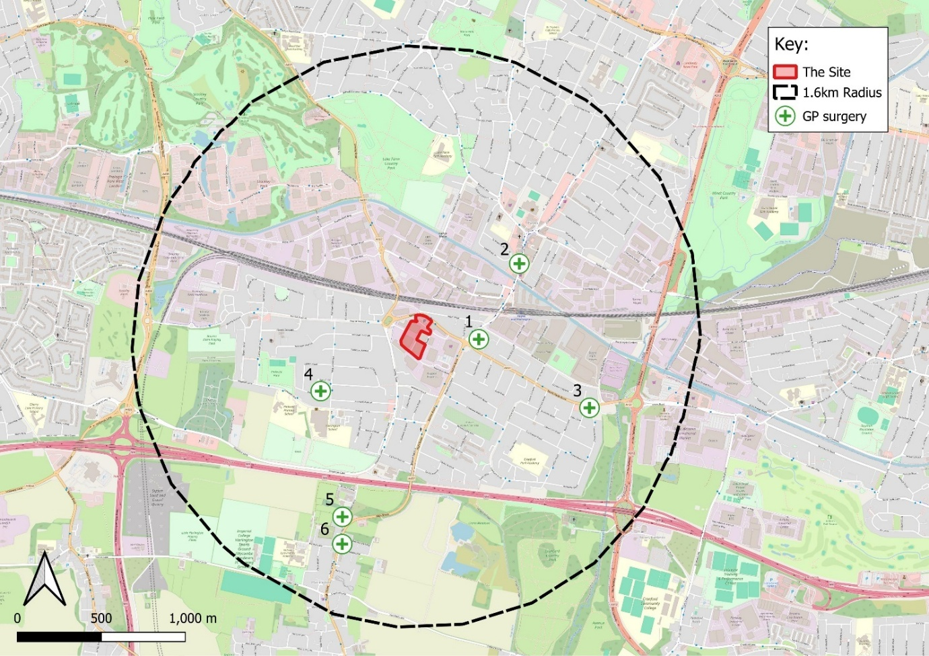
Base Map Source: OpenStreetMap (2024) and OS data © Crown copyright and database right 2024.

Primary Education
- There are 14 community or voluntary aided primary schools within a 3.2km walking distance of the Site, which have an overall surplus capacity of 698 places, or 7.0% of overall capacity at 95% of actual capacity.
- Six primary schools exceed recommended capacity, but the two closest primary schools to the Site, Pinkwell Primary School and Cranford Park Academy, have surplus capacity (6.0% and 1.2%, respectively). Information on local primary school capacity is shown in Table 8 and Figure 6.
- Local Primary School Capacity
Map Ref. | Primary School Name | Walking Distance | Capacity | Capacity at 95% | Number of Pupils on Roll | Surplus / Deficit Number at 95% Capacity | Surplus / Deficit % at 95% Capacity
Map Ref. | Primary School Name | Walking Distance | (Number of Pupils) | (Number of Pupils) | Number of Pupils on Roll | Surplus / Deficit Number at 95% Capacity | Surplus / Deficit % at 95% Capacity
1 | Pinkwell Primary School, UB3 1PG | 1.2km SW | 690 | 656 | 616 | 40 | 6.0
2 | Cranford Park Academy, UB3 4LQ | 1.3km SE | 960 | 912 | 901 | 11 | 1.2
3 | Botwell House Catholic Primary School, UB3 2AB | 1.3km NE | 720 | 684 | 705 | -21 | -3.1
4 | Lake Farm Park Academy, UB3 1JA | 1.7km N | 720 | 684 | 702 | -18 | -2.6
5 | William Byrd Primary Academy, UB3 5EW | 2km SW | 708 | 673 | 567 | 106 | 15.7
6 | Minet Junior School, UB3 3NR | 2.3km NE | 480 | 456 | 410 | 46 | 10.1
7 | Minet Infant and Nursery School, UB3 3NR | 2.2km NE | 480 | 456 | 431 | 25 | 5.5
8 | Dr Triplett's CofE Primary School, UB3 2JQ | 2.5km NE | 420 | 399 | 452 | -53 | -13.3
9 | Wood End Park Academy, UB3 2PD | 2.3km NW | 1104 | 1,049 | 952 | 97 | 9.2
10 | Featherstone Primary and Nursery School, UB2 5JT | 2.7km E | 630 | 599 | 682 | -84 | -14.0
11 | Rosedale Primary School, UB3 2SE | 2.8km N | 480 | 456 | 411 | 45 | 9.9
12 | Guru Nanak Sikh Academy, UB4 0LT | 3.2km NE | 1500 | 1,425 | 1560 | -135 | -9.5
13 | Nanaksar Primary School, UB4 0LT | 3.2km NE | 840 | 798 | 145 | 653 | 81.8
14 | Cherry Lane Primary School, UB7 9DL | 3.2km W | 690 | 656 | 669 | -14 | -2.1
Total |  |  | 10,422 | 9,901 | 9,203 | 698 | 7.0
- Primary Schools within 3.2km Walking Distance of the Site
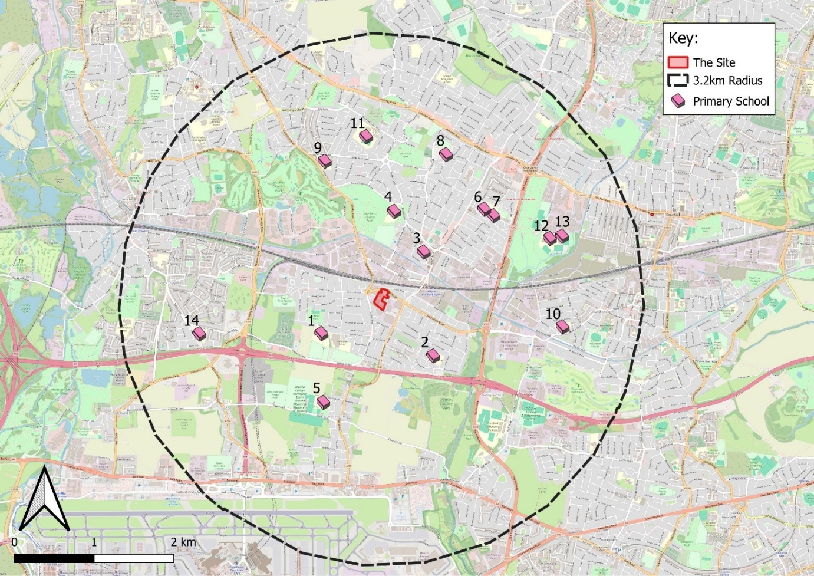
Base Map Source: OpenStreetMap (2024) and OS data © Crown copyright and database right 2024.

Secondary Education
- There are 22 secondary schools within the LBH, which are currently operating at a surplus capacity of 1,045 places, or 4.4% of overall capacity at 95% of actual capacity. The closest secondary school to the Site, Global Academy, has 26.5% surplus capacity, however, the second and third closest schools are both over capacity. Full information on local secondary school capacity is shown in Table 9 and Figure 7.
- Local Secondary School Capacity
Map Ref. | Secondary School Name | Walking Distance | Capacity | Capacity at 95% | Number of Pupils on Roll | Surplus / Deficit Number at 95% Capacity | Surplus / Deficit % at 95% Capacity
Map Ref. | Secondary School Name | Walking Distance | (Number of Pupils) | (Number of Pupils) | Number of Pupils on Roll | Surplus / Deficit Number at 95% Capacity | Surplus / Deficit % at 95% Capacity
1 | Global Academy, UB3 1DH | 700m N | 600 | 570 | 419 | 151 | 26.5
2 | Harlington School, UB3 1PB | 1.1km SW | 1,156 | 1,098 | 1,317 | -219 | -19.9
3 | Guru Nanak Sikh Academy, UB4 0LT | 3.1km NE | 1,500 | 1,425 | 1,560 | -135 | -9.5
4 | Rosedale College, UB3 2SE | 2.8km N | 1,660 | 1,577 | 912 | 665 | 42.2
5 | Parkside Studio College, UB3 2SE | 2.9km N | 300 | 285 | 61 | 224 | 78.6
6 | Park Academy West London, UB8 3GA | 3.5km NW | 1,150 | 1,093 | 878 | 215 | 19.6
7 | De Salis Studio College, UB4 8JP | 3.5km NW | 300 | 285 | 151 | 134 | 47.0
8 | Hewens College, UB4 8JP | 3.7km NW | 750 | 713 | 482 | 231 | 32.4
9 | Barnhill Community High School, UB4 9LE | 4.2km NE | 1,422 | 1,351 | 1,574 | -223 | -16.5
10 | Bishopshalt School, UB8 3RF | 4.8km NW | 1,311 | 1,245 | 1,292 | -47 | -3.7
11 | Swakeleys School for Girls, UB10 0EJ | 5.2km NW | 1,174 | 1,115 | 1,375 | -260 | -23.3
12 | Uxbridge High School, UB8 2PR | 5.6km NW | 1,298 | 1,233 | 1,358 | -125 | -10.1
13 | Oak Wood School, UB10 9HT | 5.8km NW | 1,350 | 1,283 | 1,247 | 36 | 2.8
14 | The Douay Martyrs Catholic School, UB10 8QY | 7.5km N | 1,297 | 1,232 | 1,506 | -274 | -22.2
15 | Vyners School, UB10 8AB | 8.2km NW | 1,136 | 1,079 | 1,489 | -410 | -38.0
16 | Ruislip High School, HA4 0BY | 8.5km N | 1,300 | 1,235 | 1,290 | -55 | -4.5
17 | Queensmead School, HA4 0LS | 8.8km NE | 1,476 | 1,402 | 1,491 | -89 | -6.3
18 | Bishop Ramsey Church of England School, HA4 8EE | 10.8km N | 1,245 | 1,183 | 1,265 | -82 | -7.0
19 | Haydon School, HA5 2LX | 12.6km N | 2,040 | 1,938 | 1,677 | 261 | 13.5
20 | Northwood School, HA6 1QN | 13.8km N | 1,080 | 1,026 | 1,007 | 19 | 1.9
21 | UTC Heathrow, HA6 1QG | 13.8km N | 600 | 570 | 209 | 361 | 63.3
22 | Harefield School, UB9 6ET | 14.3km NW | 1,000 | 950 | 283 | 667 | 70.2
Total |  |  | 25,145 | 23,888 | 22,843 | 1,045 | 4.4
- Secondary Schools within the LBH
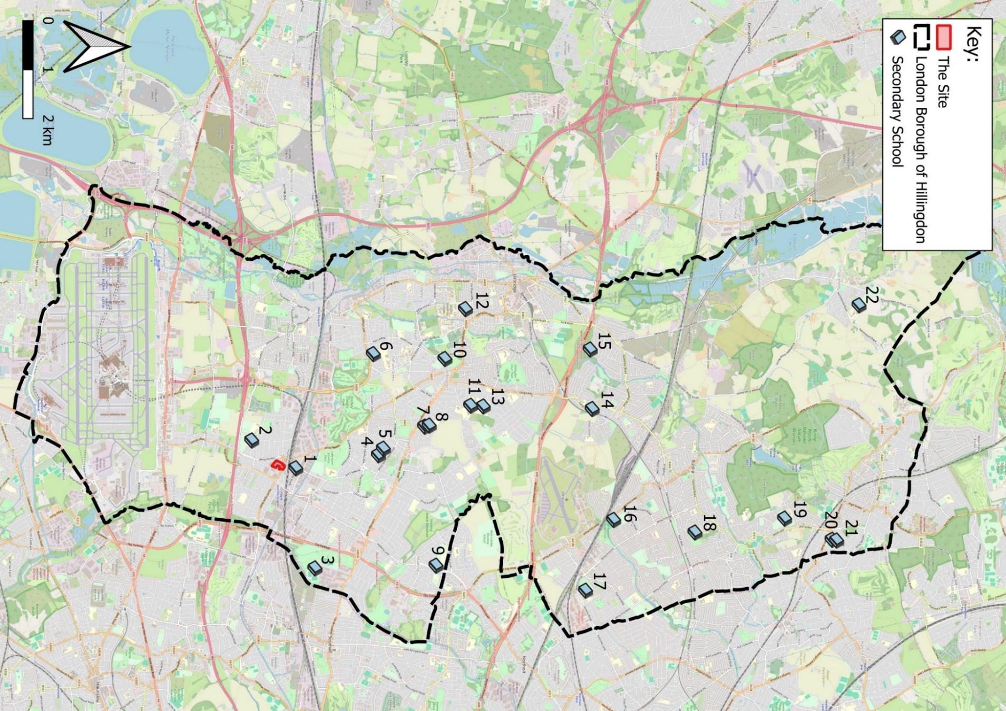
Base Map Source: OpenStreetMap (2025) and OS data © Crown copyright and database right 2025.

Open and Play Space
- Pinkwell ward is considered to have insufficient open space, recreational space, and equipped play, not meeting the minimum standards set out in the LBH’s Open Space Strategy. The Strategy also finds that a further 69 hectares of open space with unrestricted access is required, of which nearly 16 hectares should be ‘recreational’ open space. However, the Site itself is considered to have adequate access to open spaces within 1200m.
- There are six open and play spaces within a 1.2km walking distance of the Site, including Lake Farm Country Park and Pinkwell Park. These facilities offer a range of park, garden and play facilities for the local community. Table 10 and Figure 8 show the provision of public open space in relation to the Site.
- Local Public Open and Play Space
Map Ref. | Open Space Name | Walking Distance | Description of Facilities
1 | Lake Farm Country Park, UB3 1EJ | 1.0km N | Large park and gardens including a car park, skateboarding area, children’s playground, and BMX course.
2 | Pinkwell Park, UB3 1TF | 1.0km W | Park and garden including a children’s playground, basketball court and skateboarding area.
3 | Snowdon Crescent Open Space, UB3 1RJ | 1.0km W | Open green space within Snowdon Crescent.
4 | Sam Philip’s Recreation Ground, UB3 4AH | 1.1km SW | Open green space with football posts and a mix of fields and trees.
5 | Croyde Avenue Children’s Playground, UB3 4EN | 1.2km SE | Small children’s playground and surrounding open green space.
6 | Hoskins Close Playground, UB3 4LD | 1.2km SE | Small children’s playground.

- Local Public Open Space with 800m Walking Distance of the Site
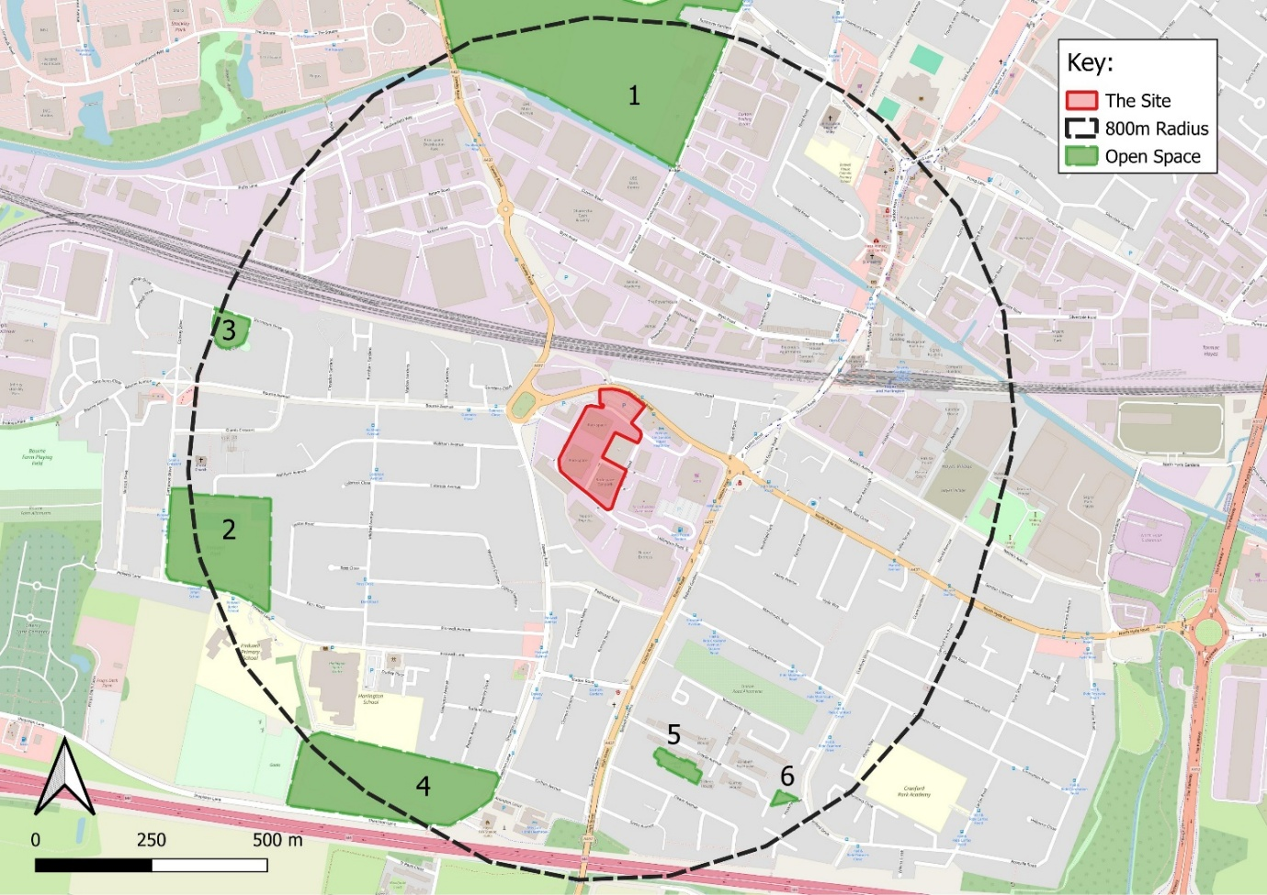
Base Map Source: OS data © Crown copyright and database right 2025

Local Economy

Labour Market
- The LBH’s gross value added (GVA) to the economy is approximately £12.24 billion per year. By comparison, London’s GVA is approximately £519.18 billion and England’s GVA is approximately £1.94 trillion.
- Approximately 218,000 workers operate in the LBH, at a density of 1.09 jobs per working age resident, which is on par with what is typical for London (1.07 jobs per working age resident). 73.2% of jobs in the LBH are full-time and 26.8% are part-time, which is comparable to London overall in which 74.7% of its jobs are full-time and 25.3% are part-time.
- The most prevalent industry within the LBH is ‘transportation and storage’ (19.1% of employee jobs), followed by ‘administration and support service activities (18.0%) and ‘wholesale and retail trade; repair or motor vehicles and motorcycles’ (11.3%). This differs from London more widely for which the largest sector is ‘professional, scientific and technical activities’ (14.6%).
- Full-time workers operating in the LBH see weekly gross pay of £803.00, which is notably lower than is typical for London (£905.50), but higher than is seen across the rest of England (£729.60). This discrepancy in pay between the borough and the region is likely due to the nature of the jobs within these areas and their corresponding sectors, as well as the higher cost of living associated with urban areas.

Economic Activity
- As shown in Figure 2 above, the majority of the LBH’s population is of working age, aged 16 – 64 years (65.6%). Table 11 below demonstrates that the majority of LBH residents of working age are economically active (83.7%), at rates which are similar to the rest of London (80.0%). Likewise, the majority of LBH residents who are economically active are in employment (81.0%), at rates which are somewhat higher than the rest of London (75.9%).
- Modelled rates of unemployment in the LBH (4.7%) and London (5.1%) are higher than the national average (3.7%). In addition, the claimant count across the LBH of unemployed individuals who qualify for Universal Credit is 5.6%. This is consistent with aforementioned rates of unemployment and is similar to the rest of London (6.1%).
- As seen amongst workers employed within the LBH, median earnings for employed residents of the borough and London are also notably higher than the national average.
- Employment Amongst Working Age Residents (16 – 64 years)
Indicator | LBH | London | England
Economic activity rate | 83.7% | 80.0% | 78.4%
Employment rate | 81.0% | 75.9% | 75.5%
Unemployment rate | 4.7% | 5.1% | 3.7%
Gross weekly pay, full time workers | £804.10 | £853.40 | £729.80
Claimant count for individuals qualifying for Universal Credit (16+) | 5.6% | 6.1% | 4.2%
Note: Figures highlighted in red are poorer than the national average, figures highlighted in orange are about equal to the national average, and figures highlighted in green are better than the national average.

Education and Skills
- As illustrated in Figure 9, 29.8% of Pinkwell ward’s working age population holds Level 4 qualifications or higher (equivalent to a bachelor’s’ degree or higher), which is lower than is typical for the rest of the LBH (37.5%), London (46.7%) and England (33.9%). 24.0% of the ward’s working age residents do not hold any qualifications, which is higher than is typical for the LBH (18.2%), London (16.2%) and England (18.1). These educational attainment rates may also contribute to the prevalence of certain industries in the borough and the relatively low average salary of LBH residents compared to London more widely.
- Highest Level of Qualification amongst Working-Age Residents

PROPOSED DEVELOPMENT EFFECTS

Demolition and Construction

Construction Employment and Employee Expenditure
- The demolition and construction phase of the Proposed Development is expected to deliver an average of 508 direct FTE jobs per year over the duration of its 9-year construction period. This includes a range of employment types and jobs may be located on- or off-Site depending on the nature of the role.
- The demolition and construction programme will also result in indirect economic benefits including supply chain effects and spending by construction workers, for example on lunches during the working week. As the number of construction workers on-Site will fluctuate over the course of the construction programme, it is not possible to quantify the level of spending captured locally. However, the Proposed Development is expected to deliver an additional 142 indirect and informal FTE jobs per year over the construction period.

Completed Development

Housing Delivery
- Table 1 above sets out the illustrative unit mix for the Proposed Development, which is expected to deliver a total of 652 market rate residential units. These 652 units, comprising a mix of one- to three-bedroom homes, represent 6.0% of the LBH’s ten-year housing target.

Social Infrastructure

Population Yield
- Using the GLA’s most up to date Population Calculator, the Proposed Development is expected to accommodate approximately 1,285 residents across the scheme’s residential dwellings.
- The age distribution of these homes’ expected population is presented in Table 12.
- Proposed Development Residential Population Breakdown
Age | Population Distribution
Early Years (0-4 years) | 96
Primary School (5-11 years) | 64
Secondary School (12-17 years) | 16
Working Age (18-64 years) | 1,075
65+ years | 26
TOTAL | 1,285

Primary Healthcare
- Based on the HUDU recommended GP to patient ratio, an additional 1,285 residents accommodated by the Proposed Development would increase the existing local GP to patient ratio from 1 GP FTE to 3,261 patients (over capacity by 1,461 patients) to 1 GP FTE to 3,323 patients (over capacity by 1,523 patients). To accommodate this change and reduce the GP to patient ratio to 1 GP FTE to 1,800 patients, this would require the equivalent of an additional 0.8 GP FTEs.
- It should be noted that this represents a worst-case scenario and some future residents of the Proposed Development may already be registered with a local surgery. It is also expected that the Site will be subject to S106 Agreements or Community Infrastructure Levies (CIL) which may be used to offset any increase in demand, to be determined in line with LBH guidance.

Primary Education
- Table 12 indicates that the Proposed Development could generate a total demand for 64 primary school places (children aged 5 – 11 years). The addition of these pupils would decrease the existing surplus in capacity from 698 places (7.0% of capacity) to 634 places (6.4% of capacity).
- It should be noted that this represents a worst-case scenario, and some future residents of the Proposed Development may already be registered with a local primary school.

Secondary Education
- Table 12 indicates that the Proposed Development could generate a total demand for 16 secondary school places (children aged 12 – 17 years). The addition of these pupils would decrease the surplus capacity from 1,045 places (4.4% of capacity) to 1,029 places (4.3% of capacity).
- It should be noted that this represents a worst-case scenario, and some future residents of the Proposed Development may already be registered with a secondary school in the LBH.

Open Space
- The Proposed Development will bring forward 8,599m² of private amenity space, comprised of private gardens terraces and balconies. These will provide direct outdoor space for individual homes, offering privacy and a connection to the landscape. In addition, the Proposed Development will bring forward 5,626m² of public green open space at ground level, including The Gateway, The Social Heart and the Nurture Garden. This will make a significant contribution to improving the open space standards in Pinkwell ward, as well providing high quality open space for new residents.

Play Space
- Based on the expected population of 184 residents aged 0 – 17 years, 1,850m² of age-specific play space is required by the Proposed Development to align with LBH guidance. The Proposed Development is expected to introduce 1,752m² of play space, divided across applicable age groups, as detailed in Table 13.
- Demand and Provision of Play Space
Age | Population Distribution | LBH Requirement | Development Provision
0-4 years | 96 | 960m² | 854m²
5-11 years | 64 | 640m² | 598m²
12-15 years | 16 | 160m² | 196m²
16-17 years | 9 | 90m² | 104m²
TOTAL | 184 | 1,850m² | 1,752m²
- Whilst this falls slightly short of the required amount of play space, it should be noted that this is an estimate of play space based on the illustrative proposed mix of residential units, and will need to be adjusted once a detailed breakdown of housing is available.
- In addition, the play space proposed on-Site will be of a high quality, with play spaces integrated throughout the masterplan, from informal natural play routes to dedicated play areas within courtyards and open spaces, ensuring accessible and engaging environments for all ages.

Operational Employment
- The total number of FTE jobs which could be supported by the Proposed Development’s employment generating floorspace has been calculated and presented in Table 14 below.
- Operational Employment Estimates
Anticipated Use | HCA Classification | Density | Floorspace (NIA) | Jobs Created (FTE)
Office/ Retail (Use Class E/ Sui Generis) | A1 – Retail | 15-20m² NIA per FTE | 127.5m² | 6-9
Gross Employment |  |  | 6 to 9
Less Existing FTE (1,691)
Net Employment |  |  | -1,685 to -1,682
Less Displacement (25%)
Total Direct Employment |  |  | -1,262 to -1,264
Economic Multiplier (1.25)
Total Indirect and Induced Employment |  |  | -315 to -316
TOTAL Net FTE Employment |  |  | -1,577 to -1,580
Source: Trium Calculations
- As presented in the above, while 6 to 9 FTE jobs would be generated by the Proposed Development under this scenario, the quantity of existing employment which would be lost on-Site results in an overall loss of 1,577 to 1,580 FTE jobs across direct and indirect employment. This loss is due to the change from commercial to residential use on-Site, and only represents approximately 0.7% of existing FTE jobs in the LBH.

Operational Worker Expenditure
- The Proposed Development is expected to generate between £13,920 and £18,560 (gross expenditure) per year in additional spend on local services by operational employees. This may include, for example, supplementary activities such as buying lunch, meeting for coffee, or using dry cleaning services. However, due to the loss of existing employment on-Site, it is expected that the Proposed Development will lead to a net loss of -£4.24 million to -£4.25 million in worker expenditure in the economy.

Residential Expenditure
- It is assumed that the occupants of residential units will contribute to the local economy in terms of ‘move-in’ costs, home upkeep and maintenance, and expenditure on other miscellaneous goods and services.
- It is estimated that the residential population of the Proposed Development will generate approximately £15.1 million in annual expenditure (assuming 652 households spend £445 per week in in a 52-week year). This totals to 0.12% of the LBH’s annual GVA.

CONCLUSION
- During the demolition and construction phase, the Proposed Development is expected to generate an average of 508 direct and 142 indirect and informal jobs per year over the duration of its 9-year construction period.
- Once complete and operational, the Proposed Development is expected to result in a net loss of approximately 1,580 FTE jobs across direct and indirect employment, due to the loss of current employment supported on-Site. This will also result in a net loss of appropriately £4.25 million per year in operational worker expenditure.
- It should be noted that whilst there is anticipated to be employment loss associated with the Proposed Development, the majority of the Site is currently vacant. In addition, the Site is allocated for residential development within the new LBH Local Plan and lies directly adjacent to the Hayes Housing Zone. Therefore, the provision of 652 residential units positively supports this allocation of the Site.
- With regard to shifting demand for social infrastructure, the Proposed Development’s new population will have a minor impact on local healthcare services, which may be mitigated through S106 or CIL payments if necessary. However, the new population of children introduced by the Proposed Development are expected to be easily accommodated within the existing primary and secondary schools in the local area. The Proposed Development will also introduce 8,599m² of private amenity space, 5,626m² of public open space and 1,752m² of play space, which will positively impact new residents and the wider local area through providing improved public realm and increasing the quantity of open and play space within the Pinkwell ward.
- Once complete and operational, the Proposed Development is also expected to generate approximately £15.1 million in annual residential expenditure.


Trium Environmental Consulting LLP
+44 (0) 20 3887 7118
hello@triumenv.co.uk
www.triumenvironmental.co.uk

LBH (2012). Hillingdon Local Plan Part 1.
LBH (2020). Hillingdon Local Plan Part 2.
London Assembly (n.d.). Housing Zones. Available at: https://www.london.gov.uk/programmes-strategies/housing-and-land/mayors-priorities-londons-housing-and-land/housing-zones?ac-26804=26781. Accessed 06/05/2025.
Ministry of Housing, Communities & Local Government (MHCLG) (2025). National Planning Policy Framework.
MHCLG (Live Document). Planning Practice Guidance.
GLA (2021). The London Plan: The Spatial Development Strategy for Greater London.
LBH (2014). Supplementary Planning Document: Planning Obligations.
LBH (2011). Hillingdon Open Space Strategy.
HCA (2015). Calculating Cost Per Job – Best Practice Note, 3rd Edition.
HCA (2014). Additionality Guide, 4th Edition.
GLA (2019). GLA Population Yield Calculator (v3.2).
HUDU (2009). HUDU Planning Contribution Model Guidance Notes.
Department for Education (DfE) (2024). Travel to school for children of compulsory school age, Statutory guidance for local authorities.
Audit Commission for Local Authorities and the National Health Service in England and Wales (1996). Trading Places: The Supply and Allocation of School Places.
HCA (2015). Employment Density Guide, 3rd Edition.
HMRC (2023). Employment Income Manual.
GOV.UK (2024). Holiday entitlement. Available at: https://www.gov.uk/holiday-entitlement-rights/holiday-pay-the-basics. Accessed 6 February 2025.
ONS (2024). Family Spending (FYE 2023 edition). Workbook 3 – Expenditure by Region. Table A33 – High level expenditure by region (3-year average).
NIA is calculated as 85% of GIA.
ONS (2022). Dataset ID TS007 – Age by single year.
ONS (2022). Census 2021: Dataset ID TS006 – Population density.
ONS (2022). Census 2021: Dataset ID TS007 – Age by single year.
MHCLG (2019). English Indices of Deprivation 2019.
MHCLG (2019). English Indices of Deprivation 2019. File 2: Domains of deprivation.
Office for Health Improvement and Disparities (OHID) (2019). Fingertips: Public health data.
GLA (2024). Residential Completions Dashboard. Available at: https://data.london.gov.uk/dataset/residential-completions-dashboard. Accessed 26/02/2025.
GLA (2024). Residential Pipeline Dashboard. Available at: https://data.london.gov.uk/dataset/residential-pipeline-dashboard. Accessed 26/02/2025.
OHID (2022; 2023). Fingertips: Public health data.
ONS (2021). TS052 – Occupancy rating for bedrooms.
ONS (2022). Census 2021: Dataset ID TS052 – Occupancy rating for bedrooms.
NHS (2024). General Practice Workforce: Selected Sub-ICB Location Information. Available at: https://app.powerbi.com/view?r=eyJrIjoiYTM4ZTA3NGItMTM2Mi00NzAwLWEyY2QtNDgyZDkxOTk3MmFlIiwidCI6IjUwZjYwNzFmLWJiZmUtNDAxYS04ODAzLTY3Mzc0OGU2MjllMiIsImMiOjh9. Accessed 13/03/2025.
Department for Education (DfE) (2024). Get Information about Schools. Available at: https://get-information-schools.service.gov.uk/Search?SelectedTab=Establishments. Accessed 13/03/2024.
Department for Education (DfE) (2024). Get Information about Schools. Available at: https://get-information-schools.service.gov.uk/Search?SelectedTab=Establishments. Accessed 13/03/2024.
LBH (2011). Hillingdon Open Space Strategy.
NOMIS (2022). UK small area gross value added estimates.
NOMIS (2022). Labour Market Profile – Hillingdon.
NOMIS (2023). Labour Market Profile – Hillingdon.
NOMIS (2023). Labour Market Profile – Hillingdon.
NOMIS (2024). Labour Market Profile – Hillingdon.
ONS (2023). Labour Market Profile – Hillingdon.
ONS (2025). Labour Market Profile – Hillingdon.
NOMIS (2024). Labour Market Profile – Hillingdon; Labour Demand.
ONS (2022). Census 2021: Dataset ID TS067 – Highest level of qualification.
GLA (2019). Population Yield Calculator (v3.2).

