
DAYLIGHT, SUNLIGHT & OVERSHADOWING
REPORT

Hyde Park, Hayes UB3 4AZ
Columbia Threadneedle Investments

CONTENTS

1. INTRODUCTION 4
2. PLANNING POLICY AND GUIDANCE 6
3. BRE METHOD OF ASSESSMENT AND NUMERICAL GUIDELINES 12
4. APPLICATION OF BRE GUIDELINES 18
5. INFORMATION USED IN THE TECHNICAL STUDY 22
6. SCOPE OF TECHNICAL STUDY 24
7. IMPACT UPON SURROUNDING PROPERTIES 25
8. DAYLIGHT AND SUNLIGHT WITHIN THE PROPOSED DEVELOPMENT 32
9. SUMMARY AND CONCLUSION 38

APPENDICES

APPENDIX A - PLAN AND 3D VIEWS OF THE COMPUTER MODEL
APPENDIX B - VERTICAL SKY COMPONENT (‘VSC’) TABLE
APPENDIX C - DAYLIGHT DISTRIBUTION TABLE
APPENDIX D - ANNUAL PROBABLE SUNLIGHT HOURS (‘APSH’) TABLE
APPENDIX E - DAYLIGHT DISTRIBUTION CONTOUR PLANS
APPENDIX F - TWO-HOUR SUN CONTOUR ON 21 MARCH DRAWINGS
APPENDIX G - SCREENSHOTS OF VSC FAÇADE TESTING
APPENDIX H - TWO-HOUR SUN CONTOUR ON 21 MARCH DRAWINGS (PROPOSED)

ROL01494
DSO
REL08
25 June 2025

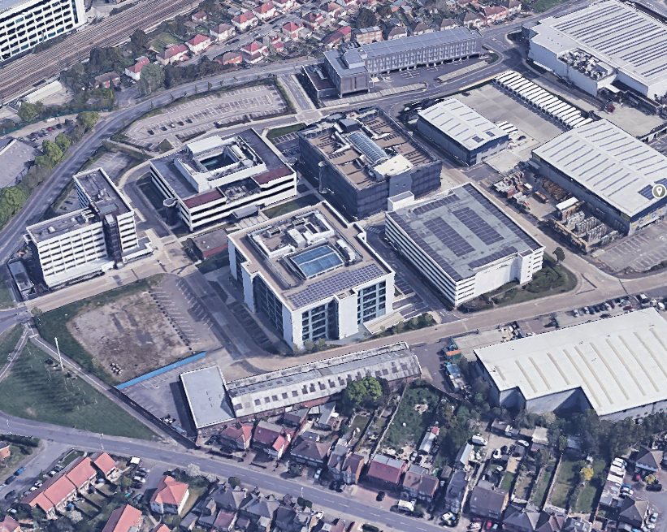
Figure 1: Oblique aerial photograph of the site looking north-west
(Source: Google)
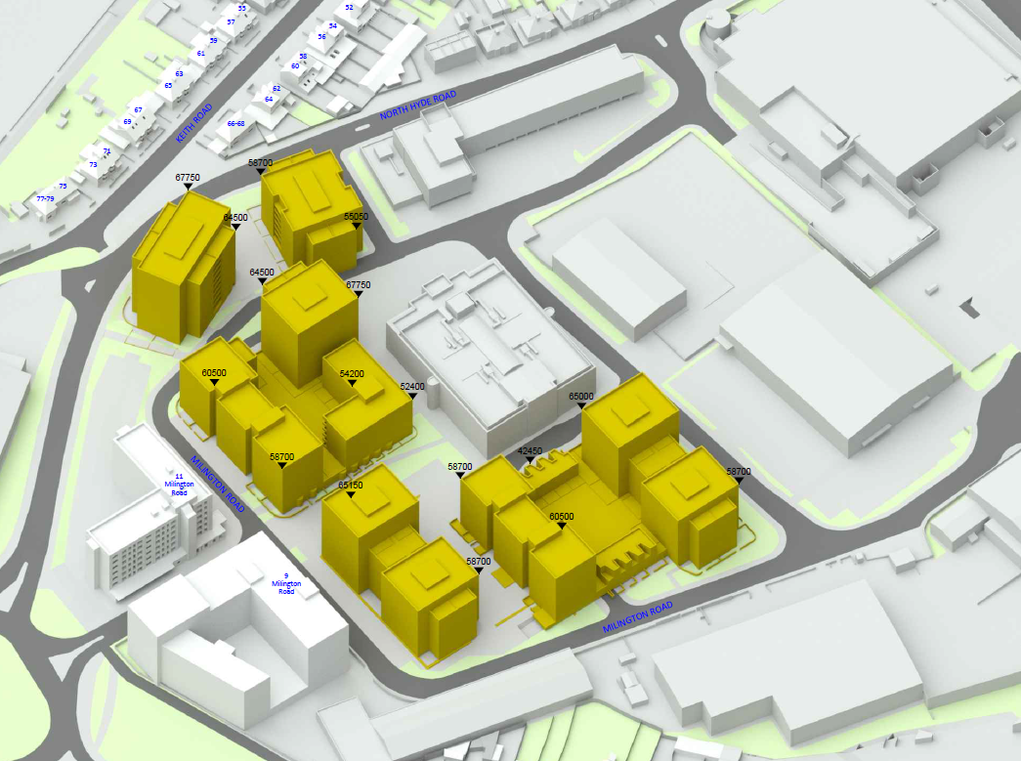
Figure 2: 3D view of computer model in the proposed condition

INTRODUCTION
  - Columbia Threadneedle Investments is proposing a development at Hyde Park, Hayes, UB3 4AZ.
  - The proposed development comprises of:
Outline planning permission (with all matters reserved excluding access) for demolition of existing buildings (above basement level) and delivery of residential development (Class C3), flexible residential / commercial floorspace, new public realm, landscaping, play space, car parking, cycle parking and associated works
  - Columbia Threadneedle Investments is conscious of the need to minimise impact on the light to neighbouring residential properties and therefore instructed Anstey Horne to work with the project architect, tp bennett architects, so that the effects of the proposed development could be properly understood and, wherever possible, minimised.
  - Anstey Horne has been commissioned to undertake a formal technical assessment of the effect of the proposed development upon the existing surrounding properties.
  - We have also been appointed to undertake an assessment of the daylight and sunlight potential of the proposed blocks and amenity spaces within the proposed development.
  - There are no mandatory standards for daylight or sunlight to dwellings, but the following publications offer guidance:
- BS EN 17037:2018 Daylight in Buildings (2018)
- BRE Report 209, Site Layout Planning for Daylight and Sunlight: A guide to good practice (third edition, 2022)
- CIBSE Lighting Guide 10, Daylighting - A Guide for Designers: Lighting for the Built Environment (SLL LG10, 2014)
  - The assessments have been undertaken based on BRE Report 209, Site Layout Planning for Daylight and Sunlight: A guide to good practice (third edition, 2022) which supersedes the second edition of the guide.
  - Our study has been carried out using 3D computer modelling and our specialist computer simulation software. Our 3D model is shown in Figure 2 on page 3.
  - This report summarises the relevant planning policy, the basic principles of daylighting and sunlighting, the methods used to assess the potential impact of the development, the information used in compiling our 3D computer model and the results of our technical assessment. Drawings and full tables of results of our technical assessment are attached in the appendices.

PLANNING POLICY AND GUIDANCE

National Planning Policy and Guidance
  - The Revised National Planning Policy Framework (December 2024) sets out the Government’s planning policies and how these are expected to be applied. It provides a framework within which councils can produce their own local plans that reflect the needs and priorities of their communities.
  - In terms of daylight and sunlight, under section 11 ‘Making effective use of land’, paragraph 130 (c) states that:
“local planning authorities should refuse applications which they consider fail to make efficient use of land, taking into account the policies in this Framework. In this context, when considering applications for housing, authorities should take a flexible approach in applying policies or guidance relating to daylight and sunlight, where they would otherwise inhibit making efficient use of a site (as long as the resulting scheme would provide acceptable living standards).”
  - The Building Research Establishment, whose aims include achieving a higher quality built environment, publish BRE guidelines 209, Site Layout Planning for Daylight and Sunlight: A guide to good practice (third edition, 2022) by PJ Littlefair. This guide gives advice on site layout planning to retain good daylighting and sunlighting in existing surrounding buildings and achieve to it in new buildings. The guide is intended for use by designers, consultants and planning officials and notes that:
“The advice given here is not mandatory and this document should not be seen as an instrument of planning policy; its aim is to help rather than constrain the designer."

Regional Planning Policy and Guidance

London Plan March 2021
  - The Mayor of London’s London Plan March 2021 sets out the spatial development strategy for London. It forms part of the development plan for Greater London, along with local plans of the London boroughs.
  - Policy D6 Housing quality and standards:
C. Housing development should maximise the provision of dual aspect dwellings and normally avoid the provision of single aspect dwellings. A single aspect dwelling should only be provided where it is considered a more appropriate design solution to meet the requirements of Part B in Policy D3 Optimising site capacity through the design-led approach than a dual aspect dwelling, and it can be demonstrated that it will have adequate passive ventilation, daylight and privacy, and avoid overheating.
D. The design of development should provide sufficient daylight and sunlight to new and surrounding housing that is appropriate for its context, whilst avoiding overheating, minimising overshadowing and maximising the usability of outside amenity space.

Mayor’s Housing Supplementary Planning Guidance
  - The Mayor of London’s ‘Housing Supplementary Planning Guidance’ (March 2016) provides guidance on how to implement the housing policies in the London Plan. It replaces the 2012 edition.
  - Part 1 of the SPG covers housing supply and sets out the Mayor’s approach to optimising housing output. In relation to the effect on daylight and sunlight to surrounding properties it advises:
“Policy 7.6Bd requires new development to avoid causing ‘unacceptable harm’ to the amenity of surrounding land and buildings, particularly in relation to privacy and overshadowing and where tall buildings are proposed. An appropriate degree of flexibility needs to be applied when using BRE guidelines to assess the daylight and sunlight impacts of new development on surrounding properties … Guidelines should be applied sensitively to higher density development, especially in opportunity areas, town centres, large sites and accessible locations, where BRE advice suggests considering the use of alternative targets. This should take into account local circumstances; the need to optimise housing capacity; and scope for the character and form of an area to change over time.”
“The degree of harm on adjacent properties … should be assessed drawing on broadly comparable residential typologies within the area and of a similar nature across London. Decision makers should recognise that fully optimising housing potential on large sites may necessitate standards which depart from those presently experienced but which still achieve satisfactory levels of residential amenity and avoid unacceptable harm.”
  - In relation to daylight and sunlight within new housing developments it advises:
“An appropriate degree of flexibility needs to be applied when using BRE guidelines to assess the daylight and sunlight … within new developments. Guidelines should be applied sensitively to higher density development, especially in opportunity areas, town centres, large sites and accessible locations, where BRE advice suggests considering the use of alternative targets. This should take into account local circumstances; the need to optimise housing capacity; and scope for the character and form of an area to change over time.”
“The daylight targets within a proposed scheme should be assessed drawing on broadly comparable residential typologies within the area and of a similar nature across London. Decision makers should recognise that fully optimising housing potential on large sites may necessitate standards which depart from those presently experienced but which still achieve satisfactory levels of residential amenity.”
  - Part 2 of the SPG covers quality and design of housing developments. It contains standards that set out the minimum level of quality and design that new homes should meet. The standards and corresponding guidance that relate to daylight and sunlight in new housing are as follows:
Home as a place of retreat
“… Natural light is also vital to a sense of wellbeing in the home, and this may be restricted in densely developed parts of the city. The Mayor seeks to encourage the kind of housing that provides comfortable and enjoyable places of retreat and privacy. Factors to be considered include privacy, the importance of dual aspect development, noise mitigation, floor to ceiling heights, daylight and sunlight.”
Dual aspect
“Standard 29 - Developments should minimise the number of single aspect dwellings. Single aspect dwellings that are north facing, or exposed to noise levels above which significant adverse effects on health and quality of life occur, or which contain three or more bedrooms should be avoided.”
“Dual aspect dwellings with opening windows on at least two sides have many inherent benefits. These include better daylight, a greater chance of direct sunlight for longer periods, natural cross ventilation and a greater capacity to address overheating, mitigating pollution, offering a choice of views, access to a quiet side of the building, greater flexibility in the use of rooms, and more potential for future adaptability by altering the use of rooms. Where possible the provision of dual aspect dwellings should be maximised in a development proposal.”
“The design of single aspect flats will need to demonstrate that all habitable rooms and the kitchen are provided with adequate ventilation, privacy and daylight and the orientation enhances amenity, including views. North facing single aspect dwellings should be avoided wherever possible. However, in applying this standard consideration should also be given to other planning and design objectives for a site, for example the aim to maximise active frontages and minimise inactive frontages.”
“Good single aspect one and two bedroom homes are possible where limited numbers of rooms are required, the frontage is generous, the plan is shallow, the orientation and or outlook is favourable, and care is taken to mitigate the potential for overheating without the need for mechanical cooling. Single aspect dwellings may also be appropriate when being used to wrap podium level car parks or large retail units with active frontages.”
“In single aspect dwellings with more than two bedrooms it is difficult to achieve adequate natural ventilation and daylight to all rooms in an efficient plan layout which avoids long internal corridors. Single aspect dwellings containing three or more bedrooms should therefore be avoided. The design of single aspect ground floor dwellings will require particular consideration to maintain privacy and adequate levels of daylight.”
Daylight and sunlight
“Standard 32 - All homes should provide for direct sunlight to enter at least one habitable room for part of the day. Living areas and kitchen dining spaces should preferably receive direct sunlight.”
“Daylight enhances residents’ enjoyment of an interior and reduces the energy needed to provide light for everyday activities, while controlled sunlight can help to meet part of the winter heating requirement. Sunlight is particularly desirable in living areas and kitchen dining spaces. The risk of overheating should be taken into account when designing for sunlight alongside the need to ensure appropriate levels of privacy. In addition to the above standards, BRE good practice guidelines and methodology can be used to assess the levels of daylight and sunlight achieved within new developments, taking into account guidance below and in Section 1.3.”
“Where direct sunlight cannot be achieved in line with Standard 32, developers should demonstrate how the daylight standards proposed within a scheme and individual units will achieve good amenity for residents. They should also demonstrate how the design has sought to optimise the amount of daylight and amenity available to residents, for example, through the design, colour and landscaping of surrounding buildings and spaces within a development.”
“BRE guidelines on assessing daylight and sunlight should be applied sensitively to higher density development in London, particularly in central and urban settings, recognising the London Plan’s strategic approach to optimise housing output (Policy 3.4) and the need to accommodate additional housing supply in locations with good accessibility suitable for higher density development (Policy 3.3). Quantitative standards on daylight and sunlight should not be applied rigidly, without carefully considering the location and context and standards experienced in broadly comparable housing typologies in London.”

Local Planning Policy and Guidance
  - The development site is located within London Borough of Hillingdon.
  - Local Plan Part 1 - Strategic policies
  - The Local Plan Part 1 sets out the overall level and broad locations of growth up to 2026. It comprises a spatial vision and strategy, strategic objectives, core policies and a monitoring and implementation framework with clear objectives for achieving delivery. These policies are supported by more detailed policies and allocations set out in the Local Plan Part 2.
Policy BE1 - Built Environment
The Council will require all new development to improve and maintain the quality of the built environment in order to create successful and sustainable neighbourhoods, where people enjoy living and working and that serve the long-term needs of all residents. All new developments should:
- Achieve a high quality of design in all new buildings, alterations, extensions and the public realm which enhances the local distinctiveness of the area, contributes to community cohesion and a sense of place;
…7. Improve the quality of the public realm and provide for public and private spaces that are attractive, safe, functional, diverse, sustainable, accessible to all, respect the local character and landscape, integrate with the development, enhance and protect biodiversity through the inclusion of living walls, roofs and areas for wildlife, encourage physical activity and where appropriate introduce public art;
  - Local Plan Part 2 - Development Management Policies
5.41 The Council will aim to minimise the impact of the loss of daylight and sunlight and unacceptable overshadowing caused by new development on habitable rooms, amenity space and public open space. The Council will also seek to ensure that the design of new development optimises the levels of London Borough of Hillingdon Local Plan Part 2 - Development Management Policies 49 daylight and sunlight. The Council will expect the impact of the development to be assessed following the methodology set out in the most recent version of the Building Research Establishments (BRE) “Site layout planning for daylight and sunlight: A guide to good practice”.

  - We confirm that we have undertaken our daylight and sunlight study in accordance with BRE Report 209, Site Layout Planning for Daylight and Sunlight: A guide to good practice (third edition, 2022).

BRE METHOD OF ASSESSMENT AND NUMERICAL GUIDELINES

Daylight to existing surrounding buildings

  - Section 2.2 of the BRE Guidelines makes recommendations concerning the impact on daylight to existing buildings. In summary, the BRE report states that:
“If any part of a new building or extension, measured in a vertical section perpendicular to a main window wall of an existing building from the centre of the lowest window, subtends an angle of more than 25° to the horizontal, then the diffuse daylighting of the existing building may be adversely affected. This will be the case if either:
- the VSC [vertical sky component] measured at the centre of an existing main window is less than 27%, and less than 0.8 times its former value; [or]
- the area of the working plane in a room which can receive direct skylight is reduced to less than 0.8 times its former value.”
  - So, where the angle to the horizontal subtended by the new development measured at the centre of the lowest window in an existing surrounding building (the angle of obstruction) is less than 25° (see Figure 3 below), the diffuse daylight to that building is unlikely to be significantly affected and need not be tested.
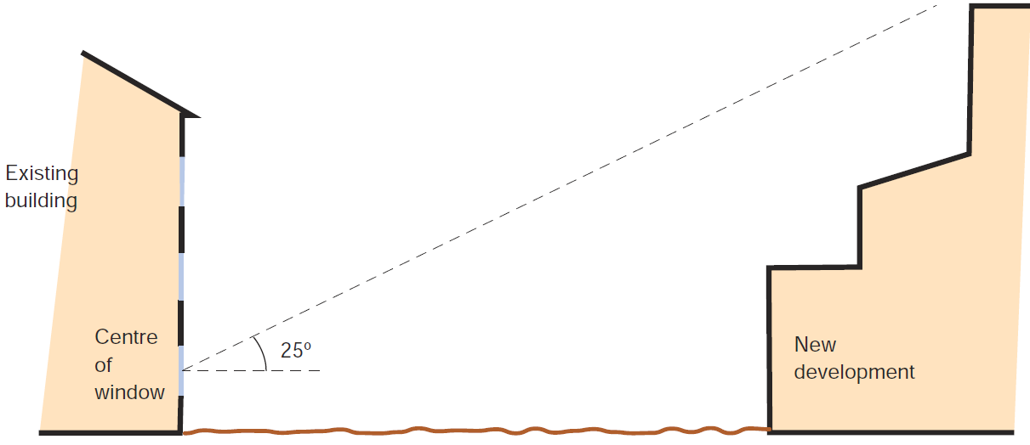
Figure 3 - Section perpendicular to a main window wall of an existing building showing a new development subtending an angle of less than 25° to the horizontal from the centre of the lowest window.
(© BRE Report 209)
  - Where the obstruction angle is greater than 25°, both of the more detailed daylight tests should be undertaken, namely vertical sky component (‘VSC’) at the window and daylight distribution on the working plane. For each test the guidelines operate on the general principle that if the amount of daylight is reduced to less than 0.8 times its former value (i.e. there will be more than a 20% loss) the reduction will be noticeable to the building’s occupants.
  - ‘Noticeable’ does not necessarily equate to ‘unacceptable’ and the BRE’s standard target values should not be considered as pass/fail criteria. Ultimately the local planning authority will need to make a judgement as to whether any impacts are acceptable when weighed against the many other planning considerations.
  - The VSC test measures the amount of skylight available at the centre of a window on the external plane of the window wall. It has a maximum value of almost 40% for a completely unobstructed vertical window wall. If a room has two or more windows of equal size, the mean of their VSCs may be taken. As the VSC calculation takes no account of the size of the window being tested, the size of the room it lights or multiple windows of unequal size, it does not measure light inside the room. It merely measures the potential conditions in the room. The VSC results can therefore be potentially misleading if considered in isolation and should be read in conjunction with those of the second test - daylight distribution.
  - The daylight distribution test calculates the area of the working plane inside a room that will have a direct view of the sky. This is done by plotting the no-sky line, i.e. the line on the working plane that divides those areas that receive direct skylight from those that do not, as shown in Figure 4 below.
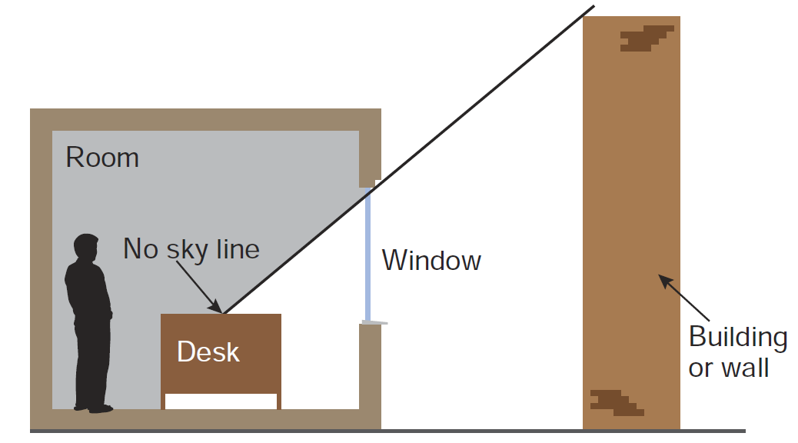
Figure 4 - The no-sky line divides areas of the working plan which can and cannot receive direct skylight. (© BRE Report 209)
  - One benefit of the daylight distribution test is that the resulting contour plans show where the light falls within a room, both in the existing and proposed conditions, and a judgement may be made as to whether the room will retain light to a reasonable depth.
  - The BRE Guidelines are intended for use for rooms in adjoining dwellings. They may also be applied to any existing non-domestic buildings where the occupants have a reasonable expectation of daylight, which could include schools, hospitals, hotels and offices. For dwellings it states that living rooms, dining rooms and kitchens should be assessed. Bedrooms should also be checked, although it states that they are less important. Other rooms, such as bathrooms, toilets, storerooms, circulation areas and garages need not be assessed.

Sunlight to existing surrounding buildings
  - Section 3.2 of the BRE Report makes recommendations concerning the impact on sunlight to existing dwellings or non-domestic buildings where there is a particular requirement for sunlight. The guide notes at paragraph 3.2.2 that:
“obstruction to sunlight may become an issue if:
- some part of a new development is situated within 90° of due south of a main window wall of an existing building; and
- in the section drawn perpendicular to the existing window wall, the new development subtends an angle greater than 25° to the horizontal measured from the centre of the lowest window to a main living room.”
  - If these angle criteria are not met, the guide recommends a more detailed check to calculate the impact of the proposed development on the available sunlight.
  - The BRE suggests:
“all main living rooms of dwellings, and conservatories, should be checked if they have a window facing within 90° of due south. Kitchens and bedrooms are less important, although care should be taken not to block too much sun. In non-domestic buildings any spaces which are deemed to have a special requirement for sunlight should be checked; they will normally face within 90° of due south anyway.” (BRE paragraph 3.2.3)
  - The available sunlight is measured in terms of the percentage of annual probable sunlight hours (‘APSH’) at the centre point of the window. ‘Probable sunlight hours’ is defined as:
“the long-term average of the total number of hours during a year in which direct sunlight reaches the unobstructed ground (when clouds are taken into account).”
  - Paragraph 3.2.13 of the BRE Guidelines summarises its sunlight guidance as follows:
“If a living room of an existing dwelling has a main window facing within 90º of due south, and any part of a new development subtends an angle of more than 25º to the horizontal measured from the centre of the window in a vertical section perpendicular to the window, then the sunlighting of the existing dwelling may be adversely affected. This will be the case if the centre of the window:
- receives less than 25% of annual probable sunlight hours and less than 0.80 times its former annual value; or less than 5% of annual probable sunlight hours between 21 September and 21 March and less than 0.80 times its former value during that period;
- and also has a reduction in sunlight received over the whole year greater than 4% of annual probable sunlight hours”.

Sunlight to existing surrounding gardens and open spaces
  - Section 3.3 of the BRE Guidelines makes recommendations concerning the impact of proposed development on sunlight to open spaces between buildings, such as main back gardens of houses, allotments, parks and playing fields, children’s playgrounds, outdoor swimming pools, sitting-out areas, such as in public squares and focal points for views, such as a group of monuments or fountains. The guide recommends that the level of overshadowing on such areas should be checked on the equinox (21 March).
  - The BRE Guidelines recognises that each of these spaces has different sunlighting requirements and that it is difficult to suggest a hard and fast rule. It recommends that at least half of the amenity area should receive at least two hours of sunlight on the equinox on 21 March.
  - When assessing the impact of a proposed development on the level of overshadowing of an existing open amenity, the BRE Guidelines recommends that:
“if, as a result of new development the area which can receive two hours of direct sunlight on 21 March is reduced to less than 0.8 times its former size, this further loss of sunlight is significant. The garden or amenity area will tend to look more heavily overshadowed”.
  - Sunlight at an altitude of 10° or less does not count, because it is likely to be blocked by planting anyway. Driveways and hard standing for cars is usually left out of the area calculation. Around housing, front gardens which are relatively small and visible from public footpaths can be omitted with only main back gardens needing to be analysed.
  - Fences or walls less than 1.5 metres high can be ignored. The BRE notes that:
“normally, trees and shrubs need not be included, partly because their shapes are almost impossible to predict, and partly because the dappled shade of a tree is more pleasant than a deep shadow of a building”.
This is especially the case for deciduous trees, which provide welcome shade in the summer whilst allowing sunlight to penetrate during the winter months.
  - Paragraph 3.3.13 of the BRE Guidelines notes that:
“Where a large building is proposed that may affect a number of gardens or open spaces it is often illustrative to plot a shadow plan showing the location of shadows at different times of day and year.”

Computer simulation
  - Appendix A of the BRE Guidelines describes a method for calculating VSC and APSH using various indicator templates and Appendix D shows how the no-sky line may be plotted inside a room. Where the obstructions on the skyline are complex these manual methods can be difficult to apply and the results can be crude. We therefore prefer to use computer simulation and our specialist software, which is based on the more accurate Waldram method, which is described in Appendix B of the BRE guide.
  - The information upon which our computer model was based is explained in the section 5 of this report.
  - Section 2.1 of the BRE Guidelines makes recommendations concerning daylight in new buildings. At the site layout stage of the design process, when window positions and sizes are unknown, the potential for daylight may be checked at a series of reference points on each main face of the building. At each of these reference points the amount of available skylight falling on the vertical wall can be quantified as the vertical sky component (VSC).
  - The maximum VSC value that can be achieved on a completely unobstructed vertical wall is nearly 40%. The BRE guidelines advise that a VSC of 27% or more indicates the potential for good daylighting. A VSC of 27% equates to an obstruction of uniform height subtending an angle of 25° to the horizontal (i.e. a 65° angle of visible sky) and is therefore representative of a typical residential street of low-rise terraced housing.
  - Paragraph 2.1.6 of the BRE Guidelines advises that whilst the amount of daylight needed in a room depends on what it is being used for, roughly speaking, if the VSC is:
- at least 27% (i.e. the angle of obstruction is less than 25° and angle of visible is greater than 65°) conventional window design will usually give reasonable results;
- between 15% and 27% (i.e. the angle of obstruction is between than 25° and 45° and the angle of visible is between 45° and 65°) special measures (larger windows, changes to room layout) are usually needed to provide adequate daylight;
- between 5% and 15% (i.e. the angle of obstruction is between than 45° and 65° and the angle of visible is between 25° and 45°) it is very difficult to provide adequate daylight unless very large windows are used; and
- less than 5% (i.e. the angle of obstruction is greater than 65° and angle of visible is less than 25°) it is often impossible to achieve reasonable daylight, even if the whole window wall is glazed.

APPLICATION OF BRE GUIDELINES

Flexible application of the guidelines
  - In its introduction the BRE Report 209 (third edition, 2022) states:
- (Its) "main aim is … to help to ensure good conditions in the local environment, considered broadly, with enough sunlight and daylight on or between buildings for good interior and exterior conditions.” (BRE paragraph 1.5)
- “The guide is intended for building designers and their clients, consultants and planning officials. The advice given here is not mandatory and this document should not be seen as an instrument of planning policy; its aim is to help rather than constrain the designer.” (BRE paragraph 1.6)
- “Although it gives numerical guidelines, these should be interpreted flexibly since natural lighting is only one of many factors in site layout design.” (BRE paragraph 1.6)
  - Clearly, the BRE guide is an advisory document, not a rigid set of rules. Care must therefore be taken to apply its recommendations in a manner fitting to the location of the proposed development.

Alternative target values
  - In theory the BRE Guidelines’ numerical guidelines may be applied to any setting, whether that is a city centre, suburban area or rural village. However, it notes:
“In special circumstances the developer or planning authority may wish to use different target values. For example, in a historic city centre, or in an area with modern high rise buildings, a higher degree of obstruction may be unavoidable if new developments are to match the height and proportions of existing buildings… The calculation methods … are entirely flexible in this respect.” (BRE paragraph 1.6)
  - At paragraph 2.2.3 the BRE states:
“Note that numerical values given here are purely advisory. Different criteria may be used, based upon the requirements for daylighting in an area viewed against other site layout constraints.”

  - Appendix F of the BRE Guidelines gives advice on setting alternative target values for skylight access. At page 85 it states:
“different targets may be used, based on the special requirements of the proposed development or its location”.
  - Furthermore, as noted at paragraph 2.7 above, the Mayor of London’s Housing Supplementary Planning Guidance emphasises that fully optimising housing potential on large sites may necessitate departure from conventional guidelines and the adoption of alternative target values.
  - Clearly, rigid application of the numerical guidelines could well give rise to an inappropriate answer and form of development for city centre sites, in which case it may be appropriate to adopt lower target values that are more appropriate to the location concerned.

Proximity of neighbouring building to the boundary
  - The BRE Guidelines permits the reasonableness or otherwise of the distance of the neighbouring building from the boundary to be taken into account. At paragraph 2.2.3 it states:
“Another important issue is whether the existing building is itself a good neighbour, standing a reasonable distance from the boundary and taking no more than its fair share of light”.

Interpretation of relative impacts
  - Except where the BRE Guidelines’ specified minimum values will be retained in the proposed condition (see paragraphs 3.1, 3.13 and 3.14 above, the guide advises that a loss of light will be noticeable if the amount retained will be less than 0.8 times its former value. (We refer to this as the ‘BRE 0.8 guideline’.) Care must be taken when interpreting the ‘relative impact’ figures (in the columns marked “factor of former value” in the tables of results), because where an existing value is low even a small reduction in real terms can manifest itself as a large relative impact. For example a reduction from 6% VSC to 3% VSC will appear as a reduction to 0.5 times its former value, and is therefore a transgression of the guidelines in theory, but in reality a loss of 3% VSC is very small and would be barely perceptible.

  - When the BRE launched the second edition of their guidelines in 2011, they cited the above logic as the reason for introducing the third tier to their sunlight criteria, as referred to in paragraph 3.13 above, namely that sunlight will be adversely affected where it is reduced below 25% APSH annually or 5% APSH in winter and to less than 0.8 times its former value and where the reduction annually is greater than 4% APSH.

Balconies, projecting wings and other self-obstructing projections
  - The BRE Guidelines acknowledges that balconies and projecting wings to existing neighbouring buildings artificially limit the available daylight and sunlight and, as a consequence, larger relative reductions in light may be unavoidable. More specifically it states:
“Existing windows with balconies above them typically receive less daylight. Because the balcony cuts out light from the top part of the sky, even a modest obstruction opposite may result in a large relative impact on the VSC, and on the area receiving direct skylight. One way to demonstrate this would be to carry out an additional calculation of the VSC and area receiving direct skylight, for both the existing and proposed situations, without the balcony in place. For example, if the proposed VSC with the balcony was under 0.8 times the existing value with the balcony, but the same ratio for the values without the balcony was well over 0.8, this would show that the presence of the balcony, rather than the size of the new obstruction, was the main factor in the relative loss of light.” (BRE paragraph 2.2.11)
“A larger relative reduction in VSC may also be unavoidable if the existing window has projecting wings on one or both sides of it, or is recessed into the building so that it is obstructed on both sides as well as above.” (BRE paragraph 2.2.14)
“Balconies and overhangs above an existing window tend to block sunlight, especially in summer. Even a modest obstruction opposite may result in a large relative impact on the sunlight received. One way to demonstrate this would be to carry out an additional calculation of the APSH, for both the existing and proposed situations, without the balcony in place. For example, if the proposed APSH with the balcony was under 0.8 times the existing value with the balcony, but the same ratio for the values without the balcony was well over 0.8, this would show that the presence of the balcony, rather than the size of the new obstruction, was the main factor in the relative loss of sunlight.” (BRE paragraph 3.2.11)
  - Clearly, where windows are inset or self-obstructed by balconies or other projections they will be unusually sensitive to changes in massing opposite and transgressions of the BRE’s default numerical guidelines are more likely to arise. In such circumstances flexible application of the guidelines is very important.

Deep rooms
  - The BRE Guidelines advises that light penetration into deep rooms lit from one side only may be unavoidably affected. At paragraph 2.2.12 it states
“The guidelines … need to be applied sensibly and flexibly. There is little point in designing tiny gaps in the roof lines of new development in order to safeguard no sky lines in existing buildings. If an existing building contains rooms lit from one side only and greater than 5 m deep, then a greater movement of the no sky line may be unavoidable.”

INFORMATION USED IN THE TECHNICAL STUDY
  - In order to carry out the tests recommended in the BRE Guidelines, we commenced by building a 3D computer model of the existing buildings on the site, the existing surrounding buildings to be studied, other relevant background massing and the proposed scheme. The computer model is illustrated on the drawings at Appendix A and is based on the information listed below.
Proposed scheme:
- tp bennett’s drawings of the proposed scheme received on 20 June 2025
Existing building on the site and existing surrounding buildings:
- Point cloud data collected on November 2024
- OS map
- Aerial photography from Google Earth
- Site photographs
Internal arrangements within existing surrounding buildings:
Property | Drawings with planning application ref.
71 Keith Road | 13452/APP/2020/3757 (Existing)
69 Keith Road | 75563/APP/2020/2300 (Proposed)
67 Keith Road | 14848/APP/2010/2092 (Proposed)
63 Keith Road | 34214/APP/2004/863 (Proposed)
61 Keith Road | 10401/APP/2015/2110 (Existing)
66 Keith Road | 17851/APP/2013/2297 (Proposed)
64 Keith Road | 26249/APP/2022/770 (Proposed)
60 Keith Road | 22423/APP/2011/1255 (Proposed)
56 Keith Road | 77733/APP/2022/3741
90 Dawley Road | Estate agent plans
90B Dawley Road | Estate agent plans
96 Dawley Road | 72904/APP/2017/2255 (Proposed)
98 Dawley Road | 40092/APP/2017/2324 (Proposed)
100 Dawley Road | 39285/APP/2017/2325 (Proposed)
102 Dawley Road | Estate agent plans
104 Dawley Road | Estate agent plans
114 Dawley Road | 49016/APP/2021/1683 (Existing)
116 Dawley Road | 33677/APP/2019/1703 (Proposed)
11 Millington Road | 67702/APP/2018/920 (Proposed)

  - Extensive research has been undertaken to establish the usage and internal configuration of neighbouring properties surrounding the site. Where plans of the existing surrounding buildings were not available, we estimated the internal arrangements and room uses based on an external inspection which is considered to be in accordance with industry standards and best practice.
  - Where we have had to estimate internal arrangements and room uses, this has no bearing upon the tests for VSC or APSH because the reference point is at the centre of the window. It is relevant to the daylight distribution assessment, but in the absence of suitable plans, estimation is a conventional approach.

SCOPE OF TECHNICAL STUDY
  - Having regard to the preliminary 25-line test and orientation test recommended in the BRE Guidelines, as explained above in paragraphs 3.1 to 0 and 3.9, we have calculated the impact of the proposed development on the daylight and sunlight levels to relevant rooms in the following existing surrounding buildings:
Table 1 - Scope of assessments
Properties | Daylight | Sunlight | Sunlight to gardens
55-79 Keith Road | Yes | Yes | No
58-68 Keith Road | Yes | Yes | Yes
50-56 Keith Road | Yes | Yes | No
90-110 Dawley Road | Yes | Yes | Yes
112-116 Dawley Road | Yes | Yes | No
9 Millington Road | Yes | Yes | No
11 Millington Road | Yes | Yes | No

  - We have only tested the impact on the main rooms in each property, as advised in the BRE Guidelines. It is not necessary to test staircases, hallways, bathrooms, toilets etc.
  - Each of the existing surrounding buildings tested is shown labelled on the plan views of the computer model on our drawings at Appendix A of this report.
  - The daylight distribution contour plans at Appendix E show the window positions and room layouts that have been tested in each of the buildings concerned.
  - We have calculated the impact of the proposed development on sunlight on 21 March to the gardens/open spaces at 58-68 Keith Road and 90-110 Dawley Road. The locations of these spaces and the proportion of each that receives at least two hours of sunlight on 21 March in the existing and proposed conditions are shown on our drawing(s) at Appendix F. In addition, we have produced transient overshadowing snapshots shown on our drawing(s) at Appendix G.

Daylight and sunlight to SURROUNDING PROPERTIES
  - In this section of our report, we set out our analysis of the results of our technical study under the headings of daylight and sunlight. For each element we will provide commentary on the results taking each property, or groups of properties, in turn.
  - To re-cap briefly on the assessment criteria explained in section 5, each of the tests is run in the existing and proposed condition so that the daylight and sunlight levels before and after development are quantified and the relative change is determined. Except where the BRE guide’s specified minimum values will be retained in the proposed condition, it advises that a loss of light will be noticeable if the amount retained will be less than 0.8 times its former value (the “BRE 0.8 guideline”).

Daylight to existing surrounding buildings
  - The numerical results of the vertical sky component (‘VSC’) test are tabulated at Appendix B. For the daylight distribution (DD) test, numerical results are tabulated at Appendix C and no-sky contour plans are shown on our drawings at Appendix E. On the plans, the area of the room with a view of sky in the proposed condition is enclosed by the red contour and in the existing condition by the green contour. Where there will be no effect on the no-sky contour the red contour sits on top of the green one and only the red contour is visible. Where there will be a change, the areas of the room that will either lose or gain a view of sky are cross-hatched black.
  - In terms of daylight to neighbouring properties, the overall levels of strict BRE compliance is as follows:
- 380 (71%) of the 538 windows tested for VSC achieve the guideline values
- 249 (76%) of the 328 rooms tested for DD achieve the guideline values
  - The neighbouring properties at 55-63 Keith Road, 60-64 Keith Road, 50-56 Keith Road, 90-116 Dawley Road achieve full adherence to the BRE guidelines for daylight. The remaining properties are discussed in further detail below:
77-79 Keith Road:
  - This residential neighbouring property is located to the north of the development site and the internal layouts have been based on reasonable assumptions.
  - The results show that 4 (57%) of the 7 windows assessed achieve the guideline values for VSC by retaining greater than 0.8 times their former value. On the ground floor, there is 1 window (W1) that will experience a change in VSC of 0.73 former value, marginally beyond the BRE’s suggested permissible 0.8. Importantly however, it will retain an absolute VSC value of 20.68% which is very encouraging in an urban setting such as this. There are 2 further windows on the first floor that will experience changes in VSC between 0.75-0.69 their former value. It should be noted that these windows have a largely unfettered view over the vacant part of the development site and consequently, record very high levels of light in the existing condition. The BRE acknowledge situations such as this and advise that the numerical criteria be applied flexibly by also taking account of alternative target values that are appropriate for its setting. The average retained VSC for the first floor windows within this property that face the site is 22.46% which could be considered commensurate with the wider area and other boroughs around London.
  - The daylight distribution results demonstrate that all 4 rooms (100%) assessed meet the guideline values, each achieving a factor former value of at least 0.93.
75 Keith Road:
  - This residential neighbouring property is located to the north of the development site and the internal layouts have been based on reasonable assumptions.
  - The results show that none of the 3 windows assessed achieve the guideline values for VSC. However, all of these windows achieve a factor former value of 0.73 or greater and therefore only fall slightly short of the guidelines. Furthermore, the average retained VSC for these windows is 21.19% which could be considered commensurate with the wider area and other boroughs around London.
  - The daylight distribution results demonstrate that all 3 rooms (100%) assessed meet the guideline values, each achieving a factor former value of at least 0.97.
73 Keith Road:
  - This residential neighbouring property is located to the north of the development site and the internal layouts have been based on reasonable assumptions.
  - The results show that 5 (71%) of the 7 windows assessed achieve the guideline values for VSC by retaining greater than 0.8 times their former value. On the ground floor, it can be seen that a single window which forms part of larger bay window configuration will experience a change of 0.78 former value. The remaining windows serving this room all adhere to a strict application of the BRE Guidelines. Additionally, 1 window on the first floor will experience a change of 0.77 former value, although the retained VSC value is circa 26% which is considered excellent in a location such as this.
  - The daylight distribution results demonstrate that all 3 rooms (100%) assessed meet the guideline values, each achieving a factor former value of at least 0.97.
71 Keith Road:
  - This residential neighbouring property is located to the north of the development site and the internal layouts have been based on information obtained from the planning portal.
  - The results show that 6 (67%) of the 9 windows assessed achieve the guideline values for VSC by retaining greater than 0.8 times their former value. The 3 windows which fall short of the guidelines are located on the ground and first floors, and 2 of these windows achieve a factor former value of 0.76 or greater and therefore only fall slightly short of the guidelines. The remaining window is located on the ground floor (W1) and forms part of a bay window configuration which allows light to penetrate the room behind from a variety of different directions, as shown by the daylight distribution results reported below.
  - The daylight distribution results demonstrate that all 4 rooms (100%) assessed meet the guideline values, each achieving a factor former value of at least 0.97.
69 Keith Road:
  - This residential neighbouring property is located to the north of the development site and the internal layouts have been based on information obtained from the planning portal.
  - The results show that 7 (78%) of the 9 windows assessed achieve the guideline values for VSC by retaining greater than 0.8 times their former value. On the ground floor, it can be seen that one window which forms part of larger bay window configuration will experience a change of 0.72 former value. The remaining windows serving this room all adhere to a strict application of the BRE Guidelines.
  - The daylight distribution results demonstrate that all 5 rooms (100%) assessed retain their existing DD levels and therefore meet the guideline values.
68 Keith Road:
  - This residential neighbouring property is located to the north of the development site and the internal layouts have been based on reasonable assumptions.
  - The results show that none of the 2 windows assessed achieve the guideline values for VSC. These windows are on the first floor that will experience changes in VSC between 0.73-0.79 their former value. It should be noted that these windows have a largely unfettered view over the vacant part of the development site and consequently, record very high levels of light in the existing condition. The BRE acknowledge situations such as this and advise that the numerical criteria be applied flexibly by also taking account of alternative target values that are appropriate for its setting. The average retained VSC for the first floor windows within this property that face the site is at least 25% which could be considered commensurate with the wider area and other boroughs around London.
  - The daylight distribution results demonstrate that both rooms (100%) assessed achieve the guideline values.
67 Keith Road:
  - This residential neighbouring property is located to the north of the development site and the internal layouts have been based on information obtained from the planning portal.
  - The results show that 7 (88%) of the 8 windows assessed achieve the guideline values for VSC by retaining greater than 0.8 times their former value. On the ground floor, it can be seen that one window which forms part of larger bay window configuration will experience a change of 0.78 former value. The remaining windows serving this room all adhere to a strict application of the BRE Guidelines. The average retained VSC for this window is circa 23% which could be considered commensurate with the wider area and other boroughs around London
  - The daylight distribution results demonstrate that all 3 rooms (100%) assessed retain their existing DD levels and therefore achieve the guideline values.
66 Keith Road:
  - This residential neighbouring property is located to the north of the development site and the internal layouts have been based on information obtained from the planning portal.
  - The results show that none of the 3 windows assessed achieve the guideline values for VSC. These windows are on the ground floor that will experience changes in VSC between 0.75-0.77 their former value. It should be noted that these windows have a largely unfettered view over the vacant part of the development site and consequently, record very high levels of light in the existing condition. The BRE acknowledge situations such as this and advise that the numerical criteria be applied flexibly by also taking account of alternative target values that are appropriate for its setting. The average retained VSC for the first floor windows within this property that face the site is at least 25% which could be considered commensurate with the wider area and other boroughs around London.
  - The daylight distribution results demonstrate that both rooms (100%) assessed achieve the guideline values.

65 Keith Road:
  - This residential neighbouring property is located to the north of the development site and the internal layouts have been based on reasonable assumptions.
  - The results show that all 8 windows (100%) assessed achieve the guideline values for VSC by retaining greater than 0.8 times their former value.
  - The daylight distribution results demonstrate that 3 of the 4 rooms (75%) assessed achieve the guideline values. The room which falls short of the guidelines is located on the ground floor, and achieves a factor former value of 0.73 and therefore only fall slightly short of the guidelines. It is important to note that this room is receiving low levels of daylight in the existing condition and therefore any meaningful development would cause reductions outside of the guidelines.
58 Keith Road:
  - This residential neighbouring property is located to the north of the development site and the internal layouts have been based on reasonable assumptions.
  - The results show that 4 (80%) of the 5 windows assessed achieve the guideline values for VSC by retaining greater than 0.8 times their former value. The window which falls short of the guidelines is located on the ground floor, and achieves a factor former value of 0.09. It is important to note that this window is receiving low levels of daylight in the existing condition, achieving a VSC figure of 0.11 and therefore any meaningful development would cause reductions outside of the guidelines. It is also important to note that this window forms part of larger bay window configuration and the remaining windows serving this room all adhere to a strict application of the BRE Guidelines.
  - The daylight distribution results demonstrate that all 3 rooms (100%) assessed meet the guideline values for daylight distribution, each achieving a factor former value of at least 0.96 .
11 Millington Road (HPH3):
  - This building is located to the north-west side of the site and was recently converted from commercial to residential use. The building was modelled based on information from the planning portal.
  - The VSC results show that 120 (66%) of 183 windows tested would meet or exceed the BRE recommended values. The 63 windows that fall short of the guidelines are located on the ground to fourth floors, and 8 of these windows achieve a factor former value of 0.70 or greater, falling only slightly short of the guidelines. Of the remaining 55 windows, 45 have retained VSC values in the mid-teens or above. Whilst it is important to consider the relative change in light from the existing condition in respect of light amenity, it is increasingly common (particularly in urban contexts) to also look at the quality of retained light following the development of site. To that effect, retained VSC values of mid-teens (15%) are increasingly being accepted by local authorities in urban locations.
  - The DD results show that 95 (75%) of 127 rooms tested would achieve the guideline values. The 32 rooms that fall short of the guidelines are located on the ground to third floors, and 9 of these achieve a factor former value of 0.70 or greater, falling only slightly short of the guidelines. In addition, most of the rooms that fall short of the guideline values are bedrooms, which the BRE guidelines state are less important when it comes to daylight distribution.

Sunlight to existing surrounding buildings
  - The numerical results of the percentage of annual probable sunlight hours (‘APSH’) test are tabulated at Appendix D. Only those buildings identified by application of the BRE guide’s preliminary 25° line test and orientation test, as explained above, have been tested.
  - All of the neighbouring properties with the exception of 11 Millington Road (HPH3) achieve full adherence to the BRE guidelines for sunlight.
11 Millington Road (HPH3)
  - The APSH results confirm that 118 rooms (93%) of 127 relevant for analysis would achieve the guideline values on an annual basis, and 123 (97%) would achieve the guideline values on a winter basis.

Sunlight to surrounding gardens and open spaces
  - In accordance with the BRE guide we have calculated the effect on the gardens by plotting the two-hour sun contour on 21 March in the existing and proposed condition as shown on our drawings at Appendix F. The parts of each garden receiving at least two hours of sunlight are shaded yellow and expressed as a percentage on the drawings. The figures are also set out in Table 2 below, along with the factor by with the existing sunlit area will change as a consequence of the proposed development.

Table 2 - Summary of two-hour sun-on-ground results
Address | Area ref. | Proportion in sun for ≥ 2 hrs on 21 March |  | Factor of former value
Address | Area ref. | Existing | Proposed | Factor of former value
66-68 Keith Road | A13 | 58.11% | 51.35% | 0.88
64 Keith Road | A14 | 78.28% | 72.26% | 0.92
62 Keith Road | A15 | 82.22% | 82.04% | 1.00
60 Keith Road | A16 | 77.35% | 76.65% | 0.99
58 Keith Road | A17 | 80.08% | 79.90% | 1.00
90 Dawley Road | A1 | 71.02% | 71.02% | 1.00
90A Dawley Road | A2 | 59.72% | 59.72% | 1.00
90B Dawley Road | A3 | 47.47% | 47.47% | 1.00
92 Dawley Road | A4 | 58.83% | 58.83% | 1.00
94 Dawley Road | A5 | 65.25% | 65.25% | 1.00
96 Dawley Road | A6 | 73.62% | 73.62% | 1.00
98 Dawley Road | A7 | 90.68% | 90.68% | 1.00
100 Dawley Road | A8 | 93.08% | 93.08% | 1.00
102 Dawley Road | A9 | 92.06% | 92.06% | 1.00
104 Dawley Road | A10 | 77.13% | 77.13% | 1.00
110 Dawley Road | A11 | 68.39% | 68.39% | 1.00
112 Dawley Road | A12 | 66.68% | 66.68% | 1.00

  - The results of the two-hour sun contour test confirm that all of the gardens tested will achieve the BRE recommended levels of sunlight following the proposed development.

DAYLIGHT AND SUNLIGHT WITHIN THE PROPOSED DEVELOPMENT
Given that an outline planning application is being sought, the detailed unit layouts have not been formulated at this stage. Therefore, we have sought to understand the daylight and sunlight potential of the proposed blocks by undertaking façade mapping assessments using the methodologies recommended by the BRE Guidelines.
Daylight – VSC Façade Mapping
  - We have run the VSC façade mapping analysis to all proposed elevations, with screenshots of the assessment shown at Appendix G. This exercise essentially plots thousands of points at 1m intervals along an elevation, and all of these points are then assessed against the VSC test. As mentioned above, this exercise does not consider balcony placement, quantity of glazing or layout of rooms.
  - The colours are denoting the below absolute VSC values achieved on the facades, with the BRE providing 27% as the recommended value whereby enough skylight should still be reaching the window. However, good levels of light can still be expected for VSC values that are not able to reach the BRE’s target of 27%, which by its nature does not take any account of the area of glazing or the size of the room behind the window. The VSC assessment considers the relative obstruction to the amount of skylight falling on a vertical window or in the case of this exercise, numerous points placed along the façade.
- Green = 27% VSC and above
- Yellow = 15% -27% VSC
- Orange = 5%-15% VSC
- Red = 5% VSC and below

Proposed Blocks A1 and A2
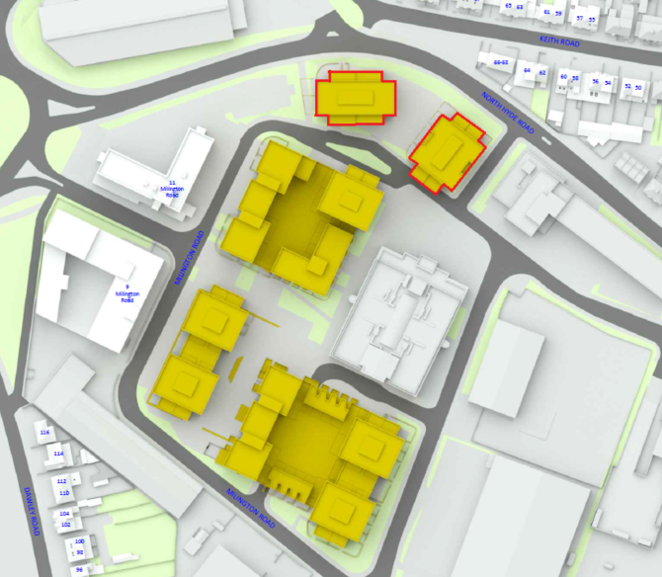
  - The results indicate that, of the points tested, 66% achieve VSC values of at least 27%, 30% fall between 15% and 27%, 3% fall between 5% and 15%, and the remaining 1% receive less than 5% VSC.
Proposed Blocks B1, B2 and B3
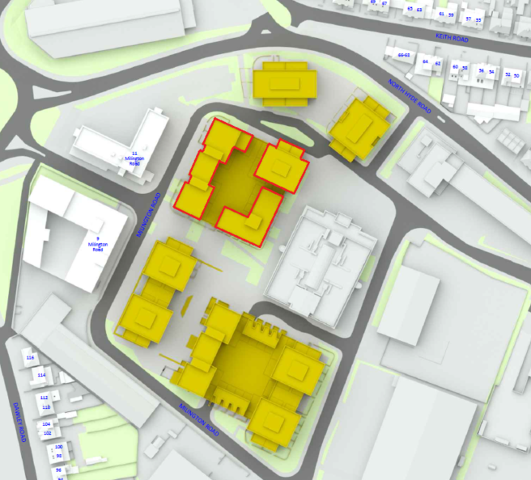
  - The results indicate that, of the points tested, 44% achieve VSC values of at least 27%, 38% fall between 15% and 27%, 15% fall between 5% and 15%, and the remaining 3% receive less than 5% VSC.
Proposed Block C
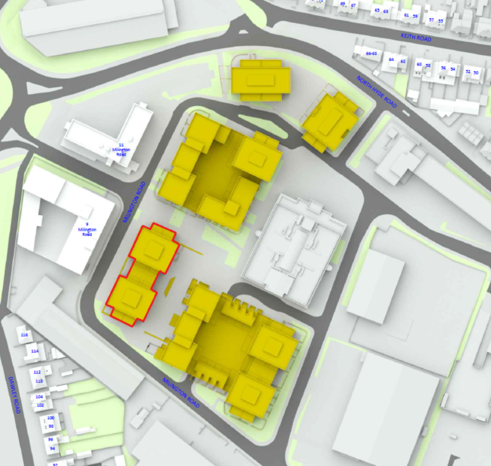
  - The results indicate that, of the points tested, 51% achieve VSC values of at least 27%, 39% fall between 15% and 27%, 10% fall between 5% and 15%.

Proposed Blocks D1 and D2
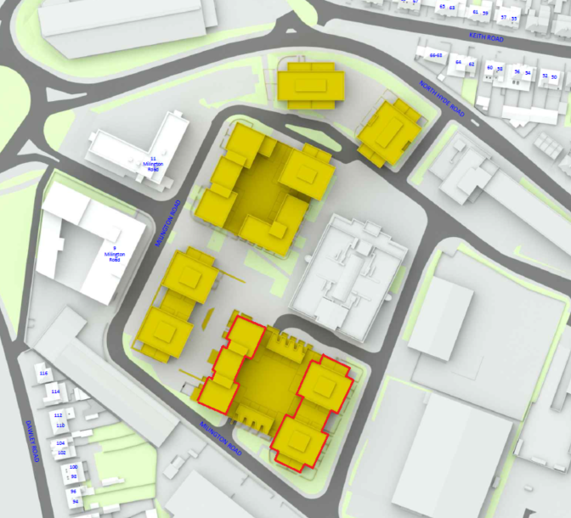
  - The results indicate that, of the points tested, 64% achieve VSC values of at least 29%, 27% fall between 15% and 27%, 6% fall between 5% and 15%, and the remaining 1% receive less than 5% VSC.
Proposed Townhouses
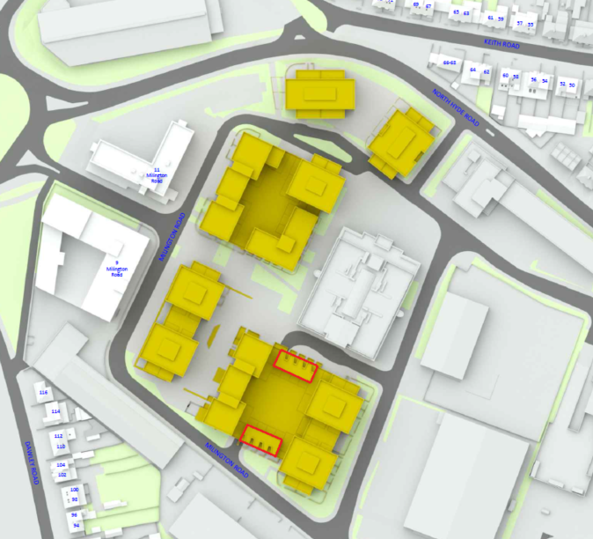
  - The results indicate that, of the points tested, 18% achieve VSC values of at least 27%, 44% fall between 15% and 27%, 19% fall between 5% and 15%, and the remaining 19% receive less than 5% VSC.
  - Overall, the results show that the scheme has been designed such that many areas will have very good access to daylight in general terms. At the appropriate time, it will be necessary to work closely with the wider design team to ensure that the proposed layout and balcony configuration maximises the natural light potential within the development.
Sunlight to proposed amenity areas
  - We have run the sun-on-ground analysis on 21st March and 21st June to the proposed amenity spaces. On the associated drawings found at Appendix H, the yellow shaded areas show the adherent areas of amenity that receive two-hours of direct sun. The BRE’s target is to get 50% of a proposed amenity area to achieve the recommended two-hours.
Area ref. | Proportion in sun for ≥ 2 hrs on 21 March | Proportion in sun for ≥ 2 hrs on 21 June
Area ref. | Proposed | Proposed
A1 | 72.97% | 98.18%
A2 | 99.35% | 100%
A3 | 35.29% | 82.85%
A4 | 72.38% | 92.62%
A5 | 95.50% | 99.83%
A6 | 86.65% | 99%
A7 | 86.71% | 99.01

  - On 21st March, all of the proposed amenity spaces—except for A3—meet the BRE-recommended level of 50%. A3 is located within the courtyard area, which, while providing residents with immediate access to valuable amenity space, results in constrained sunlight access on the March assessment date. Residents will also have access to rooftop areas and other parts of the block where sunlight availability is higher. These additional spaces provide opportunities for sunlight levels beyond what is available in the courtyard alone, ensuring a balanced provision of sunlit amenity across the development.
  - On 21st June, all proposed amenity spaces receive excellent levels of sunlight, with each achieving the BRE-recommended sunlight hours to at least 82% of its area.
  - In reality, we understand that the amenity areas are more likely to be used by future occupants during the summer months. On 21st June, all areas receive at least two hours of sunlight over 80% of their area, which represents a reasonable level of sunlight provision.

SUMMARY AND CONCLUSION
  - We have undertaken a study of the impact of the proposed development on the relevant rooms in the surrounding dwellings. The tests were undertaken in accordance with the BRE Report 209, Site Layout Planning for Daylight and Sunlight: A guide to good practice (third edition, 2022). The BRE guide gives useful advice and recommends various numerical guidelines by which to assess the impact of development on daylight and sunlight to existing surrounding properties.
  - The results of our technical assessments indicate that the majority of the windows (71% for VSC) and rooms (76% for DD) tested within the neighbouring buildings will satisfy the BRE criteria for daylight. For sunlight, the vast majority of the rooms (93% for APSH and 95% for WPSH) will achieve the BRE target for sunlight. Therefore, the Proposed Development is considered to perform well overall against the default values in the BRE Guidelines.
  - An internal daylight and sunlight assessment of the proposed scheme and its amenity areas confirms that the design delivers superior light levels throughout. Living spaces—especially those on outward-facing facades—benefit from excellent daylight penetration, while the communal amenity areas receive good levels of sunlight. In our opinion, the scheme optimises both daylight and sunlight access to create bright, healthy interiors for future occupants.
  - In conclusion, the layout of the proposed development aligns with the principles in the BRE Guidelines and its practical application to make efficient use of development sites. Furthermore, the facade mapping exercises within the proposed development demonstrate good levels of daylight and sunlight for the purpose of an outline planning application.

………………………..
ANSTEY HORNE
X June 2025


APPENDICES

APPENDIX A
-
PLAN AND 3D VIEWS OF THE COMPUTER MODEL
DRAWING NOS. ROL01494_R08_V01_3D-001 to 006

APPENDIX B
-
VERTICAL SKY COMPONENT (‘VSC’) TABLE

APPENDIX C
-
DAYLIGHT DISTRIBUTION TABLE

APPENDIX D
-
ANNUAL PROBABLE SUNLIGHT HOURS (‘APSH’) TABLE

APPENDIX E
-
DAYLIGHT DISTRIBUTION CONTOUR PLANS
DRAWING NOS. ROL01494_R08_V01_PL-101-01 to ROL01494_R068_V01_PL-137-07

APPENDIX F
-
TWO-HOUR SUN CONTOUR ON 21 MARCH DRAWINGS
DRAWING NOS. ROL01494_R08_V01_SOG-301-01 to 02

APPENDIX G
-
SCREENSHOTS OF VSC FAÇADE TESTING

APPENDIX H
-
TWO-HOUR SUN CONTOUR ON 21 MARCH DRAWINGS (PROPOSED)
DRAWING NOS. ROL01494_R08_V01_SOG-302-01 to 02



BRE Report 209, Site Layout Planning for Daylight and Sunlight: A guide to good practice (third edition, 2021).

