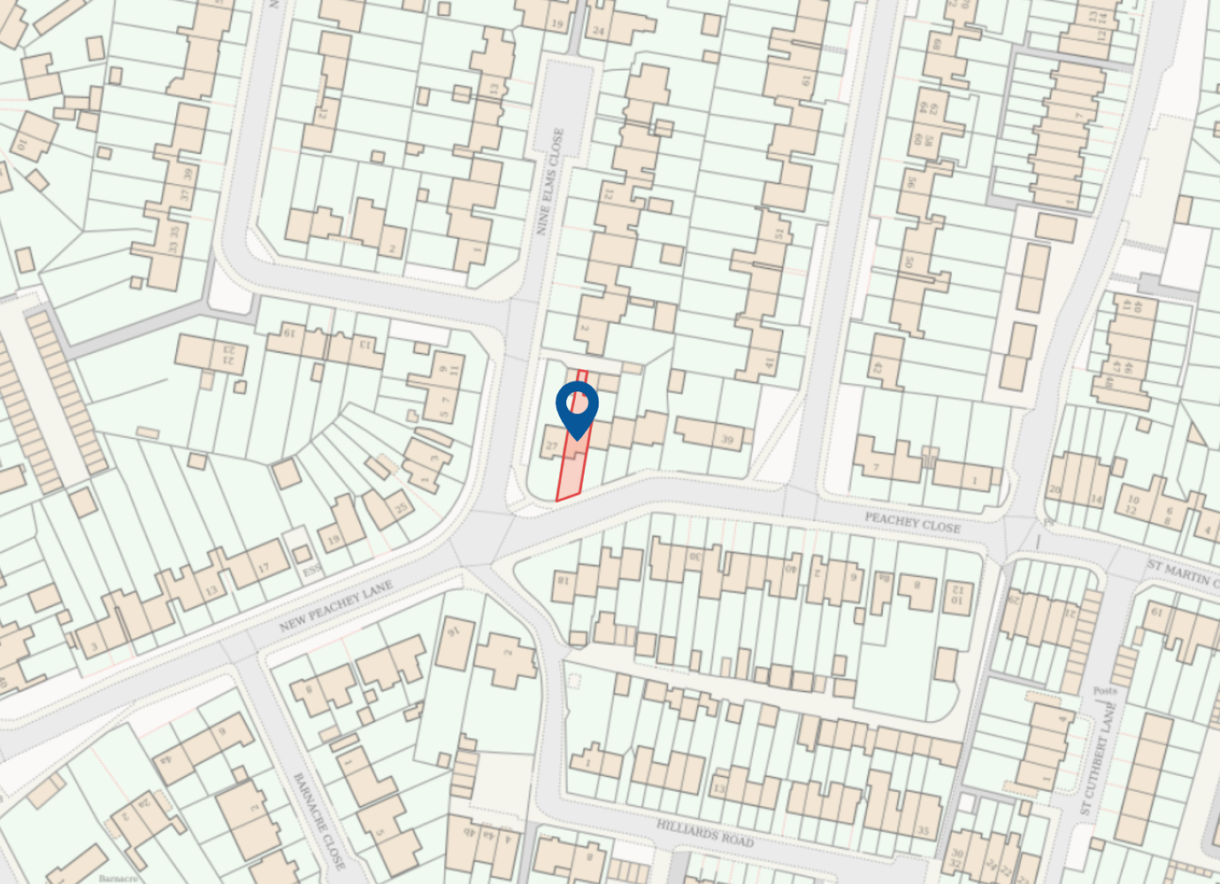

Location Map
(1:1250)

29 Peachey Lane
Uxbridge
UB8 3SX

