PLANNING APPLICATION
68 WEST DRAYTON ROAD, HILLINGDON.
LONDON. UB8 3LA.

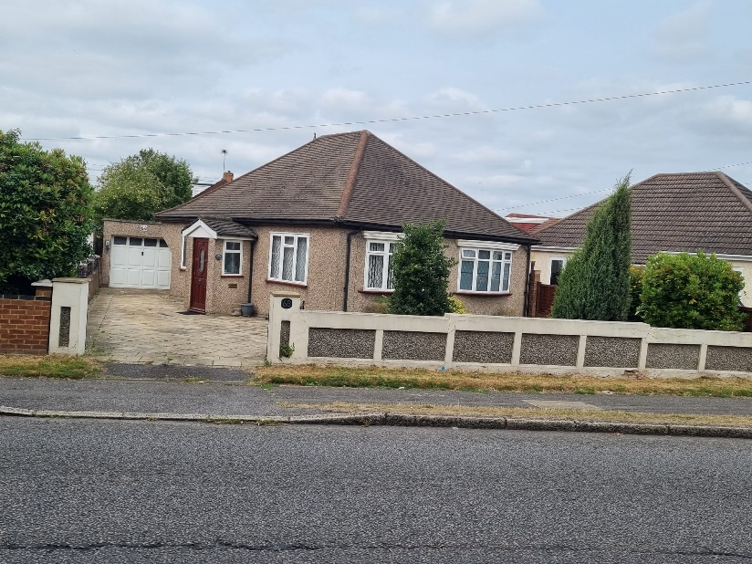/

PLANNING APPICATION .

TO RAISE THE GABLE WALL TO A PITCH,
AND INSTALL NEW ROOF WITH DORMERS TO EITHER SIDE.
TO FORM HABITABLE SPACE

PLANNING APPLICATION
68 West Drayton Road, Hillingdon, London, UB8 3LA
Proposal:
To raise the existing gable wall to form a pitched roof and install a new roof structure incorporating dormer extensions to both side elevations, thereby creating habitable accommodation at first-floor level.

Description of Proposal:
No. 68 West Drayton Road is a modest, two-bedroom detached bungalow situated among a group of similar properties, originally constructed in the 1920s. The architectural style of these homes typically features a hipped roof, sloping on all four sides. Over time, many of the surrounding properties have been extended and modernised, with gable walls added to the front and rear elevations and a variety of dormer extensions introduced on the sides.
The subject property is currently in a worn and dated condition and is well-suited for refurbishment and modernisation. This planning application proposes the replacement of the existing roof structure with a new pitched roof design, incorporating dormer extensions on both side elevations. These changes will mirror similar developments at neighbouring properties, such as No. 52 and No. 6 West Drayton Road.
The proposed development will enhance the property's appearance and provide a significantly improved internal layout. The new design includes an upgraded and spacious ground floor family living area, as well as three bedrooms and two bathrooms on the newly created first-floor level.

If you would like, I can also help you format this for submission (e.g. into a PDF or Word document) or assist with architectural visuals or diagrams if needed.

