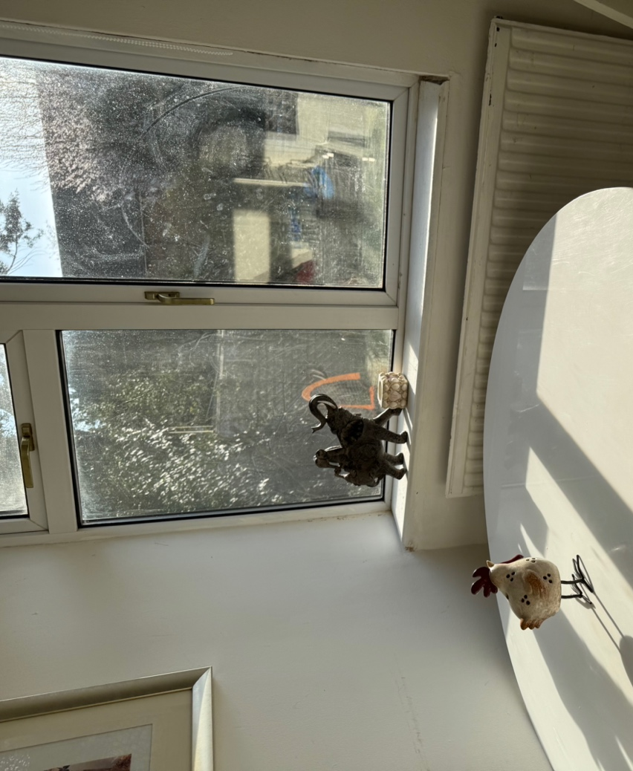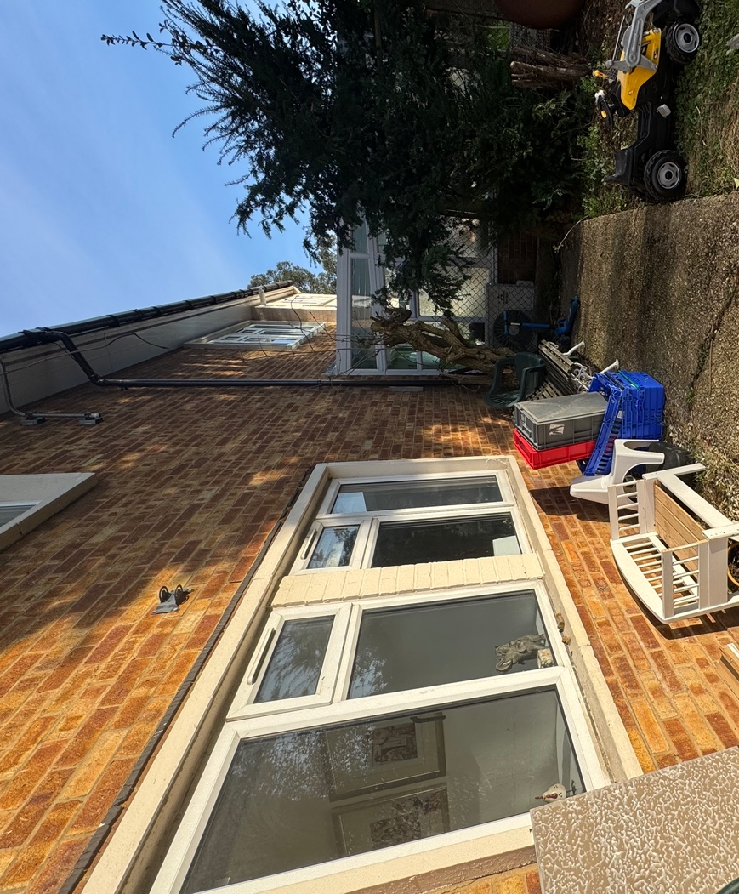
Kitchen Windown from outside
Kitchen Windown from inside.
The door will be 210cm X 120cm
Neighbors Conservatory

