DESIGN STATEMENT
ERECTION OF 2M HIGH SECURITY FENCING TO BOUNDARY OF FORMER CARPARK
FORMER CAR PARK, SPRINGWELL LOCK, HAREFIELD WD3 8UU

1 SITE AND SURROUNDINGS
1.1. The application site is located on the North West side of the Grand Union Canal at Springwell Lock, Herefield. The site was previously leased to London Borough of Hillingdon for use as a car park. The lease had lapsed many years ago and the car park has since fallen into disrepair, become overgrown and although vehicles still parked there it was unmonitored (other than by the Police), and had been subject to criminal damage to vehicles, theft and was frequented by drug users.
1.2. In the Hillingdon Local Plan the site falls within
- The Green Belt
- Springwell Lock Conservation Area
- Nature Conservation Site Grade 1
1.3. The South West part of the site abuts Springwell Lane, which is an adopted public highway
1.4. The North West of the site abuts the River Colne
1.5. The Southern part of the site is an access road (owned by the applicant over which an access easement is provided to the pump station on the otherside of the bridge over the Colne
2 THE WORKS
2.1. The applicant has erected a 2m tall galvanised steel pallisade security fence to the perimeter of the former carpark to ensure that the land cannot be used by the vehicles which had previously been accessing the site without the owners agreement.
Approximately 11.8m of the new fencing, which includes the access gate into the site, is adjacent to the public highway.
The reset of the fence is erected either on land away from the highway, or adjacent to the access road to the pump station, which is owned by the applicant.
The applicant intends to plant mature Laurel bushes behind the fence to soften the appearance of the new enclosure.

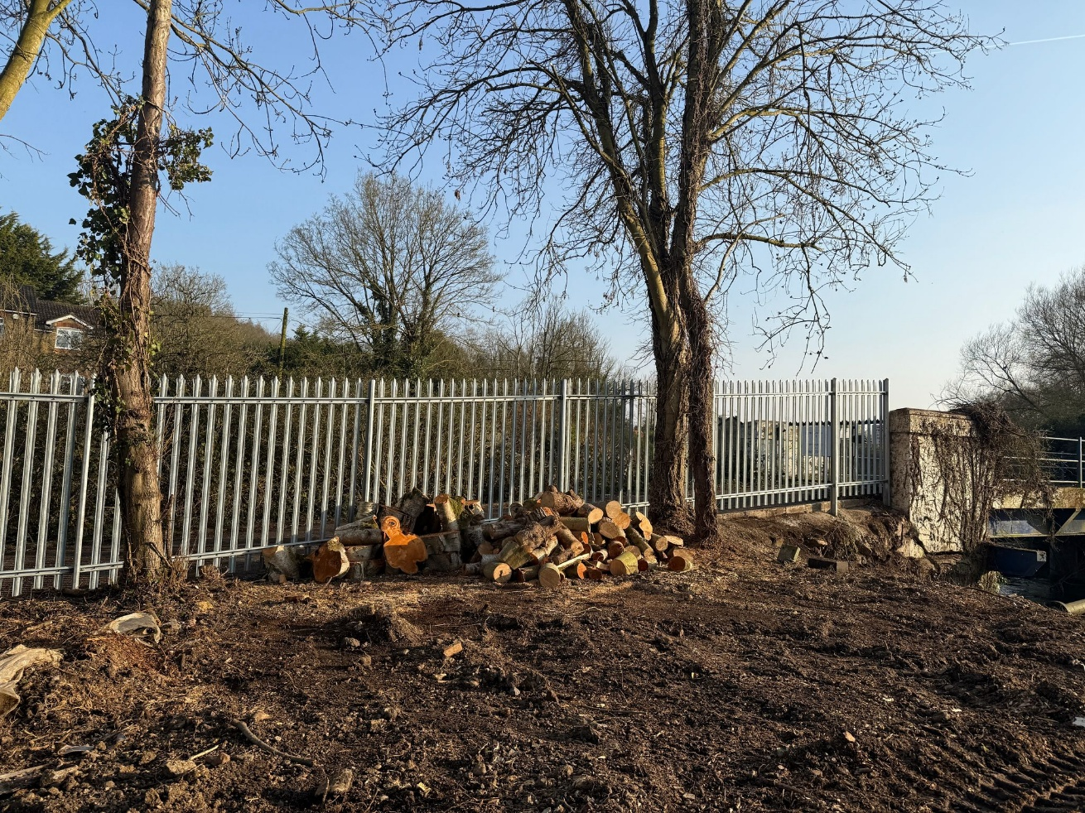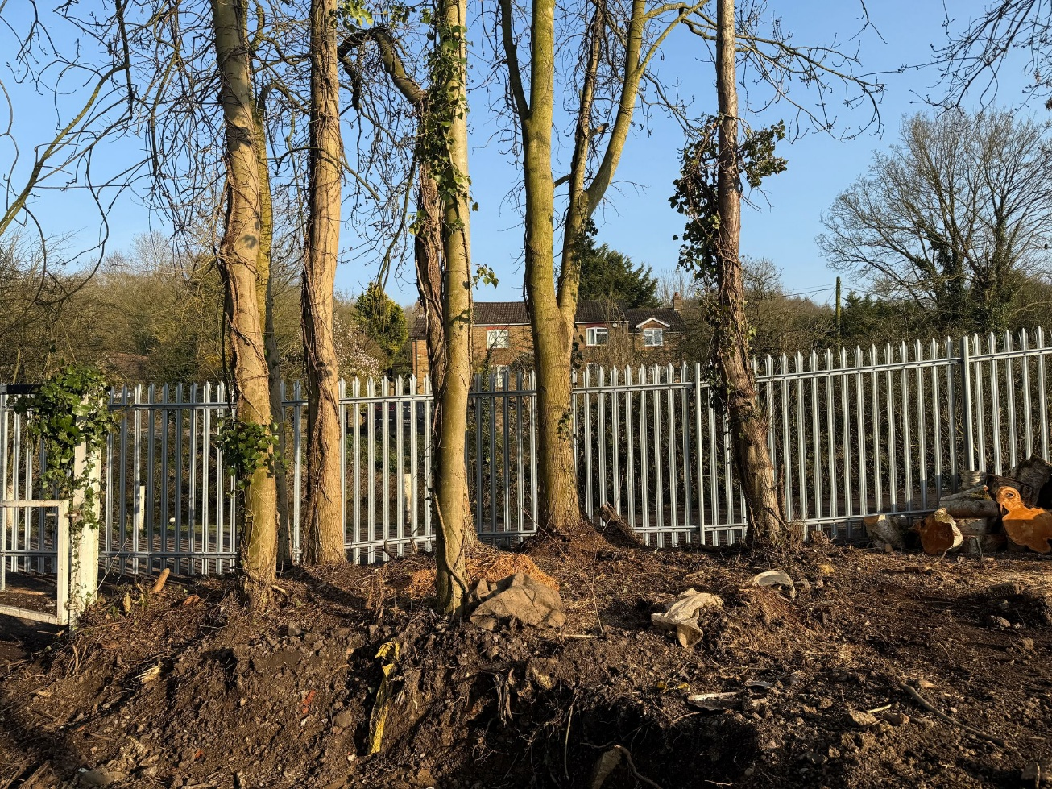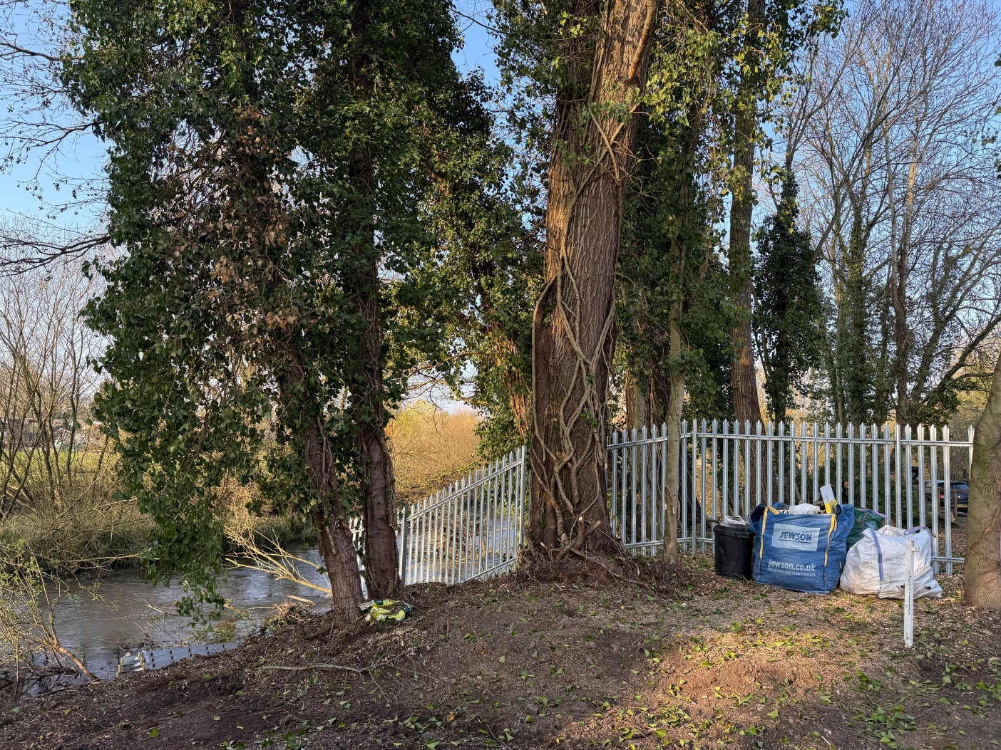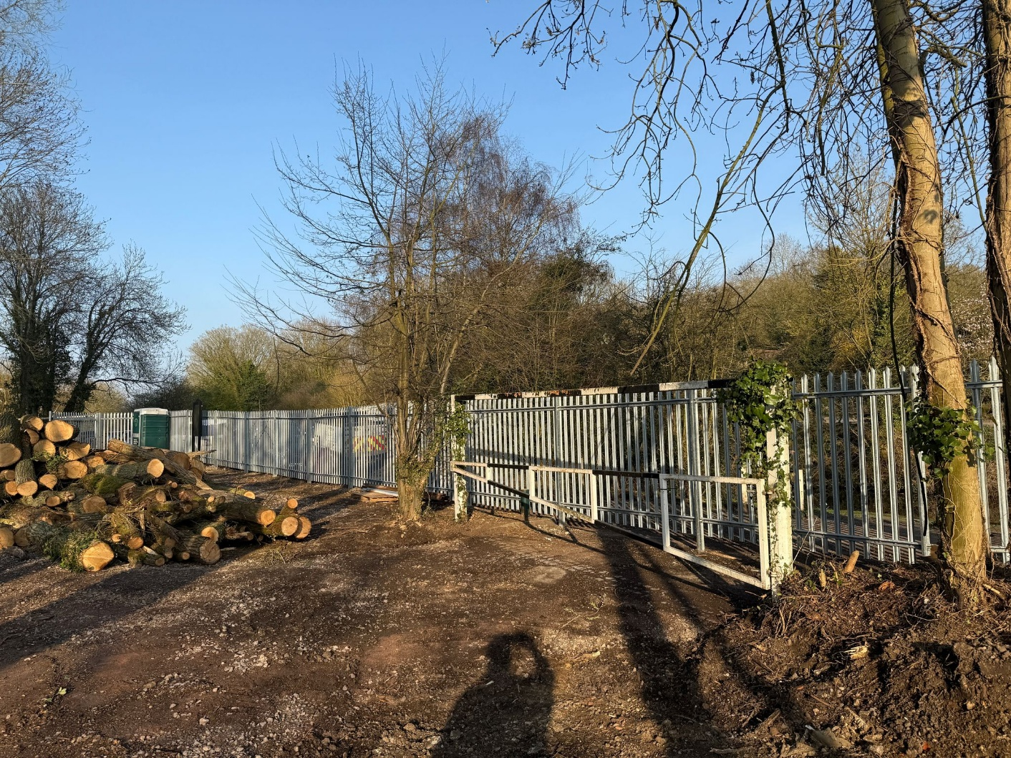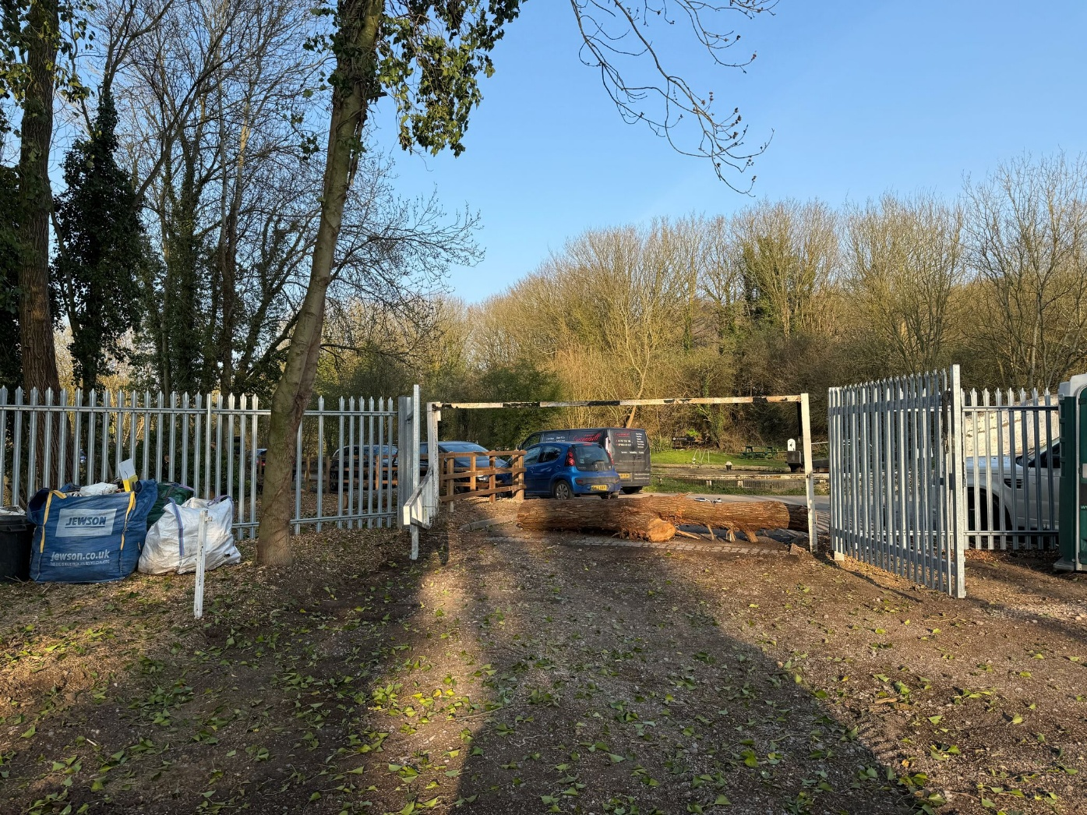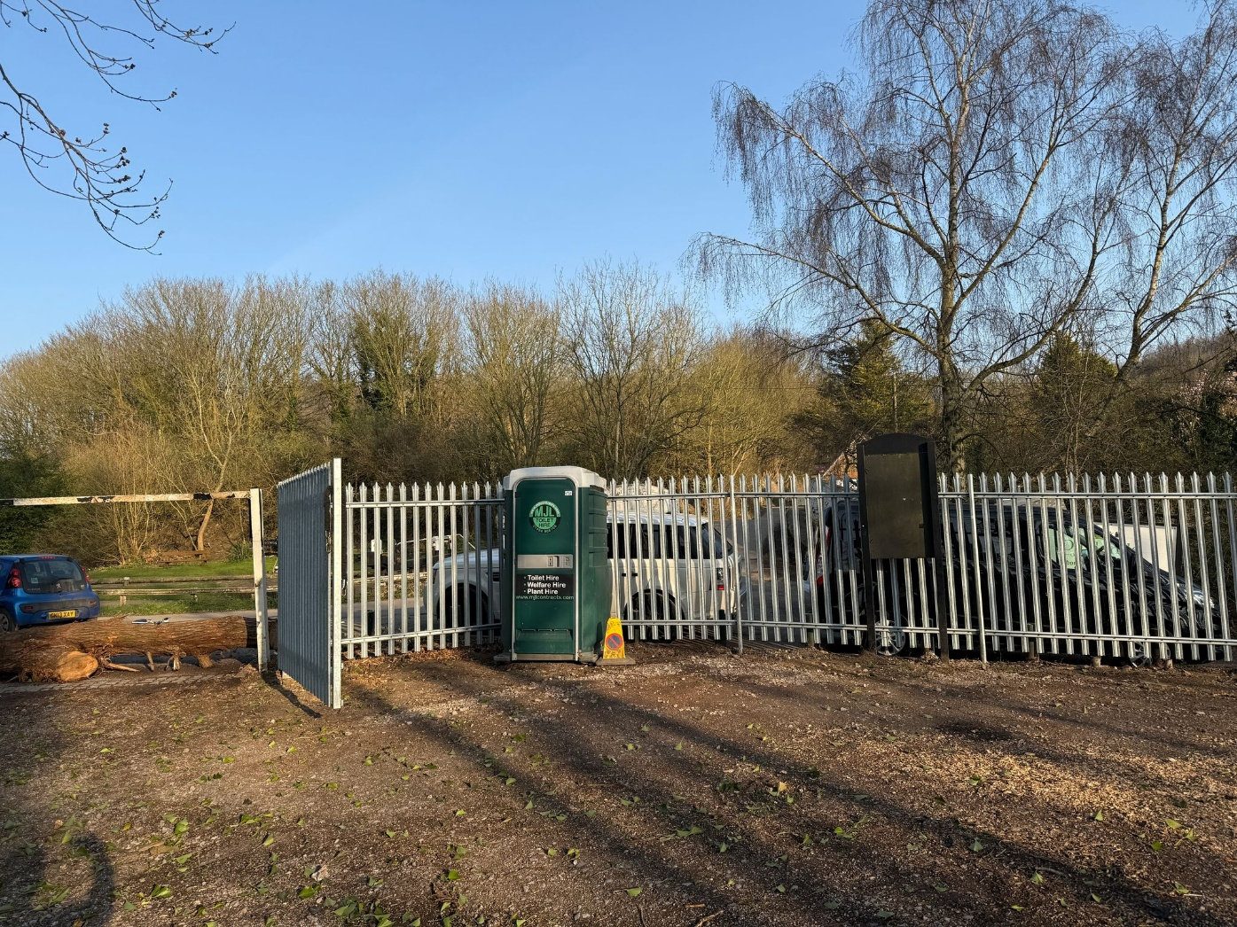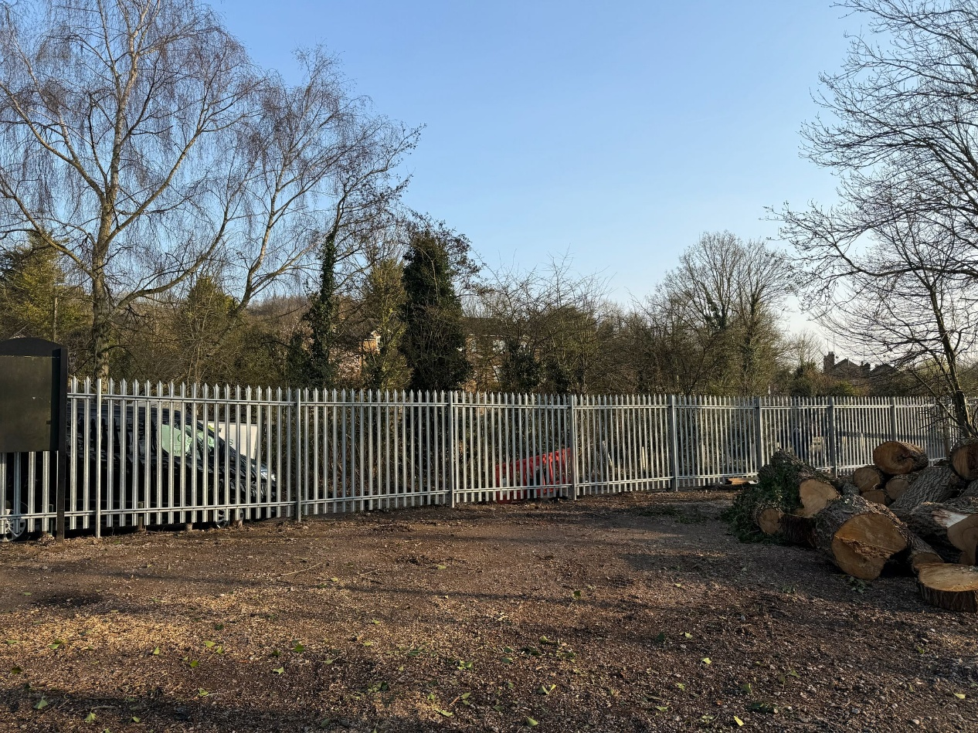
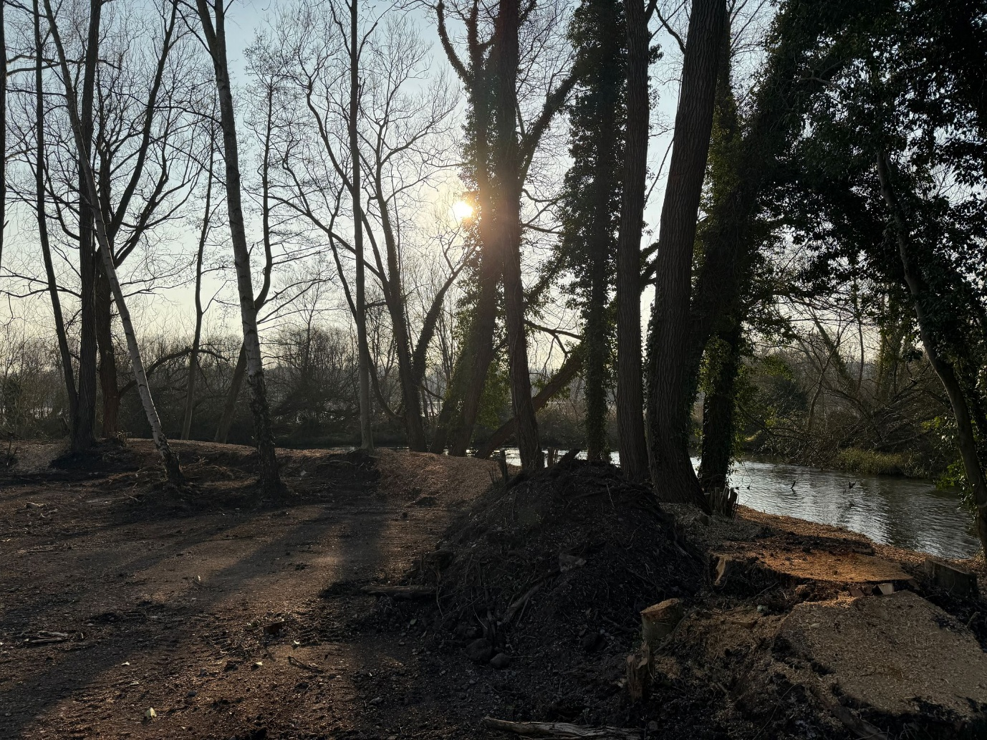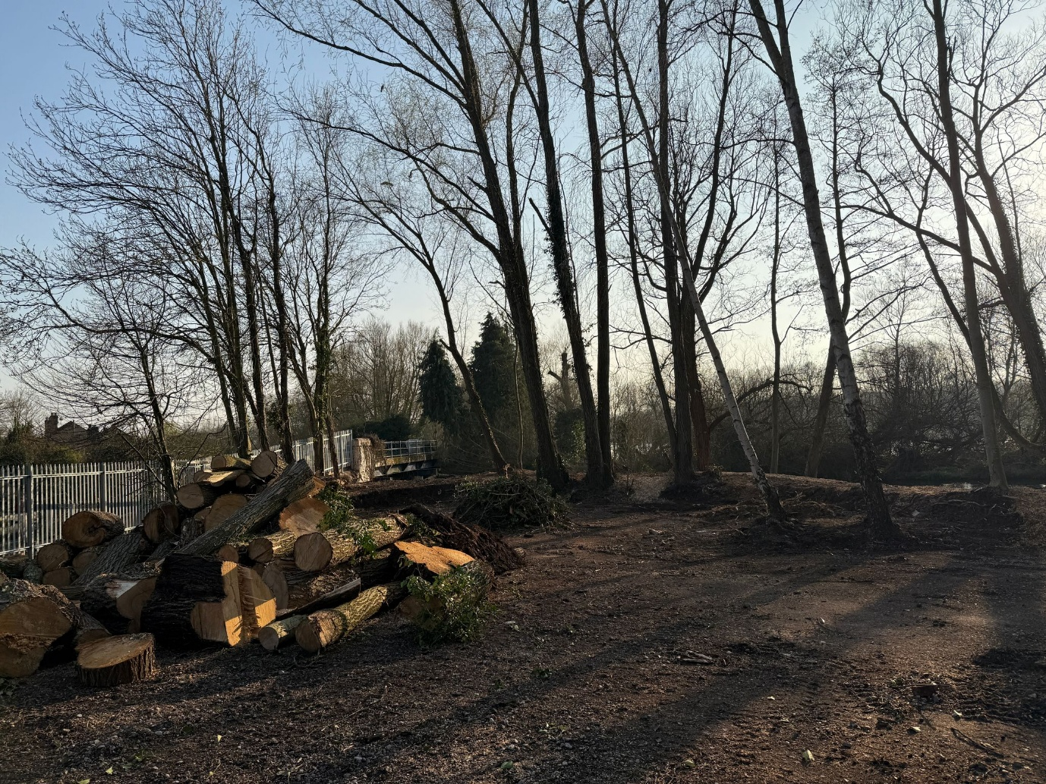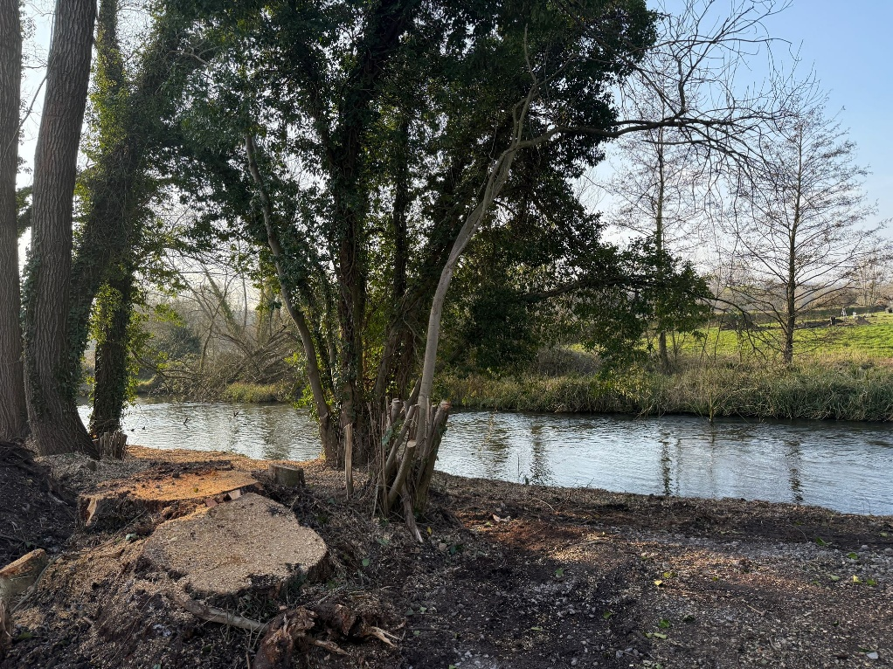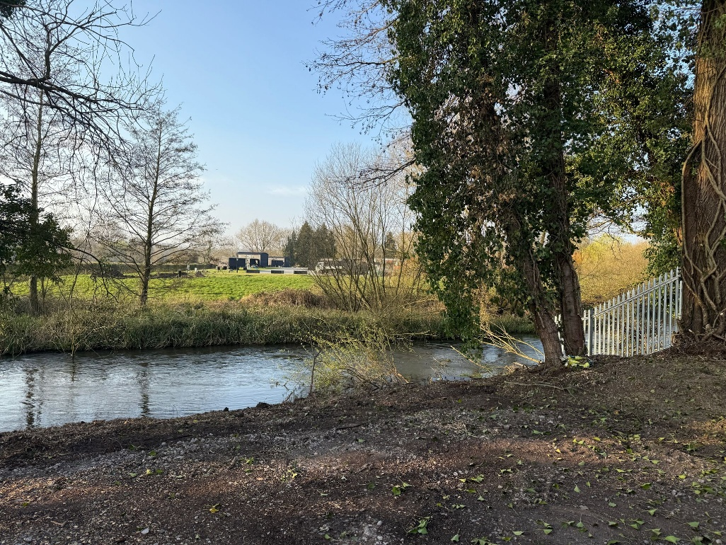

3 CONCLUSION
4.1. The new fence is required to ensure that the land owned by the applicant is not accessed illegally by persons parking vehicles there.
4.2 The site had previously been used by drug users on a regular basis, the fencing will now prevent this.
4.3 The applicant is currently seeking clarification on potential uses for the site and the fence will ensure the site is secure until that can be determined.

