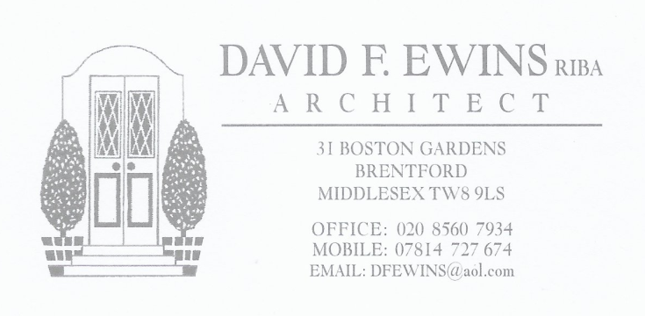
38 HALL DRIVE, HAREFIELD, UB9 6LA.
DESIGN AND ACCESS STATEMENT
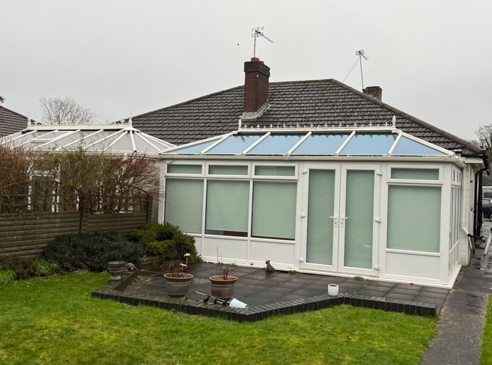

- EXISTING BUILDING
The existing building is a semi-detached bungalow, that has been extended with a conservatory to the rear.

- PROPOSED ALTERATIONS.
The proposed works are to replace the conservatory with a three metres deep, pitched roof, rear extension.

- LIST OF DRAWINGS.
Drawings included with this application are:

1931 / 01 AS EXISTING plans
02 AS EXISTING elevations and section
03 LOCATION PLAN
04 AS PROPOSED plans
05 AS PROPOSED elevations and section

- DISABLED ACCESS DESIGN.
The proposed works will have no effect on the disabled access to the property.

