ARBORICULTURAL IMPACT ASSESSMENT
MALLARDS, NORTHGATE, NORTHWOOD, HA6 2TJ
.
Introduction
This assessment evaluates the potential effects of the proposed development to Mallards, Northgate on protected trees and outlines strategies to mitigate any adverse impacts.
It is provided in response to the request received as part of pre-planning report following a successful pre-app meeting with planning officer Becky Smith (reference 79080/PRC/2024/235).
Purpose & Context:
The purpose of this document is to evaluates the potential effects of proposed development on protected trees pertaining to Tree Protection Order 131.
Most recent documentation was requested from the council and the below listing for TPO 131 is up to date as of 11th June 2024. It should be noted that a separate planning application has been submitted regarding remaining trees contained within the site, approved on 2nd November 2024, as such the below council notations are out of date since approval of application 9512/TRE/2024/171 (removal of one Ash Tree and one Cypress).
Site Context:
TPO131 contains the following applicable considerations for the above mentioned property:
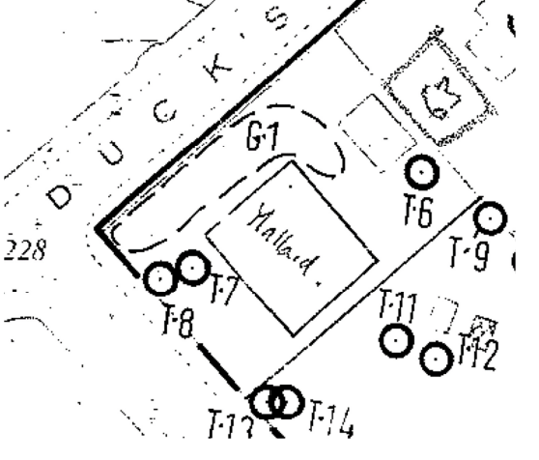
The excerpt shows the species of the trees in or near the property:
- G1 = 8 sycamores and 1 ash
- T6 = Gum tree
- T7 = Gum tree
- T8 = Cupressus
- T9 = Ash (situated on neighbouring property Mewburn)
- T11 = Blue Cedar (situated on neighbouring property Mewburn)
- T13 = Flowering plum (situated on neighbouring property Mewburn)
- T14 = Hawthorn (situated on neighbouring property Mewburn)
Following a site survey, a tree assessment report was provided to the council to accompany approved application 9512/TRE/2024/171 on 7th September 2024. This report was authored by Glen Harding, GHA Trees, and can be found in the associated documentation of that application for completeness.
The Assessment cites the following findings:
- After assessing the trees on site and looking at the TPO document, the following trees are no longer present:
- The sycamore trees in G1 (approved for removal as noted in the TPO but no date is given), T2, T3, T6 (approved for removal in 1982), T7, T9 (4m stump remains and is visible) T11 and T14.
- The stumps of some sycamore trees in G1 are still present and I estimate they were felled in the last 10 to 15 years and they seem to be present in 2006 according to Google Earth historic photos, but these are somewhat unclear.
- T8 is still present I believe, but the location may be erroneous on the TPO document.
In line with these findings, this AIA submission is pertaining to the updated presence of the following trees only:
- G1 = 1 ash tree
- T8 = 1 cupressus

Approved Tree Retention and Removal
G1 Ash tree and T8 Cupressus tree are the only protected trees on the property that relate to TPO131. Although more trees were cited within TPO131, there is no evidence of their current existence through professional survey.
Removal:
In line with approved application 9512/TRE/2024/171: To carry out tree surgery including the removal of one Ash (G1 on TPO 131) and the removal of one Cypress (T8 on TPO 131) both within Mallards, Northgate, Northwood, the following trees will be felled:
- G1 = 1 ash tree
- T8 = 1 cupressus

Replacement Planting:
In line with application 9512/TRE/2024/171, approval is subject to the following condition:
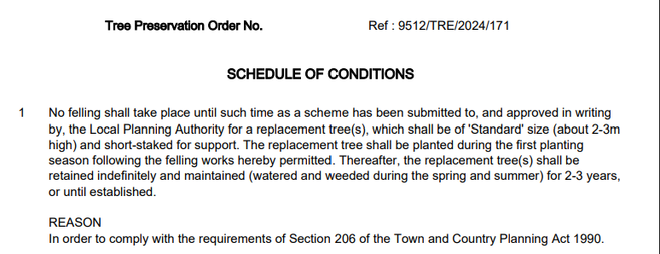
As such, this planning application seeks to ensure the condition is met with the following proposal included within proposed planning drawings:
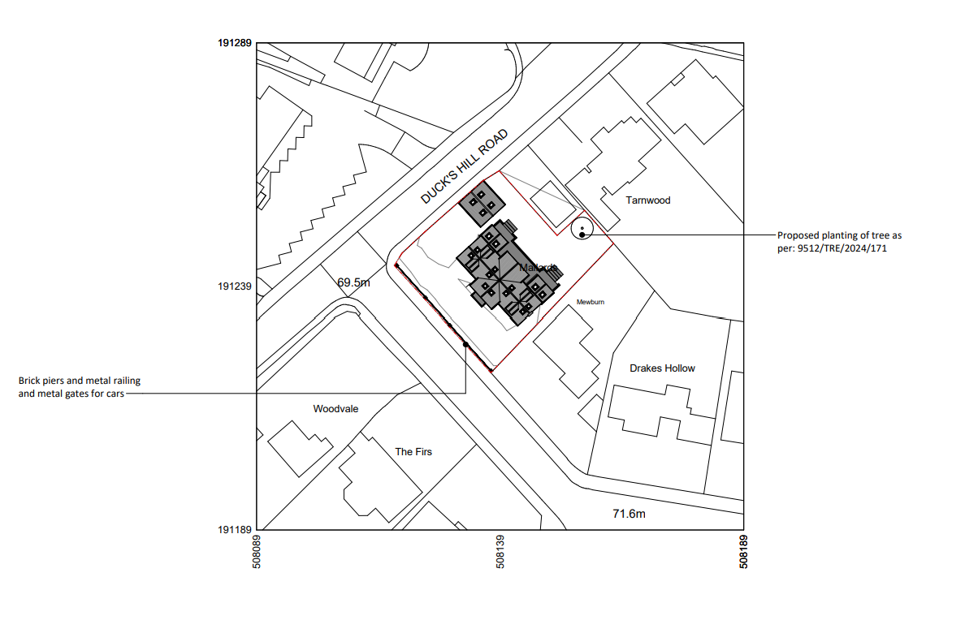
Post-Construction Care:
It is taken under advice that this tree be planted at the completion of construction work in order to minimise tree disruption and allow the tree to settle once planted.
In addition, residents will employ the following post-construction practices to encourage growth and stability:
- Regular checks during the first two years to support overall health, canopy development, and any signs of stress
- Watering checks: Monitor soil moisture levels regularly to encourage root establishment
- Support Review: check tree guards, stakes, and root zones for damage or movement to the support systems
Conclusion:
In line with the tree assessment provided in application 9512/TRE/2024/171, the approval conditions, and the proposed re-planting included in this application, the proposed development does not affect the protected trees on this site or neighbouring properties’ trees within 20m of the planned works. As such, there will be no impact on protected trees as a result of this development, resolving need for specific tree protection plans during construction. The household will take due consideration to their surrounding areas in an effort to limit greenery disruption when carrying out works.
The conditions of application 9512/TRE/2024/171 have also been satisfied within this planning application.

