Material | Image
Bricks
Forterra Clumber Red Mixture | 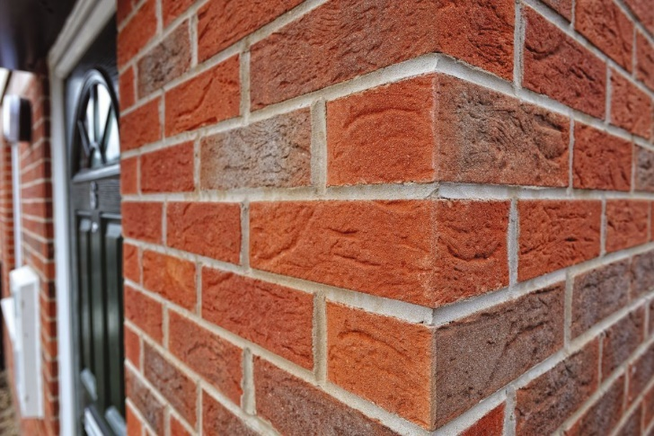
Roof Tiles
Marley Edgemere Slate Grey | 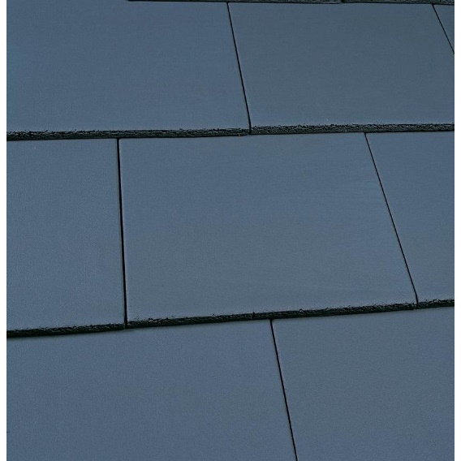
Windows
White uPVC as Architect Elevations | 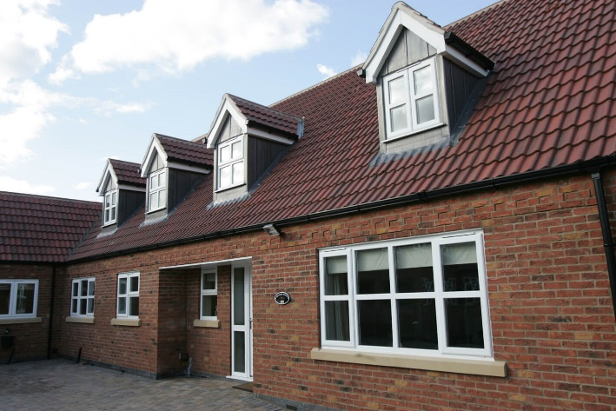  (Indicative Image)
Roof Lights
Velux’s | 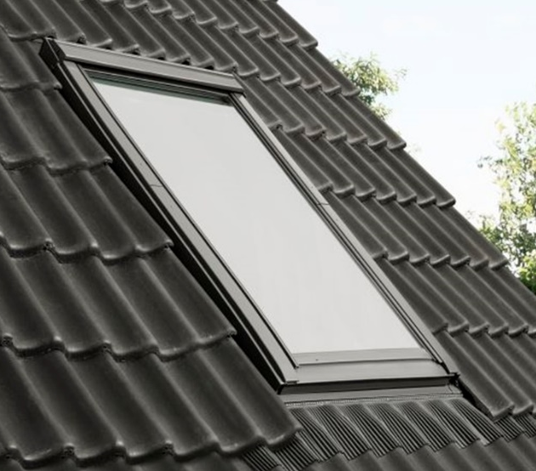  Velux Centre Pivot Roof Window:  (Indicative Image)
Dormers:

Dormers | 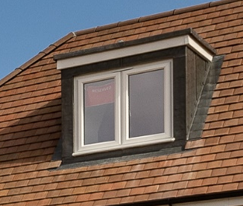  Cut Timbers constructed on site:  (Indicative image)
Guttering and Downpipes:
Black uPVC Deepflow Gutters and Downpipes | 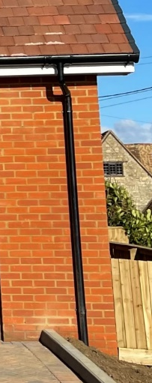  (Indicative image)
Front Door:
Aluminium/Reinforced GRP Communal  Entrance Door | 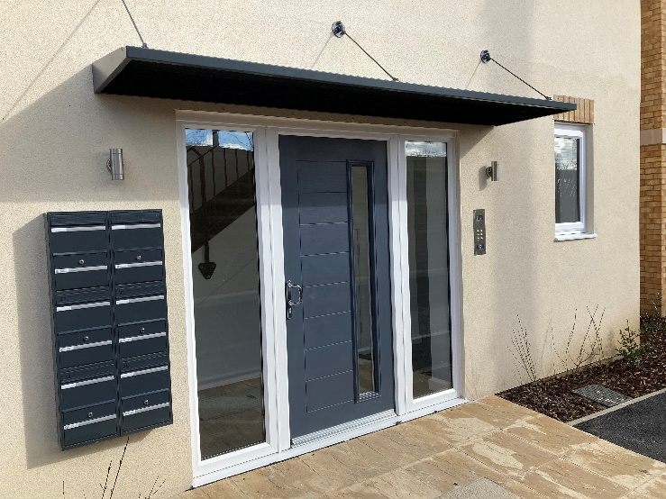  (Indicative Image)
Balconies:
Structural Gun Metal Grey Steel Posts with  Glass Balustrades | 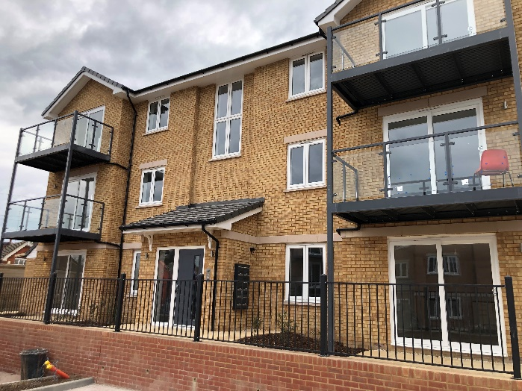  (Indicative image)

