PLANNING STATEMENT

FOR CONVERSION OF EXISTING HOUSE TO 2no FLATS

AT

75 HALSWAY, HAYES, MIDDLESEX, UB3 3JU

FOR

ASIM BUTT

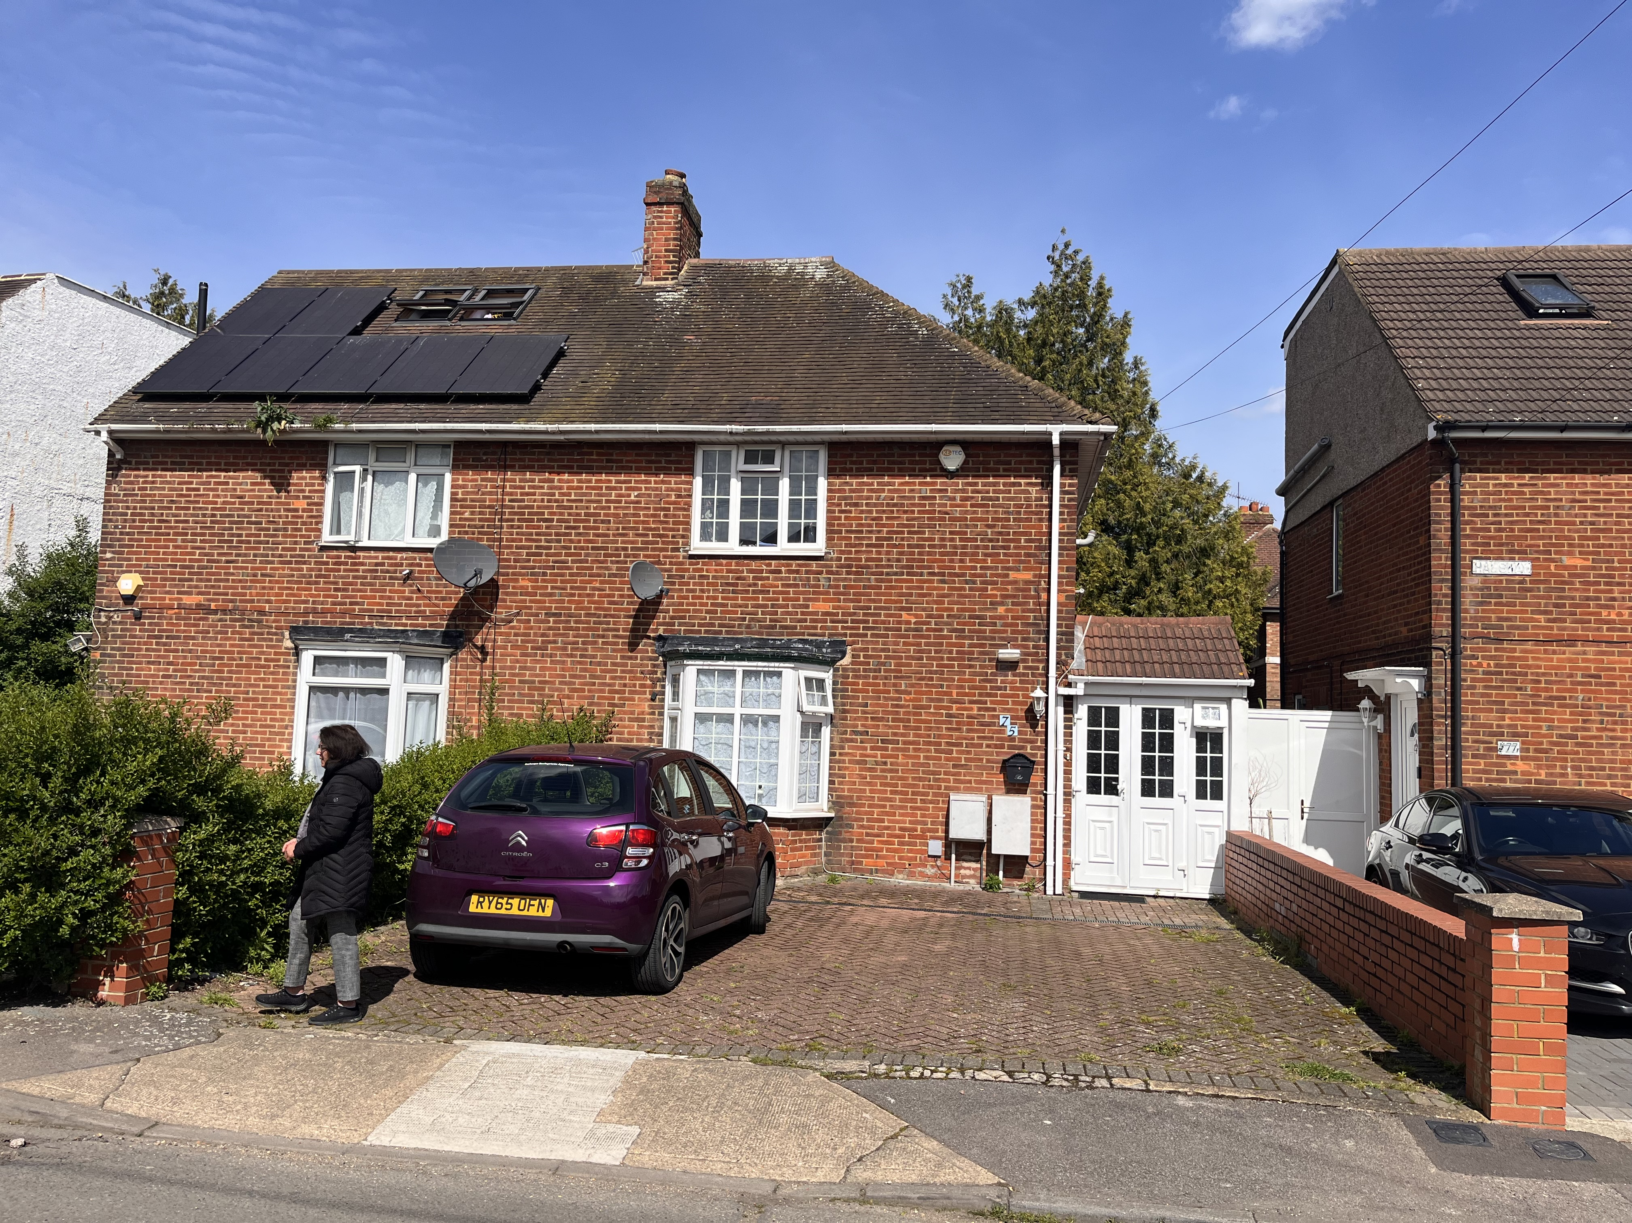



Address : 12 Station Road, London W7 3JE
TEL : 020 8840 7300
FAX : 020 8840 7307 Date: Sept. 2024
Email : tekton.dpw@btconnect.com Ref : 22/508/WR/D&A Stat.
Registered in England No

Introduction

tekton dpw have been instructed by the owner, Asim Butt , to support of a full planning application for the conversion of an existing semi-detached house at 75 Halsway into 2no flats, including parking for 2no cars.

The Planning, Design and Access Statement is submitted in support of the application, pursuant to Paragraph 33 of the Planning Policy Statement - Delivering Sustainable Development - and should be read in conjunction with the submitted application forms, certificate and plans. This Design and Access Statement is also informed by the requirements of CABE’s “Design and Access Statements: How to write, read and use them” (2006).
The primary objectives of this Design and Access Statement are to demonstrate:

                - The principle of this proposal is to improve the existing building
                - The plans submitted with this application represent a carefully considered proposal, incorporating a sensitive approach towards the design and access without compromising the facilities and amenities of the local residents or public.
                - The extension of this building will not affect adversely the character of the listed building, including architectural style, scale, height and rhythm.
                - The proposal provides a sustainable form of development.
Drawings List

This Statement should be read in conjunction with the following drawings:

24/543/PH/01 – SITE PHOTOGRAPHS
24/543/LP/01 – LOCATION PLAN @ 1:1250
24/543/SP/01 – EXISTING SITE PLAN @ 1:500
24/543/SP/02 – PROPOSED SITE PLAN @ 1:500
24/543/SP/01 – EXISTING & PROPOSED LANDSCAPE SITE PLAN @ 1:100
24/543/EX/01 – EXISTING FLOOR PLANS @ 1:100
24/543/EX/02 – EXISTING ROOF PLANS @ 1:100
24/543/EX/03 – EXISTING STREET & EAST ELEVATIONS @ 1:100
24/543/EX/04 – EXISTING GARDEN ELEVATION @ 1:100
24/543/EX/01 – PROPOSED GROUND & FIRST FLOOR PLANS @ 1:100
24/543/EX/02 – PROPOSED SECOND FLOOR & ROOF PLANS @ 1:100
24/543/EX/03 – PROPOSED STREET & EAST ELEVATIONS @ 1:100
24/543/EX/01 – PROPOSED GARDEN ELEVATION @ 1:100

Site Location
75 Halsway is located in the heart of the estate of similar properties built during the 1970’s to meet the growing needs for social housing, it is currently a two storey semi-detached house in a quite street of similar terraced & semi-detached properties.

Total Site Area : 240 sq. m.
Surrounding Land Uses

The application site is located in a generally residential area comprising similar post –war two storey semi & terraced house and flats. The Estate was constructed to provide social housing for families, and provided good space standard’s, and including generous external areas to front and rear of the properties. Locally the area is service by local schools, shops, public facilities and public transport in Hayes Town.
The existing Semi detached house comprises a two storey house providing 3-bedroom accommodation for a single family.

See Drawing No : 24/543/EX/01.

Existing Internal Floor Area - 110.0 sq. m.

Design

Our design philosophy has been to modify and refurbish the existing providing family dwelling by extending the accommodation into the roof and providing new loft extension to increase the total floor area and convert the existing property into two flats. Tiu will meet the growing demand for small affordable accommodation in this area. That meet all the current space standards from the current local plan part 2 – Development Management Polices.

See Drawing No : 24/543/FC/PR/01.
See Drawing No : 24/543/FC/PR/02.

Proposed Internal Floor Areas

Unit 1 – 2bed 4person flat @ 72 sq. m. GFA
Unit 2 – 2bed 2person flat @ 58 sq. m. GFA

Car Parking and Landscape

The overall site benefits from a large open area to the front garden which will be given over to accommodating 3no car parking spaces, bin and bike storage, to meet the local authority standards. The existing site benefits from a drop kerb this is proposed to be extended to accommodate the additional car space and has been applied for from the Hillingdon highways Department.
The rear garden will be given over to providing open space to the ground floor unit.

See Drawing No : 24/543/SP/PR/03.

Scale & Neighbourliness

Overlooking and proximity can sometimes be a problem however this proposal incurs no such problem because the development follows the general pattern locally and will match the neighbouring semi (no 73) creating a match appearance.

Materials & Aesthetics

The choice of materials in this instance is governed by the existing traditional methods of construction, in brickwork, clay tiles and render. The proposal is for new loft and existing alterations uses traditional cavity construction and render. The windows have been replaced with UPVC and the roof will retain its plan roof tiles to match existing.
The front garden hard surfacing is will be constructed in permeable brick paving.

Access

The Street access will be from Halsway and the pedestrian access will be from the front garden area, via level entrances to facilitate disabled access.

Summary

Further more, This proposal not only reflects an ongoing improvement in the condition of the property but ensures that this investment in improvement and enhancement aims to reflect the benefits of modifying and improving the character by the use of good design and will ensure that this listed building continues to give pleasure to villagers and owners alike.

David Williamson riba
tekton dpw limited

September 2024

