TOWERS ASSOCIATES LTD
towers
Harefield Oil Terminal
Harvil Road,
UB9 6JL
01895 812822
Release of conditions:
Site name: Land to the rear of 58 Beechwood Avenue
House Materials: -

Roof tiles – Redland Renown Concrete Roof Tile – Tudor Brown
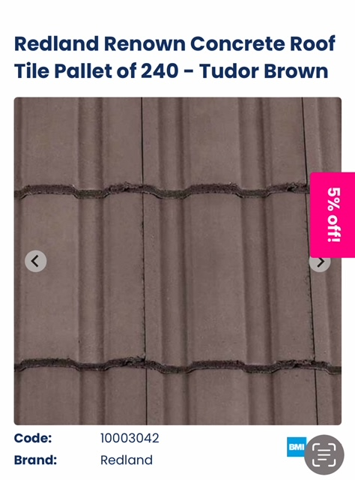

Walls

Brick – Wienberger Charthurst Red Multi Chepstow Multi 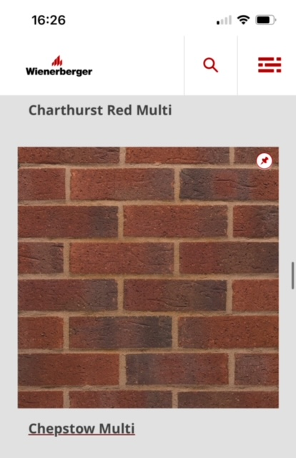

Please note – the planning elevations showed render and brick. The client wishes to use red multi brick throughout, as has been done by other local developments. However, if this is not possible, please do not hesitate to get in touch and we will specify a render if necessary.

Tuscan Red Mu
Fascia & Soffit
Black UPVC
Windows

Rehau Black UPVC
Door
Black composite door , black patio door

