DESIGN & ACCESS STATEMENT

Site Address: 20 The Sigers, Eastcote, HA5 2QH

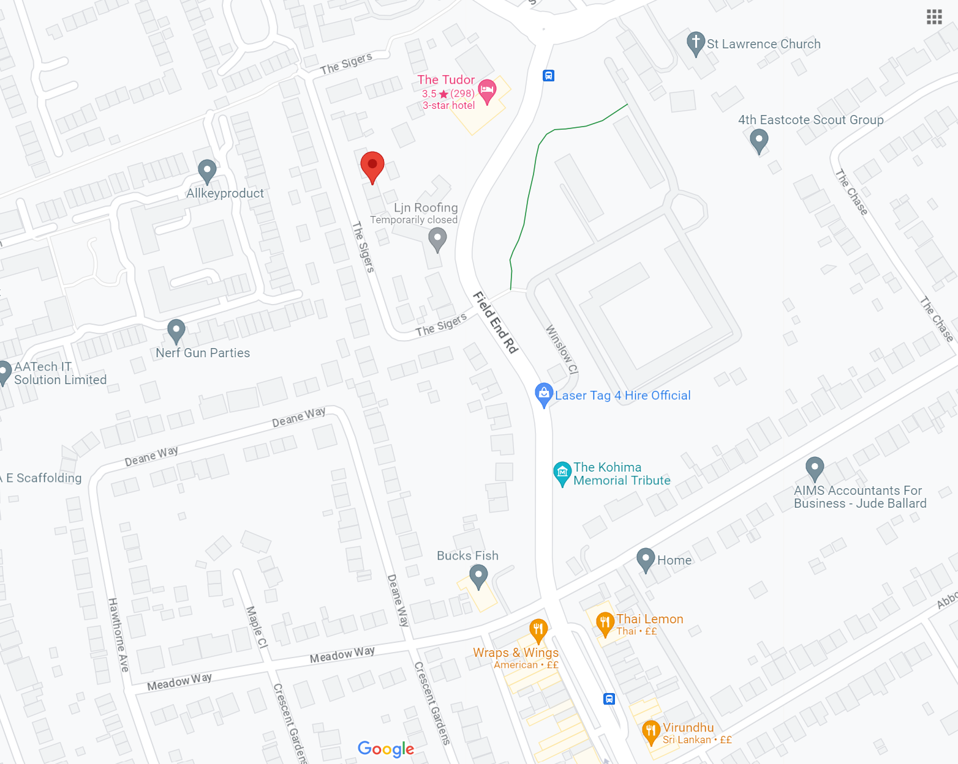

Proposal: Erection of a detached timber shed/outbuilding

Introduction: The applicant seeks to erect a timber garden building in the rear garden which will be used for storage of gardening equipment and seating and occasional use for hobbies such as painting. There is an existing timber garden shed which has gone into disrepair due to leaks in it’s roof and so the applicant is seeking a replacement, but a slightly larger one to make better use of the space.

The proposed shed would sit on existing hardstanding and so wouldn’t result in the loss of any green cover, and it would be no higher than the existing shed. It will not be visible from the maisonette at ground floor (no.18), and not visible from the neighbouring garden no.22 or driveways. There is a 2m high fence/hedge dividing the no.16 The Sigers’ garden and the existing shed is already very slightly visible from no.16, however the proposed shed would not be any higher than the existing. There are 2.5m high fences/hedges or the garage building on all other sides of the garden, which block views of the shed all around.

The proposed shed would cover much less than half of the original garden area. The proposal would meet all the requirements to qualify for permitted development if it were a freehold property.

Permission has also been sought and given by the freeholder of the property.

Area Summary:
20 The Sigers is residential street in Eastcote, Greater London, which is predominantly semi-detached maisonettes and some semi-detached houses.

The property is within a pleasant location and the applicant has been mindful to respect the area and ensure the materials used are timber, in keeping with the existing shed/outbuilding and the neighbouring garden sheds on the street.

Aerial view of site, proposed building in red
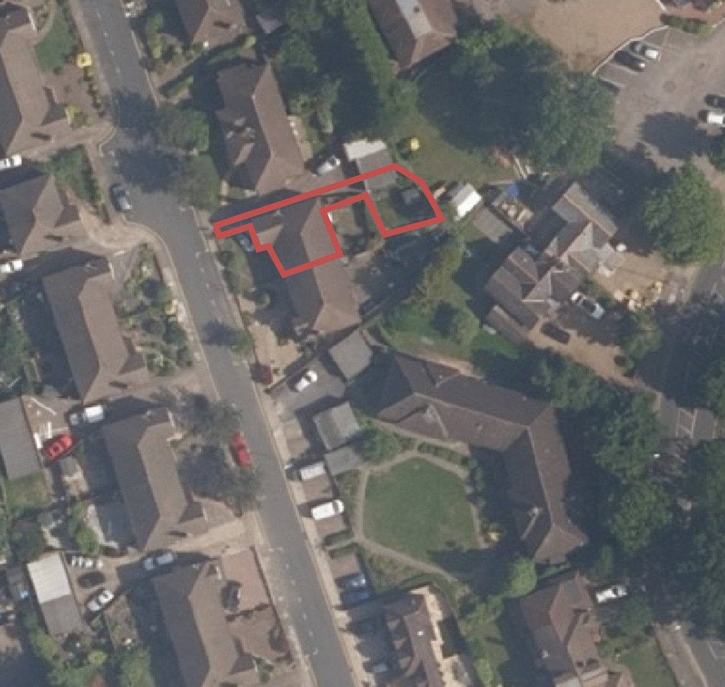
Effect of the proposal on the character & appearance of the area:
The new building will be located in the rear garden and will not be visible from the road.
The new building will not block any light, it will not impact any rights of way or access to this or any other properties.

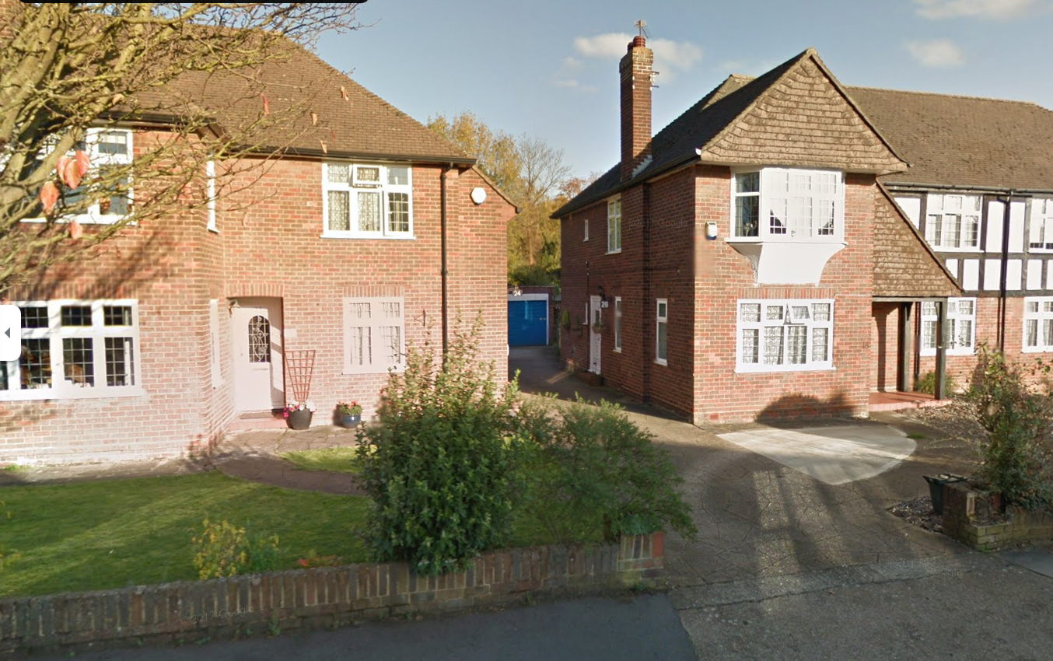
Front or property. Access to garden is to the rear with the entrance adjacent to the blue garage door. Main dwelling residence is to the side of the building.

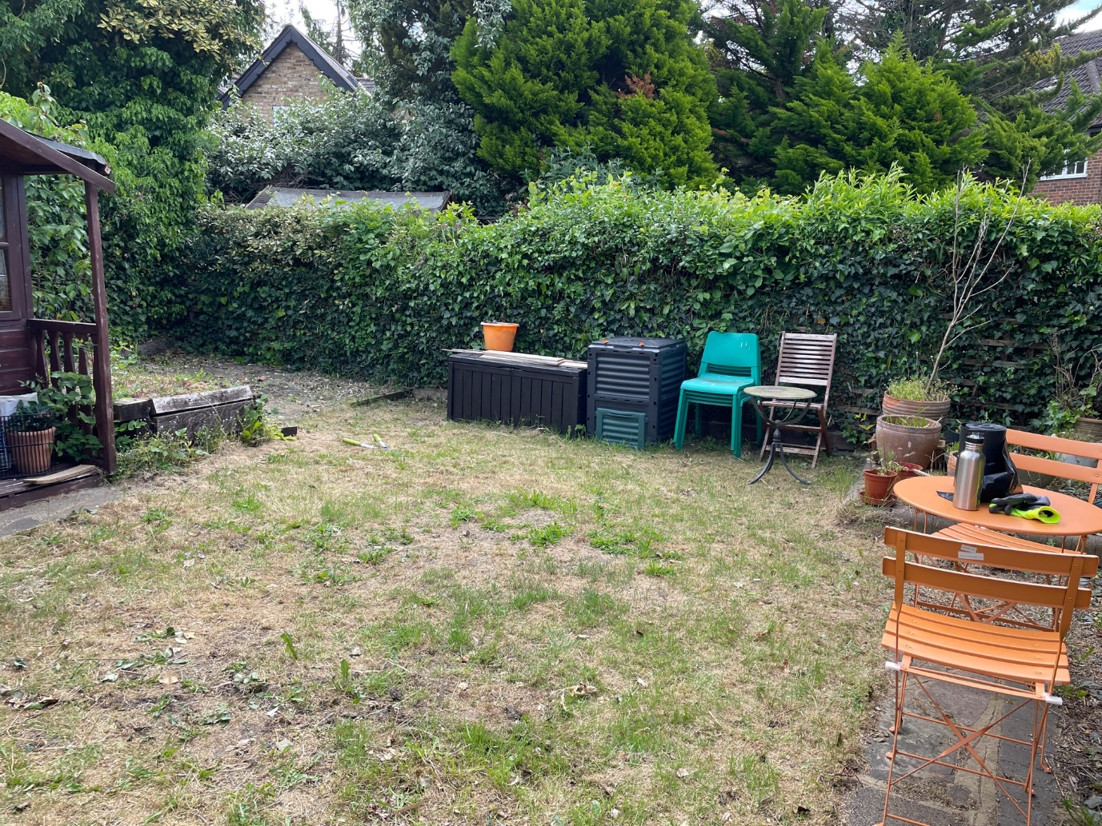
View of garden from the garden entrance which is adjacent to the blue garage door. Fencing and hedges provide screening from the north, east and south of the site. Existing hardstanding where proposed garden shed is proposed.

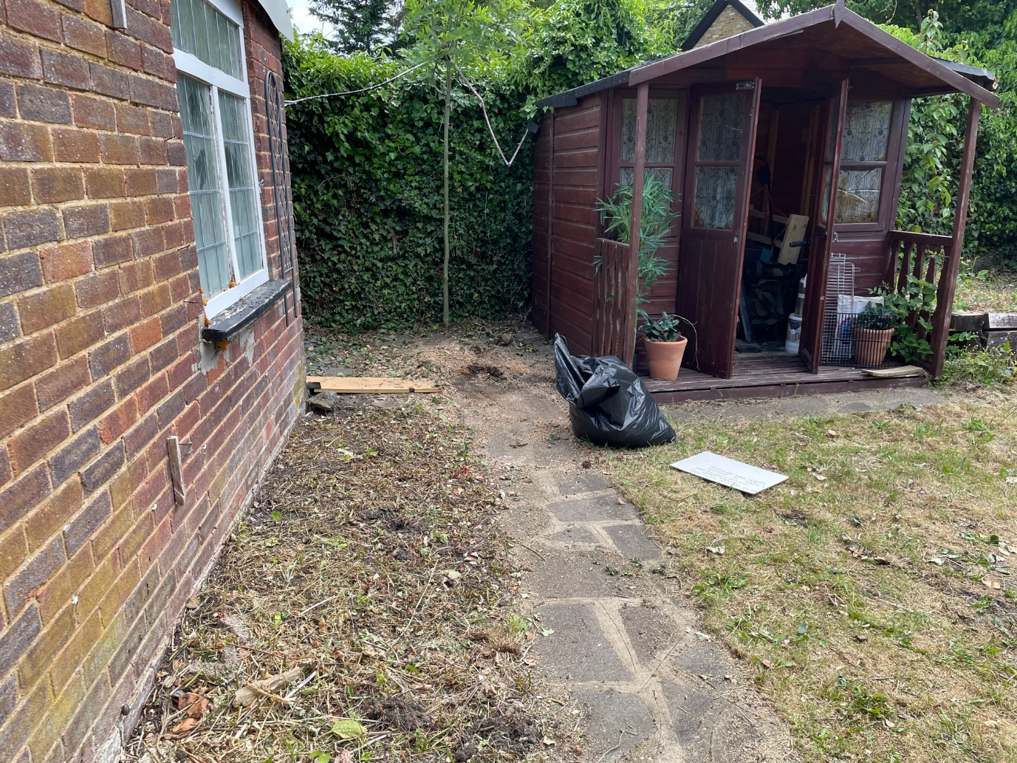
View of the garden from the garden entrance. Existing shed on existing hardstanding. Garage to the left provides screening of garden.

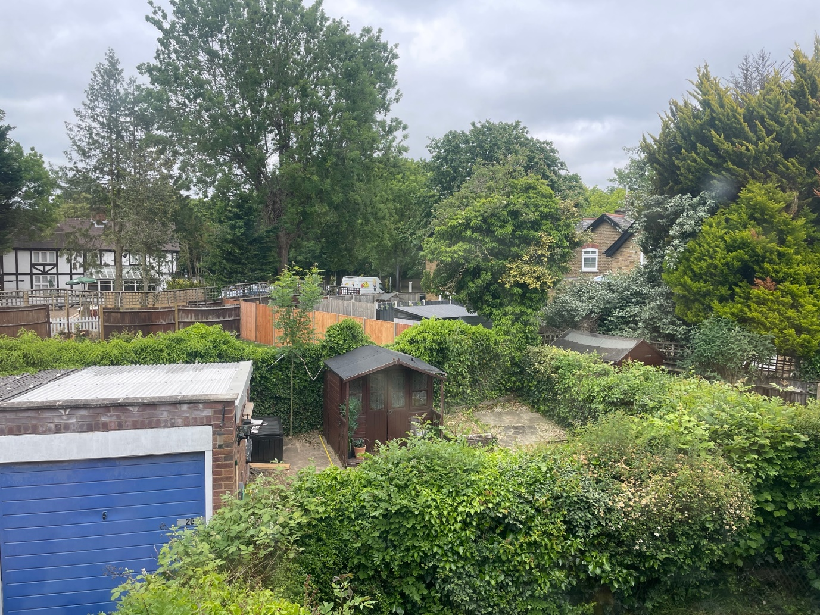
Birds eye view of garden: Proposed shed would be enclosed and screened from all angles.
Design of the building – Scale, Bulk, Design Approach:
The building has a low-key design to blend in with its surroundings and will be thoroughly in keeping with the property and the area. It is made of timber using tongue and groove joinery and can be easily dismantled and moved like a temporary structure if ever required.

Size: 4.5m x 3m
Internal measurements 4300mm x 2800mm (12sq metres)
Max internal height of 1.9m at the highest point
Roof height of 2.15m
Flat pent roof
Access to the building is via a simple set of double doors.
Walls: Elevated & insulated floor on 150mm joists with T&G flooring over. All timbers are stained and fully pressure treated.
EXTERIOR COLOUR = Natural timber
Windows: Timber framed double glazed windows
Doors: Timber framed
Roof: Flat pent roof with mineral felt covering – same as existing
The proposed building can be installed in two days which will create minimal disturbance for neighbours.
The building can be deconstructed and moved and are therefore not considered as permanent structures.

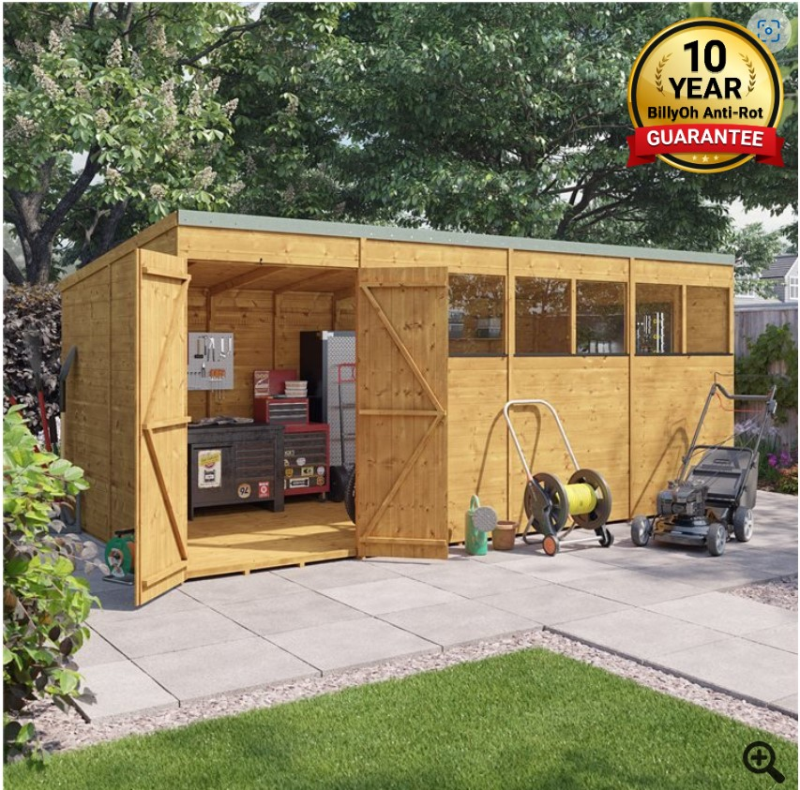
Style and size of proposed garden shed (not actual image) Please refer to plans for exact location of windows and door.
Rainwater Mitigation
The garden shed will be sited on existing hardstanding. The garden shed will be installed with guttering to the rear with a downpipe, which will be fed into a water butt.
Therefore, the installation of this garden building should not cause any concerns in terms of rainwater dispersion. As the shed is proposed on existing hardstanding, it is not considered that any natural drainage would be lost as a result of this proposal. Further, the site is not within an area of flood risk.

Amenity of neighbouring occupiers:
The size, height and outlook of the structure prevent it giving rise to any residential amenity concerns in relation to privacy, overlooking or daylight and sunlight.
The rear garden is bordered by fencing and 2m high hedges to the rear, front and side, with a 2.5m high garage building to the other side (leading to the garden entrance and driveway), and so the building won’t have any greater impact on views than the existing garden shed.
The neighbouring properties on The Sigers have a variety of different outbuildings in their rear gardens, varying in sizes, heights and designs. The structure is therefore considered to be acceptable with regards to the amenity of neighbouring occupiers.
Effect on trees and landscape / Biodiversity:
The proposed garden shed has no impact on trees of amenity value, nor does it unacceptably affect the landscape or biodiversity value of the property’s garden. The building will be installed on existing hardstanding and so it will be extremely quick to install and the not intrusive to surrounding vegetation.

Conclusion:
The proposed garden shed will be used as a garden storage and seating as well as occasional use for hobbies such as painting, allowing the applicant the flexibility to enjoy the garden more whilst still retaining the green cover.

The building is designed to respect the character, form, scale, and materials of the property and surrounding area. The height is limited to match the existing garden shed and so it is not expected that there will be any additional impact compared to the existing.

It is therefore considered that the proposal will have no harmful effect on the character and appearance of the surrounding area, and no negative effect in terms of loss of green space and biodiversity due to the shed being built on existing hardstanding.

