DESIGN STATEMENT - LOFT
5 BARWICK DRIVE

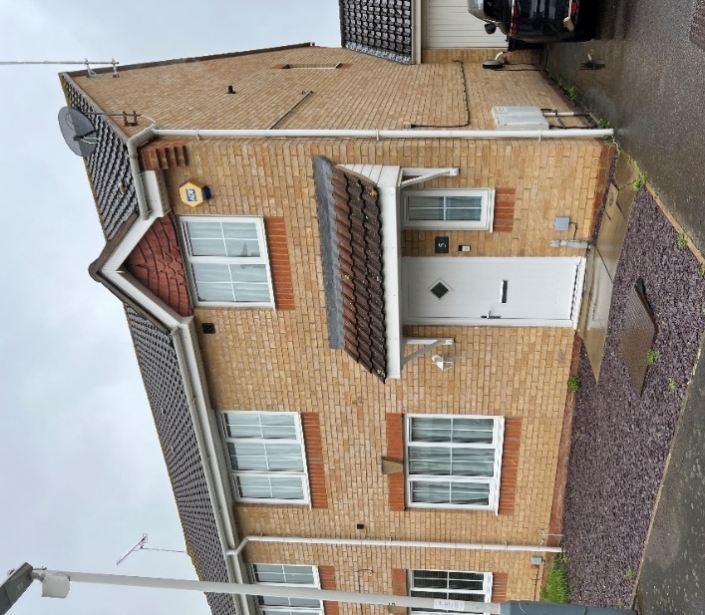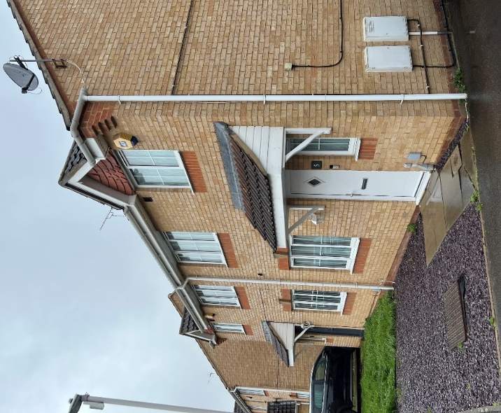
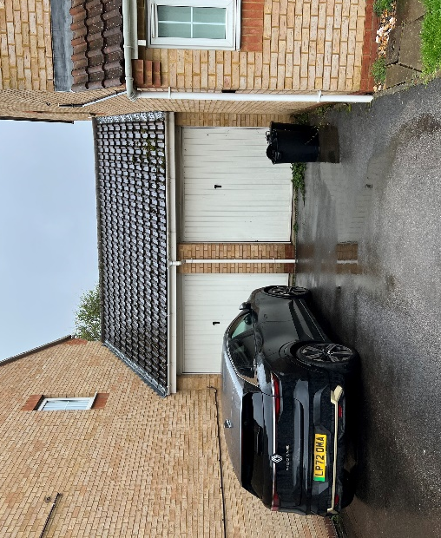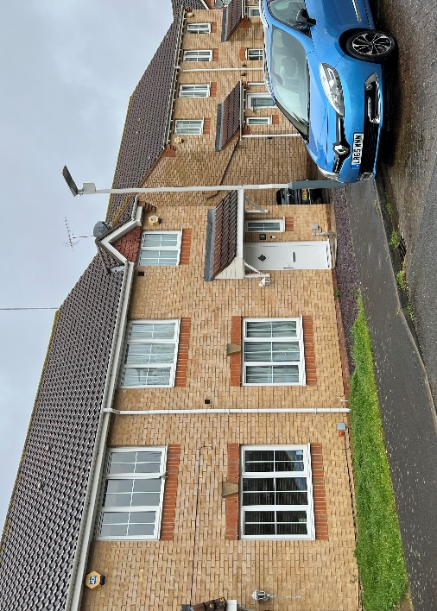
Front of house

GENERAL
The house is within a development of similar 2 storey, 3 and 4 bedroom, houses which form a quiet cul-de-sac off the busy A437, Harlington Road . The ground floor of No 5 has a small kitchen but no laundry space. On the first floor there are 2 double bedrooms and one single bedroom. Planning permission was granted 1st August 2023 (your ref 78046/APP/2023/1476) for a single storey rear extension.
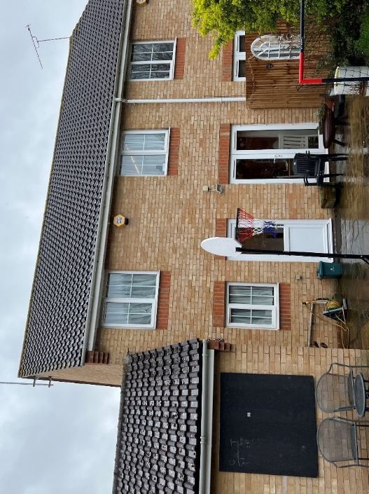
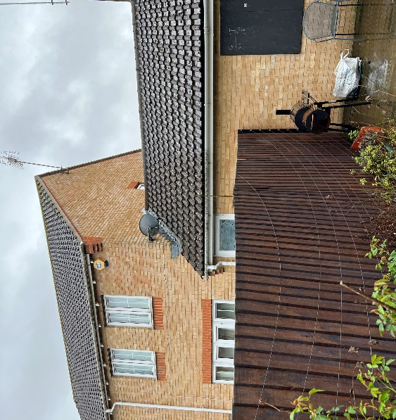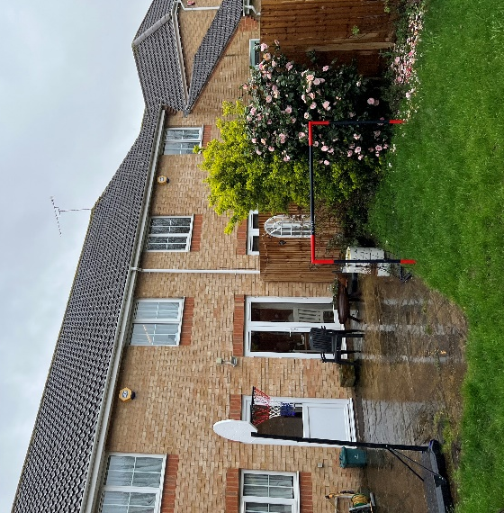
Rear of house
PROPOSAL
Additional spaces are needed to accommodate working from home and a third double bedroom is necessary to accommodate the growing family
A loft conversion is proposed. This meets the criteria of the Hillingdon Local Plan: Part two – Development Management Policies (2020) for roof extensions.
MATERIALS
New materials are to match the existing i.e. Roofing tiles to the dormer cheeks and white Upvc windows to match the existing the same size as the existing. Velux type roof windows are proposed to the front roof slope.
TM: 30 August 2023

