DESIGN STATEMENT
5 BARWICK DRIVE

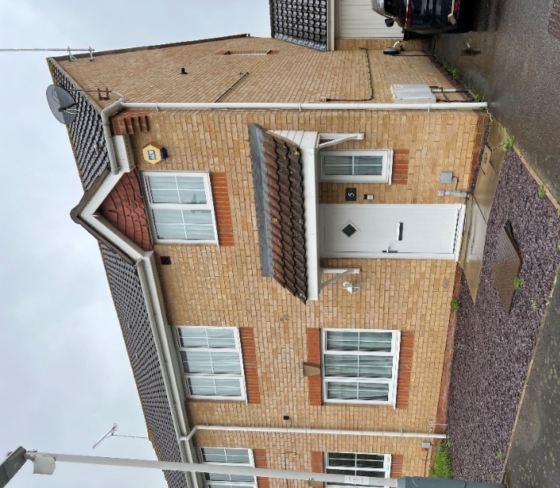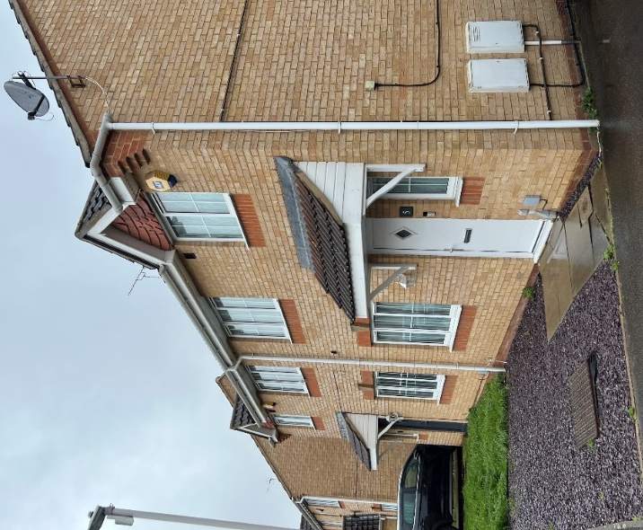
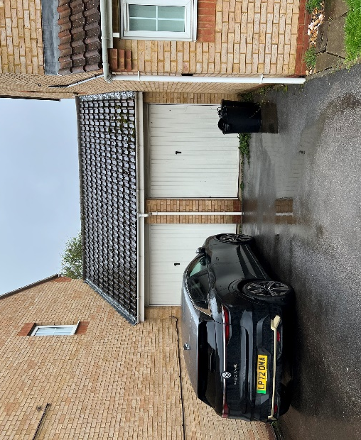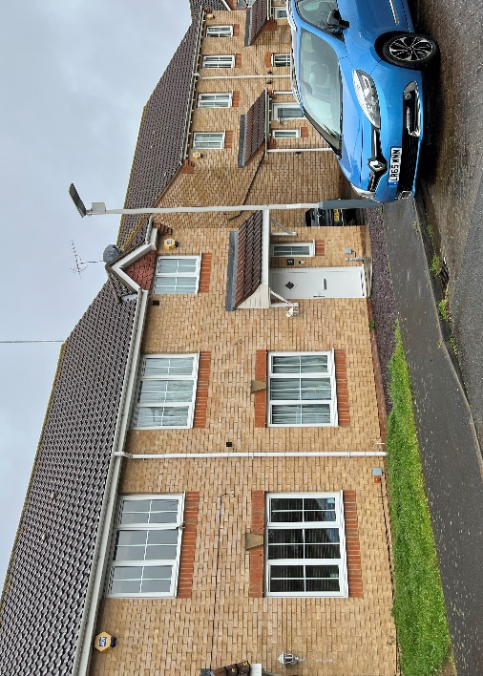
Front of house

GENERAL
The house is within a development of similar 2 storey, 3 and 4 bedroom, houses which form a quiet cul-de-sac off the busy A437, Harlington Road . The ground floor of No 5 has a small kitchen but no laundry space. On the first floor there are 2 double bedrooms and one single bedroom. Additional living spaces are needed to accommodate working from home and a third double bedroom is necessary to accommodate the family
.
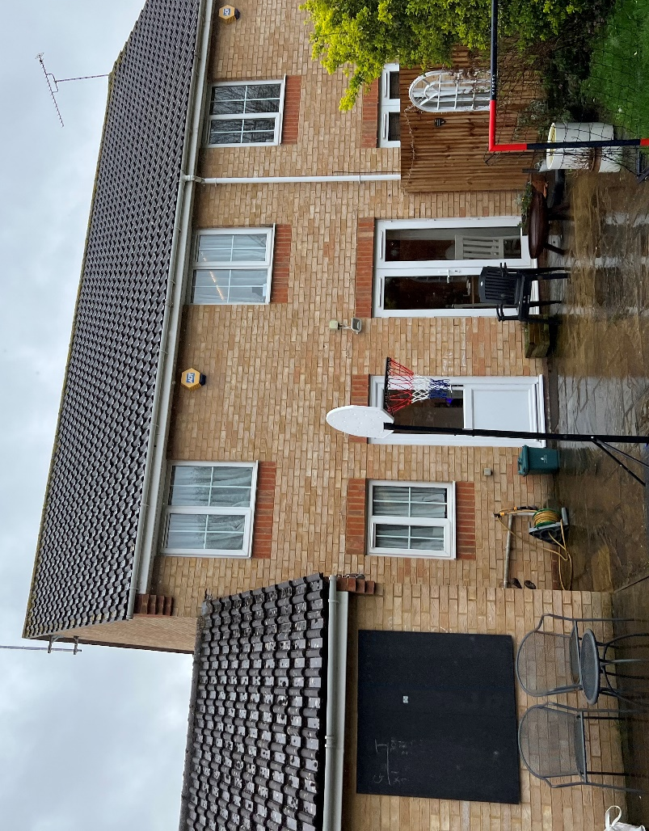
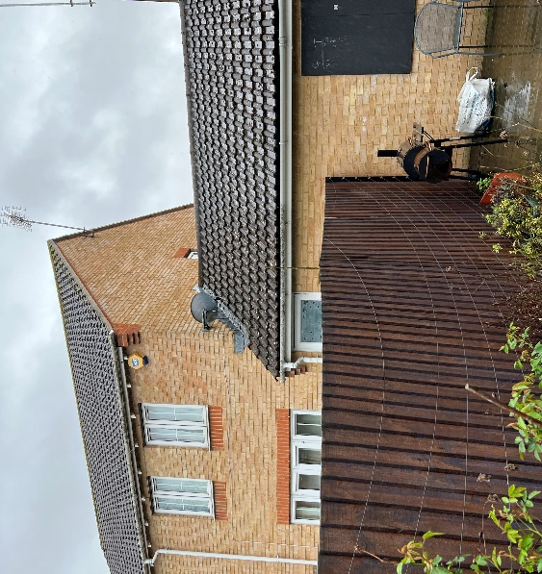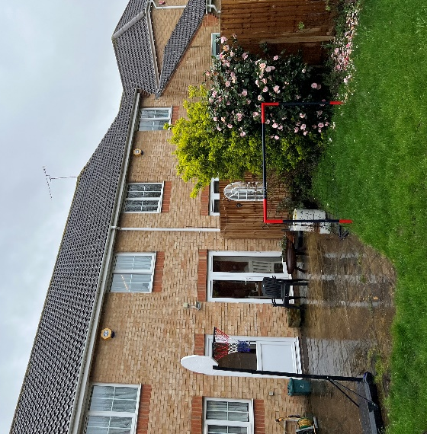
Rear of house

PROPOSAL
A single storey rear extension is proposed 3.3 meters deep, which is less than the 3.6 meters maximum depth stated in the Borough’s HDAS document for houses more than 5.2 meters wide. This extension is to have a flat roof 2.6 meters above ground level with brick parapets so there will be no need for gutters on the boundary. The top of the parapets will be 3.00 meters above ground level (i.e. less than 3.1 meters mentioned in the Borough’s guidance). The foundation of the new wall on the south west will be off-set so that it will not encroach onto the neighbours property.
The kitchen is to be re-located and will be larger to accommodate a washing machine and dryer.
A loft conversion is proposed to accommodate a new double bedroom and a study. The volume of the extension will be 29 square meters which is less than 40 square meters in accordance with permitted development.
The existing windows are small making the interior of the house rather dark. Therefore large glass sliding doors and a flat rooflight are proposed to the ground floor living area. The first floor landing is very dark. A new window on the side of the loft will bring natural light to the top of the stair and to the first floor landing. To comply with permitted development requirements the window will be non-openable and have obscured glass.
MATERIALS
New brickwork, (including corbel details and soldier courses) roof tiles and hung tiles to gables are to match the existing. New windows to landing and loft are to be white Upvc to match the existing. The sliding doors are to be aluminium with a grey powder coated finish.
ACCESS
The small step which provides easy disabled access at the front door is to be retained. The new sliding doors will have a level threshold with a drainage channel to provide easy access to the garden.

TM: 19 May 2023

