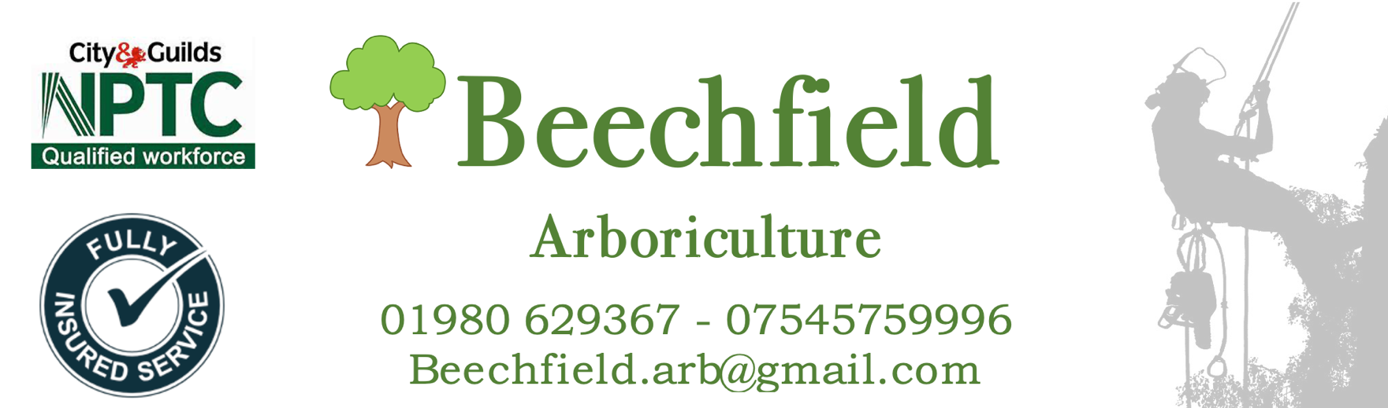
Tree Report for
ROBINS CLOSE, UXBRIDGE UB8 2LL

SITE 3

Contents
Tree report and colour coded work schedule
- Individual tree ID number (trees have been marked with corresponding number)
- Species of tree
- Estimated height of the tree
- DBH (Diameter at breast height) Trunk Circumference measured at 1.5m from highest soil line
- Estimated age of tree (using mitchell's rule at 25mm)
- Observations/comments/notes made of the tree
- Safety or maintenance requirements
- Tree maintenance recommendations follow British Standard 3998:2010 - Tree Work Recommendations.
- The maintenance advice has been triaged into

  - RED – Denoting that urgent work will need to be completed as a priority due to a safety concern or imminent risk
  - AMBER – Denoting that maintenance that will be required this year to benefit the trees development
  - GREEN – Denoting that no maintenance required this year
Tree Preservation Order (TPO)
There is a TPO for this site which is included for your convenience. Prior to any work being started permission must be granted by the tree protection office in accordance with the TPO or a fine of up to £20,000 could be enforced per tree worked on.
British Standard 3998:2010 - Tree Work Recommendations.
The British Standard regulating some of the technical operations carried out by an Arborist (tree surgeon) It gives guidance on management options for established trees.
Site 3 – ROBINS CLOSE, UXBRIDGE UB8 2LL Friday 16th December 2022
Tree ID Number | Tree Species | Tree Height (m) approx. | Trunk  (DBH)  (mm) | Age  Estimate | Condition/  Comments | Maintenance  Advice
03/001 | Willow, crack  (Salix fragilis) | 17 | 3400 | 136 | Tree is in very poor condition. Recent pollard (2-3 years). Multiple hole and cavities in limbs and trunk. Evidence of bracket fungus on limbs. Multiple dead/cracked limbs. Poses a threat to people and property. | Remove  Note will require bat inspection prior to removal
03/0022 | Sycamore  (Acer pseudoplatanus) | 8 | Multi stem | 30 | Tree in poor condition with a heavy congested canopy. Unfortunately, the lack of maintenance has caused damage to the tree | Remove
03/003 | Cherry  (Prunus avium) | 10 | 1270 | 51 | Healthy tree just needing routine maintenance | Canopy Reduction
03/004 | Crab Apple  (Malus sylvestris) | 9 | 1000 | 40 | Promote growing straighter by removing unbalanced lower limb | Canopy Reduction
03/005 | Sycamore  (Acer pseudoplatanus) | 15 | 1600 | 64 | Healthy tree with a slight lean, will just needing routine maintenance. | Canopy Reduction
03/006 | Sycamore  (Acer pseudoplatanus) | 8 | 1200 | 48 | Poorly maintained. The canopy will need some maintenance | Canopy Reduction with thinning
03/007 | Cherry  (Prunus avium) | 6 | 540 | 22 | Healthy tree growing well | No maintenance required
03/008 | Crab Apple  (Malus sylvestris) | 6 | 900 | 36 | Healthy tree growing well | No maintenance required
03/009 | Sycamore  (Acer pseudoplatanus) | 4 | 610 | 24 | Due age-related maintenance and removal of deadwood | Remove deadwood and crossing branches
Tree ID Number | Tree Species | Tree Height (m) approx. | Trunk  (DBH)  (mm) | Age  Estimate | Condition/Comments | Maintenance  Advice
03/010 | Sycamore  (Acer pseudoplatanus) | 5 | 710 | 28 | Healthy tree growing well but needs some shaping | Reduction and crown raise Canopy
Number Of Trees  To Be Removed/Priority Maintenance Required | Number Of Trees That Require Routine Maintenance | Number Of Trees That Require No Interventions
2 | 6 | 2
Summary
Trees in this site are generally heathy but due to no maintenance in the past they will require a reduction of the canopy to promote a canopy that will cause less issues in the future. 03/001 will need to be inspected for bat habitat before work commences.
Moving forward the trees will need to be maintained by a professional arborist working to BS3998:2010 every 1-2 years depending on the extent of the damaged caused previously.
Due to this being a residential area, a recommendation would be made to replant removed trees. With a suitable replacement. With an acceptation to the diseased cherry trees and trees interfering with properties.

Survey completed by
Karl Bulpitt FdSc DipArb

