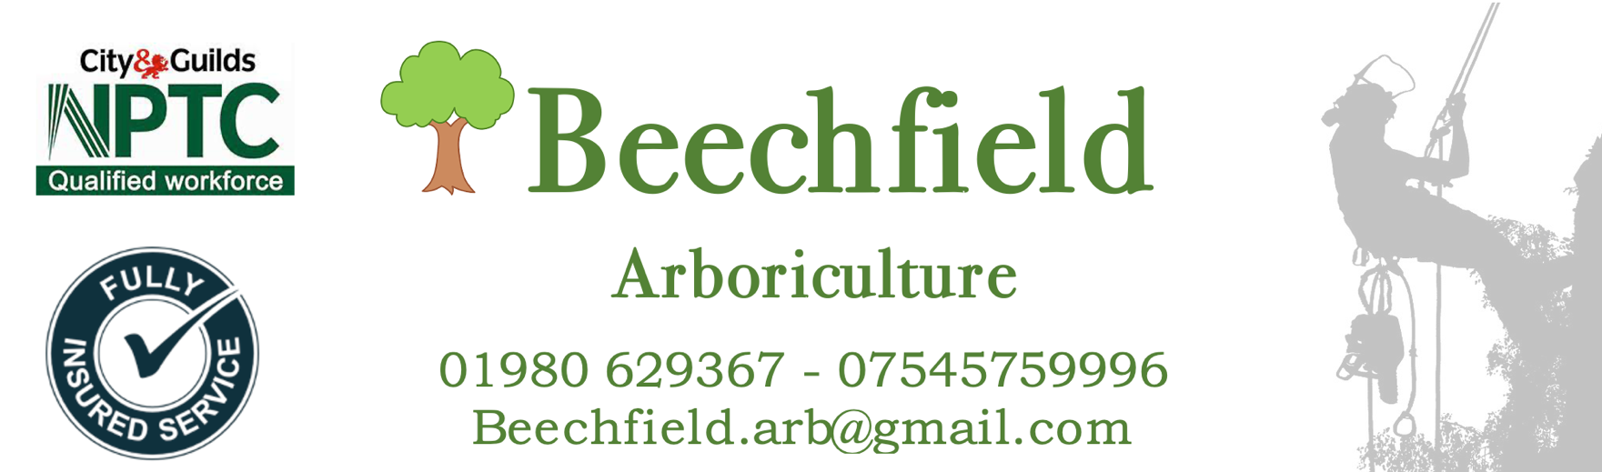
Tree Report for
NEW COURT, UXBRIDGE UB8 2LL

SITE 2

Contents
Tree report and colour coded work schedule
- Individual tree ID number (trees have been marked with corresponding number)
- Species of tree
- Estimated height of the tree
- DBH (Diameter at breast height) Trunk Circumference measured at 1.5m from highest soil line
- Estimated age of tree (using mitchell's rule at 25mm)
- Observations/comments/notes made of the tree
- Safety or maintenance requirements
- Tree maintenance recommendations follow British Standard 3998:2010 - Tree Work Recommendations.
- The maintenance advice has been triaged into

  - RED – Denoting that urgent work will need to be completed as a priority due to a safety concern or imminent risk
  - AMBER – Denoting that maintenance that will be required this year to benefit the trees development
  - GREEN – Denoting that no maintenance required this year
Tree Preservation Order (TPO)
There is a TPO for this site which is included for your convenience. Prior to any work being started permission must be granted by the tree protection office in accordance with the TPO or a fine of up to £20,000 could be enforced per tree worked on.
British Standard 3998:2010 - Tree Work Recommendations.
The British Standard regulating some of the technical operations carried out by an Arborist (tree surgeon) It gives guidance on management options for established trees.
Site 2 – NEW COURT, UXBRIDGE UB8 2LL Friday 16th December 2022
Tree ID Number  TPO REF | Tree Species | Tree Height (m) approx | Trunk  (DBH)  (mm) | Age  Estimate | Condition/  Comments | Maintenance  Advice
02/001  T101 | Common Beech  (Fagus sylvatica) | 12 | 1840 | 74 | Healthy tree that needs to be reduced and shaped. | 20% CANOPY REDUCTION
02/002  T105 | Cherry  (Prunus avium) | 10 | 1700 | 68 | Poorly maintained, extensive deadwood and crossing/rubbing branches. | 20% CANOPY REDUCTION, THINNING, REMOVE DEADWOOD
02/003  NOT LISTED | Sycamore  (Acer pseudoplatanus) | 12 | 1740 | 70 | Healthy tree that needs to be reduced and shaped. | 20% CANOPY REDUCTION
02/004  T107 | Cherry  (Prunus avium) | 8 | 1450 | 58 | Poorly maintained, extensive deadwood and crossing/rubbing branches. | 20% CANOPY REDUCTION,  THINNING, REMOVE DEADWOOD
02/005  T108 | Norway Maple (Acer platanoides) | 8 | 1690 | 67 | Healthy tree that needs to be reduced and shaped. | 20% CANOPY REDUCTION
02/006  NOT LISTED | Norway Maple (Acer platanoides) | 10 | 1300 | 52 | Healthy tree that needs to be reduced and shaped. | 20% CANOPY REDUCTION
02/007  T110 | Norway Maple (Acer platanoides) | 10 | 1300 | 52 | Healthy tree that needs to be reduced and shaped. | 20% CANOPY REDUCTION
02/008  T112 | Norway Maple (Acer platanoides) | 12 | 1750 | 70 | Healthy tree that needs to be reduced and shaped. | 20% CANOPY REDUCTION
02/009  T114 | Common Beech  (Fagus sylvatica) | 15 | 1670 | 66 | Healthy tree that needs to be reduced and shaped. Some branches nearing property. | 20% CANOPY REDUCTION  REMOVE BRANCHES NEARING PROPERTY
Tree ID Number  TPO REF | Tree Species | Tree Height (m) approx | Trunk  (DBH)  (mm) | Age  Estimate | Condition/  Comments | Maintenance  Advice
02/010  NOT LISTED | Sycamore  (Acer pseudoplatanus) | 6 | 380 | 16 | Healthy tree that needs to be reduced and shaped. | 20% CANOPY REDUCTION
02/011  T103 | Norway Maple (Acer platanoides) | 6 | 1150 | 46 | Heathy tree with good shape | NO MAINTENANCE REQUIRED
02/012  T102 | Norway Maple (Acer platanoides) | 7 | 1350 | 54 | Generally untidy. Branches have been cut badly in the past causing abnormal shape and deadwood | 20% CANOPY REDUCTION,  THINNING, REMOVE DEADWOOD.
02/013  NOT LISTED | Cherry  (Prunus avium) | 5 | 1210 | 48 | Very congested canopy, significant amounts of crossing and rubbing branches. | 20% CANOPY REQUIRES THINNING
02/014  NOT LISTED | Norway Maple (Acer platanoides) | 5 | 800 | 32 | Multiple reseeded regrowth, main tree itself is healthy but is being suffocated. | REMOVE REGROWTH LEAVING LARGEST TREE WHICH WILL NEED 20% CANOPY REDUCTION
02/015 NOT LISTED | Silver Birch  (Betula pendula) | 4 | 480 | 19 | Healthy tree but some dead wood where the leader had been damaged. | 20% CANOPY REDUCTION,  REMOVE DEADWOOD TRY TO RESHAPE
02/016  NOT LISTED | Sycamore  (Acer pseudoplatanus) | 5 | 820 | 33 | Canopy has become congested and heavy. | 20% REQUIRES CANOPY THINNING
02/017  NOT LISTED | Cherry  (Prunus avium) | 6 | 1070 | 43 | Ivy clad, Poor pruning has led to a misshapen tree. | REMOVE
02/018  T146 | Norway Maple (Acer platanoides) | 12 | 1660 | 66 | Healthy tree that needs to be reduced and shaped. | 20% CANOPY REDUCTION,  REMOVE DEADWOOD
Tree ID Number | Tree Species | Tree Height (m) approx. | Trunk  (DBH)  (mm) | Age  Estimate | Condition/Comments | Maintenance  Advice
02/019  T144 | Rowan  (Sorbus aucuparia) | 12 | 1340 | 54 | Healthy tree that needs to be reduced and shaped. | 20% CANOPY REDUCTION,  REMOVE DEADWOOD
02/020  T143 | Silver Birch  (Betula pendula) | 10 | 1120 x2 |  | Healthy tree that needs to be reduced and shaped. | 20% CANOPY REDUCTION
02/021 T147 | Silver Birch  (Betula pendula) | 12 | 150 | 6 | Healthy tree that needs to be reduced and shaped. | 20% CANOPY REDUCTION
02/022  NOT LISTED | Cherry  (Prunus avium) | 6 | 1000 | 40 | Healthy tree that wouldn’t benefit from any maintenance this year. | NO MAINTENANCE REQUIRED
02/023  NOT LISTED | Common Beech  (Fagus sylvatica) | 5 | 970 | 39 | Healthy tree that needs to be reduced and shaped. | 20% CANOPY REDUCTION
02/024  NOT LISTED | Sycamore  (Acer pseudoplatanus) | 10 | 1680 | 68 | Healthy tree that needs to be reduced and shaped. | 20% CANOPY REDUCTION
02/025  T100 | Silver Birch  (Betula pendula) | 8 | 780 | 31 | Healthy tree that needs to be reduced and shaped. | 20% CANOPY REDUCTION
02/026  T99 | Silver Birch  (Betula pendula) | 15 | 780 | 31 | Healthy tree that needs to be reduced and shaped. | 20% CANOPY REDUCTION

Summary
The trees surveyed shows evidence of either no maintenance or poor maintenance technique that has had an impact on how the trees present. This is evident by deadwood stubs and sporadic epicormic growth, showing that the tree is struggling.
Moving forward the trees will need to be maintained by a professional arborist working to BS3998:2010 every 1-2 years depending on the extent of the damaged caused previously.
Due to this being a residential area, a recommendation would be made to replant removed trees. With a suitable replacement. With an acceptation to the diseased cherry trees and trees interfering with properties.

Number Of Trees To Be Removed | Number Of Trees That Require Maintenance | Number Of Trees That Require No Interventions
1 | 22 | 2

Survey completed by
Karl Bulpitt FdSc DipArb

