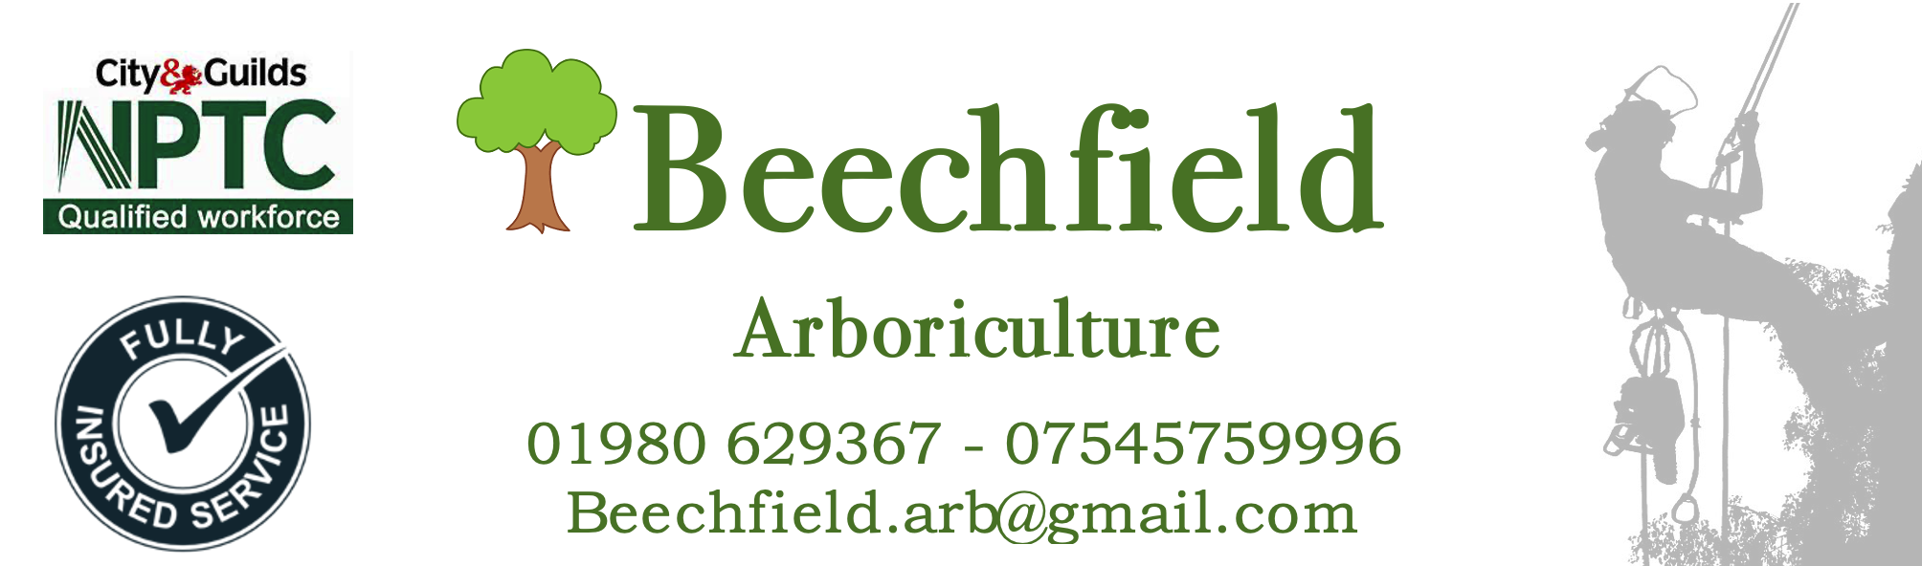
Tree Report for
VERONA CLOSE, UXBRIDGE UB8 2LL

SITE 1

Contents
Tree report and colour coded work schedule
- Individual tree ID number (trees have been marked with corresponding number)
- Species of tree
- Estimated height of the tree
- DBH (Diameter at breast height) Trunk Circumference measured at 1.5m from highest soil line
- Estimated age of tree (using Mitchell’s rule at 25mm)
- Observations/comments/notes made of the tree
- Safety or maintenance requirements
- Tree maintenance recommendations follow British Standard 3998:2010 - Tree Work Recommendations.
- The maintenance advice has been triaged into

  - RED – Denoting that urgent work will need to be completed as a priority due to a safety concern or imminent risk
  - AMBER – Denoting that maintenance that will be required this year to benefit the trees development
  - GREEN – Denoting that no maintenance required this year
Tree Preservation Order (TPO)
There is a TPO for this site which is included for your convenience (at back of report). Prior to any work being started permission must be granted by the tree protection office in accordance with the TPO or a fine of up to £20,000 could be enforced per tree worked on.
British Standard 3998:2010 - Tree Work Recommendations.
The British Standard regulating some of the technical operations carried out by an Arborist (tree surgeon) It gives guidance on management options for established trees.
Site 1 – VERONA CLOSE, UXBRIDGE UB8 2LL Friday 16th December 2022
Tree ID Number  TPO Reference | Tree Species | Tree Height (m) aprox | Trunk  (DBH)  (mm) | Age  Estimate | Condition/  Comments | Maintenance  Advice
01/001  Not listed | Sycamore  (Acer pseudoplatanus) | 8 | 1020 | 41 | Healthy tree but showing signs of dead wood in the canopy. Damage could be from animals or poor pruning. | 20% CANOPY REDUCTION
01/002  Not listed | Sycamore  (Acer pseudoplatanus) | 8 | 1020 | 41 | Large canopy tree encroaching on adjacent property. 2.3 m from building. Root system would undoubtably be compromising the properties foundation integrity. | REMOVE TREE DUE TO INTERACTION WITH PROPERTY. WILL ALSO REQUIRE STUMP GRINDING TO ELIMINATE REGROWTH.
01/003  T83 | Sycamore  (Acer pseudoplatanus) | 10 | 1510 | 60 | Multi stem tree with Codominant Stems. Tree is leaning heavily towards property and at risk of hitting building if union was to fail. | REMOVE TREE DUE TO INTERACTION WITH PROPERTY
01/004  Not listed | Hawthorne  (Crataegus monogyna) | 5 | 450 x 2 | 18 | In poor health, multi stem tree with fence compartmentalised. The tree would never be able to be shaped after the neglect. | REMOVE TREE DUE TO THE POSITION OF THE TREE
01/005  T78 | Common Beech  (Fagus sylvatica) | 13 | 1720 | 69 | Noticeable amount of dead wood in the canopy. Epicormic growth evident on most limbs. Tree structurally sound currently. | REMOVE DEADWOOD  20% REDUCTION TO CANOPY
01/006  T79 | Cherry  (Prunus avium) | 12 | 1640 | 66 | Noticeable amounts of dead wood in the canopy, tree is unbalanced. Large dead limb overhanging car park - Dangerous | REMOVE TREE
01/007  T65 | Norway Maple (Acer platanoides) | 10 | 1380 | 55 | Tree in good health with even canopy. | 20% REDUCTION
Tree ID Number | Tree Species | Tree Height (m) aprox | Trunk  (DBH)  (mm) | Age  Estimate | Condition/  Comments | Maintenance  Advice
01/008  T77 | Pillar CrabApple  (Malus tschonoskii) | 6 | 910 | 36 | Tree in good health but due to lack of maintenance there are multiple crossing branches and rubbing. | 20% REDUCTION AND TO REMOVE RUBBING BRANCHES
01/009  T76 | Pillar CrabApple  (Malus tschonoskii) | 6 | 1140 | 46 | Tree in good health but due to lack of maintenance there are multiple crossing branches and rubbing. | 20% REDUCTION AND THINNING TO REMOVE RUBBING BRANCHES
01/010  T75 | Pillar CrabApple  (Malus tschonoskii) | 8 | 1320 | 52 | Tree in good health but due to lack of maintenance there are multiple crossing branches and rubbing. | 20% REDUCTION AND THINNING TO REMOVE RUBBING BRANCHES
01/011  T74 | Pillar CrabApple  (Malus tschonoskii) | 6 | 1300 | 52 | Tree in good health but due to lack of maintenance there are multiple crossing branches and rubbing. | 20% REDUCTION AND THINNING TO REMOVE RUBBING BRANCHES
01/012  T71 | Norway Maple (Acer platanoides) | 15 | 1650 | 66  M | Tree in good health will need reshaping | 20% REDUCTION
01/013  T70 | Cherry  (Prunus avium) | 15 | 1750 | 70 | Tree in poor condition, evidence if significant gummosis and canker. Evidence of poor pruning and past maintenance. Possibly diseased from a bacterial canker as all the cherry trees are in a similar condition. | REMOVE – DUE TO DISEASE
01/014  T69 | Cherry  (Prunus avium) | 12 | 1750 | 70 | Tree in poor condition, evidence if significant gummosis and canker. Evidence of poor pruning and past maintenance. Possibly diseased from a bacterial canker as all the cherry trees are in a similar condition. | REMOVE – DUE TO DISEASE
01/015  T68 | Cherry  (Prunus avium) | 12 | 1720 | 70 | Tree in poor condition, evidence if significant gummosis and canker. Evidence of poor pruning and past maintenance. Possibly diseased from a bacterial canker as all the cherry trees are in a similar condition. | REMOVE – DUE TO DISEASE
Tree ID Number | Tree Species | Tree Height (m) aprox | Trunk  (DBH)  (mm) | Age  Estimate | Condition/  Comments | Maintenance  Advice
01/016  T67 | Cherry  (Prunus avium) | 10 | 1550 | 62 | Tree in poor condition, evidence if significant gummosis and canker. Evidence of poor pruning and past maintenance. Possibly diseased from a bacterial canker as all the cherry trees are in a similar condition. | REMOVE – DUE TO DISEASE
01/017  T66 | Cherry  (Prunus avium) | 6 | 920 | 36 | Tree in poor condition, evidence if significant gummosis and canker. Evidence of poor pruning and past maintenance. Possibly diseased from a bacterial canker as all the cherry trees are in a similar condition. | REMOVE – DUE TO DISEASE
01/018  Not listed | Cherry  (Prunus avium) | 12 | 1550 | 62 | Tree in poor condition, evidence if significant gummosis and canker. Evidence of poor pruning and past maintenance. Possibly diseased from a bacterial canker as all the cherry trees are in a similar condition. | REMOVE – DUE TO DISEASE
Summary
The trees surveyed shows evidence of either no maintenance or poor maintenance technique that has had an impact on how the trees present. This is evident by deadwood stubs and sporadic epicormic growth, showing that the tree is struggling.
Moving forward the trees will need to be maintained by a professional arborist working to BS3998:2010 every 1-2 years depending on the extent of the damaged caused previously.
Due to this being a residential area, a recommendation would be made to replant removed trees. With a suitable replacement. With an acceptation to the diseased cherry trees and trees interfering with properties.

Number Of Trees To Be Removed Or Need Priority Maintenance | Number Of Trees That Require Maintenance | Number Of Trees That Require No Interventions
10 | 8 | 0

Survey completed by
Karl Bulpitt FdSc DipArb

