SUPPLEMENTARY TRANSPORT NOTE
Rosemay Hotel, 116–118 Church Road, Hayes, UB3 2LW

This supplementary note has been prepared in response to the Highway Authority’s comments regarding the proposed development at Rosemay Hotel.
Location and accessibility:
Rosemay Hotel location is not a “car-dependent” but it is a transport-connected Heathrow hotel
- Walking distance to Hayes & Harlington Station
- Elizabeth Line connectivity to Heathrow & Central London
- Direct bus from Heathrow Central – 278 bus that stops outside the hotel

Existing Parking Provision
The property currently benefits from on-site parking provision, which remains unchanged as part of this proposal.
Cycle parking provision is also available on-site, supporting sustainable transport choices for both guests and staff.

Guest Travel Behaviour (Modal Split)
Based on operational experience at the hotel, the majority of guests do not rely on private car usage.
The typical modal split is as follows:
- Airport travellers (majority of guests):
Arrive via taxi/private hire (Uber/Bolt) or bus routes
- Corporate guests (e.g. Stockley Park):
Predominantly use ride-hailing services (Uber) or pre-arranged transport
- Public transport users:
A significant proportion of guests utilise the Elizabeth Line via Hayes & Harlington Station, which provides direct and efficient connectivity to Central London and Heathrow
The following pie chart shows demographic of our guests for the past 15 months.

Private car users:
A minority of guests arrive by private vehicle – see below pie chart. Over 2.65% of guests arrive via their own car and requested car parking which we had accommodated.
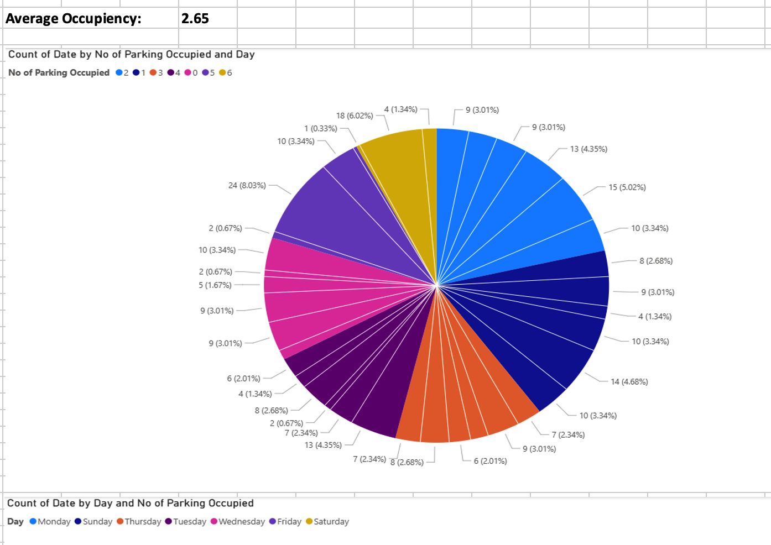
The above pie chart illustrates the demographic profile of our guests over the past 15 months. The data shows that many of our guests are overseas travellers, who typically rely on taxis, airport transfers, or public transport rather than private vehicles.
Although the property provides 8 on-site parking spaces, actual usage remains minimal. This reflects the low demand for parking, as guest travel patterns are largely non-car dependent.
Cycle facilities:
In addition to car parking provision, the property also includes dedicated cycle parking facilities. However, based on operational experience to date, there has been no observable demand for cycle usage from guests. This is consistent with the hotel’s customer profile, which is predominantly comprised of overseas travellers and short-stay visitors who rely on airport transfers, taxis, and public transport links such as the Elizabeth Line. Photographic evidence of the cycle stands has been provided for reference.
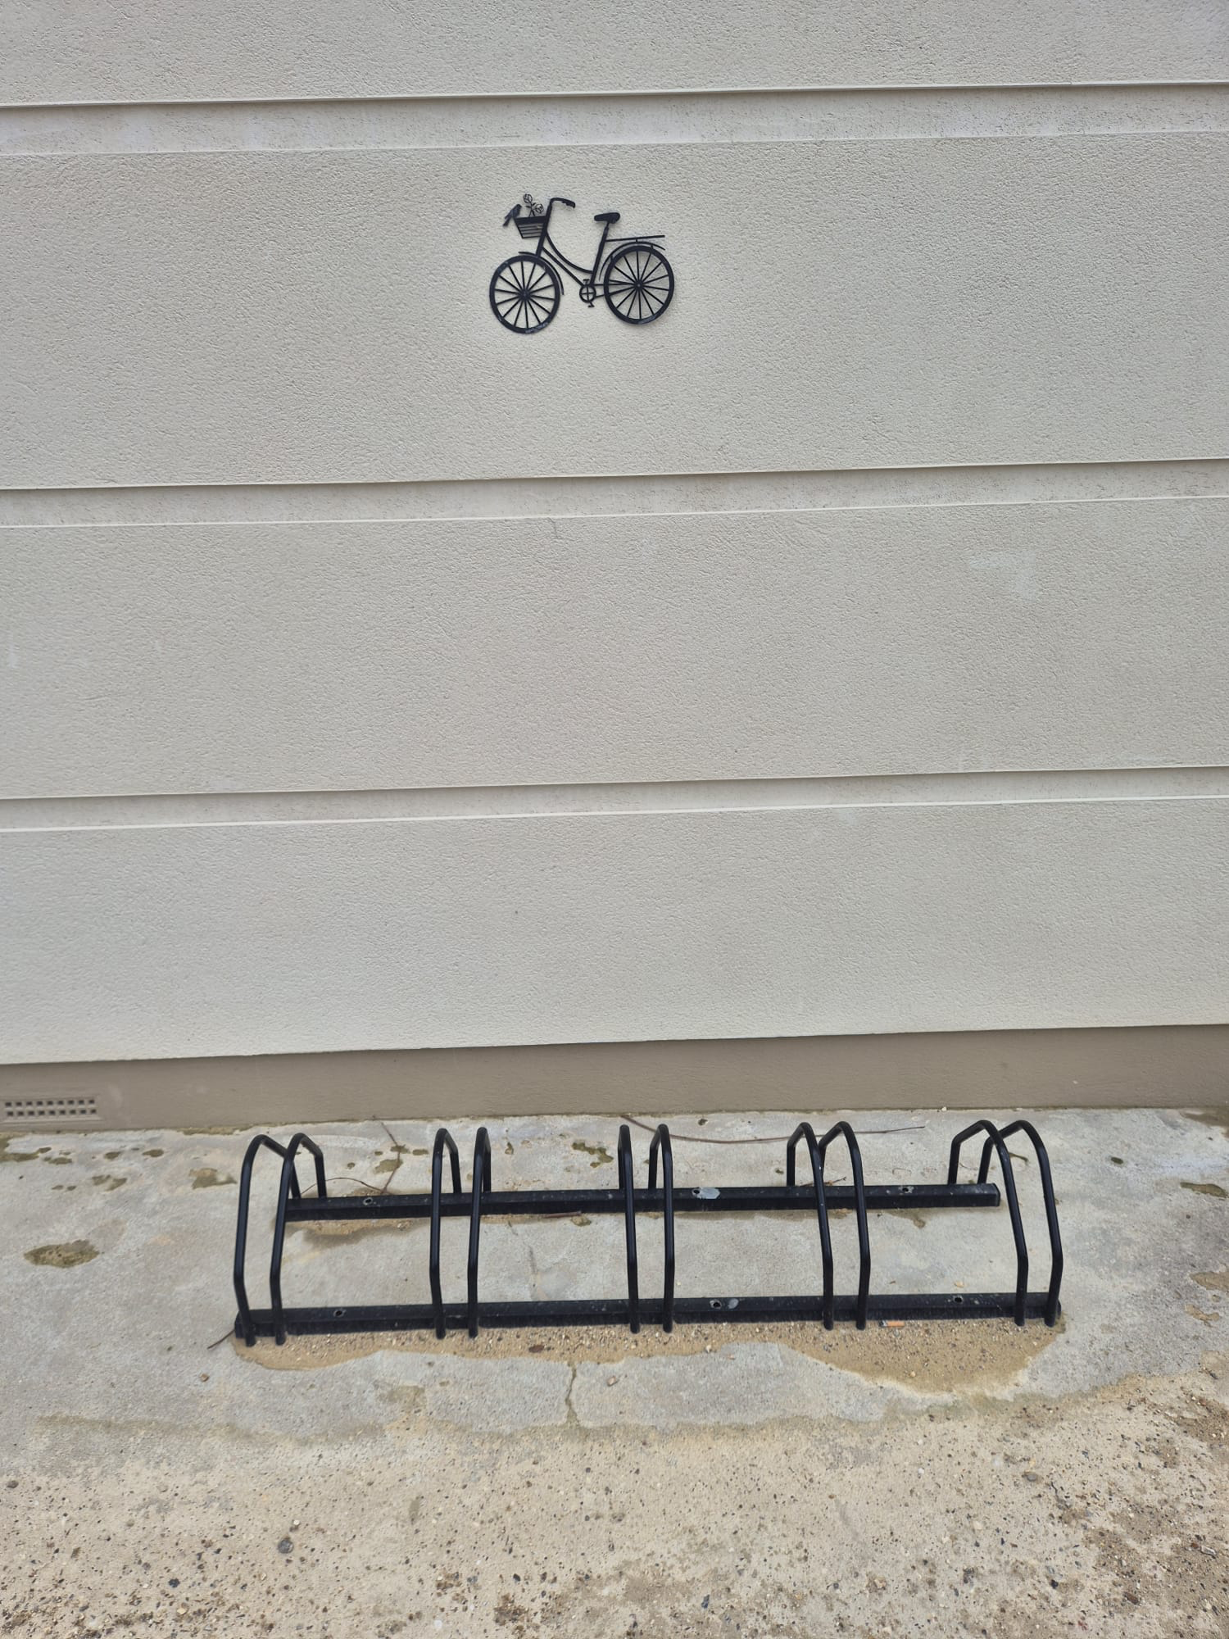
Taken together with the minimal utilisation of existing car parking spaces, this further demonstrates that the proposal will not generate additional pressure on transport infrastructure. The current provision comfortably accommodates demand, and therefore the proposed extension is not expected to have any material impact on parking or sustainable transport requirements.

Transport Impact
Given:
- The addition of only one guest bedroom
- The existing travel patterns of guests
- The strong reliance on sustainable and non-car modes
It is considered that the proposal will not result in any material increase in parking demand or highway impact.
Policy Compliance
The proposal aligns with the following policies:
London Plan Policy T5 (Cycling):
The development supports cycling through existing provision and promotes sustainable travel options.
London Plan Policy T6 (Car Parking):
The proposal reflects a car-light approach, with low reliance on private vehicles and no increase in parking demand.
Hillingdon Policy DMT1 (Managing Transport Impacts):
The development does not generate significant additional trips and therefore does not adversely impact the local highway network.
Hillingdon Policy DMT6 (Vehicle Parking):
Adequate parking provision is maintained, and the proposal does not create additional parking stress.
Conclusion
In summary, the proposed development is considered to have a negligible impact on transport and parking.
The addition of a guest bedroom, combined with the established travel patterns of guests, ensures that there will be no material increase in demand for car parking.
The proposal therefore complies with relevant local and London-wide transport policies.

