PLANNING STATEMENT

Site: 70 Victoria Avenue, UB10 9AJ
Proposal: Front Porch and rendering to the existing pebble dash house.
Description:
The proposal is render the property with the insulation [K-Rendering], with the porch construction. Closed porch area is 2.09Sqm and 4.32Sqm is including external space. There is similar K-rendering in the same road. Door No: 12 Victoria Ave, 21A Victoria Ave, 30 Victoria Ave, 43 Regent Avenue are having K-rendering in the surrounding area. There are many houses in the Hillingdon borough having K-rendering. Due to the changes made on Energy efficiency Building control services are encouraging the public to go for the additional insulation to the property. K-rendering is providing additional external insulation to the existing property.
The closed porch is 2.09Sqm of complying the permitted development regulation. The external open area is 2.23Sqm area is external open area. The height of the porch is complying with the planning regulation.
Conclusion:
This proposal is not affecting the street view. The character of the building is not effect by this development. Therefore we are requesting to approve the planning permission.

APPENDIX
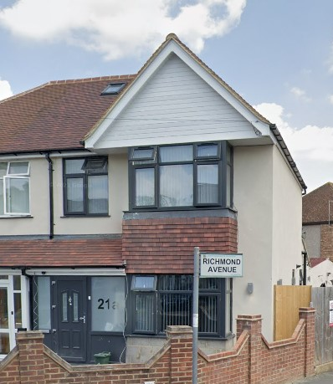
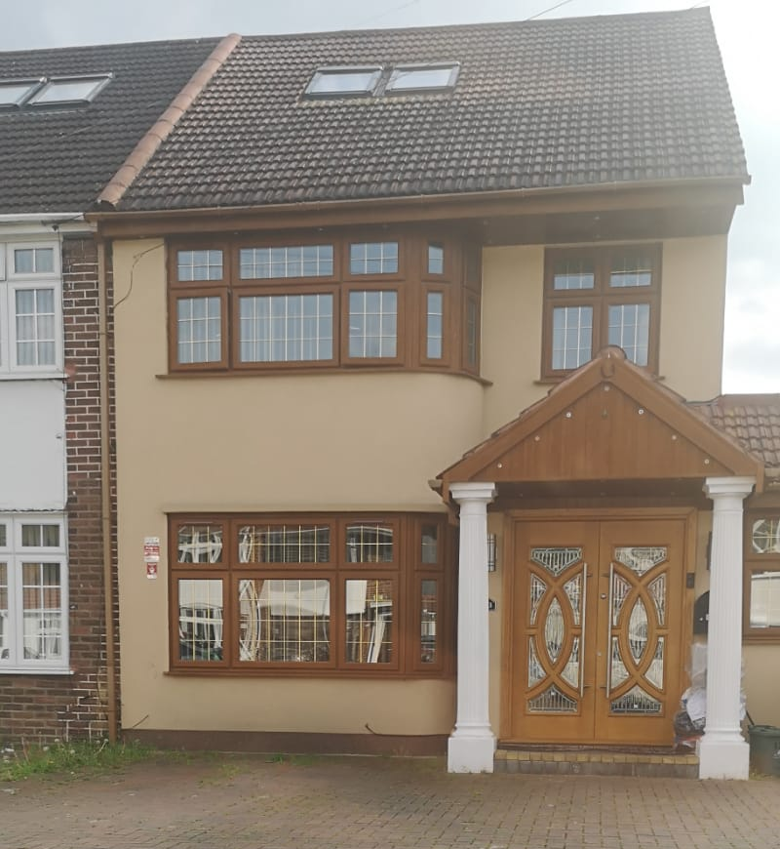
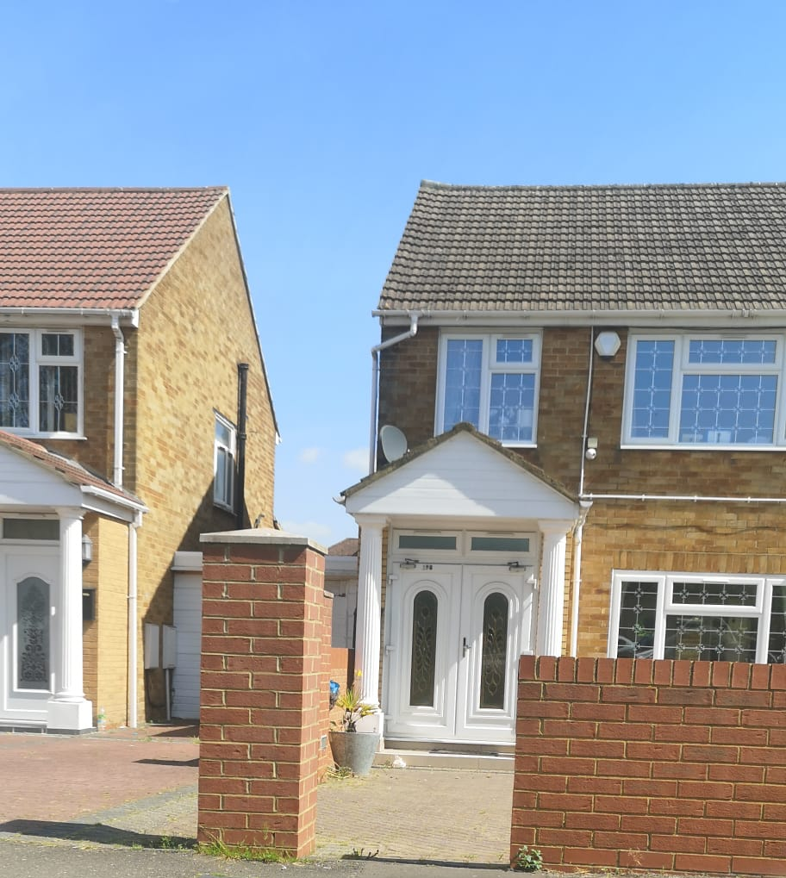
13 BARNHILL UB4 9AP 21A VICTIRA AVENUE, UB10 9AJ
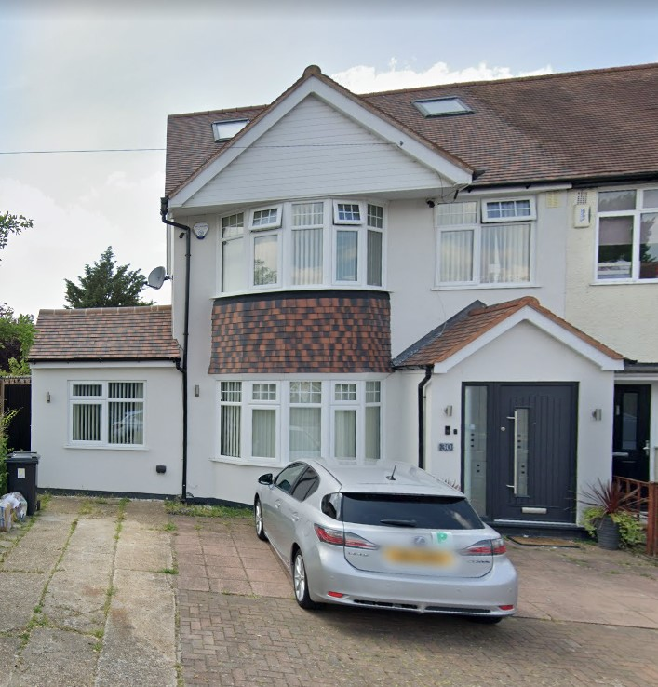
198 UXBRIDGE ROAD UB1 3DX 30 VICTORIA AVENUE, UB10 9AJ

