Virtus London 7.5 Data Centre

Virtus London 7.5 Data Centre, Stockley Park

Construction Phase Health & Safety Plan

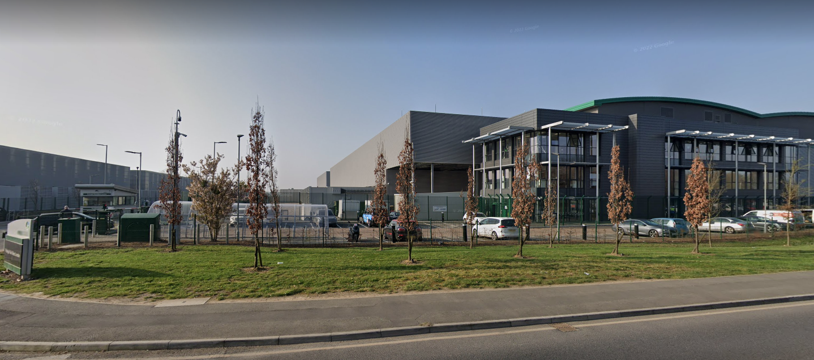

QA 10,010 Construction phase Plan
Reference | 0130-ESG-XX-XX-PL-0001
Revision | 04
Date | Sept 2023


Document Control
Document | Construction Phase Plan – 0130-ESG-XX-XX-PL-0001  Virtus London 7.5
Project № | 0130 |  | Author |  | DC |  | Checked | LAC
Revision |  | Date |  | Author |  | Amendments
00
01
02
03 |  | June 2023 |  | DC
04 |  | Sept 2023 |  | BL

Approved by:
Name | Company/Department | Signature | Date
Warren Bradshaw | Operations Director
Derek Richardson | Project Director
Distribution
Name Company/Department Email
Warren Bradshaw | Operations Director | wbradshaw@esglimited.com
Derek Richardson | Project Director | drichardson@esglimited.com
Chris Pinniger | MEP Services Lead | Cpinninger@esglimited.com
Jim Cole | Project Manager | jcole@esglimited.com
Stephen Philbin | Electrical Project Manager | sphilbin@esglimited.com
Paul Sherrin | Commercial Director | psherrin@esglimited.com
Georgia Ware | Document Controller | gware@esglimited.com
TBA | Logistics Manager | TBA
Newton Dsouza | SHE Manager | ndsouza@esglimited.com
Lee Cowlbeck | SHE Director | lcowlbeck@esglimited.com

Contents
Virtus London 7.5 Data Centre, Stockley Park 1
Construction Phase Health & Safety Plan 1
1.0 Introduction 5
1.1 Project description and programme details (including any important dates) 5
1.1.1 Overview 5
1.1.2 Site Setup & Enabling Works 7
1.2 Project Programme 12
1.4 Client & Project Team Contacts 12
1.5 Extent and location of existing records and plans relevant to health and safety on site 14
1.5.2 Existing Services 14
1.5.3 Access and Egress for all Project Personnel 14
1.5.4 Site Deliveries, Material/Equipment movement 14
1.5.5 Traffic systems/ Parking 15
2.0 Management of the work 16
2.1 Management structure and responsibilities 16
2.2 Management: 17
2.2.1 Project Directors 18
2.2.2 Project Manager or nominated representative 18
2.2.3 Supervisor or nominated person in charge 18
2.2.4 Health, Safety and Environmental Manager 19
2.2.5 Contractors 19
2.2.6 All Employees and subcontractors (where relevant) 19
2.3 Health and safety goals for the project and arrangements for monitoring and review of health and safety performance 20
2.3.1 Project Safety Goals 20
2.3.2 Other Project Health and Safety Goals 21
2.4 Arrangements for the management of work 22
2.4.1 Arrangements for regular liaison between parties on site 22
2.4.2 Project Meetings: 22
2.4.3 Consultation with workforce 22
2.4.4 Arrangements for the exchange of design information between the Client, Principal Designer, Designers and Contractors on site 23
2.4.5 Arrangement for handling design changes during the project 23
2.4.6 Arrangements for Contractor selection and control of contractors 24
2.4.7 Management of Contractors: 25
2.4.8 Arrangements for the exchange of health and safety information between contractors: 24
2.4.9 Arrangements for Site Security 26
2.4.10 Arrangements for Site Induction 27
2.4.11 Arrangements for training 27
2.4.12 Welfare facilities and first aid 29
2.4.13 Incident reporting procedures 30
2.4.14 Risk assessment and method statements (RAMS) 29
2.4.15 Site Rules 31
2.4.16 3rd Party Complaint Handling ………………………………………………………………………………………………………………………..32
2.5 Fire and Emergency procedures 32
2.5.1 Emergency procedures 33
2.5.2 Emergency services contact details 34
3.0 Arrangements for controlling significant site risks 35
3.1 Safety risks 35
3.2 Health risks 44
3.3 Personal Protective equipment (PPE) 48
3.4 Permits to work 48
3.5 H&S Inspections and Audits 49
4.0 The health and safety file 51
4.1 Layout and format. 51
4.2 Arrangements for the collection and gathering of information 52
4.3 Storage of information. 52
5.0 Appendences 53

Introduction

This Construction Phase Plan (CPP) has been prepared in accordance with the Construction (Design and Management) Regulations 2015 and it is the Principal Contractor’s responsibility to minimise risk to all parties involved in the construction and future maintenance of the project.

The Principal Contractor will ensure, that, so far as reasonably practicable, employees working on the site, visitors or any person who may be affected by the works are protected against injury and risks to their health. The CPP was compiled from relevant information provided by the Client and the Design Team, including the Pre-Construction Information Pack produced by the CDM Principal Designer.

Project description and programme details (including any important dates)

Overview
Virtus London 7.5 Data Centre Project is in an industrial development located at 200 Horton Road, West Drayton, London. UB11 1HB. The project comprises the development of new power and cooling systems located between LONDON7 and LONDON8 buildings to support a 4.5 MW IT fit-out of a new Data Hall within LONDON7.
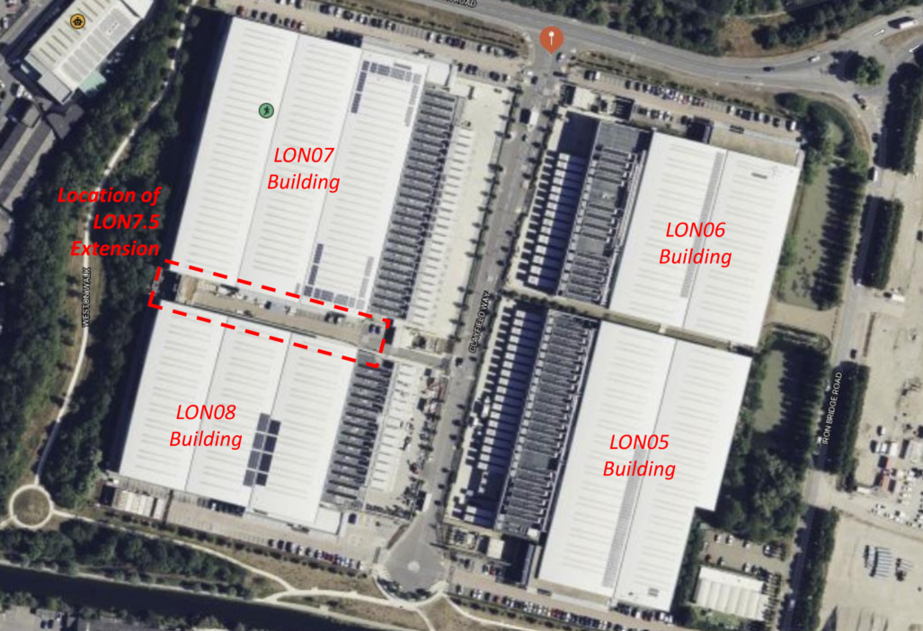

A new three-level gantry shall be constructed, in the car park/access area between LONDON7 and LONDON8, to accommodate new power and cooling plant. Standby generators shall be located on the east side of this vacant area, being double stacked with the upper generators being supported, independently, by an approved steel framework system.

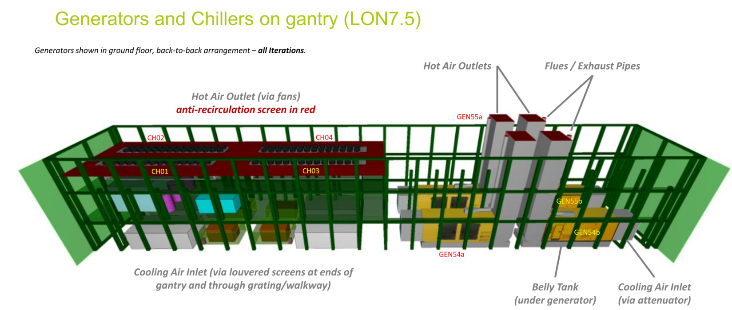

The ground floor of the new gantry on the west side of the vacant area, between LONDON7 and LONDON8, shall house the main electrical intake rooms, and associated transformers.

The first floor of this gantry shall house the primary and secondary chilled water pipework headers, secondary pump system, space for future buffer vessels and ancillary chilled water equipment, as required (e.g., pressurisation units, expansion vessels and dirt separators, etc). Chillers shall be located on level 2 of the new gantry.

Electrical rooms for new IT UPS switchboards, together with associated battery rooms, shall be located inside the building adjacent to the new data hall within LONDON7.

The work shall be completed within a live data centre environment and there must be no impact on the continued operation of the facility at any stage of the project work. Also there must be no impact on the progress and/ or completion of other fit-out works taking place on the site.

Internally within the LON 07 building the works include the construction and fit-out of data halls 5, 8 and 9. The MEP services within halls 5 & 9 emanate from the existing infrastructure whereas hall 8 is fed from the new infrastructure associated with the gantry.
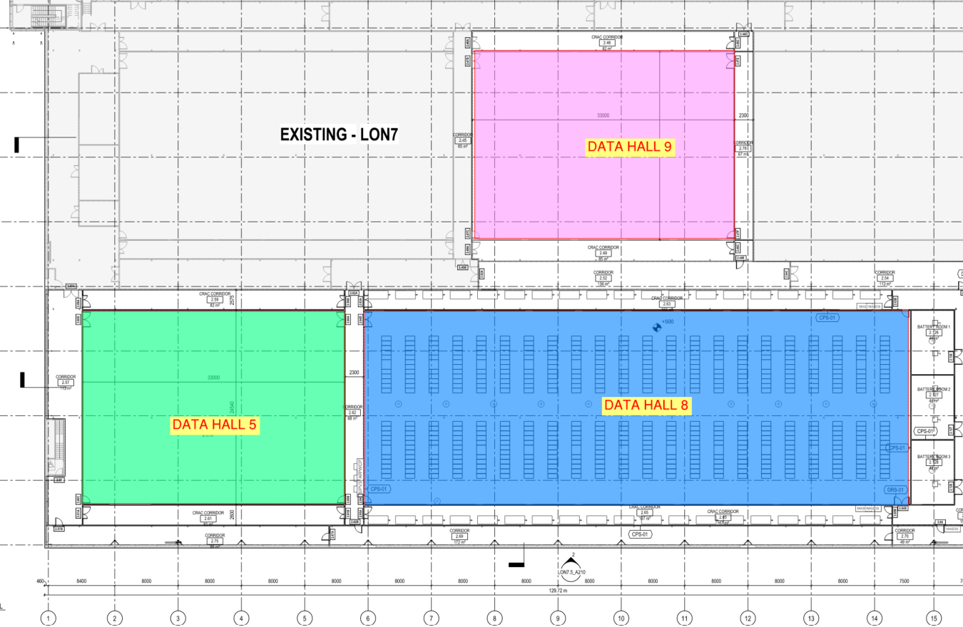

Site Setup & Enabling Works

The site welfare space within the Virtus car park area will be enclosed with a 3m fence with concrete post bases. The site will be separated into various zones, including CDM project work zones, shared access zones, and ESG welfare zones. These zones will be segregated from Virtus staff, data centre visitors, and the public by using suitable barriers. Access into Virtus areas by project operatives will be controlled with signage, existing access control and alarmed doors.

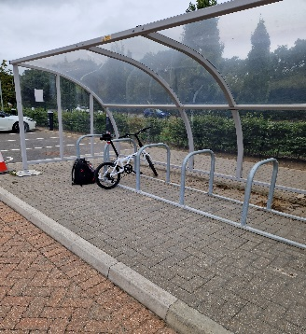
Pedestrian access to the site, including the ESG site compound, will be via the main access road off Horton Road. The access road is used for access to Virtus London 5, 6, 7, and 8, all of which are operational. A Virtus Guard Point will control access and egress for staff, operatives, and visitors entering from the access road. All personnel will need to be booked in with Virtus (via ESG) 48 hours in advance with an access code which they will need to quote. Full names must be given, and government ID presented to the guard on arrival. This is a protected entrance, separate from vehicle access and leads to a segregated walkway to the ESG Limited site yard. With the Virtus controlled car park there is a cycle shelter with security bars to enable cycles to be locked up. The area is also covered by CCTV

Access/egress to the project work zones will be via an ESG secure turnstile, in addition to a another Virtus Guard Point. The access route will be clearly signed. Access to the 1st floor internal works will be via the escape stairs opposite the ESG compound with access to the Gantry area along the fire escape route to the rear of the building.

Site welfare accommodation will be set up externally within the ESG site compound located to the north of Virtus London 7. This zone will be segregated via fencing and will be deemed a ‘Green Route.’ Where possible, office accommodation will be utilised in the existing fallow spaces internally.

There will be a separate laydown/storage zone located near the gantry, which will be utilized as a delivery offloading point. A forklift/telehandler with allocated banksman/slinger will be provided for the unloading of delivery vehicles by ESG where specialist facilities are not required by way of RAMS. Materials for the data hall project works are to be transferred to the 1st floor via goods hoist or telehandler by ESG to the scaffold deck and moved into the 1st floor fallow space. Contractors will be allocated areas in the fallow spaces that they will manage throughout their contract period.

6A secure yard has been put in place to allow storage of materials and equipment before transferring into the site as described above. The Tele-handler has a crane attachment but does not exceed the height of the building and therefore does not require obstacle lighting. No other equipment on site will require obstacle lighting
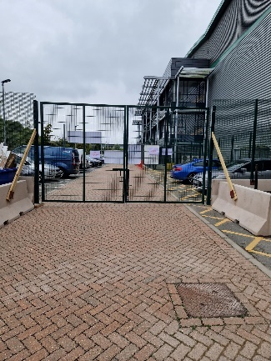
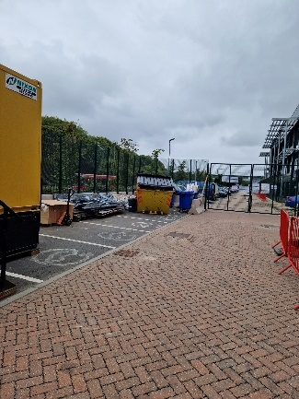
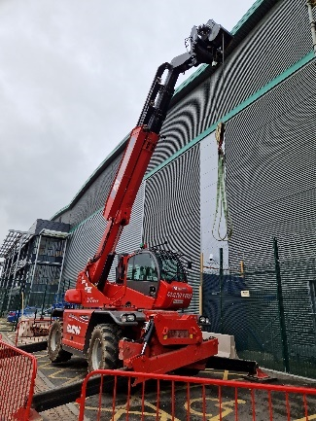

Skips will be located in the laydown / storage zone a general waste compactor. A second point of general waste storage will be in the ESG site compound zone. Local waste points with general and metal wheelie bins will be located in the internal data halls emptied as required by ESG to specific skips. Where required, additional specific waste skips and wheelie bins will be provided.

There will be no mobile crusher on-site as no concrete/brick waste will be produced and no waste will be disposed of by burning as all bin fires or bonfire are banned from ESG Limited sites

An electronic booking system will be employed to manage and coordinate site deliveries and prevent double stacking of deliveries on access roads and the site. All deliveries are to be made via the gantry vehicle gate (unless specifically for the ESG site office). A guard point will be located at the Gantry access gate with ESG booking in and issuing a delivery schedule to Virtus 48hrs in advance. All deliveries will be assigned an access code”.

The ESG site induction will include relevant details from the London 7 Virtus site induction, particularly where ESG works fall outside the CDM areas. Any works outside the CDM areas or interface with existing systems will be subject to permit to work systems implemented by the Virtus Operations Team and subject to a minimum notification and RAMS approval period of 30 days.

Traffic Management Plan
This plan covers vehicle movement to and from the main gate in Clayfield Way and the ESG secure compound at:
- Virtus Lon 7, Prologis Business Park, Clayfield Way, Horton Road, West Drayton, UB7 8HX - Entrance at What3words: soap.rigid.dish

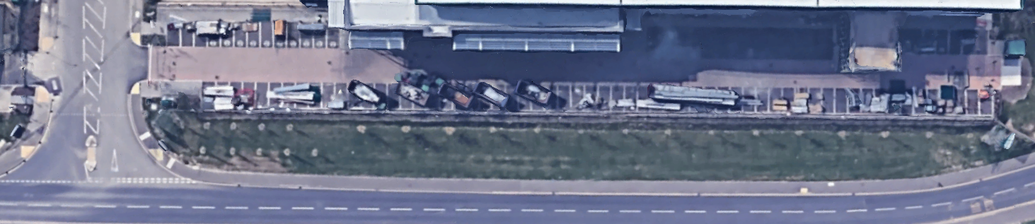
ESG secured yard and wheel wash area
Fenced pedestrian route
Shared vehicle and pedestrian road
Horton Road
Clayfield Way
Main Gate
ESG security
gate
ESG Welfare
Plan Guidance:
- There is no parking available on site. Some parking is available in Clayfield Road on a first come, first served basis
- Note that the area between the main gate and the security compound is shared with Virtus employees
- Pedestrians must use the fenced pedestrian route
- All deliveries must be booked 48 hours in advance
- Speed limit between the main gate and the secure compound is 5 mph
- Hazard warning lights must be switched on
- All reversing vehicles must be under guidance of a reversing assistant
- In all cases – PEDESTRIANS TAKE PRIORITY

Project Programme

The project Key dates are as follows.
- Preconstruction 24th March 2023 to 13th June 2023
- Construction 14th June 2023 to 13th June 2024
- Commissioning 19th March 2024 to 15th May 2024
- Practical Completion 14th June 2024

A detailed programme has been developed and it is a LIVE document (see appendices).

Location of site

The Site Address is:
Area between Virtus London 7 and London 8 Stockley Park,
200 Horton Road,
West Drayton,
London. UB11 1HB.

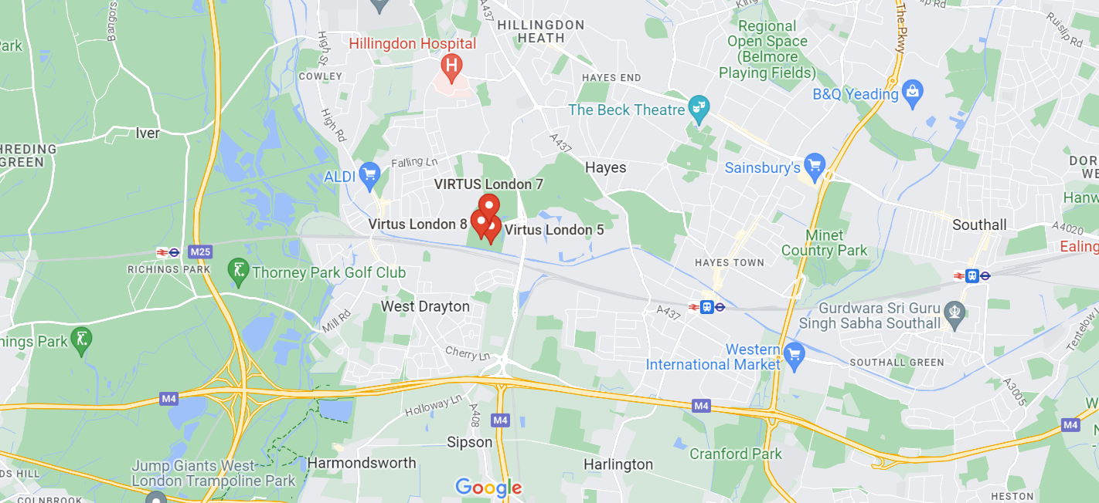

Role | Company | Address | Contacts | Contact Details | Email
Client | Virtus Data Centres  (Virtus London 7) | 20 Balderton Street London  W1K 6TL | Simon Anderson | 020 3814 3013 | Simon.anderson@virtusdcs.com
Employer’s Agent / QS | RIDER LEVETT BUCKNALL | 110 Bishopgate London  EC2N 4AY | Geoff Bowman | 07341 438241 | Geoffrey.Bowman@uk.rlb.com
Principal Designer | SPECTRA | Pacific Court, Pacific Road,  Altrincham, WA14 5BJ | Lee Taylor | 07977 101171 | Lee.taylor@thespectragroup.co.uk
M & E Designer | NOMAN, DISNEY & YOUNG | 11th Floor, 1 Angel Court,  London. EC2R 7HJ | Kevin Ristow | 020 7553 9494 | k.ristow@ndy.com
Architect | SHEEHAN NAGLE HARTRAY Associates | 20 Chiswell Street, London  Ec1Y 4TW | Silvana Trischmann | 020 3972 4242 | silvana@snh-a.com
Structural Engineer / Designer | JOHN TOOKE & PARTNERS | Block J, Unit 404, The Biscuit Factory,  100 Drummond Road, London SE16 4DJ | Bob Sheppard | 07865 378993 | Bob.sheppard@john-tooke.co.uk
Principal Contractor | Essex Services Group Ltd | Viking Business Centre, Danes Road  Romford, Essex  RM7 0HL | Warren Bradshaw  Derek Richardson (Project Director)  Chris Pinniger (Electrical) | 01708 708 888 | wbradshaw@esglimited.com  drichardson@esglimited.com  cpinniger@esglimited.com

Client & Project Team Contacts

Contractors & Specialists
Role | Company | Address | Contacts | Contact Details | Email
Fire detection & Gas suppression | DAS Fire Ltd | 13 Campbell Ct, Bramley, Tadley RG26 5EG | Paul Darke - Director | 0845 544 2316 | pauldarke@dasfire.com
Construction Package | Bell Build | Broadfield’s Farmyard, Tilbury Road, West Horndon, Brentwood, Essex, CM13 3LS | Stuart Heagren - Director | 07920-500339 | StuartH@bellbuild.co.uk
MV & LV Switchgear | Arnord Mardix | Chancerygate Business Centre,  Whiteleaf Rd, Hemel Hempstead  HP3 9HD | Luc Fancois – Project Manager  Oliver Barker – Project Manager  George Close – Sales Manager | 015 3972 0161 | luc.francois@anordmardix.com  oliver.barker@lloret.co.uk

Note – ESG will update the above table once the design and procurement of packages is finalized.

Extent and location of existing records and plans relevant to health and safety on site

Existing and Services

ESG and the design team have access to the DOME system for accessing the existing As Built drawings and O&M manuals.

Existing Services

The works are being undertaken within a live and operational data center, all operatives will be reminded of the hazards of working around live services and this shall also be captured within RAMS. Any works that require the isolation of existing services shall be planned via the Virtus Change Control process.

Externally Power, water and waste services will be provided for connection of the projects site welfare facilities and construction services.

Access and Egress for all Project Personnel

The site is located within London 5,6, & 8 Stockley Park with a gated entrance controlled by Security provided by the Client. They enforce access restrictions to protect the operation of the Data Centre.

Operatives once passed this security point must upon arrival go to the ESG Office and sign in/out of the evacuation register.

To enter the construction site an electronic security system will be utilised with individuals assigned access on successful completion of their online induction and onboarding.

All vehicles and personnel will be included on attendance and delivery registers.

Site Deliveries, Material/Equipment movement

An electronic booking system providing a daily delivery register will be maintained and communicated to the security team by ESG with major deliveries identified in Daily Briefings and on noticeboards.

A site contact name, mobile phone number and company is to be provided for all deliveries, any deliveries that do not include a contact name and company name WILL be turned away.

To be permitted access past the Client Security checkpoint, at the junction of Horton Road, delivery drivers will need to produce company details and the reason for the visit.

The project will have a storage area laydown/storage zone located near the gantry, which will be utilized for materials and bulk storage throughout the project duration. Materials storage will be segregated and labelled with fire retardant protection and clearly labelled with the relevant contractor’s details.

Delivery of Plant/Equipment to these areas along with distribution routes to Demised and Non-Demised work areas are detailed in the Site set up and Logistic Plans contained within the Appendices.

All delivery vehicles are required to be compliant with the FORS silver rating.

ESG Limited are also working with any suppliers to ensure that they also comply with the requirement of the London Freight Plan where necessary, (See 5.0 Appendences). ESG Limited haver also informed all suppliers that Heavy Good vehicles must meet the minimum 3 star rating of the Direct Vision Standard and be fitted with a Class VI mirror as per EU Directive 2007/38/EC, (See 5.0 Appendences).

Traffic systems/ Parking

A 5mph speed limit will apply throughout the site and adjacent compound.

The Principal Contractor is to manage parking on, and off site as required. On-site parking will be restricted to areas allocated by Virtus. On-site parking has limited availability.

The Principal Contractor will ensure that no vehicles park in neighboring sites, visitor or staff parking facilities and on access roads around the site.

All deliveries will follow designated routes to project storage areas as indicated on the Site Set-up & Logistic plans.

Traffic Marshals/Banksmen will be provided for delivery vehicles.

FORS Silver will be required as a minimum for all delivery vehicles. A FORS declaration will be needed at the time of delivery booking.

Management of the work

Management structure and responsibilities
Andy Hider
Managing Director
Bradley Luff
SHE Manager
Chris Cordle
Project Director
Chris Pinniger
MEP Services Lead
Lee Cowlbeck
SHE Director
Warren Bradshaw
Operations Director
TBA
CSA& Logistics Lead

Management:

Project Directors

- Will be responsible for the overall implementation of the company SH&E policies and the project SH&E plan within the scope of this project.
- Will ensure that the necessary resources both financial and physical are made available to enable this SH&E plan to be effectively implemented.
- Will take an active and continuing involvement in the projects SH&E matters.
- Will ensure that the Site Management, staff, and operatives under their control have received adequate information, instruction, and training, on SH&E requirements to be able to carry out their duties safely, efficiently, and effectively.
- Will ensure that the project line management effectively carries out their duties to monitor and adequately control the safety performance standards for the contract.
- Will be accountable to the Operations Director for all matters relating to SH&E on this project.
- Will liaise with the SH&E department, Project Manager(s), Site Supervisor(s), Project Directors to ensure that the requirements for safe working within the clients’ sites are maintained to all the relevant clients’ rules and requirements.

Project Manager or nominated representative

- Will have responsibility for the administration of the safety management and security systems and procedures on the project.
- Will monitor and appraise the SH&E performance of company specialist subcontractors and directly employed personnel.
- Will liaise with the SH&E Manager, Project Director, Site Supervisors, and client, and work teams to ensure that the contract SH&E requirements are being adequately considered, thereby ensuring the safe maintenance of a safe workplace environment.
- Will be accountable to the Project Director for all SH&E matters on this project.
- Will ensure that employees under their control carry out their duties in a safe and efficient manner and comply with any safety & security procedures or instructions.
- Will ensure that ESG employees and subcontractors’ employees are competent to carry out the duties required and attend any further site Safety Awareness Training courses, as necessary.
- Competency will be verified (Skill Cards) at time of site induction.
- Will report to the Project Director, and SH&E Manager of any breaches of SH&E requirements.
- Will actively promote high standards of housekeeping and will monitor the work areas to ensure they are always kept tidy and free from hazards and potential risks.
- Will ensure weekly (not exceeding 7 calendar days) “Toolbox Talks” are delivered to all employees.

Supervisor or nominated person in charge

- Will be responsible for the daily administration of the safety and environmental management systems and security procedures on the contract.
- Will monitor the SH&E performance of company specialist subcontractors and directly employed personnel.
- Will liaise with the Project Manager, SH&E Manager, and the client to ensure that the project SH&E requirements are being adequately considered, thereby ensuring the maintenance of the workplace safety culture and environment.
- Will be accountable to the Project Director and Project Manager for all SH&E matters on this project.
- Will ensure that employees under their control carry out their duties in a safe and efficient manner and comply with any safety and security procedures or instructions.
- Will where required, ensure that competent personnel are appointed to carry out specialist duties such as confined spaces, operation of MEWP, fork truck drivers, tower scaffold erection, etc.
- Will report to the Project Director/Project Manager/SH&E Manager and client of any breaches of SH&E requirements.
- Will ensure that work areas are always kept tidy and free from hazards and potential risks.
- Will ensure weekly (not exceeding 7 calendar days) “Toolbox talks” are delivered to all employees.

Health, Safety and Environmental Manager

- Understand the application of the Health and Safety at Work etc. Act 1974, the Management of Health and Safety at Work Regulations 1999 and other relevant legislation to our activities, and a general knowledge of the Electricity at Work Regulations 1989, The Workplace (Health, Safety and Welfare) Regulations 1992, CDM Regulations 2015 and relevant special Regulations and Codes of Practice pursuant to the business needs, including the management of OHSAS 18001:2007 process & procedures for the company.
- Be aware of changes in legislation which affect ESG activities and inform all management, staff, and suppliers.
- Co-ordinate health and safety information and hold SHE Monthly meetings with subcontractors.
- Manage and ensure that any works relating to natural gas are carried out by fully trained and certificated Gas Safe Register Engineers as certified by and fully in accordance with the requirements of Gas Safe Register.
- Review ESG health and safety and other training needs at regular intervals, and review with employees and contractors and apprentices’ hazards and specific rules relating to the work to be done.
- Take all reasonable steps to ensure the competence in health and safety of any persons or sub-contractors to whom work is subcontracted, as required by the Construction (Design and Management) Regulations 2015.
- Investigate serious accidents and dangerous occurrences.
- Ensure that all plant and equipment supplied to employees and contractors are properly maintained and that suitable maintenance records are kept.
- Ensure that Office and Site fire risk assessment and emergency procedures are in place
- Ensure that adequate supplies of first-aid equipment are issued to the Office and Site and that they are kept correctly stocked.
- Make and issue specific risk assessments where necessary and modify generic risk assessments applicable to the work. They will help to devise safe systems of work where necessary, particularly for work where specific risk assessments have been made.
- Set a personal example, including the wearing or use of protective clothing equipment as appropriate on-site visits.
- Carry out recorded inspections and Safety Audits/site visits.

Contractors

(Those who do the actual construction work. They can be either an individual or a company)
- Plan, manage and monitor construction work under their control so that it is carried out without risks to health and safety.
- For projects involving more than one contractor, co-ordinate their activities with others in the project team - in particular, comply with directions given to them by the principal designer or principal contractor.
- For single-contractor projects, prepare a construction phase plan.

All Employees and subcontractors (where relevant)

- Are to be consulted about matters which affect their health, safety, and welfare
- Take care of their own health and safety and that of others who may be affected by their actions
- Report anything, they see which is likely to endanger either their own or others· health and safety
- Co-operate with their employer, fellow workers, contractors, and other duty holders.
- Will comply with the requirements of the SH&E policies and the SH&E plan and comply with all authorised site safety and security rules and instructions.
- Will be expected to always work in a safe and efficient manner.
- Will attend daily site briefings prior to any commencement of work.
- Will not use faulty or defective equipment or plant and will report any such equipment immediately to the site supervisor.
- Will not operate special equipment or carry out specified tasks until proper risk assessments have been completed and approved.
- Will always keep their workplace clean and tidy and report to the Site Supervisor immediately any suspected hazard or potential risk in their work area.
- Will cooperate with management in the implementation of the company SH&E management systems and procedures.
- Will attend on first arrival, the site-specific induction training.
- Will thereafter attend any other Safety/Security Awareness training course when instructed to do so.
- Will report all accidents/incidents, however minor to the Site Supervisor and ensure that the details are properly recorded in the “Accident/Incident Report” form. The client’s accident forms (where specified) must also be completed and forwarded to the client’s Health & Safety department by the Site Supervisor.
- Reporting of accidents/incidents must be done immediately or as soon as may be possible, dependant on the nature of the event or injury, but not later than 24 hours in severe cases. Failure to comply may lead to disciplinary action being taken by PC, as failure to report prevents PC from carrying out its legal obligations.
- At all times will wear the PC five-point mandatory PPE as stated in the attached index, high visibility clothing, safety footwear, eye protection, gloves, safety helmets, hearing protection or any other form of PPE were instructed to do so or were advised by documentation.
- Will ensure that they are fully aware of the relevant, specific risk assessments for any task of work that could have significant risk and comply with any safe systems of work applicable to the task.
- Are accountable to their Site Supervisor and will understand that failure to follow reasonable and clear instructions regarding SH&E and security on this project may lead to disciplinary action/summary dismissal.

Health and safety goals for the project and arrangements for monitoring and review of health and safety performance

Project Safety Goals

The goal of this health and safety plan allows all sub-contractors to provide a suitable response to ensure the health and safety management will be planned into the work undertaken on this specific contract. The overall intention is to achieve the following:
- Zero accidents or Incidents
- Cooperation throughout the workforce to ensure Health and Safety is everybody’s responsibility.
- A proactive approach to health and safety by the Management Team
- A safe working environment as a condition of employment

Management both in construction and maintenance should ensure that where hazards are created or subsequently come to light, they are effectively controlled and eliminated, if possible, in the longer term. ESG will ensure that they enforce the key principles of protection and prevention as specified within CDM 2015 namely:

- Avoiding risks.
- Evaluating the risks which cannot be avoided, combating risk at source.
- Adapting the work to the individual, especially regarding the design of: Workplaces.
- Adapting to technical progress.
- Replacing the dangerous with the less dangerous.
- Developing a coherent overall prevention policy which covers technology, organisation.
- Of work, working conditions, social relationships and the influence of factors relating to: -The working environment.
- Giving collective measures priority over individual protective measures; and giving appropriate instructions to employees.

Other Project Health and Safety Goals

Health and safety goals for the project and arrangements for monitoring and review of health and safety performance

- It is the policy of the company to establish and maintain the highest practicable standards of safety & health on the project.
- The company’s safety & health policy and any revisions/amendments, which may be made will be strictly applied.
- The SH&E Manager will be based on site and advise the project management on all aspects of SH&E applicable to the project works and monitor with site management that the SH&E performance standards are being achieved.
- Site management shall ensure that SH&E matters are raised and discussed at all progress meetings upon the project including any site security aspects.
- These should be standing items on agendas for all meetings held on site. Thereby ensuring SH&E and security are not being treated as matters separate to the management systems.
- The Project Manager & SH & E Manager will be the Site SH&E Coordinators for all site activities. They will be supported in this role by line management and the company SH&E Director, who will provide any necessary assistance and advice.
- SH&E assistance and advice will initially be requested through immediate line management and the SH&E Manager when specific expertise is required. The SHE Director for the contract contact details are as follows:

Mr L A Cowlbeck DipNEBOSH, CMIOSH, MIIRSM, MaPS, PIEMA
Safety, Health & Environmental Director
Essex Services Group Ltd, Viking Business Centre, Danes Road, Romford, Essex RM7 0HL.
Telephone: 01708 708888

- In compliance with the environmental policy, the company will co-operate with the client to determine its impact on the environment associated with its contractually agreed services. In addition, it will undertake to advise the client if it observes any other potential problems throughout the site, which may have a SH&E impact, but not necessarily associated with company activities.
- The company will also require its subcontract companies to comply with all aspects of the company SH&E policies and adopt a responsible stance on to these issues.
- The SH&E Manager will undertake regular inspections with site management of the project works and carry out auditing of the safety management systems and procedures.
- The Site Management Team will further develop the Safety, Health & Environmental plan for the contract as the works progress and monitor its effectiveness and report his findings to the line managers and the client.
- Will provide reports on inspections, audits as defined in SOP 23, and where appropriate accident investigations, to the directors and the client.
- Will liaise with the client’s Safety, Health & Environmental department(s) and in conjunction with the SH&E manager interface with the Health & Safety Executive or other enforcing bodies as appropriate.

Measuring and monitoring performance standards

- The Company recognises that auditing and reviewing of its Safety, Health & Environmental management systems is an essential element in ensuring that the necessary compliance and improvements on SH&E standards and performance can be achieved.
- The Project Manager will ensure that monthly inspections are undertaken and where deficiencies are identified the necessary action is assigned to rectify the failure.
- Weekly inspections will be undertaken by the Supervisor or nominated person in charge to ensure the SH&E policies and procedures are implemented and maintained.
- The SH&E Manager will be based on site to carry out regular safety inspections / audits in conjunction with site management.

Arrangements for the management of work

Arrangements for regular liaison between parties on site

ESG Limited gives directions and co-ordinates other contractors on site via:
- The risk assessment and method statement process.
- Weekly progress and co-ordination meetings, including safety on the agenda.
- Daily start briefings / daily walks on site
- Daily verbal liaison on site.
- Daily Activity and Logistics Briefings
- Site Noticeboards
- Records of Audits & Tours will be made available on site.
This information is shared statistically with details of any open and key issues, hazards, and risks via online reporting tool ‘Yellow Jacket’ with the current report printed and displayed on site.

Project Meetings:

Meeting | Frequency | Attendees (Minimum) | To be Chaired by
Project Safety Meeting | At least monthly | ESG Project Manager ESG H&S Manager  Sub-Contractor Project Managers  Sub-Contractor SHE Manager | ESG Safety Champion ESG SHE Manager  ESG Project Manager
Project Review Meetings | Bi-Weekly | CDM Adviser  Designers/Principal Designer,  Project Administrator | ESG Project Team
Internal Progress / Co-ordination Meeting | Weekly | ESG Project Managers  Sub-Contractor Project Managers | ESG Project Managers
Client Progress Meeting | Bi-Weekly | ESG Project Managers & Client | ESG Project Director

Consultation with workforce

Consultation and feedback from operatives on site are encouraged during daily start briefings and toolbox talks, where workers contribution to the safe method is valued. Workers are also consulted by site management and the SHE Manager in an informal and practical process. Sub-Contractor Managers / SHE Managers required to attend monthly health & safety meetings.

Arrangements for the exchange of design information between the Client, Principal Designer, Designers and Contractors on site

- Design team meetings will be held weekly during the Design and Preconstruction stages, chaired by the ESG Design Lead.
- Design / Interface Workshops will be held as required chaired by the Principal Contractors’ design / engineering managers and include specialist subcontractors in line with specific meeting agendas.
- Consultants and Contractors will be invited to these meetings as required to discuss their designs and to co-ordinate with the scheme drawings and employers’ requirements, and to review the designs for health and safety issues.
- Project Managers will be responsible for liaison with the Principal Designer and for the providing information required for the health and safety file.
- ESG will use tools to facilitate the timely receipt of design information from designers and contractors. These will include the following:
  - Change Log
  - Design Meetings
  - Design / Interfacing Workshops
  - Request for Information
  - Drawing Issue and Status Schedule
  - Technical Submissions
  - Sample Submission
  - Document Control Procedure

The Change Log will be used to collate any proposed Changes to the Design or Scope identified during Design meetings, RFIs or Technical Comments against Contractors submissions. Changes will be discussed and agreed with the design team with subsequent formal instruction raised to formalise the change as required.
“Viewpoint For Projects” an online Project Management and Document Control Platform will be used by the Design Team and Contractors Team including Specialist Subcontractors as they are appointed for the management of project specific documentation.

Arrangement for handling design changes during the project

Design changes will be handled by the ESG Project Managers throughout the duration of the project and review at during scheduled Design Team meetings. The impact on the construction process will be reviewed through a process of risk assessment and programme review.

Arrangements for Contractor selection and control of contractors

- The company operates a vetting system of all subcontractors it employs to establish a register of "approved subcontractors" regarding SH&E policies, organisation, and arrangements within those companies.
- Each subcontractor will be required to complete a SH&E questionnaire and submit their SH&E documentation for consideration via an on-line pre-qualification system. Companies not meeting the required standards will not be selected as approved subcontractors.
- Where approved subcontractors fail to meet the required SH&E performance standards during their activities on site, steps will be taken immediately to ensure immediate improvement. If improvements are not sufficient, a written warning will be issued, and the contract terminated. The subcontractor in question will be removed from the approved list.
- Each subcontractor must comply with:
  - The Principal Contractor’s Safety, Health & Environmental policy which forms part of the company safety & health documentation.
  - This project "Construction Phase Plan”. Failure to comply with the requirements is construed to be breach of contract, and failure by the subcontractor to comply after written warning will lead to termination of the contract and removal from site.
- All subcontractors shall be subject to the Client’s project safety conditions. Non-compliance shall remove them from the list of approved subcontractors for all Principal Contractor / Client’s contracts.

Management of Contractors:

The management of contractors and their packaged works will be undertaken with reference and consideration of the following

- Contract conditions.
- The prequalification of contracts.
- Weekly progress and co-ordination meetings, including safety as an agenda item.
- Written instructions.
- Daily verbal liaison on site through
- Monthly site safety meetings, attended by ESG Advisor, ESG Management team and representatives of sub-contractors (Managers/HS Managers).
- Sub-contractors must not start their works, or significant elements within their works, without the approval of ESG Team. This will only be given after the approval of a satisfactory risk assessment and method statement.
- The contractor shall provide regular inspections of the work area by competent, professional health and safety personnel (NEBOSH Qualified) with direct reporting of unsatisfactory conditions to an ESG Team Member. A written report must be issued on each visit with advice and actions given. A copy of this report is to be provided to ESG within 24 hours. The contractor must ensure that the actions identified on this report are closed out and recorded as such as ESG will periodically monitor this by random inspection. The frequency of the H&S inspections is to be agreed by both ESG & the contractor at the prestart safety kick off meetings, minimum 1 visit per month or more frequently if deemed necessary by ESG.
- Contractors must always have a competent and trained supervisor (SSSTS or equivalent) in control of their works on site.
- DC 8103 Weekly Safety Return from Contractors need to be submitted to ESG Team. This weekly return will contain information on:
  - RAMS
  - Newly inducted personnel
  - Plant and equipment inspections (PUWER / LOLER)
  - Toolbox Talks
  - Daily Activity Briefings
  - PPE Issued
  - Daily Diary
  - Weekly Supervisors Inspections
  - PAT

Arrangements for the exchange of health and safety information between contractors:

- This plan will be made available to contractors together with any other relevant information as to the risks. Contractors will be required to provide detailed method statements and risk assessments (RAMS) of their activities to ESG, as part of their contract appointment documents and before they commence works on site, and to participate in joint discussions as to the safest way to execute the works.
- Contractors will review all their work activities with ESG Construction Manager or an appropriate appointed person and identify all significant, foreseeable risks arising out of their works, assess these risks and identify appropriate controls.
- All contractors to supply RAMS 2 weeks prior to starting work on site for low-risk activities and 4 weeks prior to start work on the medium risk activities e.g., shut down and isolation, detailing how they mitigate risks involved e.g., preventing falls, and working at height, Harnesses / lanyards, access equipment will be monitored and approved prior to use to ensure that they are fit for purpose.

Arrangements for Site Security

The site compound will be enclosed with a 3m fence with concrete post bases with a central vehicle access route to a dedicated loading bay, a separate pedestrian/operative gate will be provided for safe access A Virtus Guard Point will control access and egress for staff, operatives, and visitors entering from the access road. Access/egress to the project work zones will be via an ESG secure turnstile, in addition to a another Virtus Guard Point.Security guards will be appointed to manage the security arrangements.
All personnel will be required to carry out an online induction before attending site and will be added to a daily attendance register issued to the site logistics team to manage along with a schedule of planned deliveries.
A card based electronic security system linked to online pre-inductions will be fitted to the main pedestrian gate to automatically allow egress by approved, inducted, and briefed personnel.


Asset Management
- Quick and easy system
- Reduced paperwork
ESG ID Card
- Check out training qualifications
- Unique QR

Arrangements for Site Induction

- All persons employed on this project are required to complete an online induction prior to arrival on site and report to the ESG site team on their first day for onboarding.
- Personal records will be held securely via the Human Focus training portal, and will only be handled and used in compliance with the General Data Protection Regulation (GDPR).
- Induction’s prior to accessing site will cover site specific safety topics including:
  - Key staff and site layout
  - Project key hazards
  - Site safety rules
  - Permit arrangements
  - Client areas and arrangements
  - Logistic and Fire Evacuation Plan
  - Risk Assessment and Method Statements
  - Hazard/Near Miss Reporting procedures
  - Daily Start Briefing procedures
  - Working at height site specific arrangements
  - Procedures for breach of HS rules
  - Drugs and alcohol policy
  - Housekeeping, storage, waste management arrangements
  - Contractor Performance Board scoring mechanism
  - ESG ID Cards procedures
  - Environmental arrangements

- Contractors and all new starts on site are required to upload a copy of their CSCS cards to Human Focus. No-one will be permitted to sit the induction without a valid CSCS.
- Each person attending this induction course will be required to have read, understood, and verify they will comply with (relevant sections of) ESG safety rules and requirements for compliance.
- ESG require that a "Young Person" risk assessment is undertaken for any person under the age of 21. This is above the requirements of the Management of Health and Safety at Work Regulations with regards young persons aged 16-18. It does not need parent/guardian review, but must still consider their relative training, knowledge, and experience to establish appropriate levels of supervision and limitation of work to be undertaken. This should be submitted before attending the induction.
- Site induction training objectives:
  - To raise SH&E awareness amongst all site personnel.
  - To ensure that personnel are fully aware of safety and security requirements for the site/contract works

Arrangements for training
Onsite training
- ESG will provide SH&E awareness for their procedures and specific requirements for work carried out on their site via “Daily Activity Briefings”.
- The Project Manager shall establish and maintain safety/competence records for all personnel and ensure compliance to any requirements, which may be specified and continually monitor throughout the project using DC8094 ‘Site Personnel Competency Matrix’.
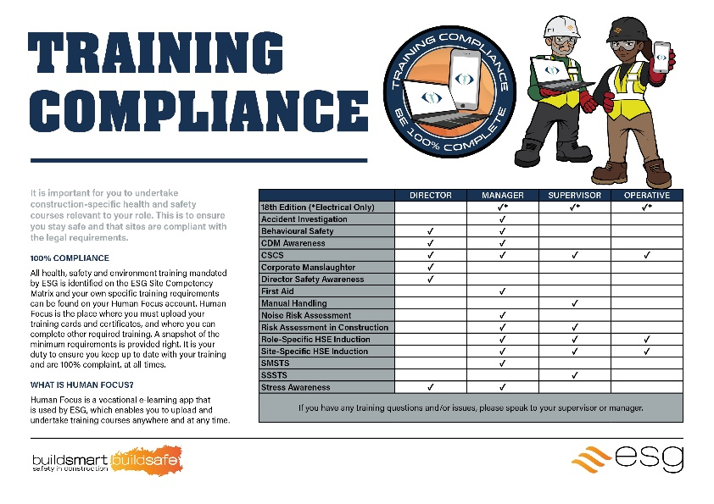
- Toolbox talks are short (no more than 15 minutes) informal training sessions designed to heighten awareness of specific Health, Safety & Environmental topics by providing the main Health, Safety & Environmental points on a particular subject.
- ESG has developed outline scripts, which form the basis of short toolbox talks which are given weekly by Site Management to employees under their control.
- ESG has developed over 40 of these toolbox talk scripts. A toolbox talk register is kept and is a LIVE document that is updated weekly. The toolbox talks are picked up on a weekly basis, depending on the risks and issues at site level and they need to be relevant to the works carried on, a schedule of planned talks will be developed to align with the project programme although this will remain a LIVE document subject to change to meet the project’s needs.
Contractors’ operatives training
- Minimum competency training is required for anyone working on an ESG site that is outlined in DC8094 Site Personnel Competency Matrix.
- Contractors are responsible for ensuring that all their employees are trained and competent to undertake works assigned to them. Supervisors will also need to be trained in the work they are supervising. Contractors are to retain records of relevant training.
- ESG will conduct audits of such records as part of ESG auditing and inspection regimes.
- All personnel accessing site will be required to provide evidence that they have received appropriate training for the work that they are to undertake.
- As a minimum, operatives, supervisors, and managers are to be in possession of a valid CSCS/CPCS card relevant to their work. Where a CSCS/CPCS card is not available, but a Contractor can demonstrate that the level of training, knowledge and experience is such that a person can be deemed competent, the person may be authorized to access site and work at the discretion of ESG Construction Manager.
- All supervisors and managers are to have attended the 2-day SSSTS or 5-day SMSTS course respectively (or equivalent or 2-day refresher) within the last 4 years.
- Supervisors will also be required to attend a site-specific supervisor's training briefing within one week of commencing on site.

Welfare facilities and first aid

ESG will provide welfare facilities in compliance with, as a minimum, Schedule 2 of CDM 2015 Regulations.
The following welfare facilities will be provided:
- Male and female toilet facilities
- Changing/drying room
- Canteen area, facilities for heating food and water
- First Aid Kit, Eye Wash, Burn Kit
- Supply of drinking water

The following office facilities will be provided:
- Project Offices
- Meeting rooms
- Induction Room
- Project Team Office

Although ESG have available several personnel who are trained first aiders, Contractors must ensure that they undertake a First Aid Assessment and provide an appropriate number of qualified first aiders to cover their workforce.

The list of First Aiders and Mental Health First Aiders will be continuously updated on the site notice boards throughout the project.

First aid kits will be located in the Main Site Office, First Aid Room and First Aid points located at key locations on site.

Incident reporting procedures

All accidents and near misses are to be reported as soon as they happen to ESG Management team using DC 8346C First Alert Notification. A competent person has 24 hours to investigate and send a report to SHE Department. A full record is kept on a register on ShareFile / and uploaded to YellowJacket.
A WhatsApp Group will be used to allow Operatives to report any hazards that could lead to an incident.
Any incident that requires reporting to the HSE under RIDDOR must be notified to ESG immediately with a copy of the F2508 forwarded via the standard submittal process. Any environmental incident requires reporting to the Environment Agency and must be notified to ESG immediately.
Contractors are required to undertake a thorough investigation following all accidents, serious near miss and dangerous occurrences and provide details of findings and corrective actions to ESG. Where the cause of an accident is not immediately apparent and preventative/ corrective measures cannot be introduced the contractor is to suspend operations where there is a risk of a reoccurrence.
Serious/ major accidents may also be investigated by ESG. Contractors are required to cooperate with ESG investigating team and make available any individual identified as a witness.

Risk assessment and method statements (RAMS)

The project program will be reviewed and, by referring to the Project Health and Safety Risk Register template, all hazardous operations are to be identified and a H&S Risk Register developed and published see section 3.0 of this document. This document represents a high- level register.

Contractors will review all their work activities with the ESG Construction Manager or an appropriate appointed person and identify all significant, foreseeable risks arising out of their works, assess these risks and identify appropriate controls.

All contractors to supply RAMS 2 weeks for low-risk activities and 4 weeks for moderate-risk activities e.g., shut down and isolation prior to starting work on site, detailing how they mitigate risks involved e.g., preventing falls, and working at height, Harnesses / lanyards, access equipment will be monitored and approved prior to use to ensure that they are fit for purpose.

All Method Statements and Risk Assessments are to be submitted, reviewed, returned, and approved. Risk Assessments and Method Statements are to be communicated by way of a briefing to relevant personnel by the Contractor and a signed register maintained of all such briefings.

Site Rules
Health and safety site rules
All Employees and contractors (where relevant):
The following site rules are to be adopted on all ESG projects and maintained as a LIVE document amended as necessary and reviewed against Program/Risk as the project develops to include site/task specific rules where necessary.

The site induction is to incorporate these site rules and any other requirements as required by third parties such as clients, local authorities and statutory undertakers, any changes throughout the life of the project will be communicated via toolbox talks.

- Comply with the requirements of the SH&E policies and the SH&E plan and comply with all authorised site safety and security rules and instructions.
- Work in a safe and efficient manner at all times.
- All operatives/visitors must be signed in and out of site at the project site office.
- Operatives must attend on first arrival, the site-specific induction training.
- Operatives must attend on first arrival, the site-specific induction training.
- Faulty or defective equipment or plant will not be used and will be reported immediately to the site supervisor.
- Special equipment will not be operated or specified tasks carried out until proper risk assessments have been completed and approved.
- Smoking is prohibited outside of designated smoking areas.
- No food or drink to be stored or consumed on site other than in designated welfare areas.
- No radios or similar, except for communication purposes, are permitted on site. Earphones should not be worn when working on site.
- No unauthorised equipment to be utilised by any site operative.
- Access to the construction site/work area is restricted to authorised personnel only.
- No plant/materials are to be evident in public areas during normal working periods.
- The use of client telephones is prohibited.
- Power tools shall be in good condition and inspected prior to use; record of inspection shall be
- available.
- No unattended hand tools are to be left in Virtus public areas.
- Operatives should not wander through non-designated Virtus areas.
- All areas must be kept clean and tidy so far as is reasonably practicable and report to the Site Supervisor immediately any suspected hazard or potential risk in their work area.
- Parking is restricted to designated areas only.
- All material deliveries must be coordinated with the Project Manager/Virtus Security.
- All personnel must be aware of action to be taken in the event of the fire alarm sounding. It is the individual’s responsibility to ensure the procedures are explained prior to commencing any work on the site.
- Material / equipment to be stored in agreed dedicated areas only.
- The consumption of alcohol and drugs is prohibited. Any person under the influence of alcohol or drugs will not be permitted entry to site, and if found on site will be removed. Prescribed drugs for medical reasons are permitted provided they in no way reduce the person's ability to carry out his duties safely.
- On site PPE will be worn based on the Risk assessment of the task the ESG five-point mandatory PPE as stated in the attached index, high visibility clothing, safety footwear, eye protection, gloves, safety helmets, hearing protection or any other form of PPE where instructed to do so or where advised by documentation.
- No cartridge-fired tools are permitted on site
- All power fed tools must be 110v or battery type.
- No petrol or petrol-fuelled appliances to be allowed on site
- All Virtus fire escapes to be always kept clear.
- Operatives will co-operate with management in the implementation of the company SH&E management systems and procedures.
- Operatives will report all accidents/incidents, however minor to the Site Supervisor and ensure that the details are properly recorded in the “Accident/Incident Report” form. The client’s accident forms (where specified) must also be completed and forwarded to the client’s Health & Safety department by the Site Supervisor.
- Reporting of accidents/incidents must be done immediately or as soon as may be possible, dependant on the nature of the event or injury, but not later than 24 hours in severe cases. Failure to comply may lead to disciplinary action being taken by ESG, as failure to report prevents ESG from carrying out its legal obligations.
- Operatives will ensure that they are fully aware of the relevant, specific risk assessments for any task of work that could have significant risk and comply with any safe systems of work applicable to the task.
- Operatives are accountable to their Site Supervisor and will understand that failure to follow reasonable and clear instructions regarding SH&E and security on this project may lead to disciplinary action/summary dismissal.
- Hoodies are not to be worn under hard hats.
- No person is to interfere with or misuse any fixtures, fittings or equipment provided in the interest of health, safety, or welfare.
- No person is to operate any mechanical plant or equipment unless they have been appropriately trained and are competent to do so and have the relevant CPCS card available for review.
- Any mechanical plant or equipment found to be defective is not to be used and must be taken out of service. All plant and equipment are to be clearly marked with the supplying contractor's name.
- Ladders are not to be used as work platforms unless alternative access is not practicable then a separate Risk Assessment must be submitted to ESG stating control measures in place. Ladders used for access must always be secured to a stable structure.
- No person, other than an authorised and competent electrician, is to make any connection, disconnection, or alteration to any electrical supply.
- Courtesy, respect, and tact must always be used when dealing with members of the public. Foul language/ gestures, wolf whistling, suggestive remarks etc. are not permitted within sight or sound of the public
- Emergency routes to exits are to be kept clear of obstruction and the following requirements must be complied with.
- All personnel are required to co-ordinate their activities so far as is practicable to ensure the health and safety of those carrying out and those affected by the construction works
All Health and safety information will be transmitted to the onsite workforce, supervisors, and managers during the daily start right briefings. In addition, there will be regular coordination meetings and Monthly Health Safety and Environmental Meetings to ensure the workforce are kept fully informed.
    - 3rd Party Complaint Handling
Complaints regarding the site will be forwarded to the Project Director, who will initiate a full investigation. Initial contact with the complainant to be made within 24 hours to clarify the complaint. Full investigation is to be completed within 7 working days and final response made to the complainant.

Fire and Emergency procedures

Emergency procedures

A Fire Risk Assessment will be completed as per the Regulatory Reform (Fire Safety) Order 2005 and Fire Plans to be developed and located within the appendices of this document. These risk assessments will be reviewed regular intervals or whenever it is suspected that they may no longer be valid. The above will be in line with existing Virtus procedures within London 7 and 8.

Fire escape plans will be detailed in the site induction, affixed to noticeboards, and positioned on Fire points.

All emergency exits and routes will be signposted out to a common site muster point outside the building (located at the end of the access road on the corner of Horton Road).

Fire points with a Sounder and fire extinguishers (of appropriate type) will be positioned throughout the site. All equipment is serviced annually, and records kept. Weekly inspections will also take place.

Fire Marshalls will be appointed and allocated to specific site zones under the management of an appointed project emergency coordinator.

As soon as the emergency alarm sounds all personnel should immediately evacuate the site and make their way to a fire point following the Fire exit signage.

The emergency procedure will be communicated in the site induction, displayed on site noticeboards and be the topic of Toolbox talks at regular intervals.

In the case of an emergency that requires the presence of the emergency services, these should be called by onsite security staff or ESG Managers only. Further details about emergencies will be given as part of the onsite Security site induction.
ESG Employees, Operatives and Visitors must sign in and out of the attendance registers for the purpose of ensuring safe emergency evacuations. The ESG Fire Marshall is responsible for ensuring everyone is evacuated from ESG Site and from the Office, in the event of a fire or emergency.

All Project personnel will follow Site evacuation procedures and routes, that will be presented at the induction. Example shown below.

What to do in the event of a fire - (If you discover a fire or one is reported to you):
- Operate the nearest Fire point sounder.
- Contact Site Security on TBC or ESG on TBC to inform them of the location of the fire
- If capable and it is safe to do so attempt to extinguish the fire with the nearest fire extinguisher. These areas are clearly identified within the Site plans
- DO NOT PUT YOURSELF AT RISK
- ENSURE YOUR ESCAPE ROUTE IS AVAILABLE
- IF THE FIRE CANNOT BE EXTINGUISHED IMMEDIATELY, WITHDRAW CLOSING DOORS BEHIND YOU AND LEAVE THE BUILDING.

Emergency Notification
In the event of an emergency, you will hear a continuous warning alarm.

Action to Take on Hearing the Emergency Alarm:
- Stop what you are doing.
- Make safe any equipment you are using.
- Make your way out of the area using the safest nearest exit.
- Do not stop to collect any tools or other personal effects.
- Follow the emergency exit signs to the outside of the building.
- Make your way to the assembly point where a roll call will be carried out by the appropriate fire marshal and wait for further instructions.
- Do NOT leave site.
The rules for storage and use of LPG and use of gas cylinders will apply.

Prior to any "Hot work" being carried out a "Hot work” permit will be obtained from ESG Management Team. The person issuing the hot work permit will have to inspect the area where the hot work was completed and 2 hours after the hot work permit was signed off by the Operative.

Flammable materials must not be used or taken onto sites without prior consultation with, and consideration and consent.

Due regard must be taken of the use, storage, containment, plus removal and disposal of any waste product or containers.

The ESG Emergency Coordinator will arrange for briefings to be held to ensure all those identified in the emergency plans are aware of their responsibilities.

Emergency services contact details

Service | Address | Telephone
Fire Brigade | Hillingdon Fire Station  3-4 Uxbridge Rd, Uxbridge UB10 0PH | 999 or 121
Ambulance |  | 999 or 121
Police |  | 999 or 121
Hospital - Accident and Emergency | Hillingdon Hospital  Pield Heath Rd, Uxbridge UB8 3NN | 01444 441881
ESG SHE Department | The Viking Business Centre, Danes Rd, Romford RM7 0HL | 01708 708888
Health and Safety Executive | Health and Safety Executive Rose Court  Southwark Bridge London SE19HS | 0845 345 0055
Local Authority | London Borough of Hillingdon  High St, Uxbridge UB8 1UW | 01895250111

Arrangements for controlling significant site risks
At the point of handover to ESG, residual risks will be identified in addition to construction risks. All risks will be maintained on a master risk register and be addressed in specific task RAMs.

Safety risks

Site Hazard | Owner | Control measures
a) Delivery and removal of materials (including waste) and working equipment | ESG | ESG will maintain the Site delivery schedule and logistics plans and nominate personnel and updated on a regular basis.  Removal of Waste:  All public areas adjacent to the site will be maintained in a safe condition free of obstruction and waste materials. The site entrance for vehicles will be segregated from pedestrian access to the site and offices as detailed in the Project Site Set-up & Logistic plans. Contractors must clear their work areas daily to skips provided by ESG. ESG will organize the removal of waste from site.  - Domestic waste from welfare facilities will be cleared daily to a skip.  - A skip exchange schedule will be created to ensure and check that skips are exchanged as programmed to eliminate any hygiene problems with household waste.  - Positions of skips are shown on the site logistic plans that will be displayed in all appropriate areas.
b) Dealing with services- water, electricity, gas including electrical installations  Live services  The removal and installation of services at high level.  Potential risk of falling objects or injury. | ESG  ESG | Works that involve isolations, modification, or addition to base build or new live services to be coordinated by ESG with any relevant utility provided as required and in accordance with ESG Safe System of Work and task specific RAMS  ESG to arrange all isolations with formal requests submitted in sufficient time.  ESG Secondary locks to be applied to all isolation points  Components/materials need to be in manageable sizes, to facilitate Transportation through the existing areas and associated lifting procedures are to be subject to task specific RAMS.
Damage to the existing building or services during plant movement  Working in common corridors |  | Protect surfaces as necessary, segregation of work areas and defined access routes for both personnel and goods in transport.  Provide warning signage at entrance to corridors and areas of work to include barriers as necessary
c) Working at Height Falling objects Falls from height  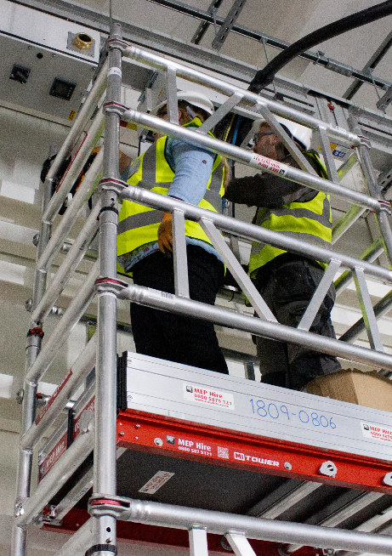 | ESG | All work undertaken at height must be carried out in compliance with the Working at Height Regulations 2005.  Prior to any work being undertaken at height task specific RAMS inclusive of risk assessments must be produced. The assessment must be undertaken with strict adherence to the implementation of the hierarchy of controls. i.e., where possible avoid work being carried out at height through appropriate planning, where working at height cannot be avoided prevent falls from occurring e.g., through the introduction of edge protection etc.  Several activities have been identified where a minimum standard of control is to be implemented as follows: -  Step ladders are only to be used on site when a risk assessment is provided to ESG that justified that other means of safer access equipment cannot be used.  All ladders are to be used in accordance with The Working at Height  Regulations 2005 inspected before use and documented in the PUWER register.  Daily user check - Check for splits or cracks in the stiles or rungs, ensure none of the rungs are missing or loose, do not use painted ladders, paint can hide defects, Report defects, label as defective and  remove from site.  Only light work of short duration, with low risk of falling should be carried out from a ladder and after assessment proved it was not practicable to use an alternative safer working platform.  All risk assessments are subject to the following rules-
Falls from height(continued) |  | - Where there is a risk from falling tools, materials or any other object while working at height, control measure must be in place to prevent items from falling.  - lanyards which meet the requirements of BS EN 354:2010 Personal fall protection equipment - Lanyards are to be attached at all times to ensure that there is no uncontrolled fall using connectors that comply with the requirements of BS EN 362:2004 Personal protective equipment against falls from a height- Connectors.  - Work areas are to be clearly identified through the posting of appropriate signage and/or barriers.  - The distance between the edge of a floor slab and a barrier is to be determined by risk assessment undertaken by the subcontractor. However, unless justified by risk assessment, this will not be less than 2m. Supervisors are to maintain a record of checks prior to personnel entering such areas to confirm that all lanyards are correctly attached before entering.  Mobile Towers  All towers must only be constructed by operatives that are trained to Prefabricated Access Suppliers’ and Manufacturers’ Association (PASMA) standard. Towers should be erected following a safe method of work.  Daily visual inspections and weekly recorded inspections to be undertaken.  MEWPS/ECO/PECO  Operators of these items of plant should have attended a recognised operator training course and received a certificate, card, or ‘licence’ (IPAF) listing the categories the bearer is trained to operate.  The hazards associated with the selected plant should be identified within a risk assessment and suitable control measures put in place i.e. entrapment, overturning, collisions etc.  It is important to select the right item of plant for the job and site.
Falls from height(continued) |  | Have a plan for rescuing someone from a MEWP and practice it – someone on the ground should know what to do in an emergency and how to operate the machine’s ground controls. ESG complete practical Toolbox Talks on emergency rescue which allows Operatives to be confident in an emergency situation.  Daily visual inspections and weekly recorded inspections to be undertaken.  - Erection of formwork and supporting structures Good practice in formwork safety to be adopted, including the use of edge protection system on formwork, intermediate platform on false work, and the use of safety harnesses when a working platform is impracticable (such as when fixing edge protection to the formwork). Netting to be used to ensure that materials cannot blow off the formwork onto the site below. Identify specific risk areas and produce risk assessments and method statements. Follow up with task briefings. Detailed method statement and false work drawings required.
d) Stability of structure whilst carrying out construction work, including temporary structures and existing structures  New plant/equipment loadings | Structural Engineer | Loadings from the new plant/equipment have been reviewed and where necessary suitable steelwork support frames have been specified to transfer the load onto the slab. Any future works within these areas will need to be carefully coordinated to ensure that this does not affect the existing structure.  Sections of steelwork designed to be in lengths to match the column locations and to ease the lifting procedures. Consideration will need be given to the method of handling / installation for the fixing to steelwork and sequencing of the works and all this to be included in RAMS.  Avoid overloading the raised floors during transportation of the new plant/equipment suitable spreader plates shall be installed to take loads directly down to the slab.
Mechanical and Manual handling for installation of the Services steelwork to the roof. | ESG | Sections of steelwork designed to be in lengths to match the column locations and to ease the lifting procedures. Consideration will need be given to the method of handling / installation for the fixing to steelwork and sequencing of the works and all this to be included in RAMS.
e) Work with or near fragile materials | ESG | Where there is a risk of fragile materials being present within a structure that is accessible to operatives and may result in a fall, suitable arrangements will be introduced to prevent access to such areas and appropriate signs placed. Any design that creates such a risk should in the first instance consider a change of design to remove the initial hazard.  Falls can be prevented by careful planning, using trained and experienced workers with suitable equipment and a high level of supervision.  ESG will ensure that a competent person assesses the roof (including voids above whitewall ceilings and POD roofs) using a safe system of work and ensure the work is properly planned in advance by a contractor with enough expertise in working on fragile roofs.  Ensure contractors have allowed enough time to carry out the work safely. Avoid workers having to go on the roof at all by adapting a method that allows works to be carried out from underneath using a suitable work platform. If the work cannot be done from underneath and workers need access to the topside of the roof: use a mobile elevating work platform (MEWP) that allows people to work from within the basket without standing on the roof itself. If access onto the fragile roof cannot be avoided, mitigate fall distance and consequences by: Installing perimeter edge protection. Ensure all the work and access platforms are fitted with guard rails, if this is not possible, install safety nets underneath the roof or use a harness system; and where harnesses are used, make sure they have adequate anchorage points and they are properly used – through appropriate discipline, training, and supervision.
f) Control of lifting operations (continued) |  | Operation of crane  The safe operation of the crane will be carefully controlled to ensure the safety of site personnel and operatives. The control measures will include the following:  - Lifting plan required.  - Crane erection method statement require approval from ESG Managers.  - Trained crane operators and slinger/signallers. Crane operators must have a CPCS card. Slinger/signallers will be provided with an on-site assessment in addition to a check of their certificates of training. Medicals required for operators. Exclusion zones to be prepared  - A site based appointed person or crane supervisor will be provided. This duty will be undertaken by a designated member of the management team who will retain overall responsibility for lifting on site.  - Maintenance of the cranes and the competence of the operators is a key consideration.  - The lead slinger/signaller will be appointed as the lifting supervisor, responsible for every day co- ordination of crane activities and reporting to the appointed person.  - The maintenance of crane and lifting tackle inspection records and operator and slinger/signaller competency will be regarded as zero tolerance items within the safety inspection routine.
g) The maintenance of plant and equipment | ESG | Access Equipment (step ladders, MEWPS, podium towers)  test certificate inspection when coming on site daily visual checks  weekly recorded inspections  Lifting Appliance  Inspected daily before use and recorded weekly inspections. This will be kept on ESG Share file.  PAT testing register kept as a live document. Contractors are to ensure that electrical equipment and the plant is clearly marked and ‘in date’ P.A.T. inspection labels attached.
h) Traffic routes and segregation of vehicles and pedestrians | ESG | Traffic routes and segregation of vehicles and pedestrians  ESG will organise and manage the site in accordance with the requirements of the CDM Regulations 2015 and the guidance contained within the Health and Safety Executive’s publication HS (G) 144  – Safe Use of Vehicles on Construction Sites.  Specifically, there will be  separate pedestrian entrances to the site and segregated pedestrian walkways to the main construction zones.  Access  ESG will strictly control access to the site, preventing unauthorized entry.  The site Set-up & Logistics plan clearly identifies the location of access points, segregated pedestrian entrances, car park, and vehicle routes.
i) Storage of materials (particularly hazardous materials) and work equipment  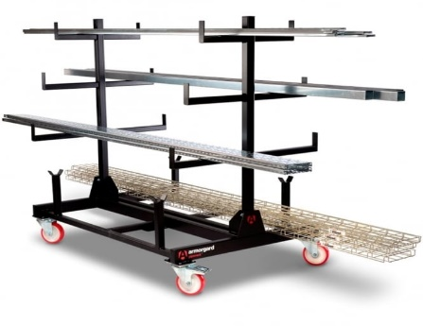 | ESG | Materials will be transported using mechanical means wherever possible, to avoid manual handling.  Materials will be kept in a designated storage area provided by ESG.  COSHH  Use of hazardous substances, particularly where there is a need for health monitoring  All substances used during and for the purposes of this project must be selected from ESGs, clients and Designers Approved Substances lists. Any substance that is not on the Approved Substances lists must be approved by the before use.  - Substances without approval shall not be used for the purposes of this contract  - ESG has a written safety procedure within the safe procedure’s manual, which forms part of the company safety documentation giving guidance to management and employees on the requirements of the above regulations.  All substances to be used by ESG that would fall under the current COSHH regulations will be identified and listed within a register. Data sheets for the substances will be obtained and used as part of the ongoing risk assessment process. The list will be formalised into a complete register by the Project Manager. Further substances that are to be used by ESG / subcontractor on site will be included in the register.
Storage of materials (continued)  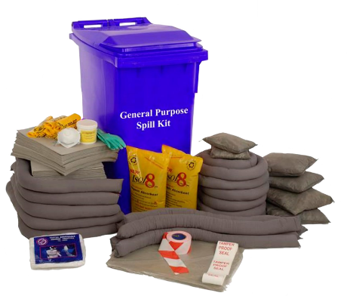 |  | Data sheets must be obtained by the Associate Director/ Contracts Manager and an assessment made prior to use by the site employees.  - In situations where specific assessments are required to be made on the work process for which the substance is being used e.g., arc welding in confined areas, this specific assessment will be carried out by the SH&E Advisor or other competent person and a written record produced.  ESG’s subcontractors will be required at the outset of the project to provide the Associate Director/Contracts/Site Manager with copies of any COSHH assessment sheets for the substances which they are using or intend to use.  Hazardous materials will be stored in lockable metal container.
j) Storage of Waste Materials | ESG | Waste materials from the construction process will be deposited in waste skips provided by the company, which will be emptied on a regular basis. A licensed waste handler will manage the waste, and a record of waste transfer notes will be maintained on site.  Any hazardous waste will be marked as such and handled and disposed of in an appropriate manner.
k) Fire protection of the structure  Fire protection on site and offices | Structural Engineer  ESG/  Contractors | Subject to building regulations requirements including intumescent paint finishes and ongoing maintenance commitments.  A fire risk assessment will be developed for the project.  ESG has a trained fire marshal that will carry out weekly recorded inspections.  These measures will include:
- Temporary Fire points.
- No smoking policy– site and offices.
- Burning of materials on site is not allowed.
- Hot Work Permits required for all flame or spark producing operations.
- Means of escape.
- Fire point compromising’s 2 suitable fire extinguishers located at strategic points in the site and welfare areas.
- All protection materials to be fire retardant.
- Rubbish to be cleared from each area daily.
- Specific fire and emergency plan to be written.
- Fire wardens to be appointed.
l) Trips, Falls due to poor lighting | ESG | General access lighting to common areas of the project will be provided by the Client and will incorporate emergency lighting in the event of a failure in the power supply.  All task lighting is to be supplied by contractors and must be maintained such that it does not cause an obstruction of tripping hazard through trailing cables.

Health risks

Site hazard | Owner | Control measures
a) Musculo-skeletal injuries    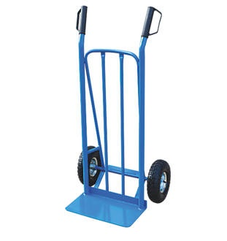  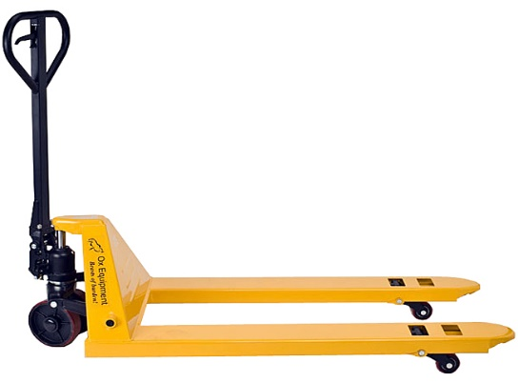 | ESG/  Contractors | Manual Handling  Plan the work to minimise manual handling. Use pallet movers within the building.  Where manual handling cannot be avoided, heavy items shall be either broken down into smaller loads or handled as a group lift. All risk assessments and method statements provided by site contractors must identify heavy items used and how they are to be handled.  Heavy items in the project area will be manoeuvred via the aid of genie lifts or similar.  Those Operatives regularly involved in manual handling will be provided with the necessary training.
b) Noise, dust, and vibration | ESG/  Contractors | Noise, dust, and vibration nuisance will always be considered in task specific RAMS and ensure minimum requirements taking all necessary measures to prevent dust or dirt infiltrating the surrounding properties.  Noise:  Noise will always be kept down to the minimum consistent with efficient working.  Personal radios/IPods Earphones/Bluetooth appliances may not be used on site.  Normal Working hours are 8am to 6pm Monday to Friday.  A list of operations/machinery for which specific noise assessments will be required (activities likely to expose a person to noise levels in excess of 80 dB(A)) will be maintained on site.  Where any person is likely to be exposed to a daily personal noise dose of more than 80 dB(A) suitable and sufficient hearing protection must be worn.  If any person is likely to be exposed to a daily personal noise dose of 85dB(A) or more an "Ear Protection Zone" will be created, and signs posted.  Guidance for noise reduction will be as per The Control of Noise at Work Regulations 2005  Public Nuisance Noise:  Noise from internal works has been monitored by external inspection and is minimal. There is an opening however sound will travel to a busy open road with no residential impact  There will be a period of external noise from a piling operation that will last no more than 1 week but again, there is no residential impact – Impact on an industrial unit, which is also owned by the client, will be measured via external observation and consultation with client employees  Guidance for the control of dust and noise will be taken from the following document, (See 5.0 Appendences).  - The Control of Dust and Emissions from Construction Sites and Demolition  - BRE – Controlling Particles and Noise Pollution form Construction Sites  - Controlling Particles, Vapour and and Noise Pollution from Construction Sites  Dust:  Where any person is likely to be exposed to construction dusts control measures will be include:  - Ventilation (natural or Local Exhaust Ventilation (LEV).  - Dust Capture Units fitted to equipment.  - Face Fit Testing.  - Training.  - No broom policy.  Public Nuisance Dust:  Dust from internal works has been monitored by external inspection and is minimal due to construction work consisting mainly of electrical data installation. There is an opening however minimal dust will travel to a busy open road with no residential impact  Guidance for the control of dust and noise will be taken from the following document, (See 5.0 Appendences).  - The Control of Dust and Emissions from Construction Sites and Demolition  - BRE – Controlling Particles and Noise Pollution form Construction Sites  - Controlling Particles, Vapour and and Noise Pollution from Construction Sites  Vibration:  Where operatives are potentially identified as being at risk of being exposed to HAVS or exceeding the duration of exposure trigger values or action levels (using HSE action level of 2.5 m/s² for various measured vibrations) then ESG will require that contractors implement a vibration management program. This should identify potentially hazardous work and work equipment and assess the risks through the established risk assessment procedures.  Preventative and correct programmes will be introduced and implemented.
Noise, dust, and vibration (continued) |  | All personnel involved in the use of work equipment that exposes them to vibration as identified in the RAMS mentioned, they should be monitored using a personal vibration monitoring device.  ESG will ensure that Suppliers and contractors include as part of their pre-qualification and working procedures a vibration management programme that addresses the following issues as a minimum:  - Identify hazardous work and assess risks.  - Introduce a preventive programme to eliminate or control the risk of injury to include  - Process Design/ selection/ modification  - Tool selection and maintenance programmes  - Training & information for operators, supervisors, and managers  - Limitation of duration of exposure ("trigger time")  - Health surveillance programme  - Tool purchasing policy.  All such programmes introduced will be regularly reviewed and subject to periodic audit by the contractor and independently by ESG.
c) COSHH | ESG/  contractors | A ‘COSHH substance’ is any material, mixture or compound used at work  or arising from work activities which is harmful to people’s health in the  form in which it occurs in the work activity. All contractors are required to  carry out COSHH assessments for hazardous substances, the contents of  which must be briefed to those using such substances.

Personal Protective equipment (PPE)

Where the risks to Health and Safety may not be adequately controlled by other means a Risk Assessment shall be carried out to assess these needs. The arrangements shall include the provision, control, monitoring, and maintenance of PPE.

The minimum requirements on all ESG sites for PPE are: -
- Hard Hat to BS EN 397
- High Visibility Vest or Jacket to BS EN 471 Class 2
- Footwear to EN245 200 with toecap and midsole
- Eye protection to EN 166 Type 1F
- Gloves: Cut Level defined by Risk assessment

Safety helmets will be colour coded in accordance with the Build UK Standard: (April 2016), as follows:
- White: Manager/ Competent Operative / Vehicle Marshal (distinguished by the wearing of an orange hi vis vest).
- Black: Supervisor Orange: Slinger Signaller
- Blue: Visitors and all others coming to site who do not fall into the above categories.

The issuing of all PPE is to be recorded in an appropriate register.

Permits to work.

The following permits are required on this project which are available from the Project team in the office:
- Hot works permits
- Electrical permits
- Step ladder permit
- Confined spaces
- Lifting Operations
- Excavations

Before starting any work, operatives will ensure they have the appropriate permit. A permit register is kept live electronically.

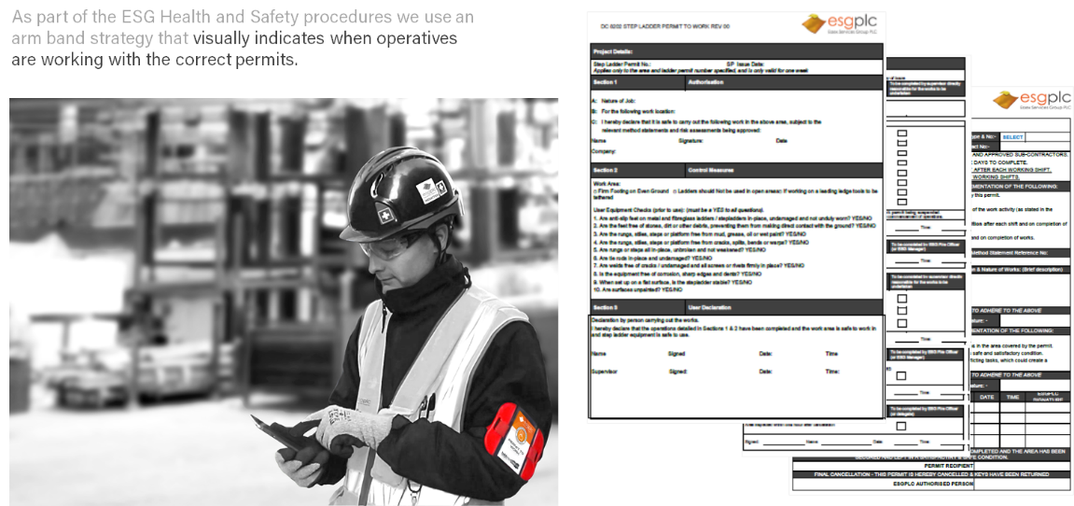

H&S Inspections and Audits

ESG project team will undertake periodic SHE inspections and produce reports in compliance with ESG standard procedures. Reports will be issued to contractors identifying findings, corrective actions, and dates for actions to be completed. Contractors are to ensure that relevant actions are closed out and confirmation returned to ESG.

The ESG project team will also establish a schedule of audits to be undertaken with contractors to establish compliance with legal requirements, policies, procedures, method statements and risk assessments. Audits will be notified in advance to contractors who are to make available relevant personnel, and they will take place every 2 weeks.

Audit reports will be issued to ESG Management team contractors with any non- conformances, corrective/ preventative actions and recommendations attached dates for completion identified.

Contractors will also be required to undertake regular recorded H&S inspections of their works and provide copies of such inspections to ESG.

The project may also be audited by Head Office or external auditors. Both the ESG project team and contractors will be required to cooperate with these auditors and assist in the closing out of any actions identified.

All inspections and audits will be recorded via an online management system called Yellow Jacket. Access to this information can be given to the Client upon request.

All Contractors are to collate and submit H&S information as and when requested by ESG. The project will also have a monitoring score system where all contractors will be scored for several Health and Safety, and Environmental Key Performance Indicators.

The health and safety file

Layout and format.

The Health and Safety File should contain the information needed to allow future construction, including cleaning, maintenance, alterations, refurbishment to be carried out safely.
The information in the file should alert those carrying out such work to the risks and should help them to decide how to work safely. The file should form a key part of the information that the Client is required to provide for future construction projects. The file should, therefore, be kept up to date after any relevant work or surveys.
In compliance with CDM Regulations 2015, the file should contain:
- A brief description of the work carried out.
- Any residual hazards which remain and how they have been dealt with (for example surveys or other information concerning asbestos; contaminated land; water bearing strata; buried services etc).
- Key structural principles (for example, bracing, sources of substantial stored energy - including pre- or post-tensioned members) and safe working loads for floors and roofs, particularly where these may preclude placing scaffolding or heavy machinery there.
- Hazardous materials used (for example lead paint; pesticides; special coatings which should not be burnt off etc).
- Information regarding the removal or dismantling of installed plant and equipment (for example any special arrangements for lifting, order, or other special instructions for dismantling etc).
- Health and Safety information about equipment provided for cleaning or maintaining the structure.
- The nature, location, and markings of significant services, including underground cables; gas supply equipment; fire-fighting services etc.
- Information and as-built drawings of the structure, its plant and equipment (for example, the means of safe access to and from service voids, fire doors and compartmentalisation etc).
- The health and safety file are kept up to date and available for inspection.
- The person responsible for keeping and maintaining the health and safety file should ensure that the information contained within it is clearly presented, legible and accessible.
The file will be audited and consolidated at regular intervals by an authorised person.

Arrangements for the collection and gathering of information.

Throughout the project those who carry out design work (including contractors) need to ensure so far as is reasonably practicable that information about any feature of the structure which will involve significant risks to health and safety during the structure’s lifetime is passed to ESG. Providing this information on drawings allows for amendments if any variations arise during construction. It also allows health and safety information to be stored on one document, therefore reducing the paperwork.
Arrangements will be made for relevant Contractors and consultants to pass on all relevant information for inclusion in the Handover O&M Health & Safety File to ESG.
ESG will collect and collate the requisite information from each contractor/subcontractor.

Storage of information.

All Health and safety information is kept on the ESG Share File system and copies of RAMS from Contractors will be kept in site office, available to be reviewed and inspected.
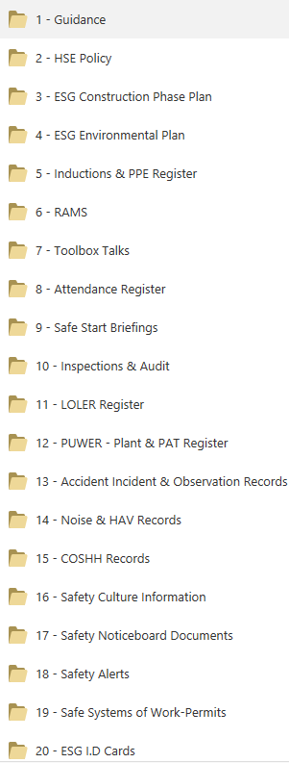
ESG electronic Health and safety file contain the following folders:

Appendences

Appendix 1 – Project Programme.
Appendix 2 – Site Logistics Plan.
Appendix 3 – Example Contractors KPI.
Appendix 4 – Sample RAMS Schedule.
Appendix 5 – Fire Plan Risk Assessment.
Appendix 6 – Principal Designer Residual Risk Register.
Appendix 7 – Health & Safety Policy.
Appendix 8 – Environnemental & Waste Management Plan.
Appendix 9 – Electrical Safety Management Plan.
Appendix 10 – Inspection & Test Plan.
Appendix 11 – Accident Investigation Flow Chart.
Appendix 12 – Official guides
- The London Freight Plan
- Direct Vision Standard
- EU Directive 2007/38/EC
- The Control of Dust and Emissions from Construction Sites and Demolition
- BRE – Controlling Particles and Noise Pollution form Construction Sites
- Controlling Particles, Vapour and Noise Pollution from Construction Sites

Appendix 01 - Project Programme

Appendix 02 - Site Logistics Plan

Appendix 03 - Example Contractors KPI’s

Appendix 04 – Sample RAMS Schedule

Appendix 05 - Fire Plan & Risk Assessment

Appendix 06 - Principal Designer Residual Risk Register

Appendix 07 - Health & Safety Policy

Appendix 08 - Environmental & Waste Management Plan

Appendix 09 - Electrical Safety Management Plan

Appendix 10 - Inspection & Test Plan

Appendix 10 - Inspection & Test Plan

Appendix 11 – Accident Investigation Flow Chart

Appendix 12 – Official Guides

