SITE SPECIFIC SUPPLEMENTARY INFORMATION

- Site Details

Site Name: | Bath Road SW | Site Address: | Bath Road,  London Borough of Hillingdon,  London,  Greater London,  UB3 5AH
NGR: | E: 509635 N: 176947 | Site Address:
Site Ref Number: | HGN11043 | Site Type: Macro | Street Works Monopole – Macro  Proposed telecommunications installation: Proposed Phase 8 Monopole C/W wrapround Cabinet at base & associated ancillary works.

- Pre-Application Check List

Site Selection

Was an LPA mast register used to check for suitable sites by the operator or the LPA? |  | No
If no explain why:

After a phone call to the LPA it was felt that the industry database was a more up to date source of information.

Was the industry site database checked for suitable sites by the operator: | Yes
If no explain why:

N/A

Pre-application consultation with LPA

Written offer of pre-application consultation: | Yes
Was there pre-application contact: |  | No
Date of pre-application contact: | N/A
Name of contact: | The Director of Planning
Summary of outcome/Main issues raised:

No comments had been received in respect to the proposals.

Ten Commitments Consultation

Rating of Site under Traffic Light Model: |  | Amber
Prior to the submission of this application the applicant initiates pre-consultation discussions with the local planning authority. This provides an opportunity for the LPA to discuss development proposals and identify site specific issues.

Summary of outcome/Main issues raised:

No responses had been received at the time of submission.

School/College

Location of site in relation to school/college:

There are no schools in close proximity to the site.

Outline of consultation carried out with school/college:

N/A

Summary of outcome/Main issues raised:

N/A

Civil Aviation Authority/Secretary of State for Defence/Aerodrome Operator consultation (only required for an application for prior approval)

Will the structure be within 3km of an aerodrome or airfield? | Yes
Has the Civil Aviation Authority/Secretary of State for Defence/Aerodrome Operator been notified? | Yes
Details of response:

N/A

Developer’s Notice

Copy of Developer’s Notice enclosed? |  | Yes
Date served: | 10th January 2021

- Proposed Development

The proposed site:
This is a highly constrained cell search area. The proposed site is located at Bath Road,
London Borough of Hillingdon, London, Greater London, UB3 5AH

There is now a requirement to upgrade the UK H3G (Three) network to provide improved coverage and capacity, most notably in relation to 5G services. This proposal is for a 18m SW (Street Works) monopole located on the adopted highways at Bath Road. The exact details of this proposal are illustrated on the enclosed drawings (Proposed Phase 8 Monopole C/W wrapround Cabinet at base & associated ancillary works). As with all 5G cells this is an extremely constrained cell search area. Options are extremely limited and the only viable solution that minimises amenity issues has been put forward.

Three are in the process of building out the UK’s fastest 5G network. Three has 140MHz of 5G spectrum (and 100MHz of it contiguous), which means our service will be much faster and able to handle more data. To bring this new technology to the people H3G will need to provide a mix of upgrades to existing sites and the building of new sites. New sites will be needed for many reasons, including that the higher radio frequencies used for 5G do not travel as far as those frequencies currently in use and that sometimes not all existing sites can be upgraded. In this area there is an acute need for a new mast to deliver the above.

It should be noted however, that the nature of 5G and the network services it provides, means the equipment and antennas required are quite different to the previous, and existing, service requirements. In particular, the nature of the antennas, and the separation required from other items of associated equipment, is such that it cannot utilise some existing structures that provide an installation for another operator, most notably in a street works or highways environment.

The site selection process has also been influenced by the numerous vertical elements of street furniture distributed around the vicinity of the site including street lighting columns. The height of the pole has been kept down to the absolute minimum capable of providing the required essential new 5G coverage. The site has been selected on a wide adopted area of the highway in a position that will not impede pedestrian flow or the safety of passing motorists. The cabinets are located at the base of the new pole and unless the site is located in Article 2 (3) land these are PD without Prior Approval and do not form part of the proposal from a planning consideration perspective.

This equipment is considered unlikely to have any material impact on the local area but significant connectivity improvements which is a material consideration in the judgment of the sites suitability. The cell search area was assessed at the Survey stage from a planning and residential amenity perspective. The planning constraints (where there are any) have shaped the location of the proposal. Figures 1-4 illustrate the site and the surrounding area.

The site is located on a grass verge on Bath Road, there is a backdrop of large trees that will aid in screening the site from nearby properties and existing vertical street furniture such as streetlights that will help the site blend into the surroundings. The site being located on a grass verge omits any impact to pedestrians and there are no highways concerns.

Figure 1:

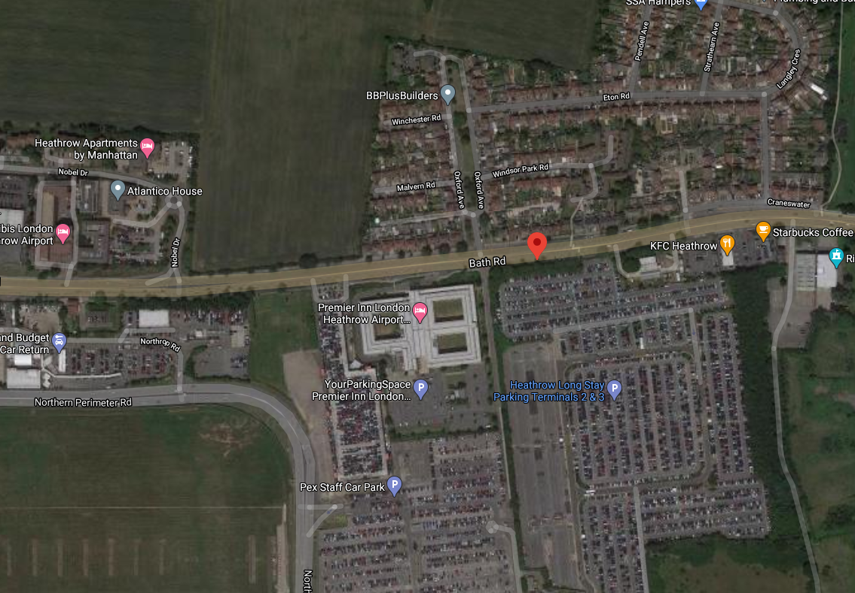

Figure 2:

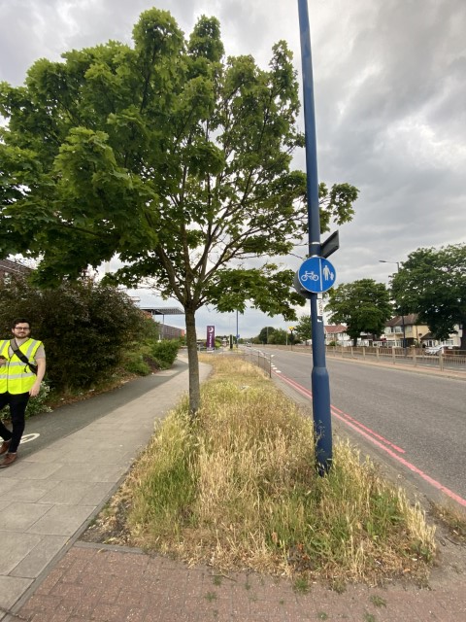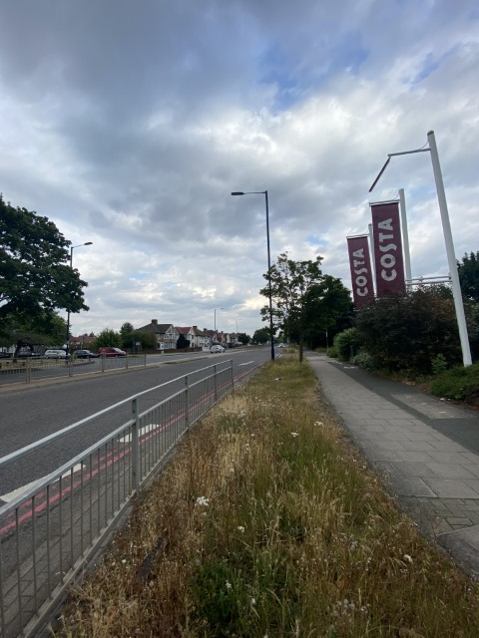

Figure 3:
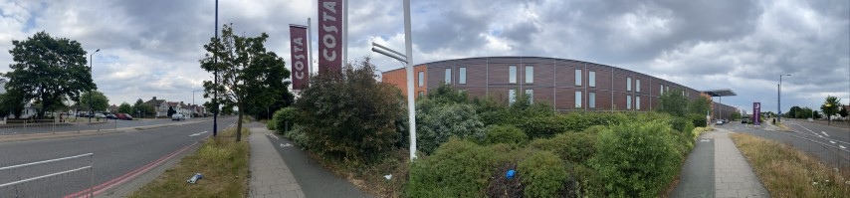

Figure 4:
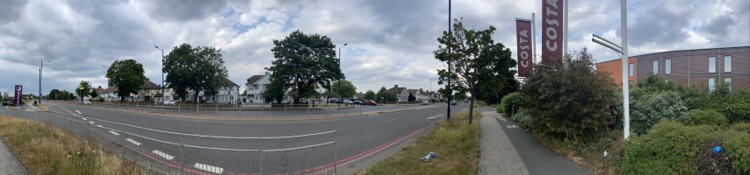

Policy Analysis:

Local Planning Authority: LB Hillingdon

Development Plan: Hillingdon's Local Plan: Part 1 -Strategic Policies (2012) / Hillingdon Unitary Development Plan (Saved Policies) (2007)

Policy Relevant to the Development Site:

The site is designated as being beyond the settlement boundary.

LB Hillingdon does have a specific telecoms policy. This, together with the NPPF is of relevance. The National Planning Policy section of this supporting statement goes into detailed analysis of why this site is in compliance with the NPPF.

The proposed works are not to the visual detriment of the surrounding area (being suitably distant from sensitive receptors). The proposal would not result in demonstrable harm to the character of the immediate or wider area, but are vitally necessary to ensure improved delivery of service. Capacity and coverage are the key drivers for this new 5G installation. The proposal would respect and continue to maintain the character of the area, would be suitably distant from potentially sensitive users, and so would accord with the principles of the Development Plan policies. It fully accords with the requirements of the NPPF.

Central Government attaches great importance to the design of the built environment and outlines this within Section 12 (para. 124) of the National Planning Policy Framework. It states:

“Good design is a key aspect of sustainable development, creates better places in which to live and work and helps make development acceptable to communities.”

In keeping with the National Planning Policy Framework (NPPF). guidelines of using: “high quality communications” (Section 10), the proposed design has been selected to minimise visual impact upon the street scene by integrating with the existing built environment.

The design of the proposed equipment is considered to be the least visually intrusive option available. Although it is accepted that there will be an intensification in the amount of equipment (an additional monopole and associated cabinets in the area) it is felt that such a minor increase would not detract from the character in which the proposal sits.

Enclose map showing the cell centre and adjoining cells:
There is an extremely small, constrained search area for this cell. See below the cell search area and the existing sites in the immediate vicinity. Often the proposal has been pulled marginally outside of the cell search area due to residential amenity, pavement width, underground services and planning issues. The mast must be in a position where it can be physically constructed. Existing underground services continue to be a significant obstacle to the deployment of this roll out. The optimum solution from a planning and radio coverage perspective has been put forward.

Figure 4 illustrates the nominal and existing 3 UK sites in the area. The nominal is captured by the pink dot below. The equipment has to be located in this pink dot or very close to it to give coverage and not to interfere with the adjoining 3UK sites.

Figure 4:
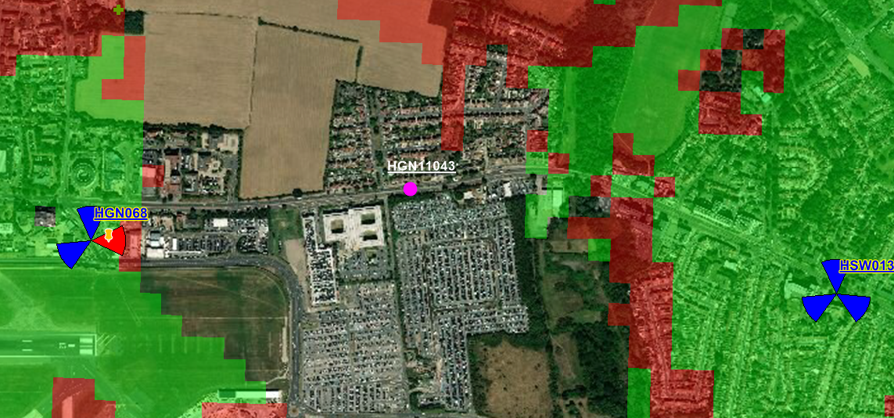

Type of Structure
Description:

Proposed Phase 8 Monopole C/W wrapround Cabinet at base.

Overall Height: +18.0m AGL
Height of existing building |  | N/A
Equipment Housing:
Length: |  | See drawings
Width: |  | See drawings
Height: |  | See drawings
Materials
Tower/mast etc – type of material and external colour: | Proposed Phase 8 Monopole C/W wrapround Cabinet at base.
Equipment housing – type of material and external colour: | Steel – Grey

Reasons for choice of design:
The proposed installation is an H3G LTE (Three) Phase 8 Monopole which will house H3G LTE (Three). The proposal is required due to acute capacity issues and will facilitate significantly improved 5G in areas that have started to gain this service and newly introduce it to the areas that have not gained this level of connectivity yet.

In keeping with the National Planning Policy Framework (NPPF July 2018). guidelines of using high quality communications infrastructure the proposed design has been selected to minimise visual impact upon the street scene by integrating with the existing street furniture, having similar vertical lines and overall appearance to the numerous street lighting columns in this area.
The 5G antennas are some 3 times as heavy as previous antennas, while the associated Remote Radio Units also now need to be placed at the top of the pole, thus many street works designs are no longer structurally capable of hosting all the equipment of 2 operators. It should be noted that the alternative option that could accommodate both operators (EE and H3G LTE who have a site sharing agreement) would be a more traditional ‘greenfield’ mast, with an open headframe and more bulky design, which would be inappropriate in a street scene location. There is no such location in this cell search area where a greenfield mast could be housed and thus site sharing is not a viable proposition.

- Technical Information

ICNIRP Declaration attached  ICNIRP public compliance is determined by mathematical calculation and implemented by careful location of antennas, access restrictions and/or barriers and signage as necessary. Members of the public cannot unknowingly enter areas close to the antennas where exposure may exceed the relevant guidelines. When determining compliance the emissions from all mobile phone network operators on the site are taken into account. | Yes

- Technical Justification

Reason(s) why site required
The National Planning Policy Framework clearly states that authorities should NOT question the need for the service, nor seek to prevent competition between operators. Notwithstanding this fact, the Applicant considers it to be important to explain the technical justification for the site and how the facility fits into the overall network.

The site is required to provide new 5G coverage for H3G LTE in order to improve coverage in the Hillingdon. The cell search areas for 5G are extremely constrained with a typical cell radius of approximately 50m meaning that it would not be feasible to site the column outside of this locale.

- Site Selection Process – alternative sites considered and not chosen

Discounted Options
In accordance with the sequential approach outlined in the National Planning Policy Framework (NPPF) following search criteria have been utilised. Firstly, consideration is always given to sharing any existing telecommunication structures in the area, secondly consideration is then given to utilising any suitable existing structures or buildings and thirdly sites for freestanding ground-based installations are investigated.

This sequential approach is outlined below:

- Mast and Site Sharing
- Existing Buildings Structures
- Ground Bases Installations

In compliance with its licence and the sequential approach outlined in the NPPF all attempts to utilise any existing telecommunication structures where they represent the optimum environmental solution have been employed. The Ofcom Site Finder mast register is always examined prior to the submission of an application.

DISCOUNTED OPTIONS:

If no alternative site options have been investigated, please explain why:

The NPPF is clear that LPAs should not question the need for the installation.

116. Local planning authorities must determine applications on planning grounds only. They should not seek to prevent competition between different operators, question the need for an electronic communications system, or set health safeguards different from the International Commission guidelines for public exposure.

The cell search area is illustrated below and is extremely constrained. The only viable option has been put forward. As with all 5G cells this is an extremely constrained cell search area. Options are extremely limited and the only viable solution that minimises amenity issues has been put forward. The proposed site is located in a densely packed residential area. The DSA (Designated Search Area) covers this densely packed residential area. There is no scope to pull the mast outside of this area and give the cell 5G coverage.

Figure 5: Discounted Options Map

D1: Bath Road - E: 509851, N: 176987. Discounted due to potential options available located closer to the nominal and limited pavement width.
D2: Bath Road - E: 509898, N: 176990. Discounted due to potential options available closer to the nominal that are more robust from a planning perspective.
D3: Bath Road - E: 509985, N: 176988. Discounted due to limited pavement width and potential options closer to the nominal.
D4: Bath Road - E: 509991, N: 177011. Discounted due to potential options closer to nominal. D5: Bath Road - E: 509555, N: 176961. Discounted due to possible residential amenity issues and concerns for visual splay at the junction.

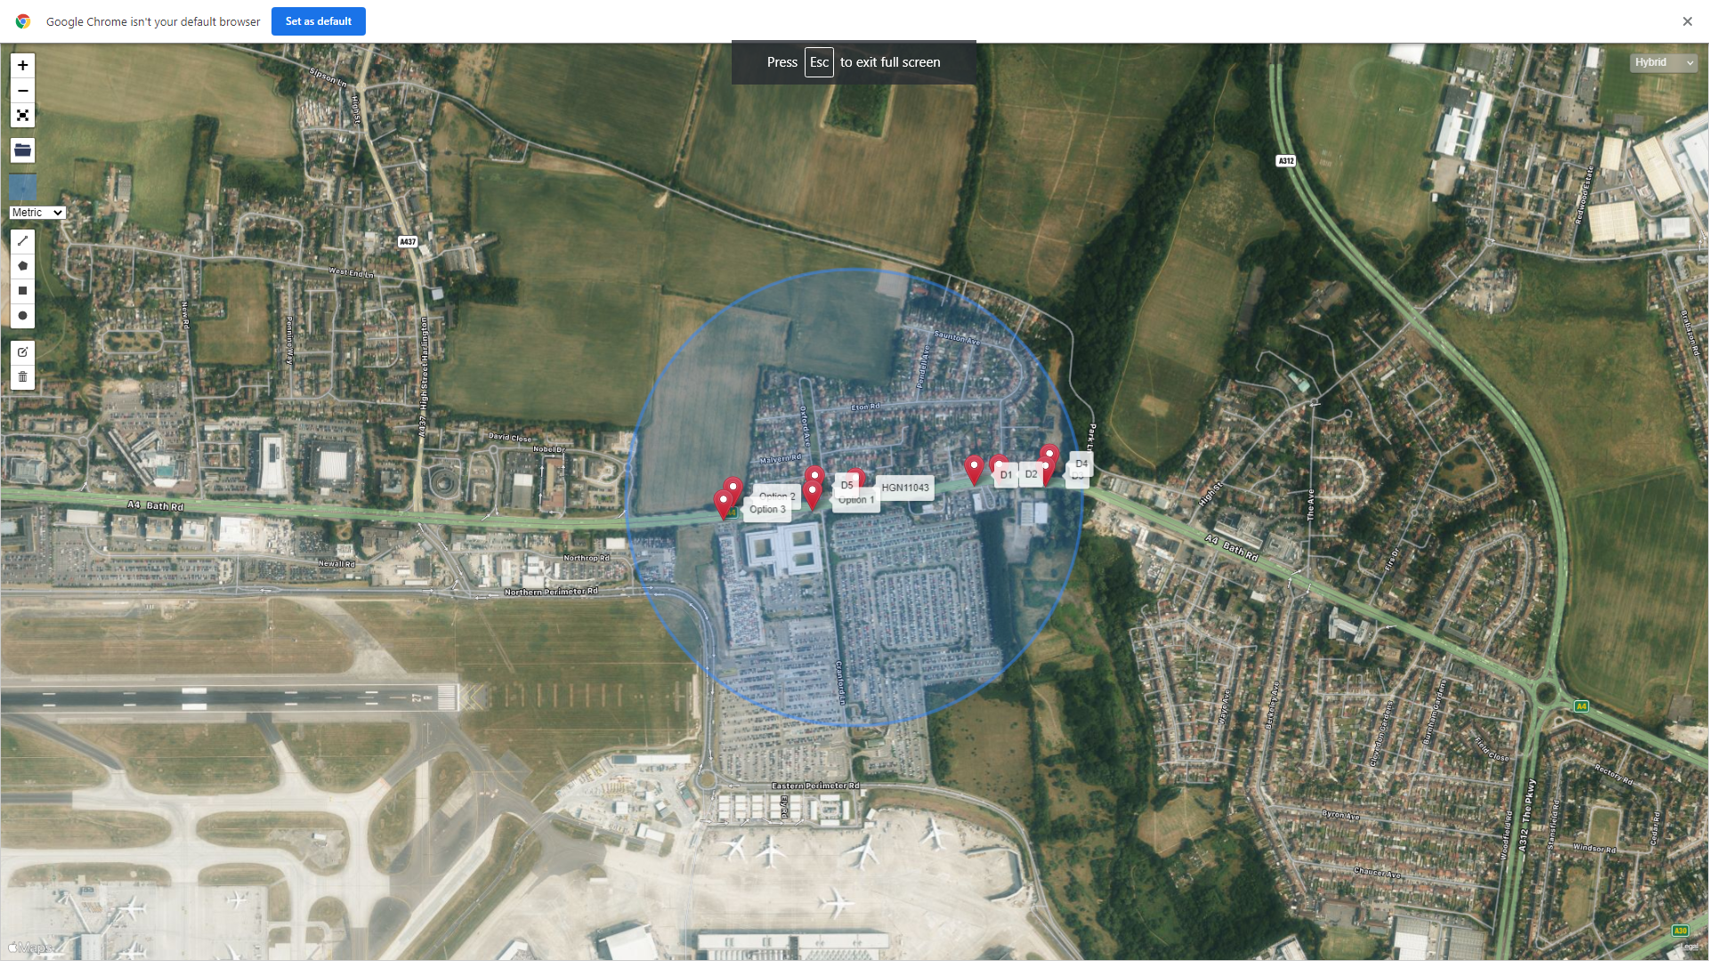

- Additional Relevant Information

Background to the Proposal
This specific proposal forms part of an integral requirement for H3G LTE to expand its 5G telecommunications network across London specifically in this instance to enhance 5G coverage levels and network capacity within the Hillingdon area.

Mobile phone base stations operate on a low power and accordingly base stations therefore need to be located in the areas they are required to serve. Increasingly, people are also using their mobiles in their homes and this means we need to position base stations in, or close to, residential areas.

A further limiting factor is that the position has to be one that fits in with the existing network. Sites have to form a patchwork of coverage cells with each cell overlapping to a limited degree with the surrounding base stations to provide continuous network cover as users move from one cell to the other. However, if this overlap is too great unacceptable interference is created between the two cells.

Siting

We have considered the detailed siting and design carefully to ensure that the scheme has a limited impact on the locality and general visual amenity.

Visual appearance

We would repeat that we have carefully placed and designed the scheme to ensure the principles of good siting and appearance are adhered to. The overall impact of the installation on the environment is limited.

DEVELOPMENT PLAN POLICY.

Development plan considerations have a special significance in law. Section 54A of the Town and Country Planning Act 1990 (The Act), and re-iterated in Section 38 of the Planning and Compensation Act 2004, it is stated that:

“Where in making any determination under the Planning Acts regard is to be had to the Development Plan, determination shall be made in accordance with the Development Plan unless material considerations indicate otherwise.”

NATIONAL PLANNING POLICY

The Government remain committed to promoting telecommunications and place emphasis on the importance of telecommunications to the wider economy. The National Planning Policy Framework (NPPF July 2018) sets out the Government’s planning policies for England and how these are expected to be applied at the Local level. It provides a framework within which local people and their accountable Councils can produce their own distinctive local and neighbourhood plans, which reflect the needs and priorities of their communities.

The purpose of the planning system is to contribute to the achievement of sustainable development. There are three dimensions of sustainable development, each of which give rise to the need for the planning systems to perform a number of roles including;

- Economic Role – contributing to building strong, responsive and competitive economy;
- Social Role – Supporting strong vibrant and healthy communities; and
- Environmental Role – Contributing to protecting and enhancing our natural, built and historic environment.
The NPPF contains at its core a presumption in favour of sustainable development which runs through both plan-making and decision-making processes. The NPPF recognises the vital importance of high-quality telecommunications and dedicates a whole chapter to this. Chapter 10 of the NPPF outlines the Governments support for high quality communications. The paragraphs below clearly outline the overarching support from Central Government for telecommunications and how Local Planning Authorities should embrace this vital infrastructure:

Paragraph 112 states:

“Advanced, high quality and reliable communications infrastructure is essential for economic growth and social well-being. Planning policies and decisions should support the expansion of electronic communications networks, including next generation mobile technology (such as 5G) and full fibre broadband connections. Policies should set out how high quality digital infrastructure, providing access to services from a range of providers, is expected to be delivered and upgraded over time; and should prioritise full fibre connections to existing and new developments (as these connections will, in almost all cases, provide the optimum solution).”

It continues in Paragraph 113

“The number of radio and electronic communications masts, and the sites for such installations, should be kept to a minimum consistent with the needs of consumers, the efficient operation of the network and providing reasonable capacity for future expansion. Use of existing masts, buildings and other structures for new electronic communications capability (including wireless) should be encouraged. Where new sites are required (such as for new 5G networks, or for connected transport and smart city applications), equipment should be sympathetically designed and camouflaged where appropriate.”

Operators always follow the sequential site selection process. Where an existing site can be shared or upgraded this will always adhered to before a new proposal is put forward for consideration. In this instance there is no scope to upgrade an existing mast nor site share.

The support for telecoms and the need not to constrain Operators is laid out in Paragraph 116

“Local planning authorities must determine applications on planning grounds only. They should not seek to prevent competition between different operators, question the need for an electronic communications system, or set health safeguards different from the International Commission guidelines for public exposure.”

Conclusion

We consider that the development is compliant with the council’s policy and that in accordance with Section 38 (6) of the Planning and Compensation Act 2004 permission should be granted for the installation.

We consider the development complies with both central government and local planning policy guidance where the underlying aim is to provide an efficient and competitive telecommunication system for the benefit of the community while minimising visual impact.

Taking into account the factors of technical constraints, available sites and planning constraints we consider that this site and design clearly represents the optimum environmental solution.

On the basis of a recognised need to expand and promote telecommunications networks across the region, it is considered that the proposal fully accords with the requirements of the National Planning Policy Framework and Council’s Local Plan Policies.

Eve Wyke BSc (Hons)
Assistant Planning Manager
Email: e.wyke@whptelecoms.com

Contact Details

Name: (Agent) | Eve Wyke  BSc (Hons) | Telephone:
Operator: | H3G LTE | Fax no: | N/A
Address: | WHP  Helena House  Troy Mills  Troy Road  Leeds  LS18 5GN | Email Address: | e.wyke@whptelecoms.com
Signed: |  | Date: | 11th January 2021
Position: | Assistant Planning Manager | Company:  (on behalf of above operator) | WHP

