Uxbridge Quaker Meeting House – Proposed garden shed images

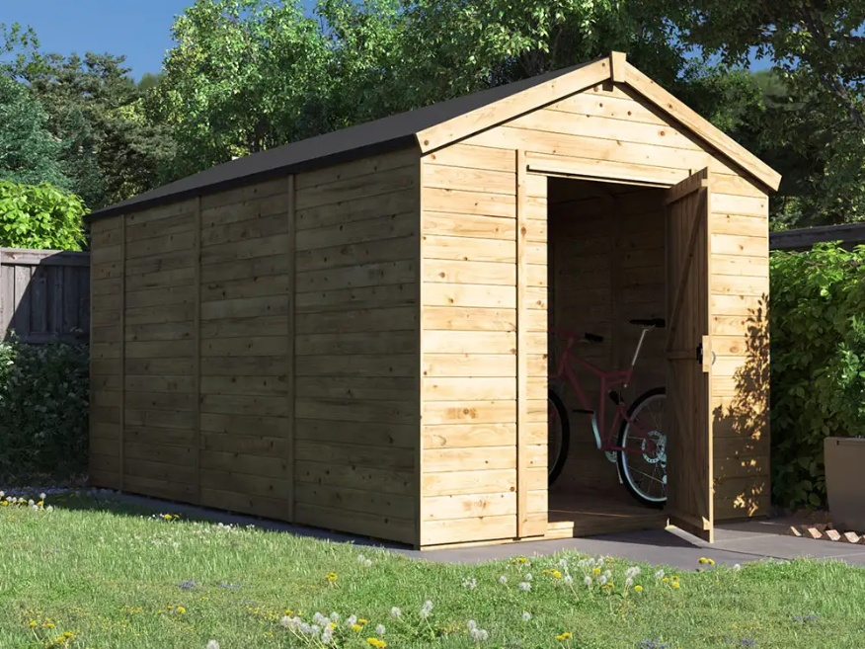
Image untreated shed
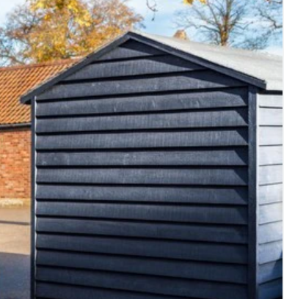
Proposed treated shed

