Discharge condition - 28 Manor Road - Ruislip – HA4 7LB
Reference | 75898/APP/2021/1062

On request of the details for the roofing materials proposed, please, see below the details:

ROOF TILE: Redland concrete plain roof tile, colour: Hand Rustic Red London (as sample).
Matching Redland concrrete External Angles and Half round Ridge.

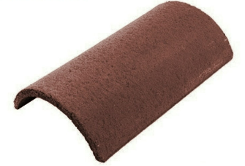
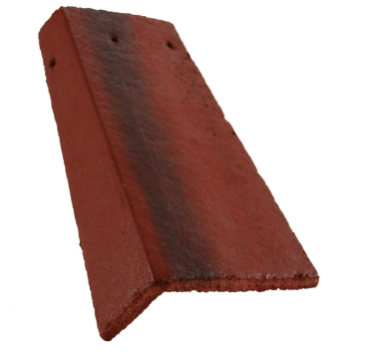
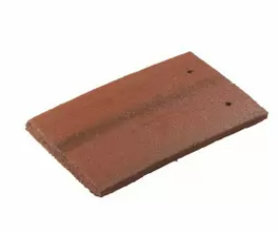
Please note the tile sample is provided for colour of all 3 elements.

