Highford Design and Build Ltd
info@highforddesign.co.uk

DESIGN AND ACCESS STATEMENT – REAR EXTENSION AND REAR FACING DORMER WINDOW
87 Swakeleys Road, Ickenham UB10 8QG

This proposal is for the redevelopment of an existing semi-detached family home located at 87 Swakeleys Drive, Ickenham, Uxbridge UB10 8QG. The proposal is to extend and provide additional rooms for a single family dwelling and consists of a part two storey, part single storey and a rear facing dormer window to proposed conversion of roofspace.
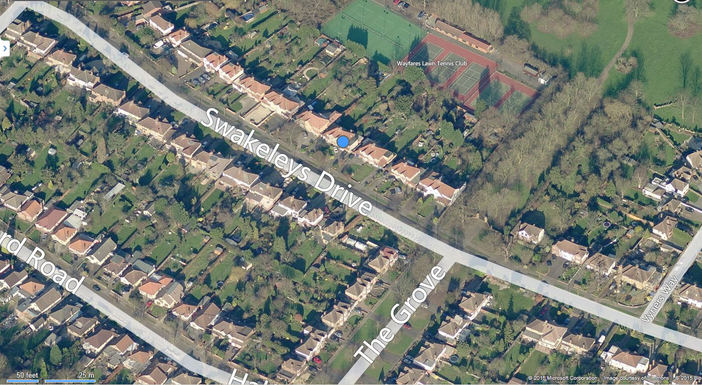
Extract from Bing maps 87 Swakeleys Drive highlighted in red.
The proposed redevelopment has taken guidance from the London Borough of Hillingdon HDAS Supplementary Planning Document.
This scheme has
- Part two storey with pitched roof, part single storey rear extension with flat roof. Maximum height of single storey element is not to exceed 3m, and the depth of the extension will be 4m from the rear of the existing house
- The existing house is set in generous grounds and the plot is 8.95m wide
- The single storey rear element of the development has now been designed with a parapet wall, in lieu of the original facia and soffit design.
- The small rear facing dormer window to the 2nd floor loft space will have a single window
- Materials and Architectural detailing to match existing and respect the established character of the neighbourhood and surrounding areas

