Planning Statement
Land adjacent to 25A Norfolk Road
This planning statement has been prepared to support the revised application at Land Adjacent to 25A Norfolk Road. It provides details in of how the proposal conforms with the relevant national, regional, and local level policies as well as a response to each of the refusal reasons from the previous application. As such we would like to ensure that the application can be supported by the Local Planning Authority and should you require any further information please contact Mr Donald using the contact details provided.
Description of development:
Erection of a 3 bedroom detached dwelling, provision of 2 off street parking spaces and amenity space.
Site description:
The application site is a garden land site, located on the northern side of Norfolk Road. Further north is the Uxbridge Common which is large green attractive green space. The character and appearance of the street comprises of a mixture of two storey detached / semi-detached dwellings which feature pitched tiled roofs and brick exterior finishes. The dwellings also feature front projection bays to the front and benefit from modest front gardens which provide off-street car parking.
Adjacent to the site and to the west of the site is a two-storey block of flats which features a white rendered finish, a pitched tiled roof and balconies to the front.
Adjacent to the east of the site is 25A Norfolk Road, a detached, two storey house built of brick construction with wooden panels to its front elevation and an integral garage.
The site is identified as being located within the North Uxbridge Area of Special Local Character.
Planning history
- The planning history for the site has caused some confusion as the Local Planning Authority have made an error when registering a planning application made for the neighbouring site which is land rear of 12 Cornwall Road. Application reference 75552/APP/2020/2236 has been registered under site address Land Adjacent to 25A Cornwall Road however the site location plan demonstrates that this is not the correct site address and is in fact the site next door. We requested that the case officer change the site address but to date it has not been changed.

- 73325/APP/2018/2474 - Erection of a two storey building with habitable roofspace to include 5 x 2-bed self-contained flats with installation of vehicular crossover, parking and amenity space.

Reason for refusal 1: The proposed development, by reason of its siting, size, scale, height, bulk, roof form and inappropriate details of design, would result in a cramped development of the site, which is visually incongruous and would fail to harmonise with the existing local and historic context of the surrounding area. The proposal would thus be detrimental to the visual amenities of the street scene and the character, appearance and local distinctiveness of the wider North Uxbridge Area of Special Local Character. The proposal is therefore contrary to Policies BE1 and HE1 of the Hillingdon Local Plan: Part One - Strategic Policies (November 2012), Policies BE5, BE13 and BE19 of the Hillingdon Local Plan: Part Two - Saved UDP Policies (November 2012), Policies 3.5, 7.1 and 7.4 of the London Plan (2016) and the adopted Supplementary Planning Document HDAS: Residential Layouts.

Reason for refusal 2: Due to the proposed siting of the off street parking bays and direct pedestrian access for the existing dwelling, the proposal would result in a large area of hardstanding/parking on the frontage, and would not allow sufficient space to mitigate this impact by way of soft landscaping. The proposal would therefore be detrimental to the visual amenities of the street scene and character and appearance of the wider North Uxbridge Area of Special Local Character, contrary to Policies BE1 and HE1 of the Hillingdon Local Plan: Part One - Strategic Policies (November 2012, Policies BE5, BE13 and BE38 of the Hillingdon Local Plan: Part Two - Saved UDP Policies (November 2012) and the adopted Supplementary Planning Document HDAS: Residential Layouts.

Reason for Refusal 3: The proposal has failed to provide adequate waste storage facilities, in a suitable location, in accordance with the council's adopted standards, and therefore the proposal is contrary to policy AM7 of the Hillingdon Local PLan - Saved UDP Policies (November 20

Reason for refusal 4: The applicant has failed to demonstrate that the proposal would provide an indoor living area of a satisfactory size and height for the occupiers of the proposed two bedroom flat at second floor level and would thus give rise to a substandard form of living accommodation to the detriment of the amenities of future occupiers, contrary to Policy 3.5 and Table 3.3 of the London Plan (2016), the Housing Standards Minor Alterations to The London Plan (March 2016), the Mayor of London's adopted Supplementary Planning Guidance - Housing (March 2016) and the Technical Housing Standards - Nationally Described Space Standard (March 2015).

- 75552/APP/2020/1351 Erection of a detached two storey 4-bed dwelling with associated parking and amenity space.

Reason for refusal 1: The proposed development, by reason of its size, scale, bulk, height and design, would result in a poor and incongruous form of development that would be detrimental to the character, appearance and visual amenities of the street scene and the surrounding North Uxbridge Area of Special Local Character. The proposal is therefore contrary to Policies BE1 and HE1 of the Hillingdon Local Plan: Part One - Strategic Policies (November 2012), Policies DMHB 1, DMHB 5, DMHB 11 and DMHB 12 of the Hillingdon Local Plan Part Two - Development Management Policies (January 2020), Policy 7.8 of the London Plan (2016) and the NPPF.

Reason for refusal 2: The proposal would result in the provision of a habitable room (Bedroom 4) with no outlook and limited levels of natural lighting that would result in a substandard form of living accommodation and reliance upon artificial means of lighting which would fail to satisfy sustainability and energy efficiency objectives and would be to the detriment of the amenity of future occupiers, contrary to Policies DMHB 11 of the Hillingdon Local Plan: Part Two - Development Management Policies (2020) and Policies 3.5 and 5.3 of the London Plan (2016).

Reason for refusal 3: The proposed development, by virtue of the poor internal layout of the proposed W/C at ground floor level would fail to provide a dwelling which is accessible and adaptable to the detriment of the amenity of future occupiers. The proposal is thus contrary to Policies 3.8 and 7.2 of the London Plan (2016) and the Technical Housing Standards - Nationally Described Space Standard (March 2015).

Conclusion
As stated above the planning history for this site has become confusing due to a mistake in registering an application which does not propose development on this site. Application ref; 73325/APP/2018/2474 propose a more holistic development of both the land to the rear of 12 Cornwall Road and Land Adjacent to 25A Norfolk Road and we took the officers comments on board hence the scheme has been reduced to developing the site within our ownership only. In addition we have taken the points which lead to the reason for refusal on the most recent application 75552/APP/2020/1351 on board and this is discussed in more detail in the design sections below.
The principle of development
The National Planning Policy Framework (NPPF) supports the delivery of homes, confirming that local authorities should, through their Local Plans, demonstrate how housing targets and objectives will be met. Particular emphasis is given to housing delivery over the next five years, but authorities are also required to consider growth beyond this
Local Plan Part 1 Policy H1 gives general support to housing provision to meet and exceed the Council's minimum strategic dwelling requirement, where this can be achieved, in accordance with other Local Plan policies.
Policy 3.3 of the London Plan seeks to ensure that London's housing needs are met. This objective is reiterated in the Mayor of London's Supplementary Planning Guidance (SPG) on Housing, although it is noted that the in achieving housing targets, full account must be given to other policy objectives.
Policy H2 of the draft London Plan states that there to be an importance on small site (sites with a site area of less than 0.25 hectares) in delivering new homes.
As the proposed site currently forms part of the garden of 14 Cornwall Road Local Plan Part 2 Policy DMH 6 is relevant to the assessment of the application.
The policy states :
Policy DMH 6: Garden and Backland Development
There is a presumption against the loss of gardens due to the need to maintain local character, amenity space and biodiversity. In exceptional cases a limited scale of backland development may be acceptable, subject to the following criteria:
i) neighbouring residential amenity and privacy of existing homes and gardens must be maintained and unacceptable light spillage avoided;
ii) vehicular access or car parking should not have an adverse impact on neighbours in terms of noise or light. Access roads between dwellings and unnecessarily long access roads will not normally be acceptable;
iii) development on backland sites must be more intimate in mass and scale and lower than frontage properties; and
iv) features such as trees, shrubs and wildlife habitat must be retained or re-provided.

For clarity each of the principles of DMH 6 is answered in order below:

- Section 7.1 of the officer report for application 75552/APP/2020/1351 states “Overall it is considered that the proposed house would not cause harm to the amenity of nearby residents.” It should be noted that the revised proposal does include a change in the location of the building within the site therefore the distances between the new and existing properties have not been compromised. As such the officers comments on the impact to neighbouring amenity should remain the same.

- As with the impact on neighbour amenity, access and parking was not raised as an issue. Section 7.2 of the Officer report states “It is proposed to provide a new detached 4 bedroom residential unit. The maximum standard requires 2 spaces and this is to be provided on the frontage. The quantum and arrangement are therefore considered satisfactory. The creation of a vehicular crossover in this location is considered to be acceptable in principle.” This remains unchanged and therefore no concerns should be raised.

- With regards to the mass and scale of the proposed new dwelling, the roof line has been set down from the two storey block of flats which is adjacent to the site to the west and sits at the same height as the neighbouring property 25A. It should be noted that no concerns were raised with the width and depth of the new dwelling which is comparable to No 25A. Some concerns were raised relating to the roof and therefore the revised plans remove the accommodation within the roof in order to reduced the scale and massing of the roof form. The image below demonstrates that the roof when viewed from the street scene is comparable with the neighbouring dwelling and therefore we do not feel that there should be any concerns with the scale and mass of the roof. In addition a section of the ground floor to the rear has been removed in order to keep the scale and massing in line with No 25A.
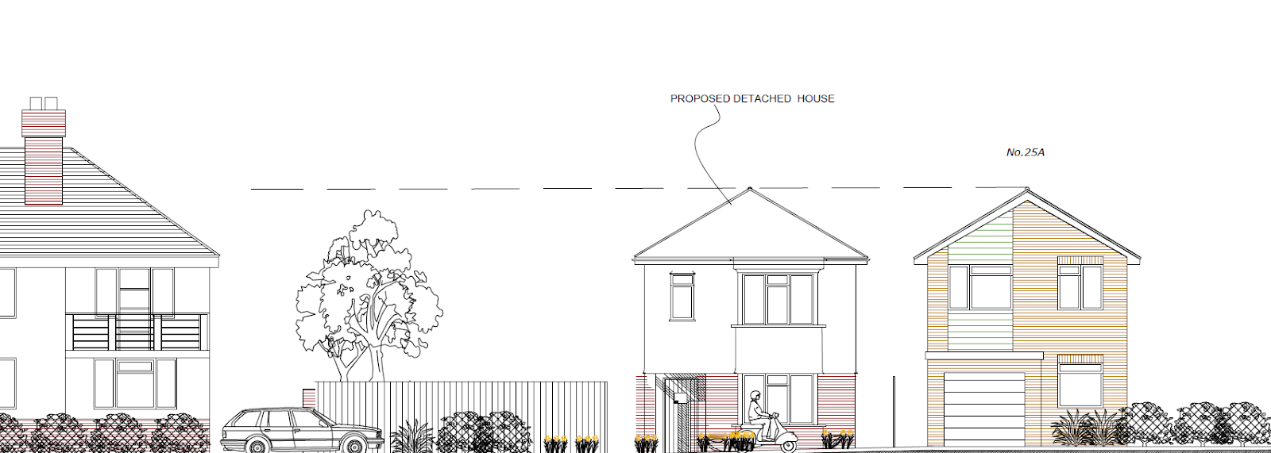
Conclusion
Taking the above points into consideration the proposal complies with all of the sections within the Garden Land policy DMH6 and the principle of developing the site should be considered acceptable. The key points of concern which formed reasons for refusal when determining the previous application have also been addressed in the revised submission and this should be taken into consideration when determining the revised application. Finally the proposal for one new dwelling on this site is considered to comply with the policies set out above and in particular the London Plan Policies relating to the development of new homes on small sites.

Design
Area of Special Local Character and the street scene DMHB 5 and DMHB 11 of the Hillingdon Local Plan Part Two
Part of the officers report for the refused application included comments from a Heritage and Conservation Officer. The comments in our opinion are considered to be a very harsh assessment of the proposal. However these comments have been taking into consideration when revising the proposed plans and hopefully we have addressed the concerns where possible. In order to justify why this development within the Area Of Special Local Character is acceptable we have answered some of the key points raised.
“The proposed house would be of a similar width and depth to 25A and would be situated within a similar plot size and it is considered that it would be suitably set away from the site boundary. However it would introduce a new housing style to Norfolk Road. It would have a somewhat generic appearance which would fail to pick up on any of the distinguishing features of the more historic houses found within the ASLC. Moreover it would introduce a roof form that would not reflect that of No. 25A or those within the surrounding area. It would have a pitched roof with a high gradient meaning that the roof would appear out of proportion with the rest of the house. No. 25A forms part of a small group of similarly designed houses of the same height and this property would be higher than those houses. As such it is considered that it would appear incongruous within the street scene.”
It is noted there are two key concerns here which are (1) scale and massing mainly relevant to the roof design and (2) The generic nature of the design and whether it continues the poor precedent set by some of the properties which have a similar design.
With regards to point (1) as stated in the sections above, we feel this point has been addressed in the reduction of the scale of the roof form by removing the accommodation within the roof which reduces the overall scale.
In terms of point (2) the key design features from within the street scene have been adopted within the design of the new dwelling. Whether these are poor precedents is a subjective opinion however the more important part seems to be the impact upon the arts and crafts design features which would have characterised the Area of Special Local Character. A walk of the street scene will identify that there is very little examples of the arts and crafts design features within the immediate street scene hence adopting this type of design could result in a development which could arguably be considered out of character with the street scene.
Whilst the design features of the properties within the immediate street scene may not be desirable, the fact remains that there is a prevailing set of features which have all been considered within the design of the new dwelling. For example the property is set back a moderate distance from the front boundary and adopts a boundary treatment very similar to the properties site on the northern side of Norfolk Road. Most of the properties feature a front projecting bay within the front façade which has been adopted also. The scale and massing has been reduced so that it is more in-keeping with the neighbouring property at No.25A.
In terms of materials this could be conditioned and we would be happy to work with the Local Planning Authority to ensure appropriate materials are used.
Some examples of the design features mentioned above are included in these images below:

Front projection bays and similar roof form
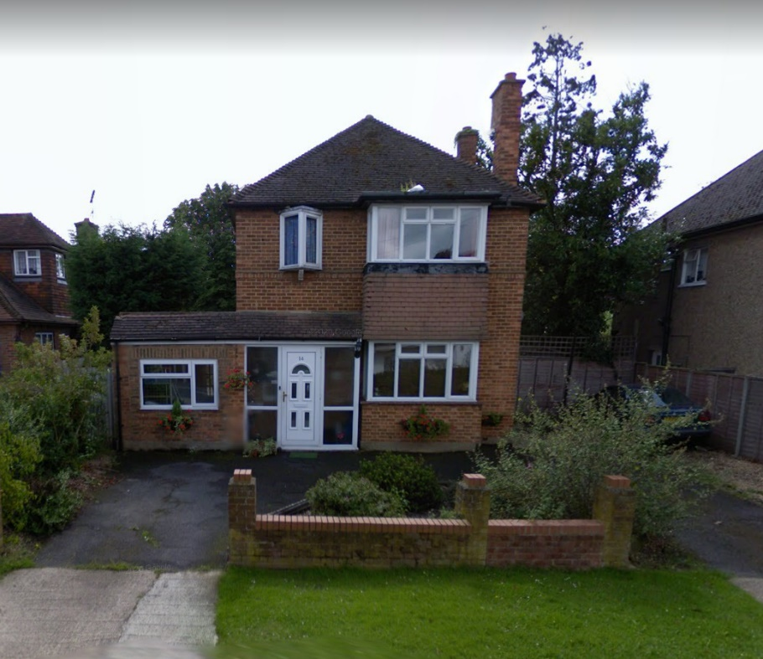
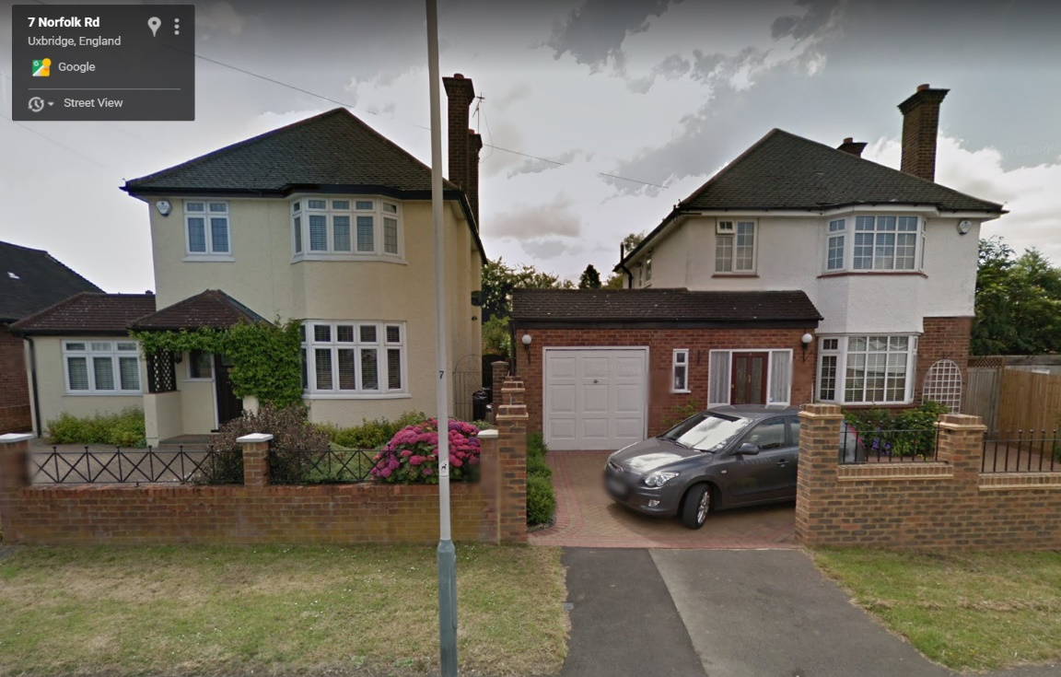
View of No.25A in the context of the site.
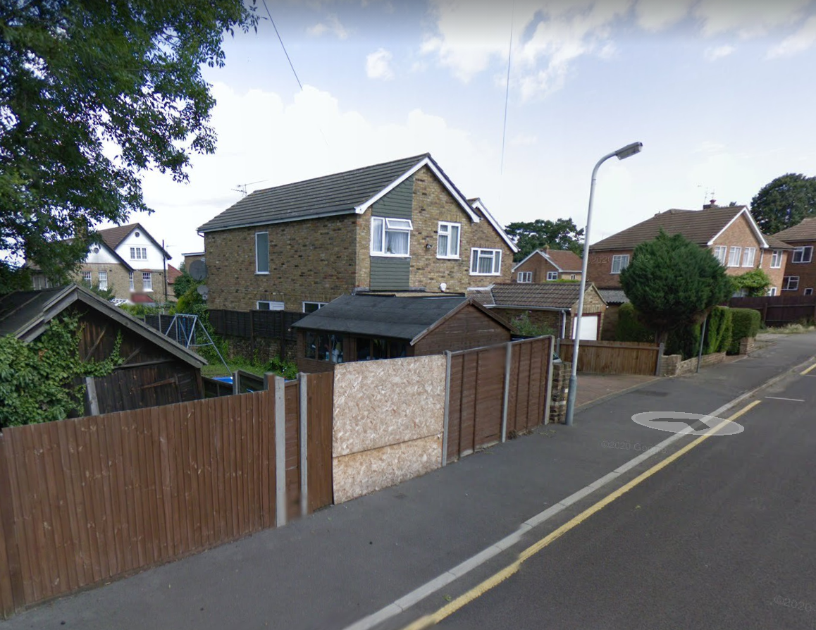
Conclusion
Whilst the development site is located within an Area of Special Local Character which may of at one period in time, been characterised by properties from the Arts and Crafts era the prevailing character is two storey dwellings set back within the site by a modest distance with pitched roof designs and front projecting bays. The materials differ between properties but mainly the dwellings feature pitched tiled roof and are constructed of external finished brickwork, although some feature render.
These design features have been included within the design of the new dwelling as has the design of the neighbouring dwelling therefore the proposed development is not considered to result in harm to the character and appearance of the street scene or the historic nature of the Area of Special Local Character. As no significant harm has been identified or elaborated on in previous decisions there should be no requirement for the applicant to demonstrate how the benefits of the scheme outweigh the potential harm.
Finally it is clear from the image above that the site frontage does not contribute positively to the street scene. This development provides an opportunity to improve this area of the street scene and should be assessed with this in mind also.

Neighbour amenity DMHB 11 of the Hillingdon Local Plan Part Two
The previous decisions did not raise any concerns with the impact of the development upon neighbouring amenity. The changes to the scheme are a reduction on the scale and massing and do not present any additional features which would compromise the protection of the amenities of neighbouring properties. The proposal should be considered acceptable in this regard.
Amenities for occupants of the development
In regards to internal living standards the internal arrangements conform to the London Plan space standards. A reason for refusal was added to the previous decision notice regarding the internal floor arrangements not meeting the M4 standards. This could have been resolved if we had been made aware of the concerns pre-determination of the application but we received no correspondence on this matter. Nevertheless this reason for refusal has been taken into consideration when redesigning the scheme.
In addition a reason for refusal from the previous application was the lack of light/outlook to bedroom 4 which was in the loft space. The bedroom within the loft has been removed from the plans and the application property is now a 3 bed.
In terms of useable amenity space, over 128sqm of useable rear amenity space is demonstrated on the proposed plans.
Conclusion
The revised plans address the previous reasons for refusal and comply with the relevant policies.
Parking, Access and Landscaping
No concerns were raised in the refusal of the previous application regarding the provision of 2 parking spaces within the front boundary of the site. There was also no objection to the construction of a new vehicular access. We have included adequate provision of landscaping to the front which will help to integrate the proposed dwelling with the rest of the street scene.

Conclusion
Following the refusal of the previous application for a 4 bed dwelling we have taken into consideration the concerns raised within the officers report and the reasons for refusal. We feel that the submission of the revised 3 bed dwelling and revised design answers these concerns and this planning statement provides adequate support for why the development should be approved.
We would be happy to work with the Council should they require further detail and would be open to discussing conditions which the Council may choose to impose on the recommendation to approve the proposal.
As such we would like to ensure that the Council keeps an open channel of communication in line with the NPPF’s requirements for decision makers to work pro-actively with applicants.

Regards

