Joel Street – Small Holding – Information Sheet

Currently the site is used to keep horses in the newly constructed stables (planning granted 2 years ago).

The site benefits from the following:
- Own main gated entrance with gravel road
- Three phase power supply
- Existing manholes to take soil waste
- Mains Water Supply

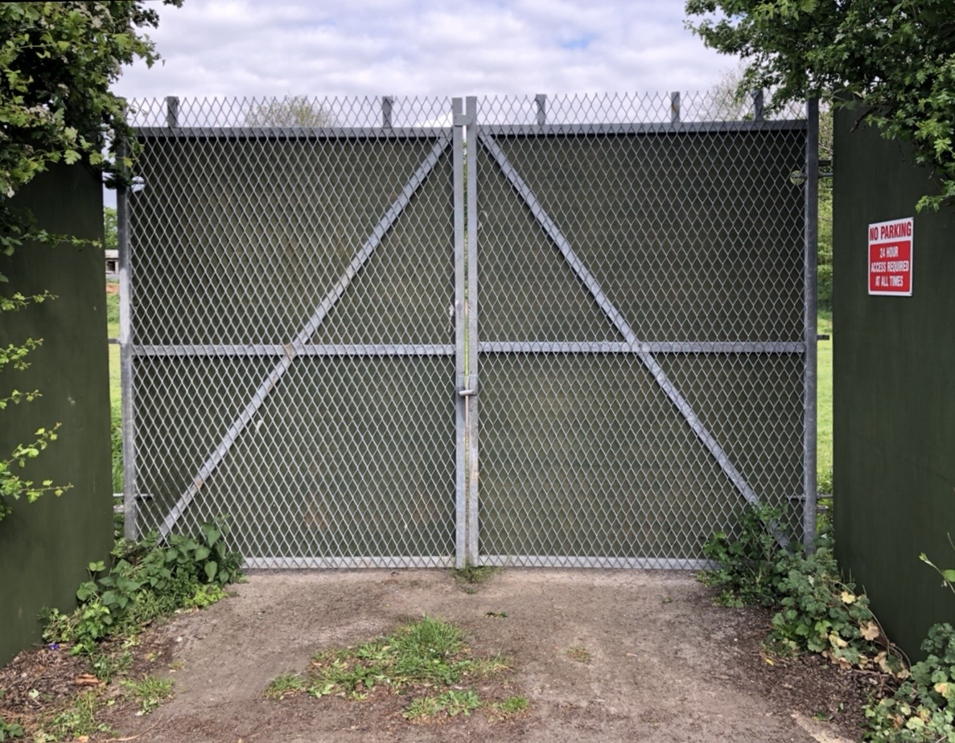
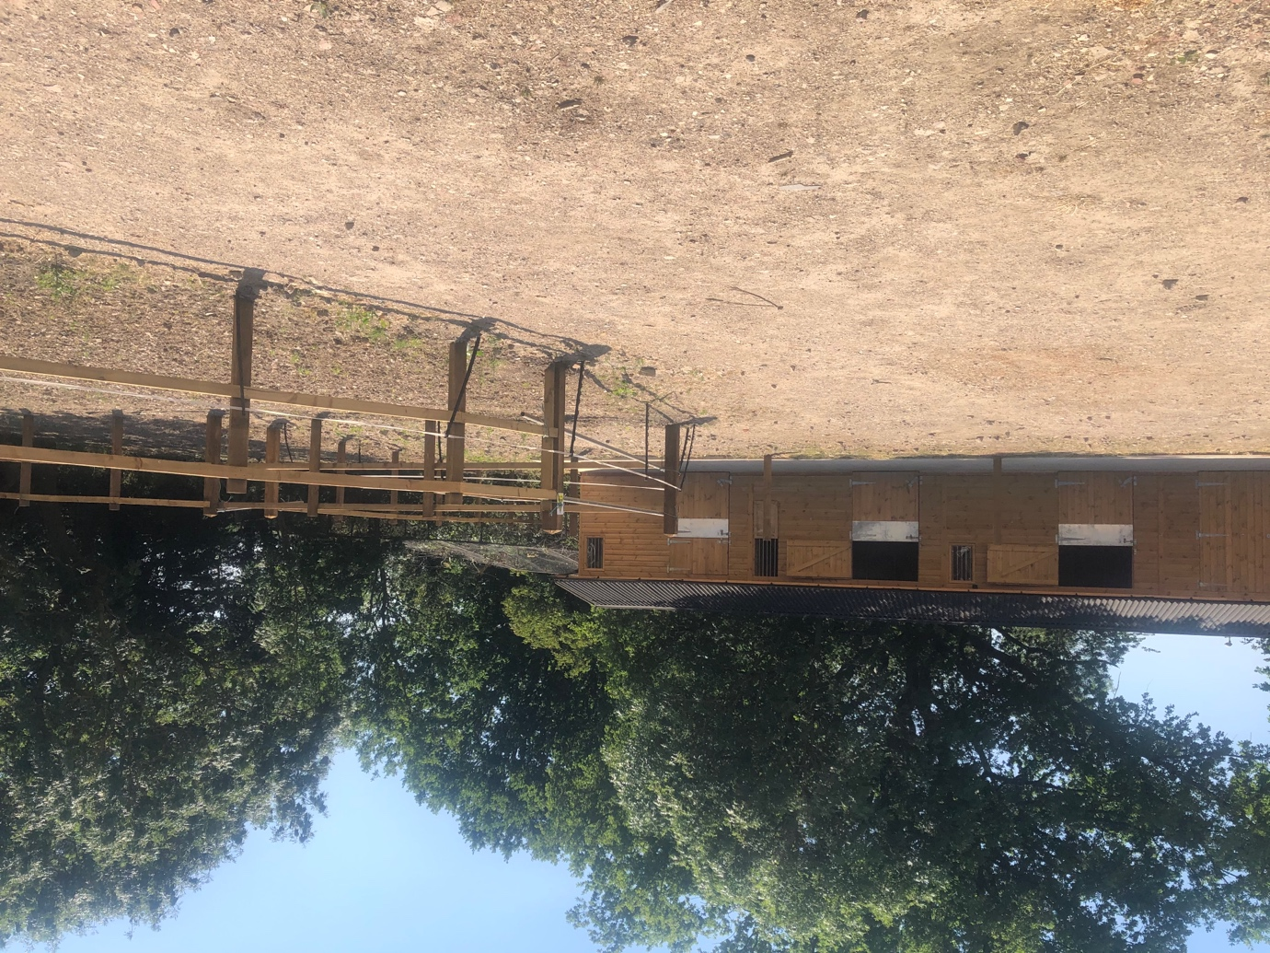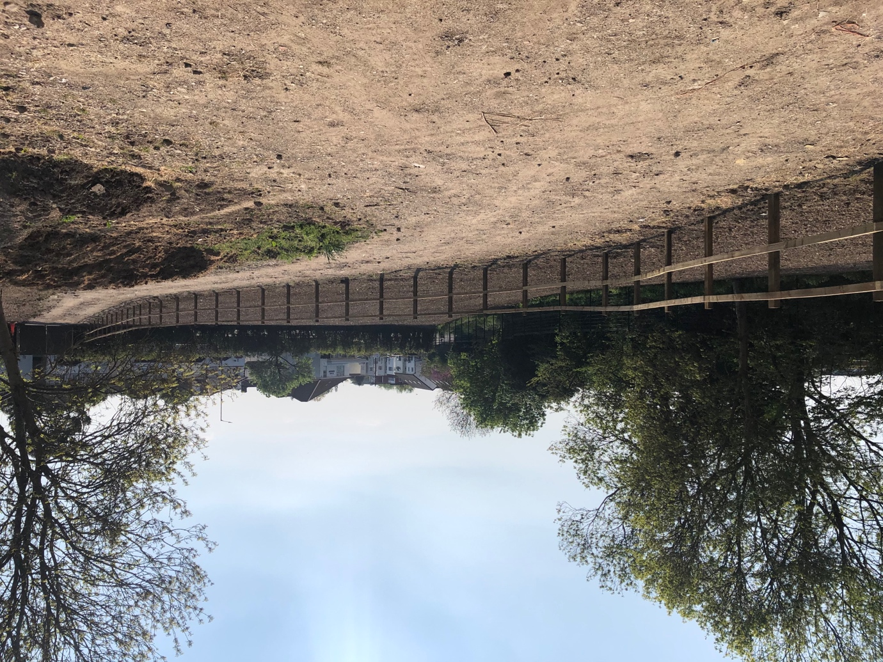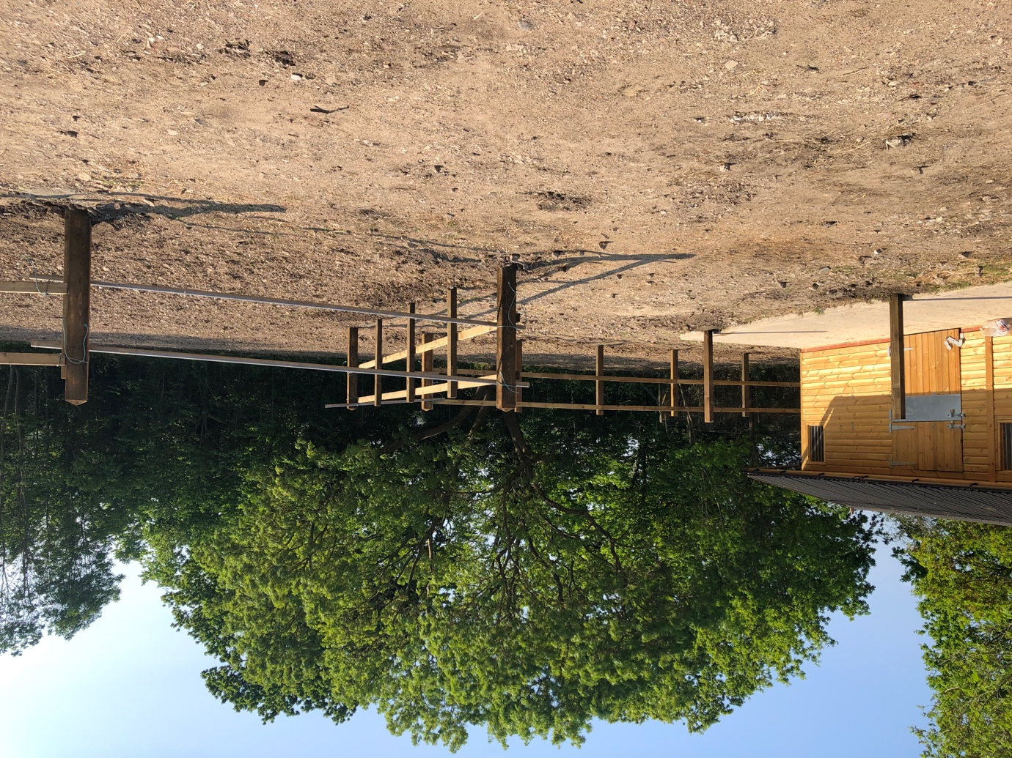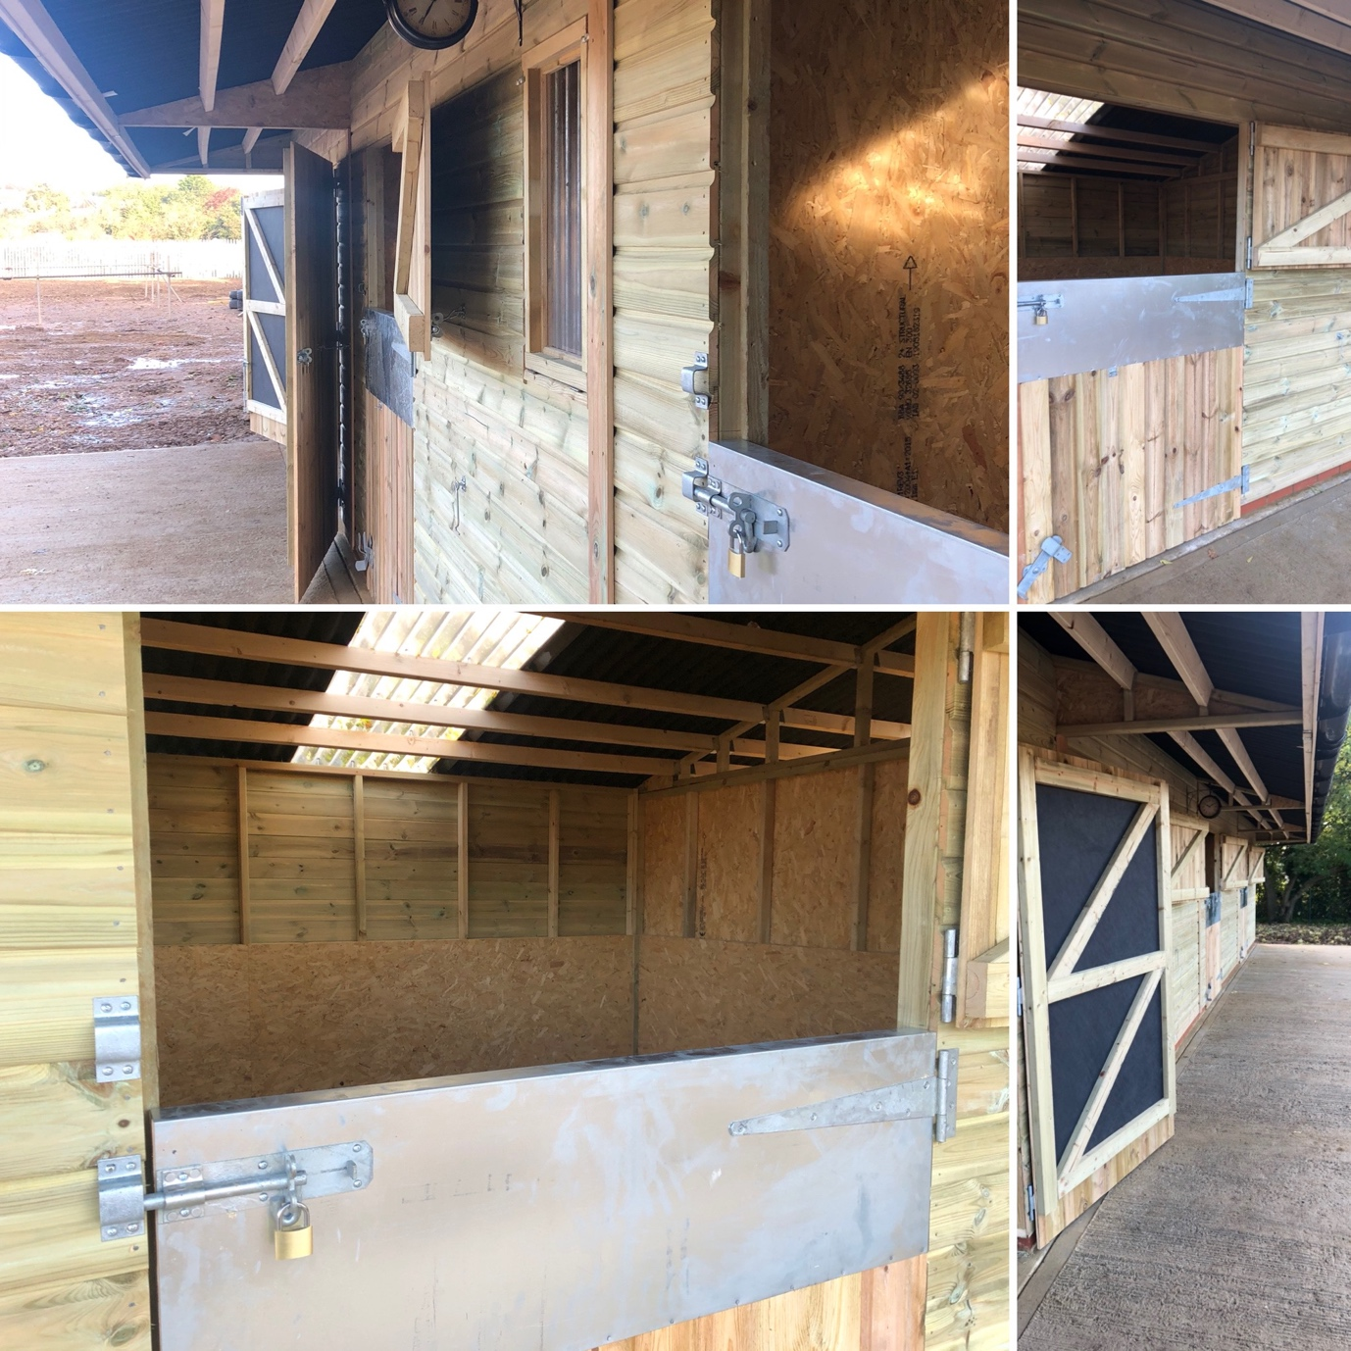
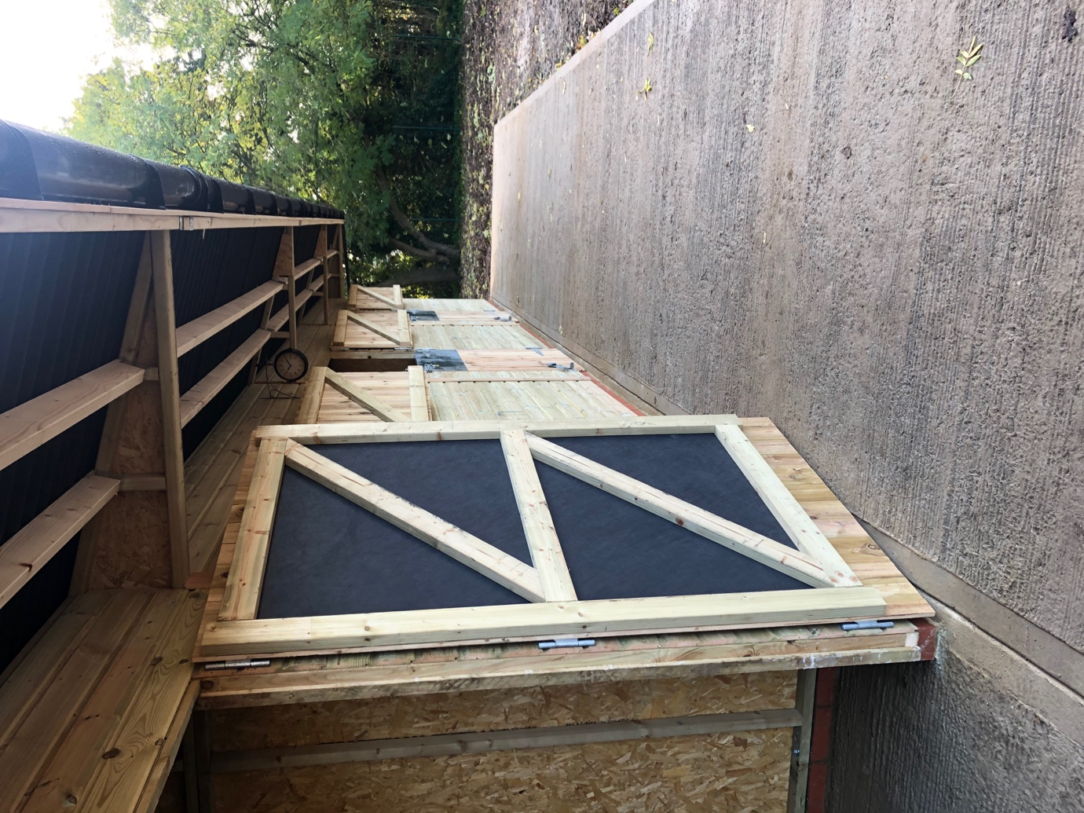
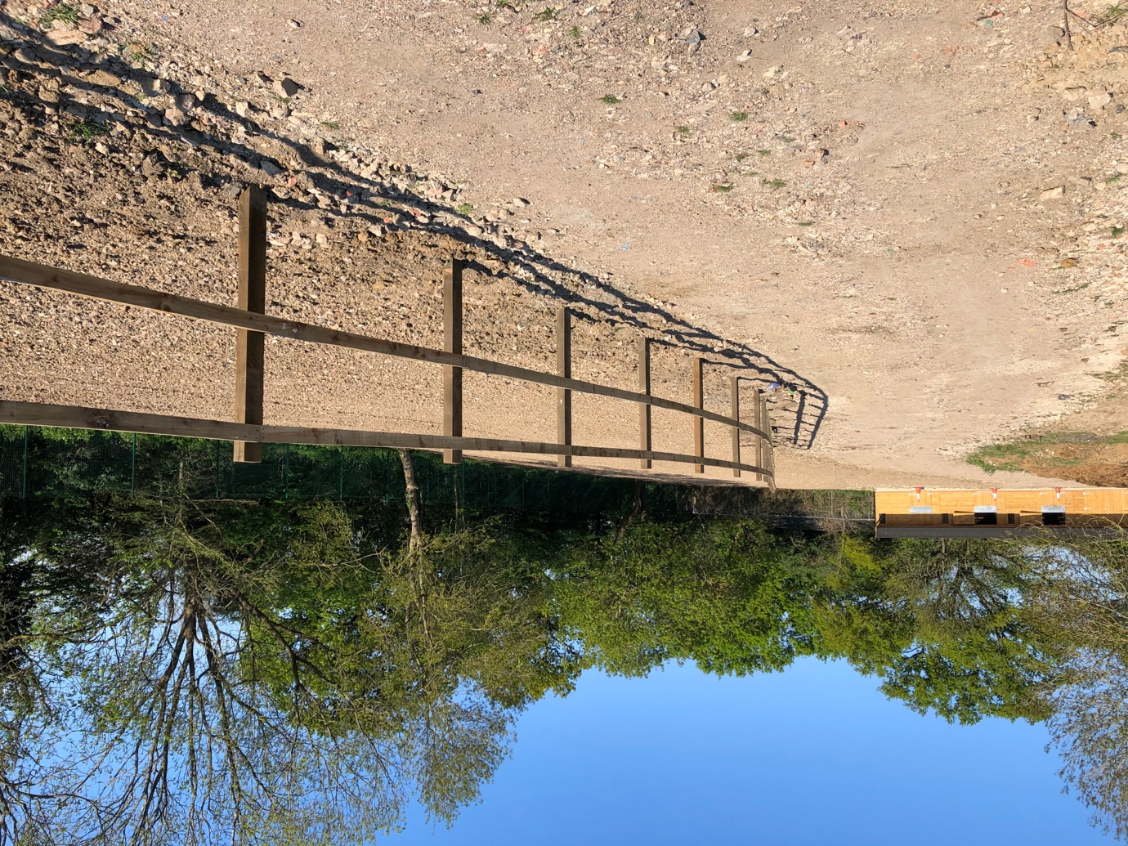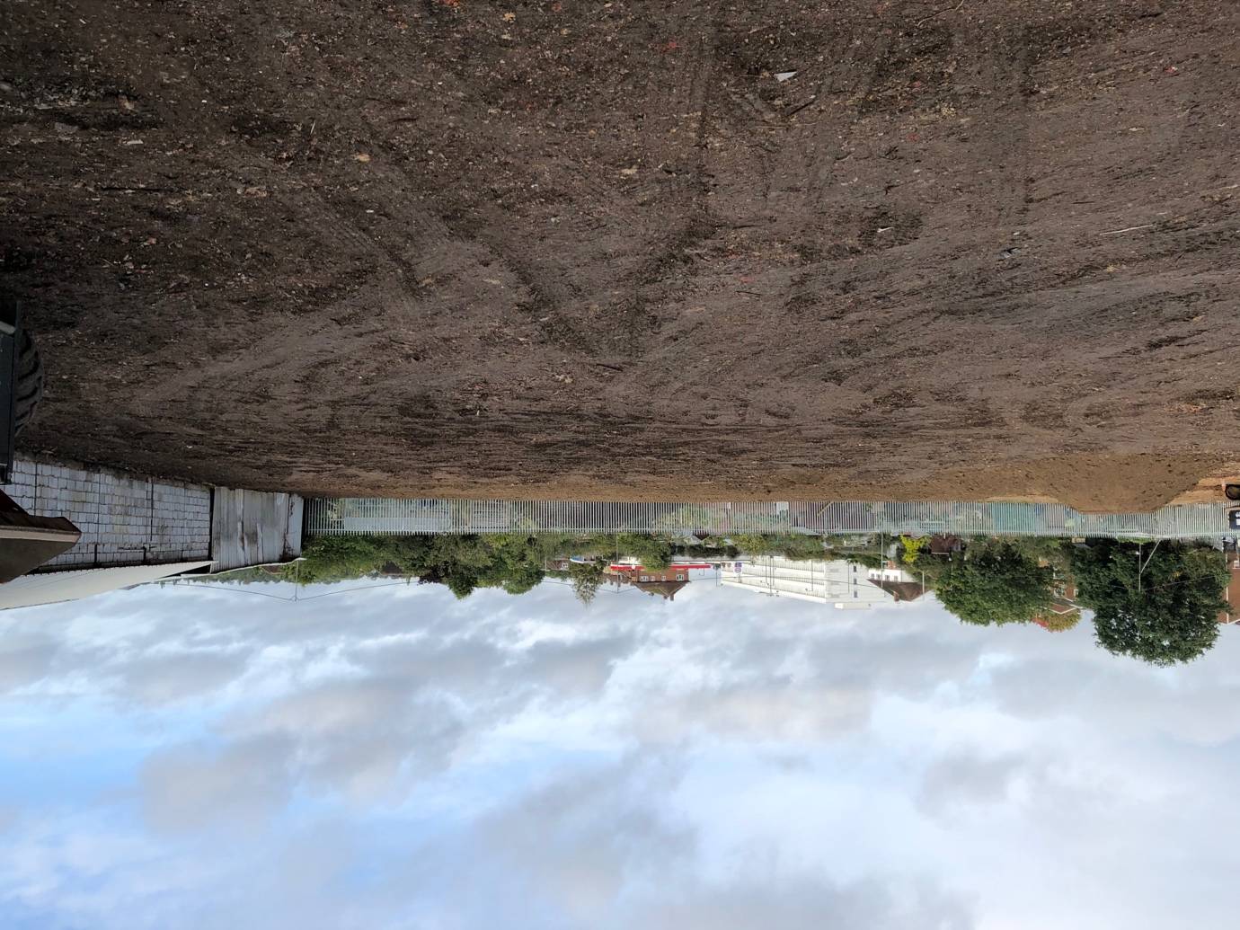

Background:

This small holding has been in my family for over 40 years, with my mother keeping her horses there as well as running a Riding School many years ago. Previous to that the site was a pig farm business for over 80 years (1000+ pigs) and held an operator’s licence for transportation purposes. After the pig farm business closed it became stables, only until buildings were too dangerous to use, hence why the budlings were demolished & retrospective planning was granted for stable block/hay barn.

Previous Buildings:

- Largest building Storage unit approx. 18m long by 5m wide & 5m high
- Boiler building
- Office / Toilet wash facility’s
- Garage
- 9 horse stables
- Housing buildings for 1000 pigs

These old buildings were constructed on concrete foundation blockwork with asbestos roofing sheets which were not only dangerous, but also becoming unsightly and derelict.

Please see below photos of the main buildings which have been demolished.
