Project – Garage Site at VERNON DRIVE , HAREFIELD

Roof Tile
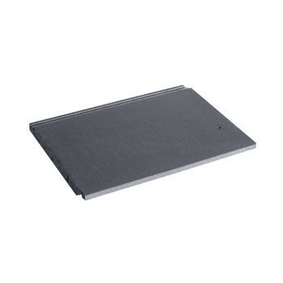
Details: - Marley Modern Roof Tile- Smooth Grey
Product code: MARLEY/MOD/SG
Brand: Marley Eternit
https://www.roofingsuperstore.co.uk/product/marley-modern-roof-tile-smooth-grey.html

Aluminium Windows

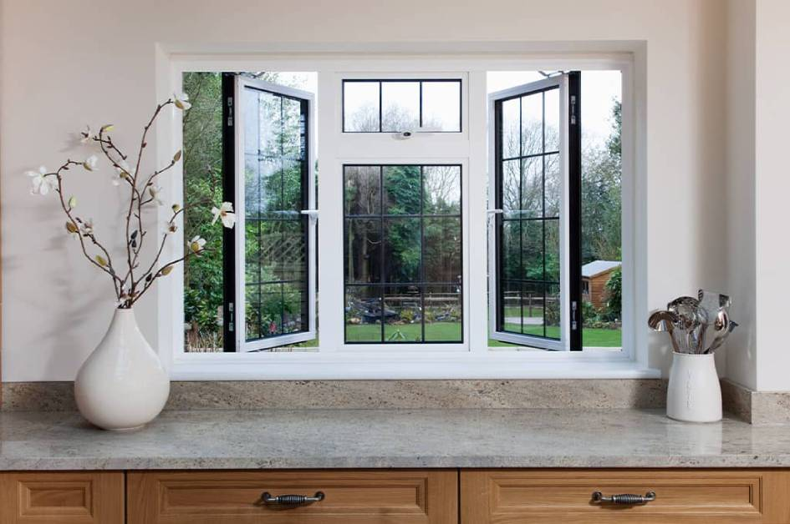
https://www.everest.co.uk/double-glazing-windows/aluminium/

Front Door
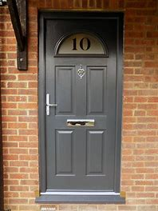 Grey Composite Door

www.door-stop-doors.co.uk

Bricks
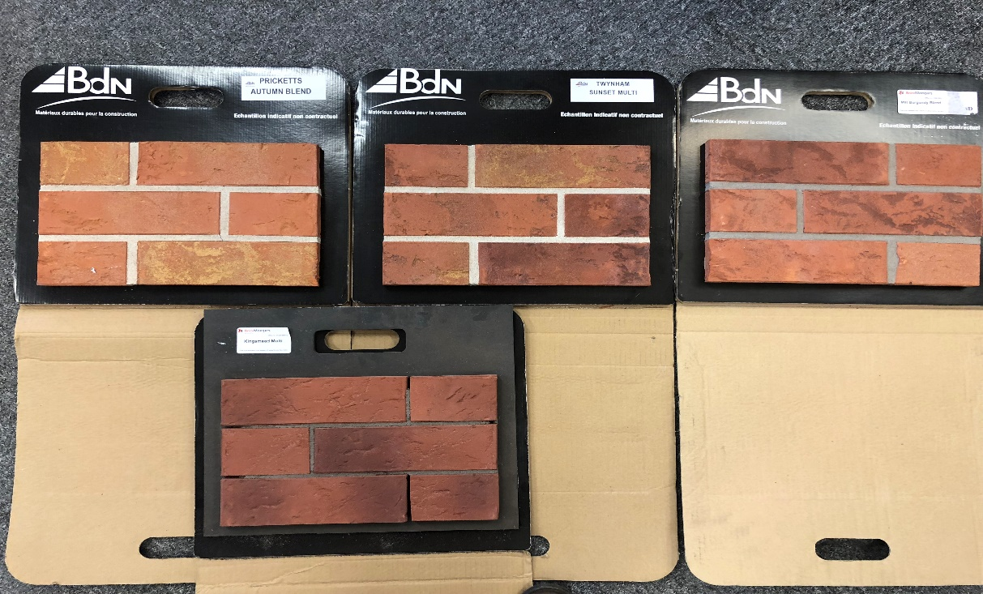

Details:- from Left 1) Pricketts Autumn Blend 2) Twynham Sunset Multi 3) Mill Burgundy Blend
Bottom 4) Kingsmead Multi
http://allbrickandstone.com/
Liquid Membrane Roof

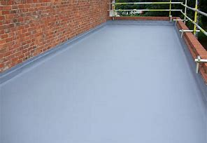 Liquid Applied Roofing System

http://www.singleply.co.uk/liquid-waterproofing-use-roof/

