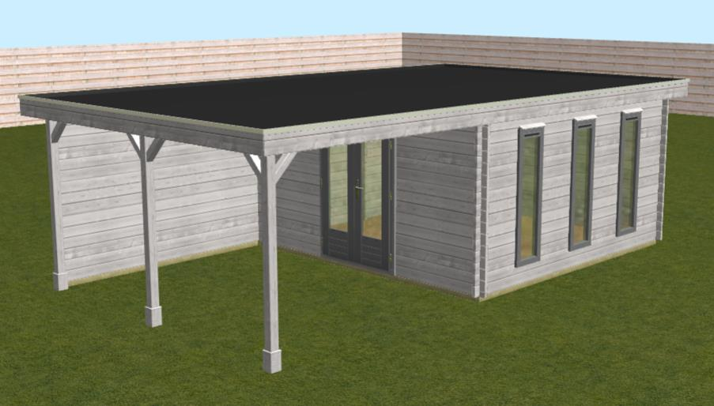

The proposal is for this garden office to be erected professionally in the south east corner of our garden. The garden is completely enclosed by fence and hedge. The flat roof of garden office is the same height as the boundary hedge. It will not be visible to anyone outside of the garden itself. Access to it will only be through the main house or using the side gate at the north east corner of the boundary.

