Project – 48-50 Maple Road, HayesUB4 9LR

Roof Tile
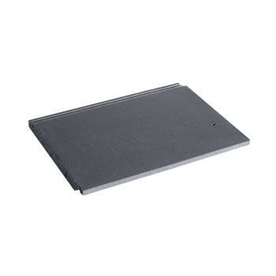
Details: - Marley Modern Roof Tile- Smooth Grey
Product code: MARLEY/MOD/SG
Brand: Marley Eternit
https://www.roofingsuperstore.co.uk/product/marley-modern-roof-tile-smooth-grey.html

Cladding

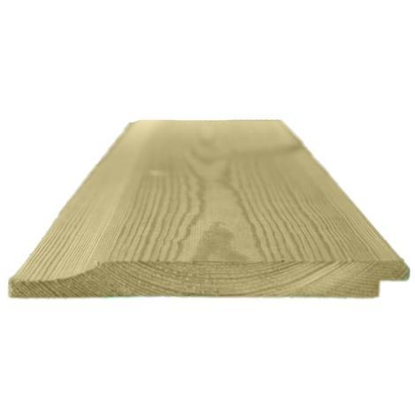
Details: - 150mm x 15mm Thick Treated Wooden Shiplap Cladding Boards - L: 3.0m - pack of 40
Reference: ME2599174

https://www.manomano.co.uk/cladding-panels-and-planks/150mm-x-15mm-thick-treated-wooden-shiplap-cladding-boards-l-30m-pack-of-40-2599174?model_id=2599174

Aluminium Windows

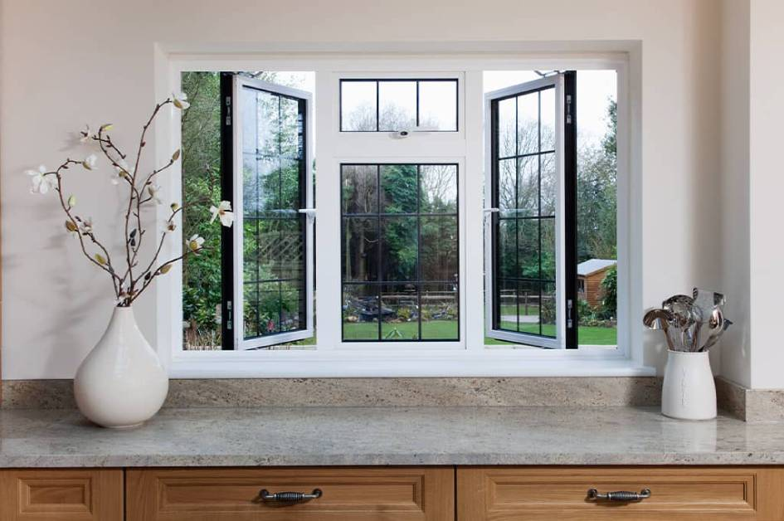
https://www.everest.co.uk/double-glazing-windows/aluminium/

K Rander

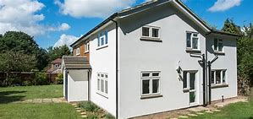 White colour K Rander

https://www.k-rend.co.uk/

Front Door
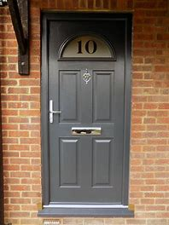 Grey Composite Door

www.door-stop-doors.co.uk

Bricks
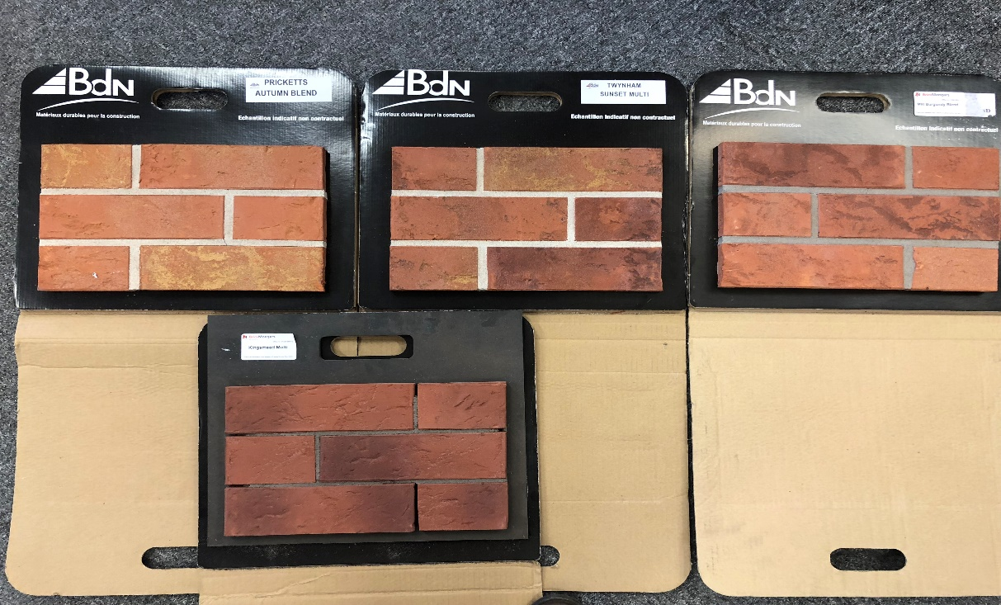

Details:- from Left 1) Pricketts Autumn Blend 2) Twynham Sunset Multi 3) Mill Burgundy Blend
Bottom 4) Kingsmead Multi
http://allbrickandstone.com/

