Site Name: | Unique Nails |  |  |  | ATM Location  Front of ATM  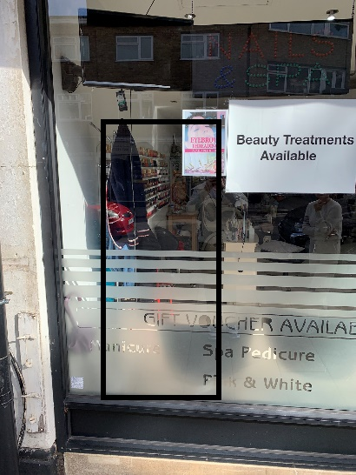  Back of ATM  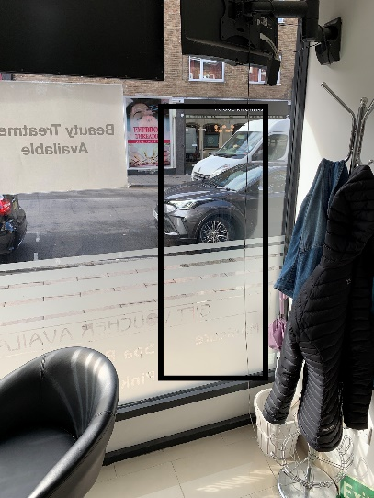  Front of Shop  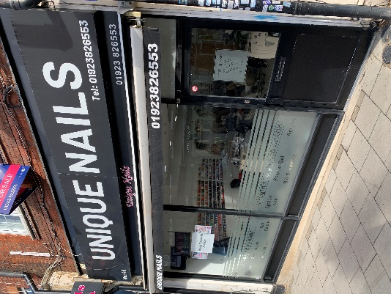
Address: | 43 Green Lane, Northwood, Middx, HA6 3AE
Site Contact: | Mrs Thi Thu Trang Tran
Phone: | M: 07429 408592 Alt : 07828 737875
Email: | Trangtran1979@hotmail.com
ATM Type: | NCR SS26 External
Opening Hours: | Mon-Thurs 1000-1900 Fri-Sat 0930-1900 Sun 1100-1600
Signage: | ATM Euronet Standard ecoflex - no wall sign
Notes: Busy shopping high street with lots of brand drivers and car parking close by. Straight forward installation, large service area with power supply very close to ATM location. Venue is close to a couple of hotels/B&Bs and Northwood Military Base, which is an American operated barracks. Pubs and restaurants close by frequented by the military personnel and their families. All the banks in the area have closed down leaving only the Nationwide TTW. The venue is also a cash preferred business so will close down their PDQ machines once the ATM is installed along with some of the eateries in the area preferring cash as well.
ATM Location:
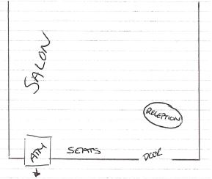

Wall Sign Council restriction on signage – No Wall Sign

ATM Proposition & Type: |  |  | Free to Use External Fully-Managed NCR SS6626
Contract Duration: |  |  | 5 Years + 2
Referral Fees: |  |  | No
Additional Sites from Same Owner: |  |  | No
Site Approved by: |  |  |  | Date:

