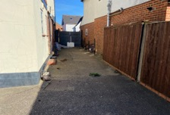
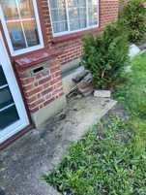
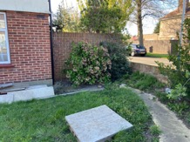
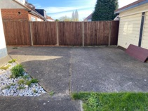
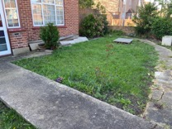
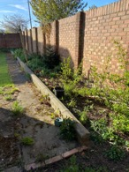
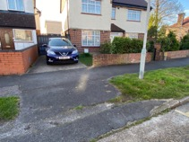
1 2 3 4 5 6 7

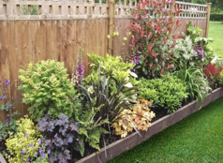
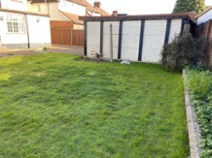
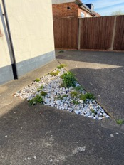
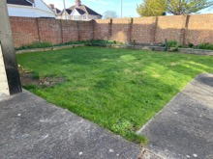
8 9 10 11 (proposed) 12 (proposed) 13 (proposed)
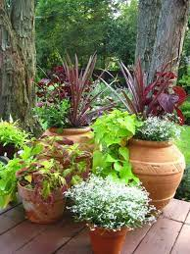
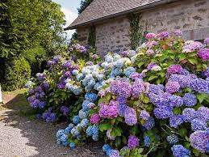
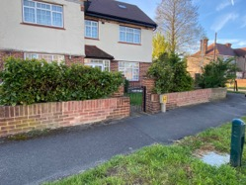
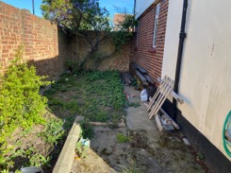

14 15

55 Wimborne Avenue.
Existing garden - path / shrubs / lawn and proposed plants.

Soft landscaping
The property already has lawn and existing flowerbeds with plants and shrubs (e.g., laural, pryacantha, hydrangers, small fir, rose bushes) these are to be retained & maintained with additional plants added to new or existing bedding (e.g. red robin, ferns, burning bush).
Adding smaller flowering potted plants to walkways.

Hard landscaping
2 cycle storage areas, one for each unit.
Refuse bins storage area at front of property in communal area and easy access for collection.
2 car parking bays (one for each unit) - one existing and one constructed at front of property
Existing outdoor lighting for patio area, new lighting to be placed at driveway and near cycle storage (low garden lighting, not floodlights).
Rear garden boundary for each flat to be separated by timber panel fencing (height between 5 to 6 ft.).

Landscape maintenance
Lawn to be mowed every month in spring to autumn months (Mar to Oct inclusive).
Shrubs to be pruned - e.g. existing laurel on front boundary wall.

