

Construction Management Plan
Green End, 17 Dene Road,
Northwood,
Middlesex.
HA6 2BX.
REVD 22/08/2025

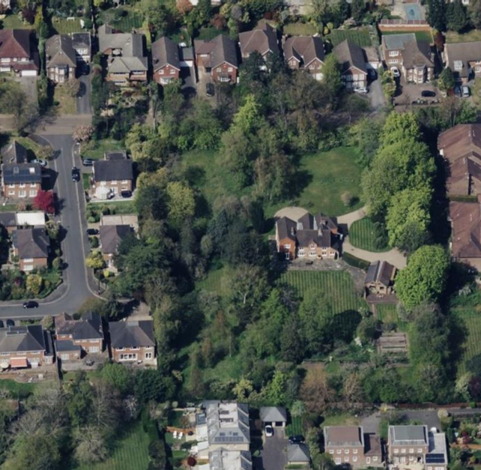

Project Overview
- Project Name: Development of Two Houses
- Address: Green End, 17 Dene Road, Northwood, HA6 2BX
- Developer: Gavacan Homes
- Project Manager: Luke Gavacan
- Site Manager: Shaun O'Brien
- Expected Duration: 18 Months
- Main Access Route: Via Dene Road, with clearly designated entry and exit points.
- Resident Contact: Shaun Obrien 07885 381621
- Working hours: restricted to Monday - Friday (8am-6pm) and Saturday (8am-1pm)
- Deliveries: 9.30am-3pm

1. Site Logistics
Access and Egress
- Access Route: All heavy goods construction traffic will enter and exit the site via Dene Road.
- Lorries will be required to wait in Dene Road until such time that the access route is clear into the site.
- Traffic Management Plan:
  - A one-way system will be implemented where feasible to prevent vehicle conflicts.
  - Banksmen will assist vehicle movements during peak periods or complex deliveries.
  - Pre-approved delivery schedules will avoid peak school or residential traffic hours.
Site Setup:
- Hoarding and Site Security:
The site is currently secured with low-level fencing along Dene Road, while the remaining boundaries are protected by existing garden fencing and hedgerows. Access gates are locked outside of working hours to ensure security.
- Site Facilities:
  - Portable units for site offices, welfare facilities, and storage.
  - Welfare facilities will comply with health, safety, and environmental standards, including toilets and wash areas.
Material Storage:
- On-Site Storage: Clearly demarcated storage zones for materials, minimizing vehicle movement on site.
- Deliveries: Just-in-time delivery approach to reduce on-site stockpiling and congestion.

Parking:
- On-site parking for essential vehicles (e.g., project manager and site manager).
- Contractors and labourers will use designated off-site parking areas to reduce disruption.

2. Construction Phases
Phase 1: Site Preparation (Months 1–3)
- Key Activities:
  - Clearing of vegetation (with local authority approval for protected trees).
  - Erection of hoarding, site establishment, and initial earthworks.
  - Installation of temporary drainage and site utilities.
- Environmental Considerations:
  - Protection of surrounding green spaces.
  - Mitigation measures for noise and dust during clearing activities.

Phase 2: Groundworks and Foundations (Months 4–6)
- Key Activities:
  - Excavation for basements and foundations.
  - Foundation works (piling, concrete pouring, and drainage systems).
- Risk Mitigation:
  - Continuous dust suppression using water sprays.
  - Structural monitoring to ensure nearby properties remain unaffected.
  - Stock pile earth to the top part of the site which will be removed from the Dene Road end and removed accordingly.
  - Concrete deliveries: concreting will be carried out over a 2-3 day period involving 2 deliveries per day of concrete
Phase 3: Structural Frame and Envelope (Months 7–12)
- Key Activities:
  - Erection of the main structure, including walls, floors, and roofs.
  - External finishes (cladding, windows, and doors).
  - Scaffold deliveries – 5-7 deliveries over a period 10 months with scaffold materials stored on-site.
  - Brickwork/ Blockwork – bulk deliveries on-site to occur once every 4 weeks
- Safety and Logistics:
  - Scaffolding with safety netting and weekly inspections.
  - Cranes or lifting equipment used under strict protocols.
Phase 4: Internal Fit-Out (Months 13–16)
- Key Activities:
  - Electrical, plumbing, and HVAC installation.
  - Insulation, plastering, flooring, and cabinetry installation.
  - Internal deliveries: 1-2 deliveries per day. Deliveries to be completed in bulk to again minimise overall deliveries required. Avoid facilitating excessive trades on-site in one phase to ensure traffic control also minimise deliveries occurring at one particular time.
  - Intention is to minimise deliveries required to 1 or 2 days of the week. This will leave other days free from deliveries save for unforeseen matters.
- Noise and Dust Mitigation:
  - High-impact activities limited to working hours.
  - Use of tools with noise suppression where possible.
Phase 5: Landscaping and External Works (Months 17–18)
- Key Activities:
  - Driveway construction, fencing, garden landscaping, and planting.
  - Final site clean-up and snagging works.
  - Minimal deliveries required with re-use of existing soil. Additional earth and make up will b brough in on isolated deliveries to ensure minimal disruption. Circa 5 deliveries.
- Waste Management:
All residual materials and debris will be removed by licensed contractors.
- Types of Plant for Construction Phase

The plant and equipment required for each key element of the construction process are outlined below in Table 1.2.

Table 1.2 Plant Used During Construction
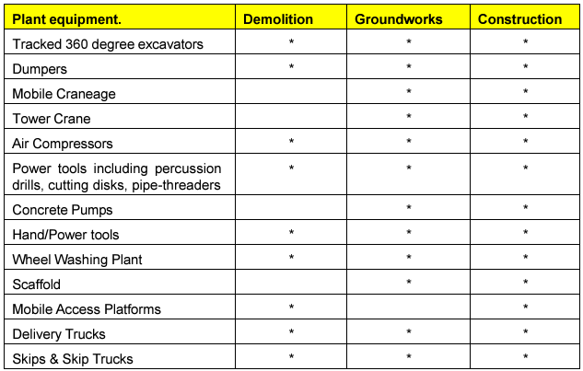

3. Health and Safety
The health and safety of all workers, visitors, and the public are paramount. Robust measures and proactive strategies will be implemented to ensure a safe working environment throughout the project lifecycle.
Key Measures:
- Risk Assessments:
  - Comprehensive risk assessments will be conducted for all tasks and activities before work begins.
  - These assessments will be regularly reviewed and updated to reflect project progress and any changes to site conditions.
  - Specific risks, such as working at height, manual handling, and use of machinery, will be assessed with appropriate control measures implemented.
- Emergency Procedures:
  - Fire Safety:
    - Fire extinguishers will be strategically located across the site, and their availability and functionality will be regularly inspected.
  - Evacuation Plan:
    - Clearly marked muster points will be designated and communicated to all site personnel.
    - Evacuation drills will be conducted periodically to ensure preparedness.
- Site Induction:
  - All workers and subcontractors will be required to attend a site-specific health and safety induction before starting work.
  - The induction will cover:
    - Site layout and emergency exits.
    - Hazard awareness and reporting procedures.
    - Use of equipment and adherence to safety protocols.
- Personal Protective Equipment (PPE):
  - Mandatory PPE includes:
    - Helmets to protect against head injuries.
    - High-visibility clothing to enhance visibility in low-light conditions.
    - Steel-toe boots to prevent foot injuries from heavy objects or sharp materials.
  - Regular inspections will ensure all PPE is in good condition and meets required safety standards.
Continuous Improvement:
Health and safety measures will be monitored through regular site audits and feedback from workers. Any incidents or near misses will be thoroughly investigated, with findings used to enhance safety protocols.

4. Environmental Management
- Waste Management:
Gavacan Homes, as both the client and main contractor for the project, is firmly committed to waste minimisation as part of its Corporate Social Responsibility (CSR) agenda. Subcontractors are expected to actively participate in waste management initiatives, reflecting the company’s commitment to sustainability.
Key Objectives:
Gavacan Homes is striving to achieve waste elimination, which sits at the top of the waste hierarchy.

Types of Waste Managed Onsite:
- Inert Waste:
  - Chemically inert, non-combustible, non-biodegradable, and non-polluting materials.
- Non-Hazardous Waste:
  - Materials that are neither hazardous nor inert by definition.
- Hazardous Waste:
  - Materials containing dangerous substances that could pose risks to human health.
Compliance Responsibility:
To meet their legal duty of care, Gavacan Homes is responsible for ensuring all site waste is disposed of at licensed and suitable facilities.

- Noise Control:
  - Noisy activities restricted to Monday-Friday (8 AM–6 PM) and Saturday (8 AM–1 PM).

5. Traffic Management
- Vehicle Movements:
  - Heavy goods deliveries and removals via Dene Road, scheduled between 8 AM and 3 PM. This is to ensure there is minimum disruption during peak times ie school traffic etc..
  - A banksman present at all times to oversee vehicle movement and pedestrian safety.
- Pedestrian Safety: Temporary footpaths and crossings where construction activities intersect public routes.
- Please note that we as residents ourselves are completely aware of the importance of minimising disruption and work continuously with local neighbours to assist the process.

Mud and Dust Control Policy
The policy is to remain proactive in controlling all mud and dust deposits at their source during both the groundworks and construction phases.
Groundworks Phase Measures:
- Jet Washing and Water Bowser:
- A portable jet washer and bowser will be used for:

  - Cleaning vehicle wheels and arches.
  - Dust suppression.
  - Muddy water will be swept onto the site ground, allowing it to drain into the surface.
  - If the power washer is unavailable, wheels will be cleaned manually using brushes and water.
- Road Suction Sweeper:
  - Primarily used for polishing road surfaces during muck-away activities.
  - Deployment can be increased if needed to manage heavier site traffic.
Vehicle Inspections:
- All vehicles will be stopped and visually inspected at the site entrance.
- Mud and debris will be cleaned from vehicles before leaving the site to prevent contamination of public roads.

Condition Survey of Surrounding Roads Leading to Site Entrance Gates.
Current Road Conditions:
The following images displays the existing condition of the roads surrounding and leading to the site entrance gates. This assessment provides a baseline for monitoring any potential impact of construction activities on road surfaces:
- Foxdell:
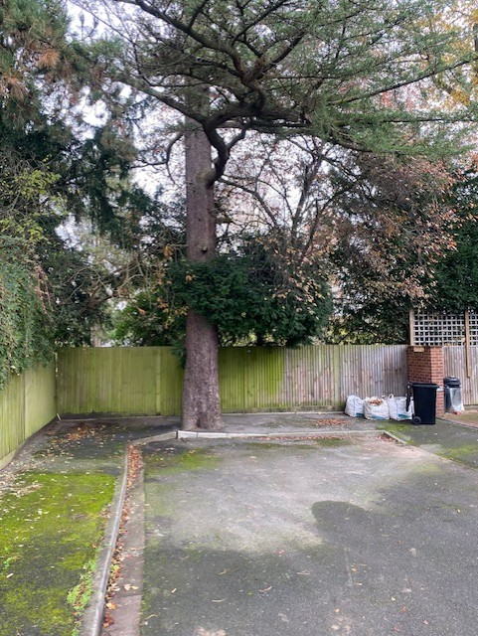

- Dene Road:
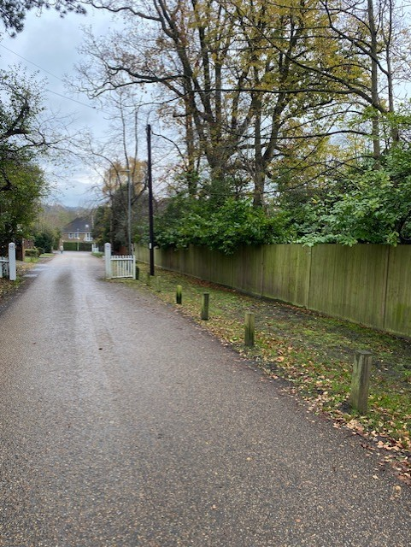

These images will be used as a reference to ensure proper maintenance and to address any issues arising during the construction phase. Regular inspections will be conducted to monitor and mitigate wear or damage.

6. Community Engagement
- Complaint Handling: A dedicated phone line and email address for residents to report concerns, managed by the Site Manager.

7. Monitoring and Compliance
- Regular Inspections: Site inspected weekly to ensure compliance with health, safety, and environmental policies.
- Noise and Dust Monitoring: Continuous monitoring to remain within local authority limits.
- Incident Reporting: Full documentation and corrective actions for any incidents or complaints.

8. Nearest Hospital
Watford General Hospital
- Address: Vicarage Road, Watford, WD18 0HB
- Distance from Site: Approximately 7 miles (15-20 minutes by car, traffic-dependent).
- Facilities and Services:
  - 24/7 Emergency Department (A&E) for urgent medical needs.
  - Specialist departments including orthopedics, cardiology, and trauma care.
  - On-site pharmacy for prescriptions and medical supplies.
  - Maternity and pediatric services.
Emergency Procedures Related to Construction Site
In case of an accident or medical emergency on-site, the following protocol will be followed:
- First Aid Response:
  - Qualified first-aiders on-site will administer immediate care.
  - The first-aid kit will be stocked and accessible at key locations, including the site office.
- Emergency Services Contact:
  - Dial 999 for ambulance assistance if the injury is severe or life-threatening.
  - Provide clear information on the location (17 Dene Road, Northwood, HA6 2BX) and nature of the emergency.
- Transport to Hospital:
  - For non-critical injuries requiring professional care, the injured individual will be transported to Watford General Hospital using a private vehicle or ambulance.
- Incident Reporting:
  - All accidents will be documented, and reports will be shared with the project manager and relevant authorities.
Route to Watford General Hospital from Site:
- Primary Route:
  - Exit Foxdell to Green Lane.
  - Turn onto Rickmansworth Road (A404).
  - Follow signs for Watford General Hospital via the A412.
- Travel Considerations:
  - The route avoids school zones and peak congestion times.
  - GPS directions will be available in the site office for quick reference during emergencies.
Regular drills and training will ensure all site personnel are familiar with the emergency protocol, including the route to the nearest hospital.

9. Conclusion
The Construction Management Plan (CMP) is designed to ensure the safe, efficient, and effective delivery of the project while minimizing disruption to the local community and environment. By integrating detailed planning and proactive management, the CMP aims to uphold high standards of safety, sustainability, and collaboration.
Key Objectives:
- Safety and Efficiency:
  - Implement robust procedures to ensure the safety of workers, visitors, and the public throughout all phases of the project.
  - Optimize workflows and logistics to prevent delays and inefficiencies on-site.
  - Freight Operators Recognition Scheme (FORS) Silver standard to be mandated by all freight operators.
- Minimizing Disruption:
  - Actively reduce noise, dust, and traffic disruptions in the local area.
  - Implement measures to mitigate environmental impact, including pollution control and sustainable waste management practices.
- Fostering Positive Community Relations:
  - Maintain open and transparent communication with local residents, businesses, and stakeholders.
  - Provide regular updates regarding project progress, key milestones, and any potential temporary disruptions.
  - Address concerns promptly and effectively to build trust and maintain good relationships.
- Environmental Stewardship:
  - Adhere to best practices to protect local ecosystems and reduce carbon emissions associated with construction activities.
Community Engagement:
- Regular Communication:
  - Provide a dedicated point of contact for community queries or complaints.
- Collaborative Planning:
  - Schedule noisy or disruptive activities at times that minimize inconvenience to the community.
  - Actively seek feedback from residents to adjust plans where feasible.
Through careful planning and a commitment to community and environmental responsibility, this CMP will ensure the project is delivered successfully while fostering positive relations with all stakeholders.

Appendix

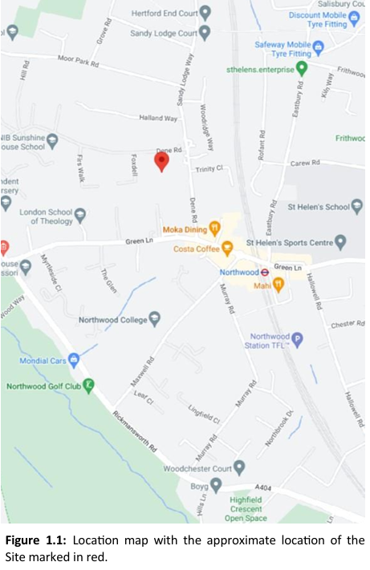

Site Layout
The drawing below shows the construction site layout of the site secured with Gavacan Homes Hoarding inclusive of site gates at the entrances. The remaining boundary is secured with existing close board fencing. Site traffic will enter the site via the entrance gates and will be supervised by a designated site operative whilst entering and egressing the site.
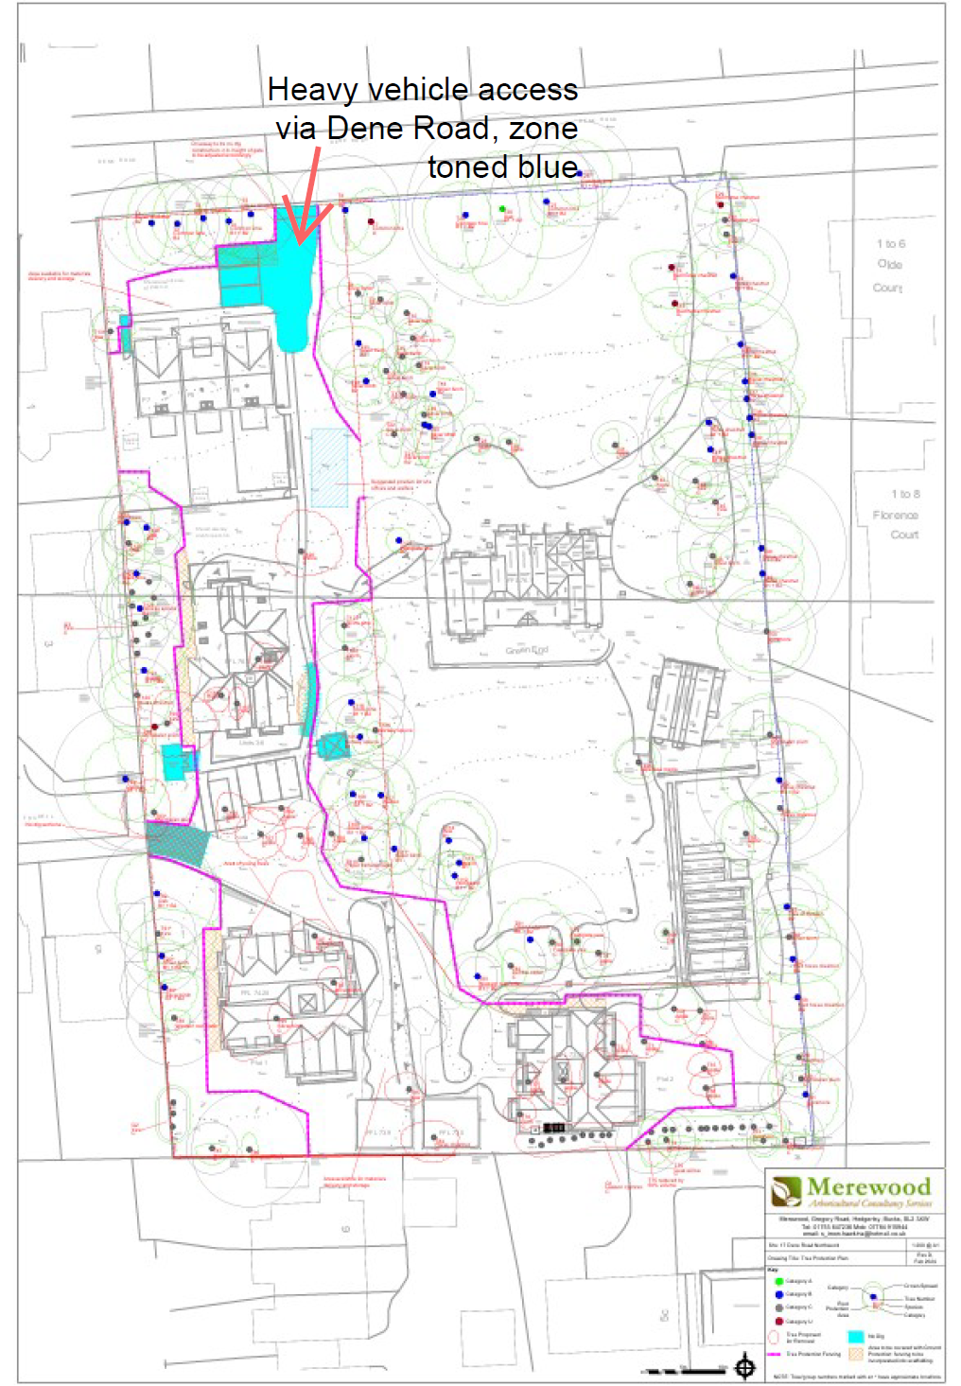
ON-SITE PARKING

