41 Broadwood Avenue
Ruislip
HA4 7XS

Proposed single storey sxtension .

Flood Risk Assesment

Hillingdon GIS shows that the site is in Zone 3 and Zone 2

The Flood Zone is shown below
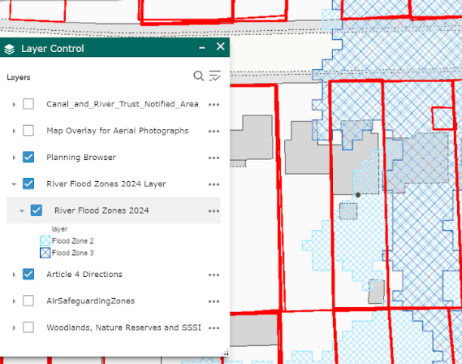
Flood map from Hillingdon Council

Proposal

The construction of a single storey extension to the existing side extension to be used for storage.

Floor Levels

The floor level of the new proposed extension will be the same as the existing

Electrical Services

Electrical sockets will be no lower than 450mm from finished floor level to reduce the risk from flooding, new wiring services will not run below this level at any point.

Surface Water

Surface water run off from the proposed development will drain to a soakaway reducing the risk of flooding.

Conclusion

The proposed work will not cause a hazard to people

