TOWERS ASSOCIATES LTD
towers
Harefield Oil Terminal
Harvil Road,
UB9 6JL
01895 812822

Construction Logistics Plan
Land Adjacent to 20 Belmont Close
Prepared by Towers Associates Ltd
July 2023

Development Name | Land Adjacent to 20 Belmont Close
Landowner | Trafalgar Developments Ltd
Site Address | Land Adjacent to 20 Belmont Close, Uxbridge
Postcode | UB8 1RF

Constructions Logistics Manager | Gary Wynne
Phone Number | 07961 149626
Email | Gary@trafalgarproperty.com
Logistics Provider Contact Name | Towers Associates Ltd
Phone Number | 01895812822
Email | info@towers-associates.com

1.0 Introduction
Towers Associates Ltd has been appointed by Trafalgar Development Ltd to provide construction logistics advice for the development located in the Land Adjacent to 20 Belmont Close, Uxbridge in the London Borough of Hillingdon. Towers Associates Ltd have prepared this CLP and will collaborate with the contractor to ensure compliance with the measures set out in the CLP. At this stage no Outline CLP has been submitted alongside the application prior to planning permission thus this CLP has been constructed in accordance with guidance set out by TFL.

  - Objectives

The overall objectives of this CLP are to:
• Lower emissions.
- Enhance safety for both road users and workers of the site.
- Reduce congestion – By reducing the number of trips generated in peak periods and overall.

To support the realisation of this objective, several sub-objectives have been agreed and include:
• Encouraging construction workers to travel to the site by non-car modes.
- Plan deliveries around peak periods where possible.
• Management of the Development in line with the CLP guidance the on-going development and delivery of the CLP with construction contractors.
- Communication of site delivery and servicing facilities to workers and suppliers.

  - Site Context

The site adjacent to 20 Belmont Close is located within Uxbridge. The surrounding area is predominantly residential and is characterised by uniquely designed two storey, detached properties with associated off-street parking and/or front gardens with landscaping.

The site has public transport accessibility level (PTAL) of 2.

The site is well-served by public transport.

The local bus stops are Belmont Road and York Road, the Belmont Road stop is shown as just 3.87 minutes away.

Uxbridge station is less than 10 minutes’ walk away and offers the services of both the metropolitan and Piccadilly lines.

  - Development Proposal

The development consists of the Erection of a detached house with 4 bedrooms and associated parking, amenity, and bin/cycle stores.

There will be off street parking provision for at least 2/3 cars during the development stage and the application for a dropped kerb has already been submitted and will be constructed as soon as possible and will assist in making this simpler.

  - Phasing of the Development
Below is a summary of the proposed phasing of the development, these are subject to many factors including but not limited to, planning permission and availability of workers and materials.
Construction phase | Start | End
Site setup and demolition | Sep-2023 | Sep-2023
Basement excavation and piling | N/A | N/A
Sub-structure | Oct-2023 | Dec-2023
Super-structure | Jan-2024 | Mar-2024
Cladding | Apr-2024 | May-2024
Fit out, testing and commissioning | Jun-2024 | Jul-2024

  - Hours of Work
In compliance with current legislation, any demolition and construction works which are audible at the site boundary shall only be carried out between the hours of 08.00- and 18.00-hours Monday to Friday and between the hours of 08.00 hours and 13.00 hours on Saturday.

No works shall be carried out on Sundays, Bank or Public Holidays.

  - As can be seen by our Construction Logistics Planning Tool provided by TFL, the number of vehicles will be aimed to be minimal and avoid peak times. The site manager will endeavour to employ a ‘just in time’ approach to avoid excessive vehicle movements during one time.
  - The site manager will act as a banksman to ensure that all vehicular movements on site are carried out safely in the interest of the site and surroundings.
  - Existing hardstanding and storage buildings will be used for the storage of materials and parking and the new dropped kerb has already been applied for and will be a top priority for ensuring on site safety.

  - CLP Structure

The CLP is divided into the following chapters:
- Introduction
- Context, considerations and challenges
- Construction programme and methodology
- Vehicle routing and access
- Strategies to reduce impacts.
- Estimated Vehicle movements
- Implementing, monitoring and updating

- Context, Considerations and Challenges
This section describes the local context and issues identified that need to be considered and addressed during construction.
  - POLICY CONTEXT

This section of the CLP references policies we have considered in the preparation of the document.

2.1.1. NATIONAL POLICY
States in Section 9 its policy guidance in relation to Promoting Sustainable Transport.
Paragraph 104 states:
‘Transport issues should be considered from the earliest stages of plan-making and development proposals, so that:
a) the potential impacts of development on transport networks can be addressed; - Please see paragraph 2.4 which explains considerations and concerns.
b) opportunities from existing or proposed transport infrastructure, and changing transport technology and usage, are realised – for example in relation to the scale, location or density of development that can be accommodated.
c) opportunities to promote walking, cycling and public transport use are identified and pursued; The local bus routes and train stations have been identified in this report. A secure space for cycles will be available to workers. Workers will be encouraged to use these greener means and will be made aware of these when employed for work on site.
d) the environmental impacts of traffic and transport infrastructure can be identified, assessed and taken into account – including appropriate opportunities for avoiding and mitigating any adverse effects, and for net environmental gains; and
e) patterns of movement, streets, parking and other transport considerations are integral to the design of schemes and contribute to making high quality places. – Please see our CLP tables and graphs to show consideration for the impact on traffic and where this can be mitigated. The list in 3.1 discusses mitigations we will put in place.
The Traffic Management Act (2004)
The act makes ‘provision in relation to the management of road networks; to make new provision for regulating the carrying out of work sand other activities in the street’.
It acknowledges that highways may be occupied due to construction activities and identifies appropriate changes levied for any extended occupation.

2.1.2. REGIONAL POLICY
The London Plan has several policies aimed at improving construction logistics, for example Policy T7.
‘Construction Logistics Plans and Delivery and Servicing Plans will be required and should be developed in accordance with Transport for London guidance and in a way which reflects the scale and complexities of developments.’ We have used TFL guidance and templates to produce both this Construction Logistics Plan and used their CLP tool to produce the necessary graphs and tables.
‘At large developments, facilities to enable micro-consolidation should be provided, with management arrangements set out in Delivery and Servicing Plans. I Development proposals must consider the use of rail/water for the transportation of material and adopt appropriate construction site design standards to that enable the use of safer, lower trucks with increased levels of direct vision on waste and landfill sites, tip sites, transfer stations and construction sites.’ - This is not a large development and consists of one new dwelling only. Due to the location of the site rail/water transportation methods were not viable, however in our proposed mitigations we have made an effort to ensure emissions are reduced by ensuring any vehicles and machinery not in use are not left running. We have also sourced materials and skips from local companies to reduce the travel distance of materials and waste.
‘The construction phase of development should prioritise and maintain inclusive, safe access for people walking or cycling at all times’ – The site is located on a cul-de-sac and therefore traffic will be able to enter and exit the site in forward gear. This will ensure the safety of pedestrians and cyclists as visibility is maintained.
‘When planning freight movements, development proposals should demonstrate through Construction Logistics Plans and Delivery and Servicing Plans that all reasonable endeavours have been taken towards the use of non-road vehicle modes.’
‘Where rail and water freight facilities are available, Transport for London’s freight tools should be used when developing the site’s freight strategy.’ - As mentioned earlier in the report, water and rail were not viable options in this location.
‘10.7.5 Delivery and Servicing Plans should demonstrate how the requirements of the site are met, including addressing missed deliveries. Appropriate measures include large letter or parcel boxes and concierges accepting deliveries. – A Site Manager will be accessible via phone to ensure deliveries are successful and can be arranged as per the plans set out in this report.
‘10.7.6 Transport for London’s guidance on Construction Logistics and Delivery and Servicing Plans should be adhered to when preparing planning applications. Plans should be developed in line with this guidance and adopt the latest standards around safety and environmental performance of vehicles. The plans should be monitored and managed throughout the construction and operational phases of the development. TfL’s freight tools including CLOCS (Construction Logistics and Community Safety), FORS (Fleet Operator Recognition Scheme) or equivalent should be utilised to plan for and monitor site conditions to enable the use of vehicles with improved levels of direct vision. This should be demonstrated through a Site Assessment within a Construction Logistics Plan. Development proposals should demonstrate ‘good’ on-site ground conditions ratings or the mechanisms to reach this level enabling the use of vehicles with improved levels of driver direct vision. To support the procurement of these vehicles and to minimise road danger, the mayor has introduced his Direct Vision Standard, which rates Heavy Goods Vehicles on a star rating from 0 (lowest) to 5 (highest), based on how much the driver can see directly through the cab windows’ – As stated previously, we have taken measures to ensure all vehicles can travel to and from site in forward gear to ensure visibility. If any concerns are raised once on site, the dedicated site manager will work to find a suitable solution.

  - CONTEXT Plans

  - The maps included in this section have been included to display the development location and surrounding areas.
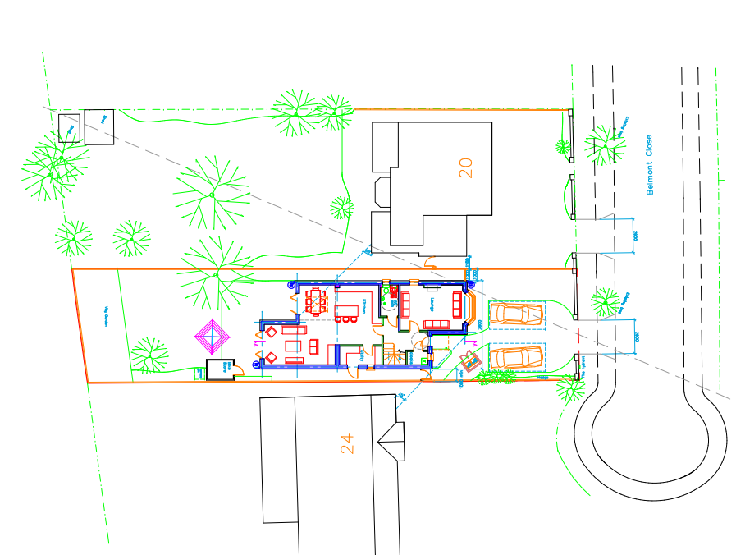
3309-03A

2.3 LOCAL ACCESS INCLUDING HIGHWAY, PUBLIC TRANSPORT, CYCLING AND WALKING

2.3.1. HIGHWAYS, CARRIAGEWAYS AND FOOTWAYS
The site is situated on Belmont Close which is a residential close, of which is subject to a 20mph hour speed limit. There are no current concerns regarding access to site.

To construct the proposed development, we do not anticipate any parking bay or footpath suspensions will be required.

  - CONSIDERATIONS AND CHALLENGES

2.4.1. SCHOOLS
There are no local schools to be affected by this development.

2.4.3. ELDERLY CARE HOME
There are no elderly care homes in the local vicinity to the site.

2.4.4. SPORTS GROUND
There are no local sites that will be affected by the development.

2.4.5. HOSPITAL
Hillingdon hospital is the nearest local hospital facilities but it not within a distance which will be affected by the development.

2.4.6. NEIGHBOURING CONSTRUCTION SITES

We are not currently aware of any upcoming developments scheduled to start in the vicinity. However, if a development becomes known, the site manager will contact the developer/contractor of any said site and when the works schedule is known, trip generation analysis will be cross-referenced to ensure precautions are taken to lower any compounding peak vehicle movements.

2.4.7. PUBLIC RELATIONS

During the development the construction logistics manager will work to mitigate and resolve any issues and difficulties in the local community.

A key aspect of the successful management of this project will be establishing and maintaining a good relationship and open routes of communication for all surrounding neighbours.

This CLP has prepared a strategy for preventing potential issues, however any difficulties encountered during construction can be reported via an emergency site contact and will be recorded and resolved as required.

All surrounding neighbours will have the open of joining an emailing list or WhatsApp group to allow a forum for residents to discuss matters such as late-night works, site boundaries and hoardings, construction vehicle congestion and general community disruption.

- Measures Proposed to Mitigate Impact of Construction Activities:

  - LIST OF MITIGATION MEASURES
  - • As can be seen on plan 3309-03A there is both a safe entry and exit to site to allow vehicles to both enter and leave the site in forward gear to ensure safety.
  - Any large deliveries will be communicated to local residents prior to arrangement of delivery.
  - Where possible construction methods will be considered to ensure noise emitted from the site is kept to a minimum.
  - Building supplies will be ordered from the local builders’ merchant where possible to reduce the number of deliveries and miles travelled by delivery vehicles.
  - Skips will be sourced locally from GBN Skip Hire and deliveries will aim to be timed when traffic is at a minimum.
  - Machines and equipment will be shut down or throttled down to a minimum when not in use.
  - . All vehicles and machinery on site will be maintained to a high standard to avoid unnecessary noise be emitted from site.
  - All temporary site lighting will be faced into the site, and not directed towards any neighbouring properties.
  - Machinery exhaust emissions will be kept as low as is practical by using well maintained vehicles and machinery at all times.
  - Hoarding will be erected around the site. Along with reducing the visual impact and providing protection for the construction workers and public, this will also act as a barrier for dust and dirt originating from within the site. The excavated material being loaded will be directly from conveyors into a lorry or for off road, so the wheel washing requirement is minimised, any overspill will be washed off the Road surface.
  - The area around the site is to be regularly and adequately swept to prevent any accumulation of dust and dirt.
  - Burning of materials on site will not be permitted in order to prevent smoke emissions.

