

Design and Access Statement to support Planning application no: PP-14208687
Natwest, 6 Coldharbour Lane, Hayes, Middlesex, UB3 3EL

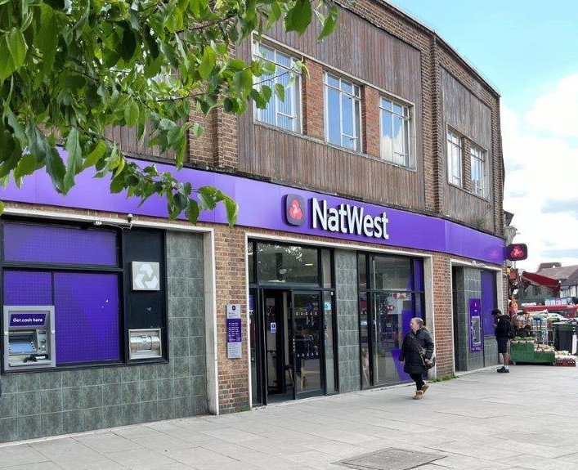

The replacement of the external ATMs

- INTRODUCTION

This Statement has been written in direct proportion to the minor scale of the proposed works. All necessary and relevant information has been included without the inclusion of any unnecessary information that does not have any relevance to proposed replacement works.

- PROPERTY DESCRIPTION

The property is a two-storey modern building of brickwork construction with cladding at first floor level and tiled detailing at ground floor level.

- DESIGN CONCEPT

The bank is currently undertaking a national programme whereby they are replacing and upgrading their ATMs. The existing units with “button” controls are now end of life and will shortly no longer be able to receive software updates that keep them safe from fraudulent attacks. Spare parts are becoming increasingly difficult to obtain as this line of machines are taken out of service. Natwest have partnered with NCR to upgrade these units to the latest touch screen-controlled options which the entire industry is gradually moving towards.

Updating these machines will ensure that the right for access locally will be maintained. The proposed replacement ATMs are essential for ensuring the local community has access to cash in line with the Financial Conduct Authority (FCA) Guidelines, which remains a vital service, particularly for those who rely on cash for their day-to-day transactions. The new ATMs are being installed with the latest fraud prevention solutions to keep customer transactions more secure than ever before. They are also accessible for people with hearing loss.

4.0 THE WORKS

The works comprise the replacement of the external ATMs. ATM N241131 is located to the right-hand side of the entrance and is being replaced ‘like for like’. ATM N233431 is located to the left-hand side of the entrance and the aperture of this machine is to be lowered to suit the new ATM and all disturbed finishes to be made good to match existing. New ATM collar to be installed and window vinyl to replace existing (see drawing).

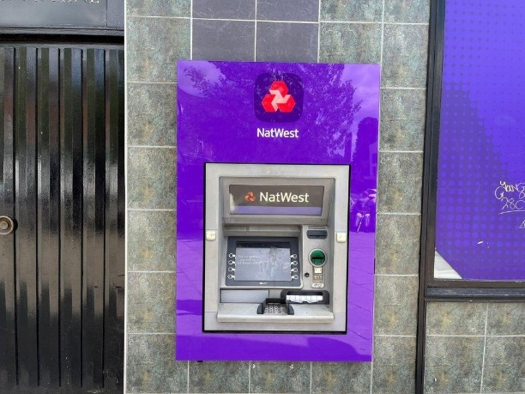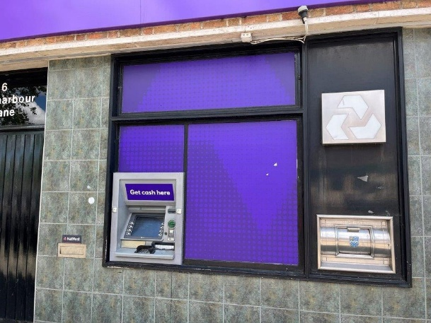
ATM N241131 ATM N233431

5.0 IMPACT OF THE PROPOSAL

The new ATMs are to replace the existing, with minimal impact on the fabric of the building

6.0 ACCESS

Access to the branch will not be affected by the proposed works nor will they affect the public space.

Agent:
Harcroft Consulting Limited
3 Highwold
Chipstead
Surrey CR5 3LG

