Neighbouring Property Streetscape – Material References
Application for: 12 Hillside Gardens

8 Hillside Gardens
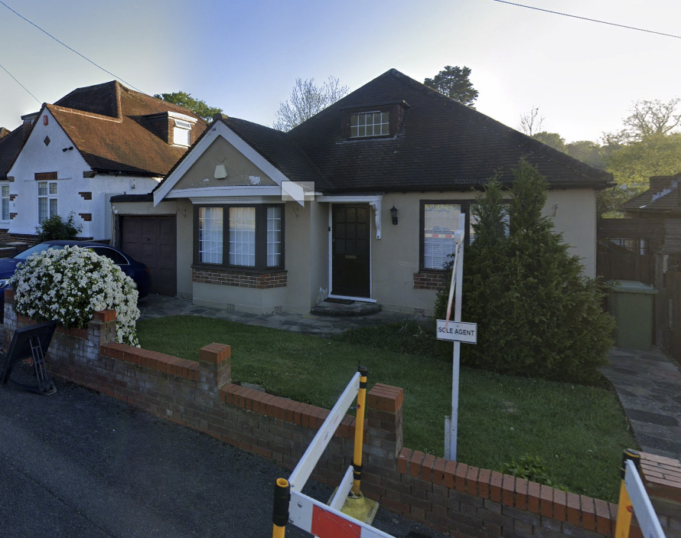

10 Hillside Gardens
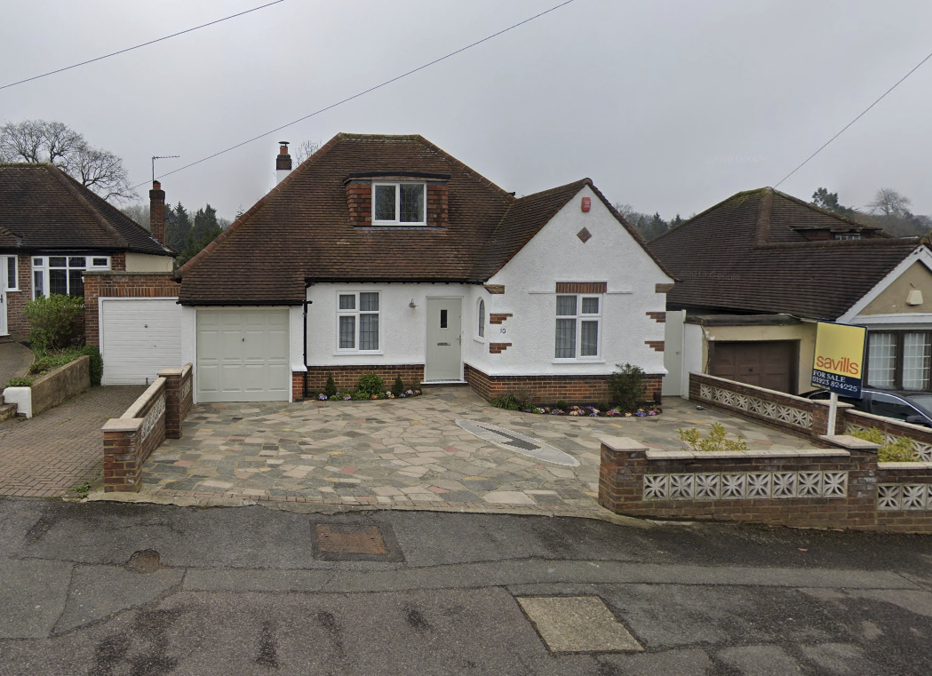

20 Hillside Gardens
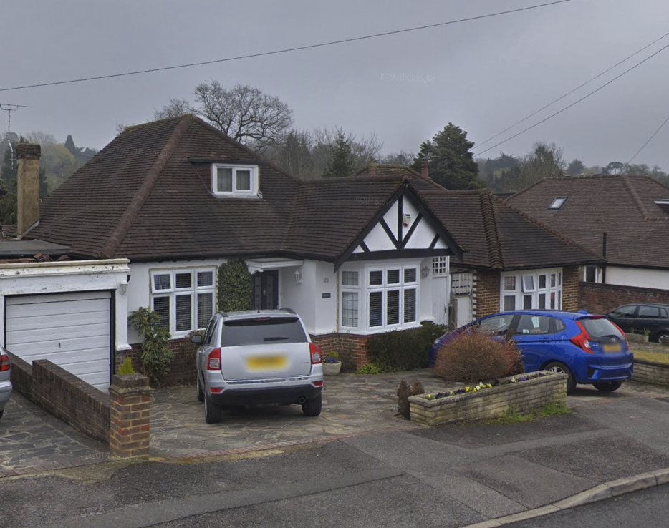

24 Hillside Gardens
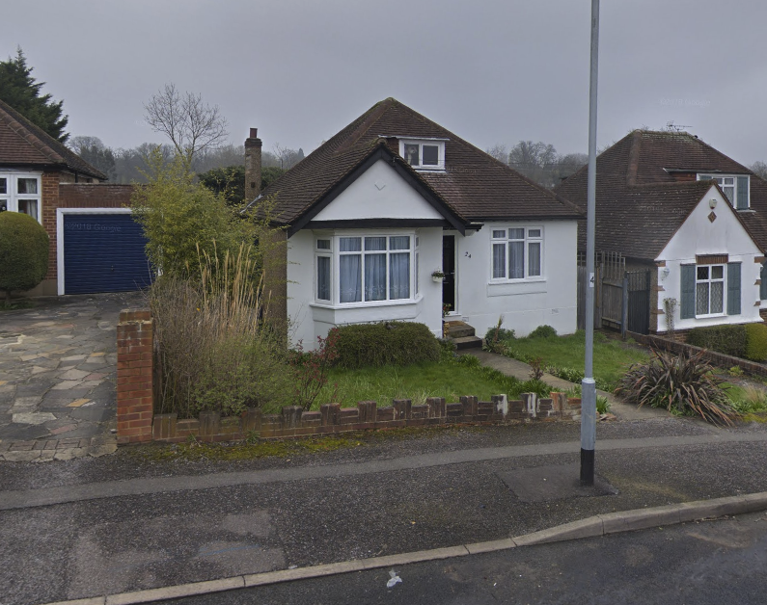

59 Hillside Gardens
