DESIGN AND ACCESS STATEMENT
1A ASHBURTON ROAD, HA4 6AA
THE PROCESS
- Assessment
- Install a new door to access the flat above.
- The structure of the building will not affect development of the planning policy.

- Involvement
- This is not applicable for this development work.

- Evaluation
- There are no conflict issues with this proposed work.

- Design
- The proposed area is one door with common porch entrance to access both flats
- There are no changes on the floor area.

USE
- There are no changes use of the building.
AMOUNT
- There are no changes on the foot print.
LAYOUT
- The proposed site accessible for the workers and the public.
- Space is safe and convenient.

SCALE
- The drawings prepared for this proposed site is with the scale of 1:100.

LANDSCAPING& APPEARANCE
This shows the front and rear of the store building.

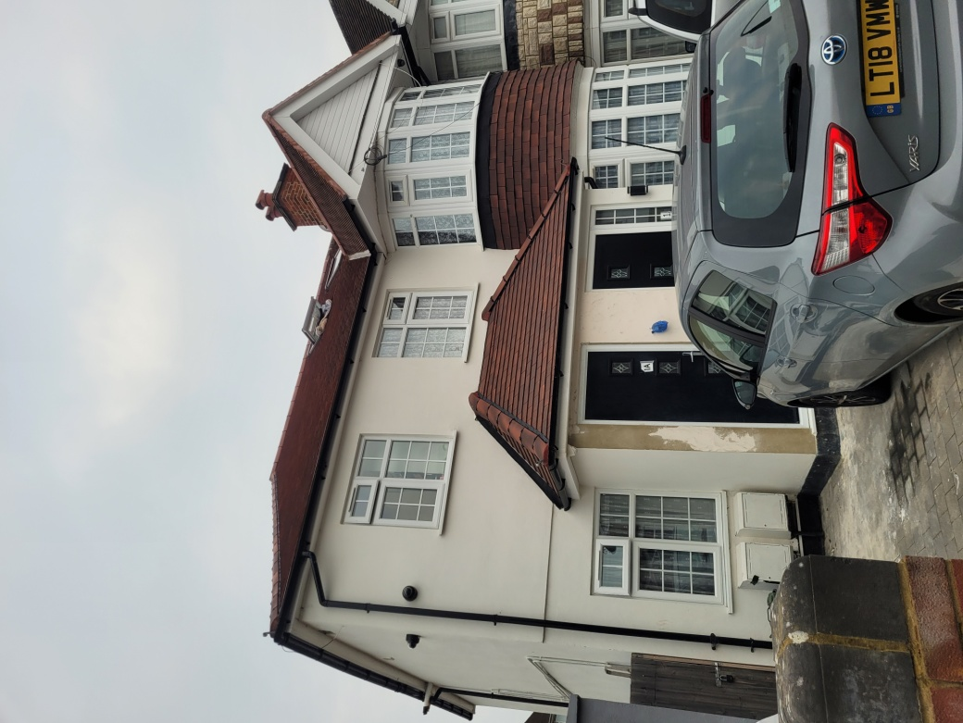

ACCESS
- There is no vehicular and transport access to the proposed site.

