Sie visit photographs – 22/11/22
Around 12pm
Case Officer: Rhian Thomas

Position of outbuilding in rear garden
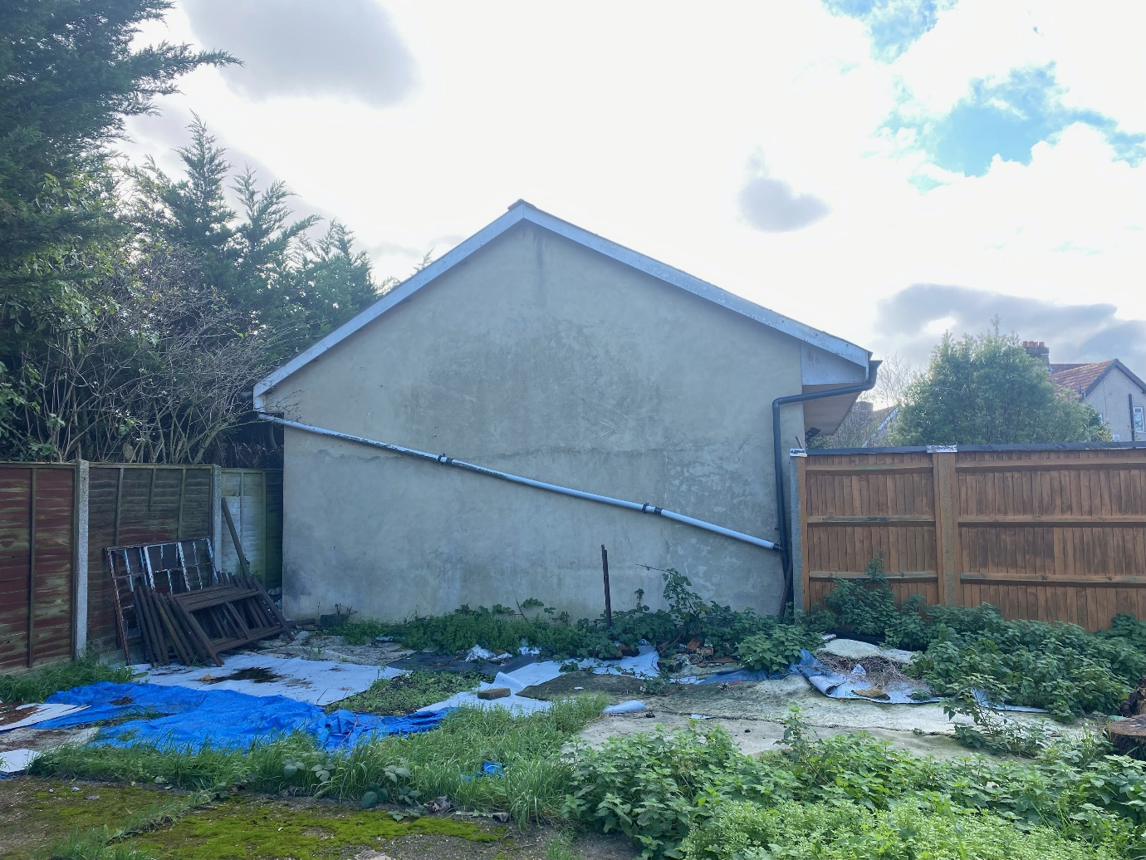

View to side
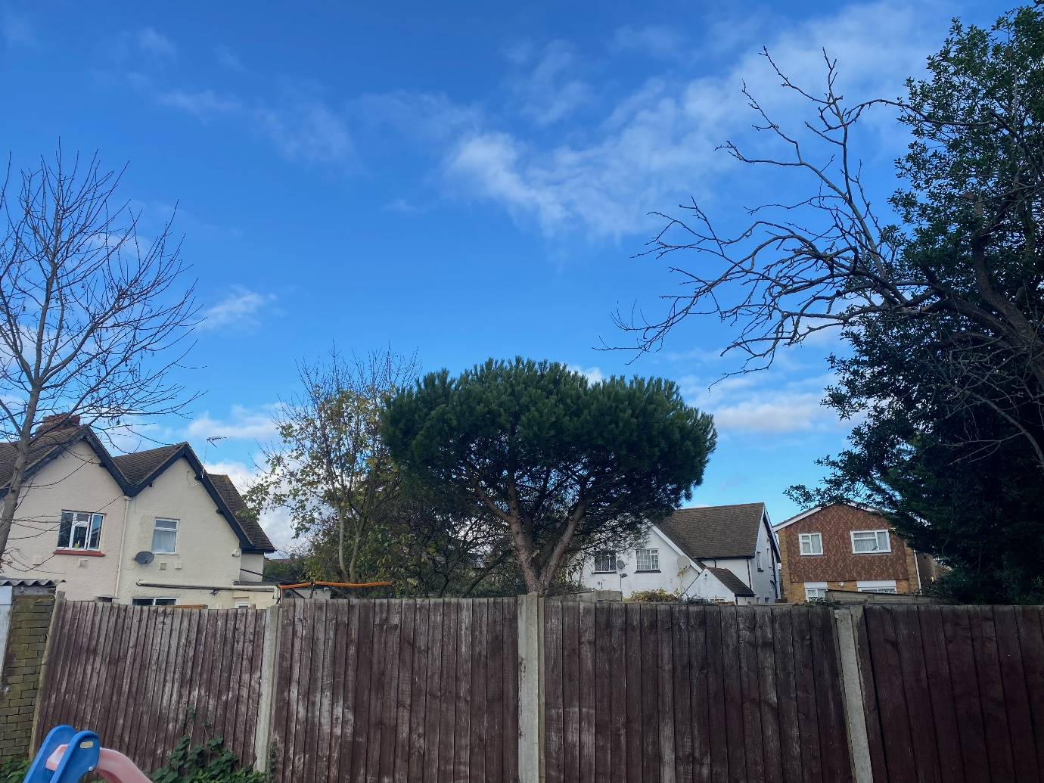

View from rear garden


