FLOOD RISK ASSESSMENT FOR DEVELOPMENT LOCATED WITHIN FLOOD ZONE3

Applicant’s address: 200 LADYGATE LANE, RUISLIP, MIDDLESEX, HA4 7QY

This FRA Statement has been prepared by Anglian Home Improvements in support of the Planning Application for the Erection of a Replica roof extension to replace existing conservatory to the rear of the property.
The application site is situated within Flood Zone 3.
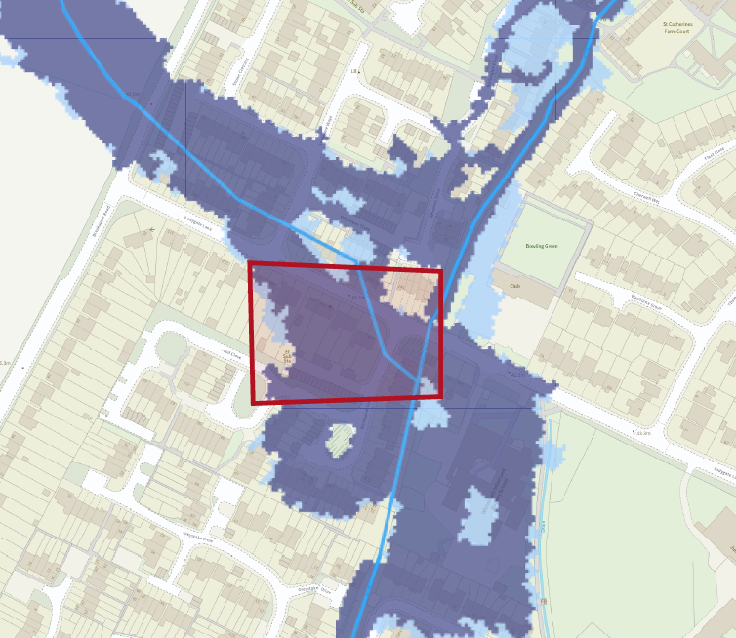
Flood risk map – not to scale – Flood map for planning from gov.uk.
Surface Water Drainage/Mitigation measures
The proposed installation, albeit of increased surface area will not impact upon the drainage and or potential flood risk area. All drainage will be dispersed of via the existing system.
All measures have been undertaken to ensure there is minimal risk in terms of flooding within the area. The proposed extension finished floor level will be 10mm below the house finished floor level.
“Using surface water as resource” from http:// www.susdrain.org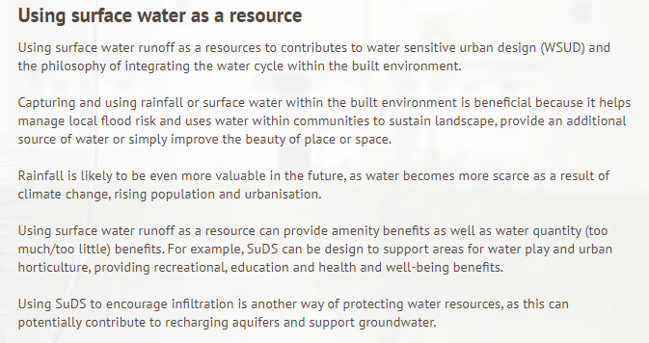

Technical Guidance to the National Planning Policy Framework advises that in this zone, developers should seek opportunities to reduce the overall level of flood risk in the area through the layout and form of the development.
Using SuDS to encourage infiltration in another way of protecting water resources, as this can easier option for many developments. By dealing with runoff at source the volume of water and the potential amount of contamination is less. Often source control components are within the curtilage of properties and maintained by the property owner and can include green roof, rainwater harvesting and water butts.

Conclusion
The proposed installation, albeit of increased surface area will not impact upon the drainage and or potential flood risk of the area. All drainage will be dispersed of via the existing system.

