Ref: APP/R5510/W/21/3282910 Land to the rear of 45 Seaton Gardens, Ruislip HA4 0BB
70507/APP/2021/1208

Release of Condition 5

Proposed Materials
Brickwork
Hanson Hampton Rural Blend
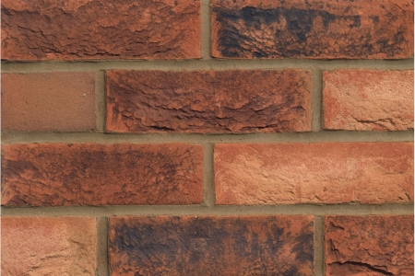

Windows
REHAU UPVC casement windows
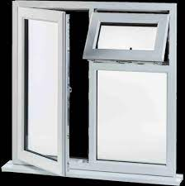
Front Door
Composite Grey Disabled Access Door with three glazing panels

External Render
Cream coloured sand and cement render



Fascia Boards + Soffit
Generic White UPVC

Guttering + Rainwater Goods
Generic Black UPVC
Driveway
Marshalls Priora Permeable Block Paving. Colour - Charcoal

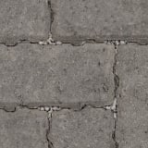

Patio + Pathway Paving
Grey Indian Sandstone Slab
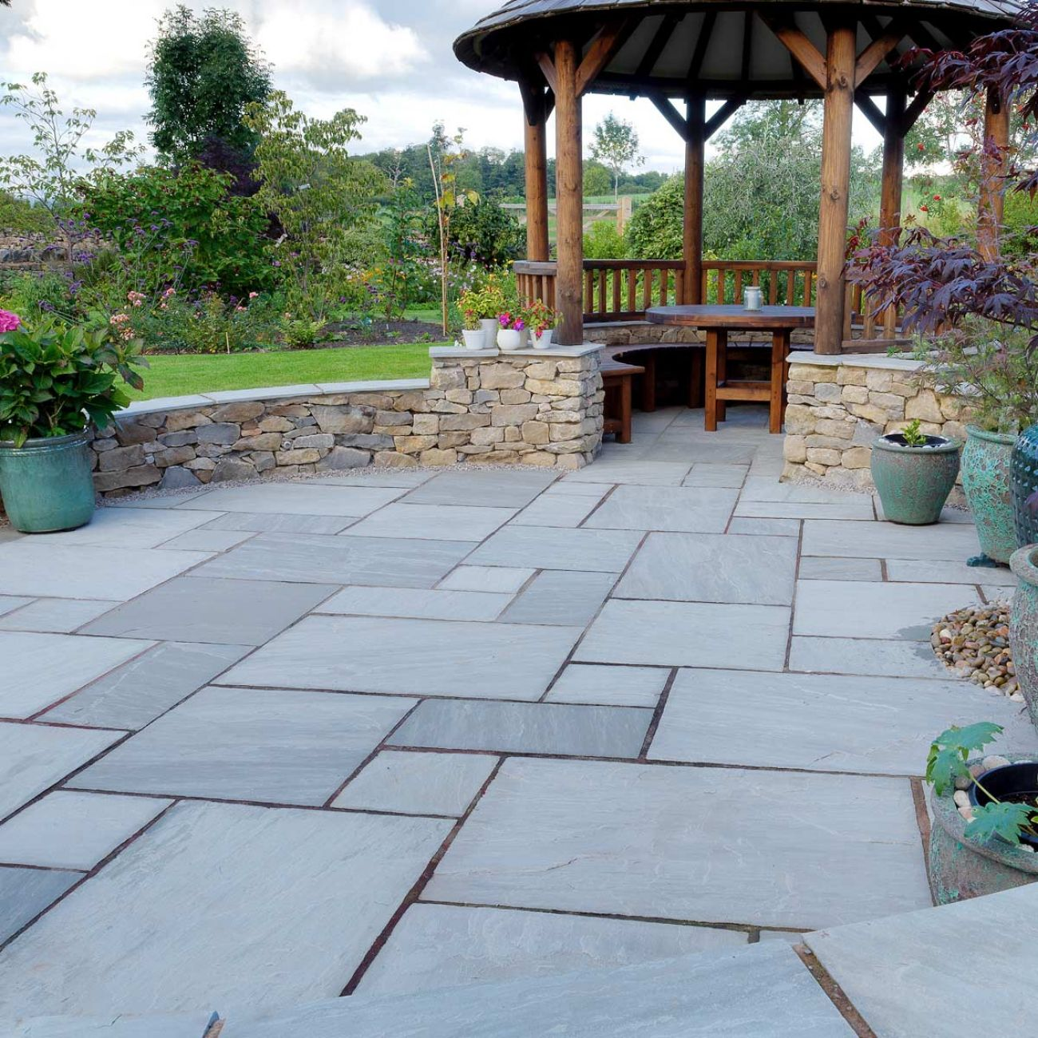

Roof Tiles
Redland Mini Stonewold Concrete Tile – Colour Tudor Brown 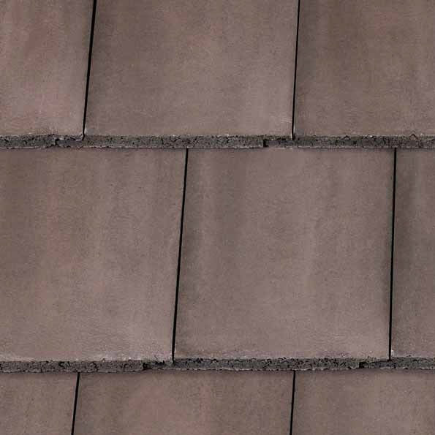

Fencing
Closeboard Fence Panels in Dark Chestnut Colouring
Bin + Cycle Store
Bespoke Built, Timber Construction finished in Dark Chestnut Colouring

