PD
Parmar Designers
T: 07415811001
Parmarplanningpermission@gmail.com

PLANNING STATEMENT

The proposal is for the extension of the raised patio in the rear garden, with the bottom part to be used for storage; the existing raised patio is to be replaced with suspended floors to create space for storage. The existing rear elevation is shown in figure 1 below. The proposed style will be similar to the existing with only doors added to access for storage.
There may be a cause for concern for privacy of the extension to the fence line, we aim to mitigate this by proposing adding an addition to the existing 2.1m high fence by adding an extra 0.9m trestle privacy part at the top, an example is shown below in figure 2.

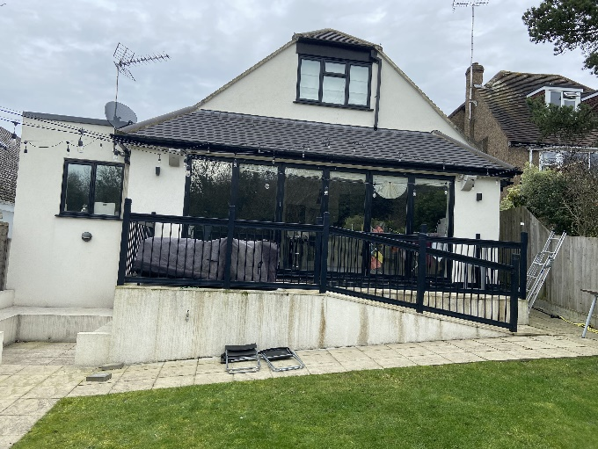
Figure 1- existing rear elevation

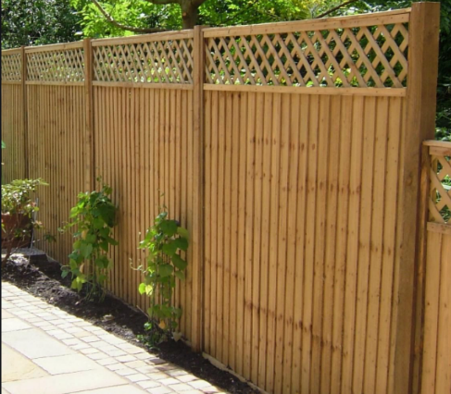
Figure 2- trestle fence panel

As the houses situated on this road are on hills, the application has shown that many neighbouring properties are able to see into this garden, which causes privacy concerns, as shown in figure 3. From figure 3 it is also clear that some properties have patios/balconies up to the edge of their side walls.
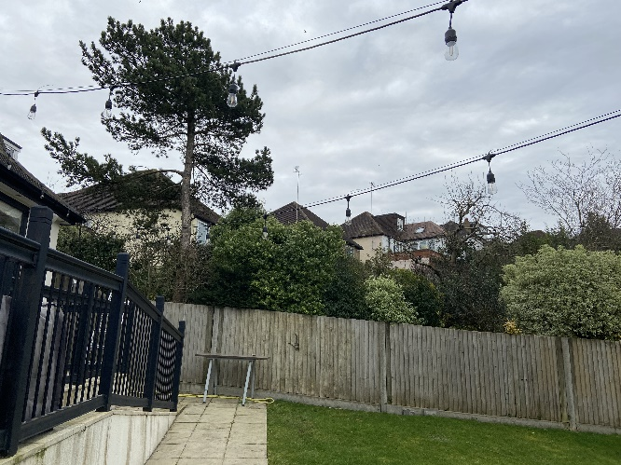

Figure 3- neighbouring properties

We hope that the additional trestle to be added to the top of the existing fence is sufficient to mitigate privacy concerns, in any case there are already existing privacy concerns which are unavoidable given that the properties are on a hill.

